Homework help
Part one
Complete the "What Is My Big Five Personality Profile?" self-assessment.
Write a 1,050-word paper in which you address the following:
- Do you agree with the results of your assessment?
- Based on the results of your assessment, what do you see as your strengths and weaknesses?
- How might your personality type influence your job performance?
Format your paper consistent with APA guidelines.
This is the results from the self-assessment
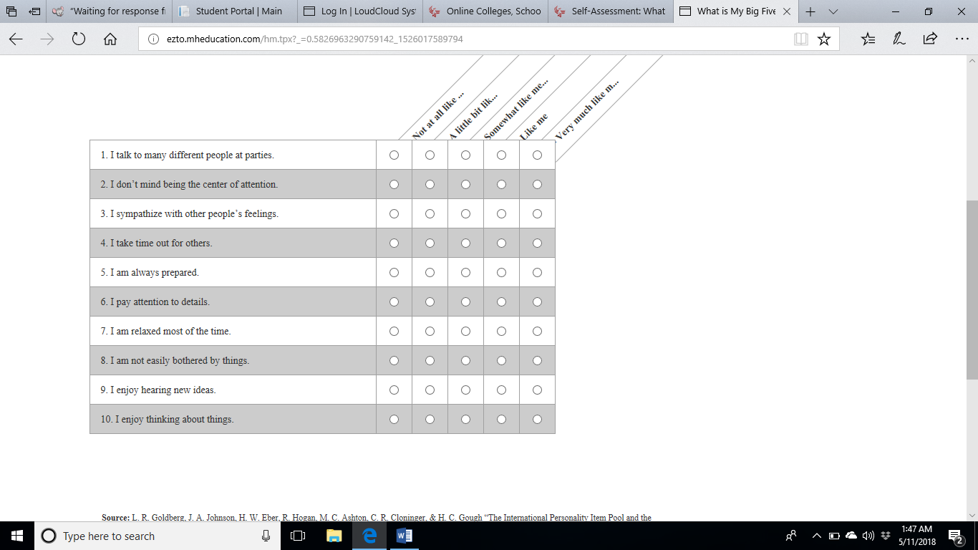
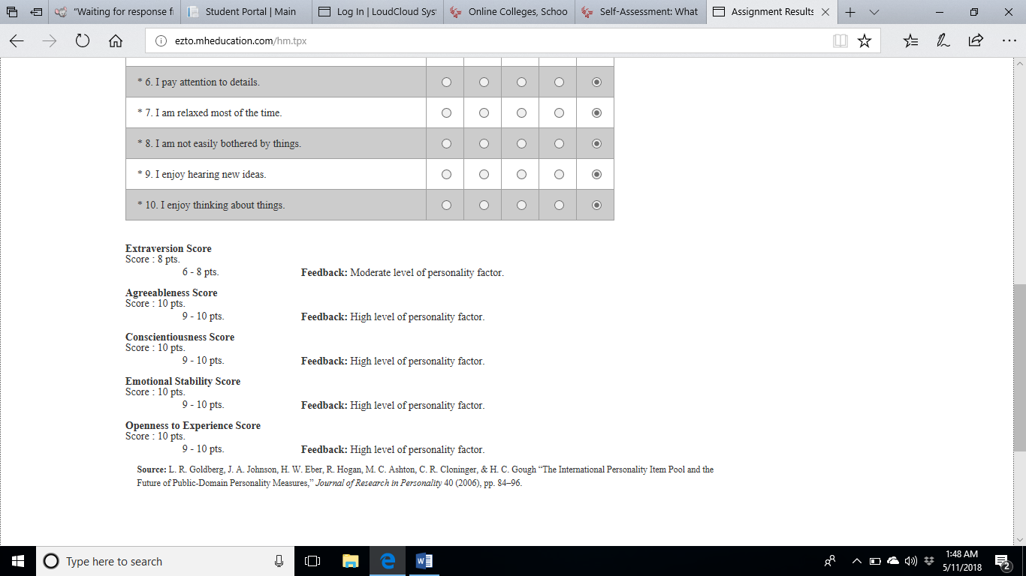

Part 2

Details:
Complete problems 6.12, S6.11, S6.20, S6.23, S6.27, and S6.35 in the textbook.
Submit one Excel file. Put each problem result on a separate sheet in your file.
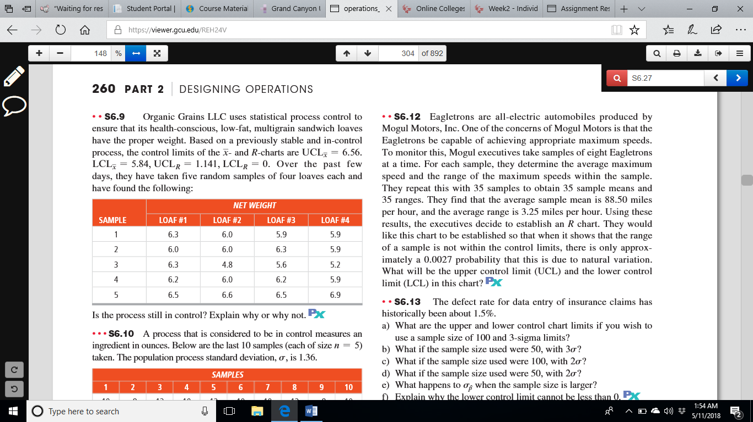
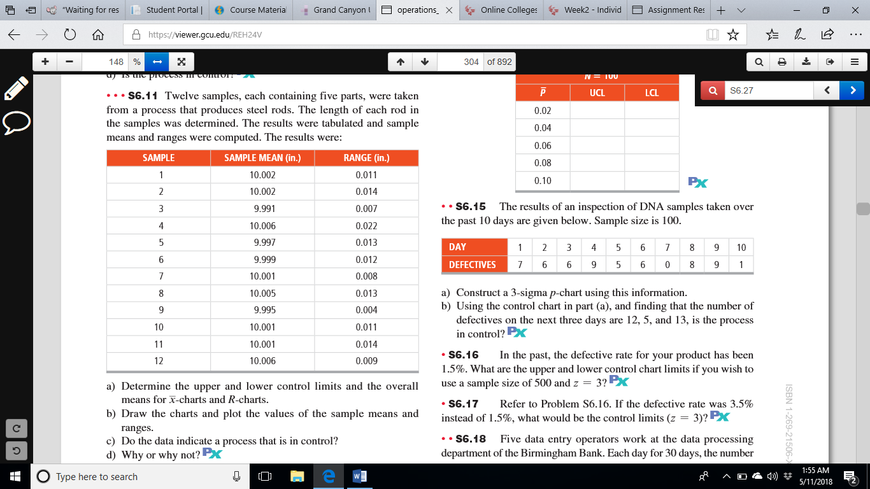
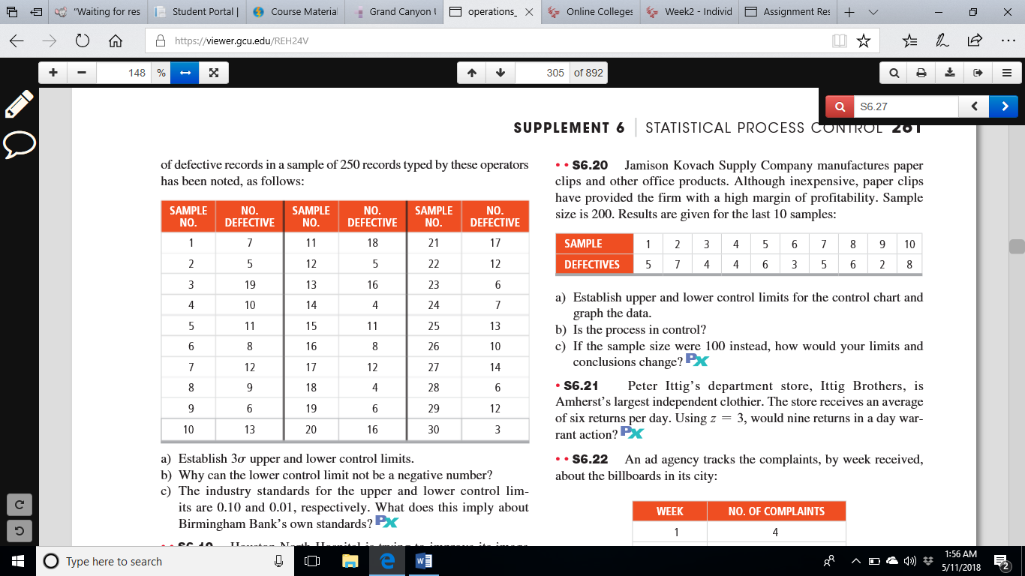
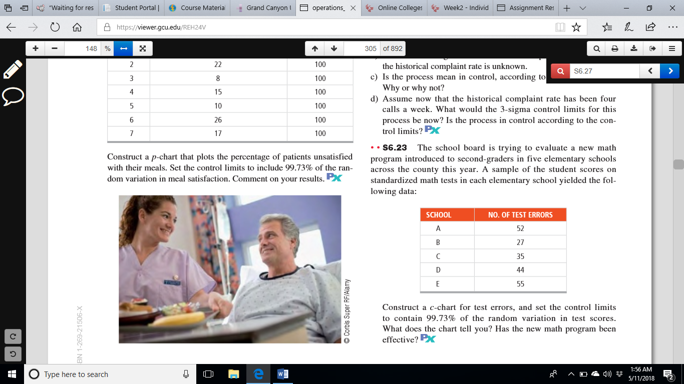
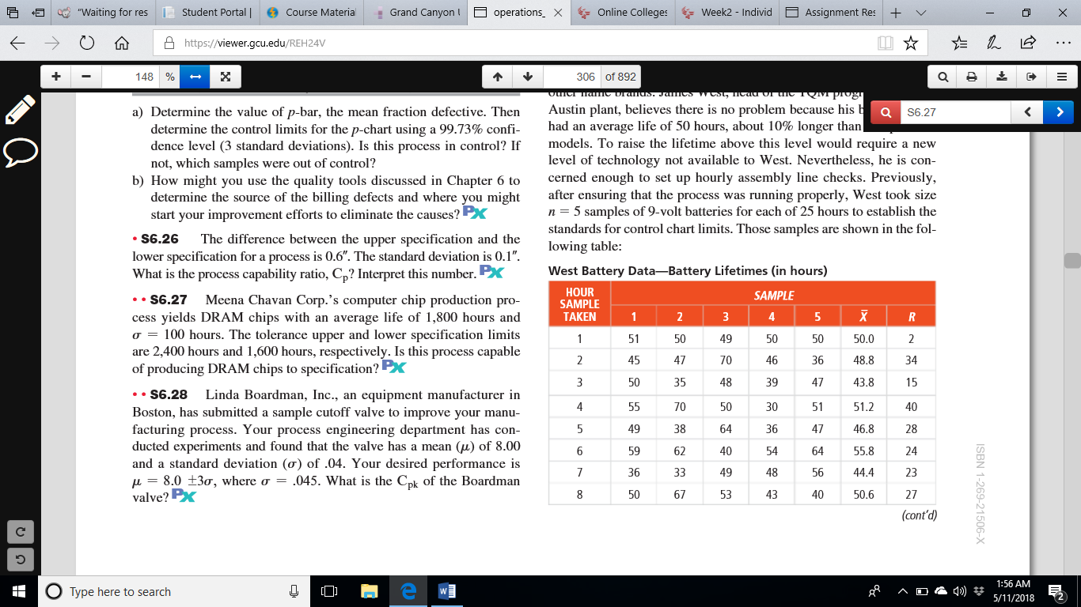
S6. 35
One of New England Air’s top competitive pri-orities is on-time arrivals. Quality VP Clair Bond decided to person-ally monitor New England Air’s performance. Each week for the past 30 weeks, Bond checked a random sample of 100 flight arrivals for on-time performance. The table that follows contains the number of flights that did not meet New England Air’s definition of “on time”:
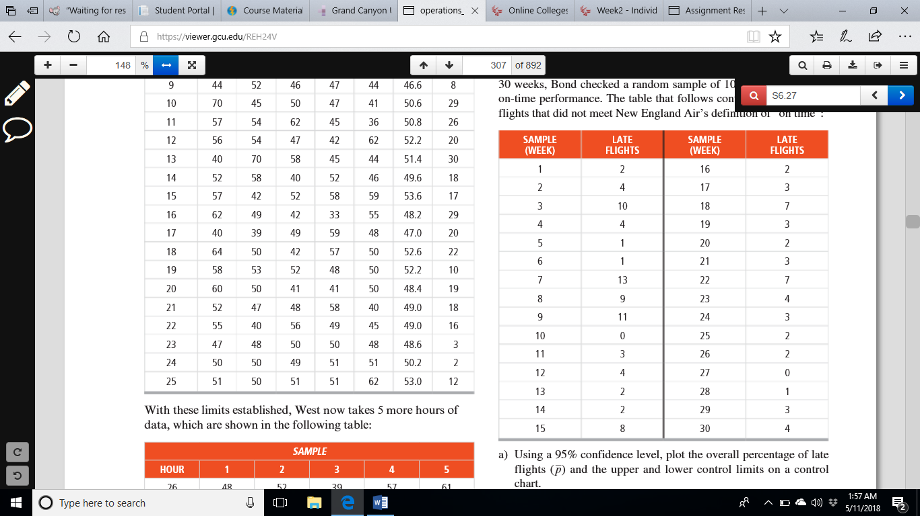
a) Using a 95% confidence level, plot the overall percentage of late flights (p) and the upper and lower control limits on a control chart.
b) Assume that the airline industry’s upper and lower control limits for flights that are not on time are .1000 and .0400, respectively. Draw them on your control chart.
c) Plot the percentage of late flights in each sample. Do all samples fall within New England Air’s control limits? When one falls out-side the control limits, what should be done?
d) What can Clair Bond report about the quality of service?

