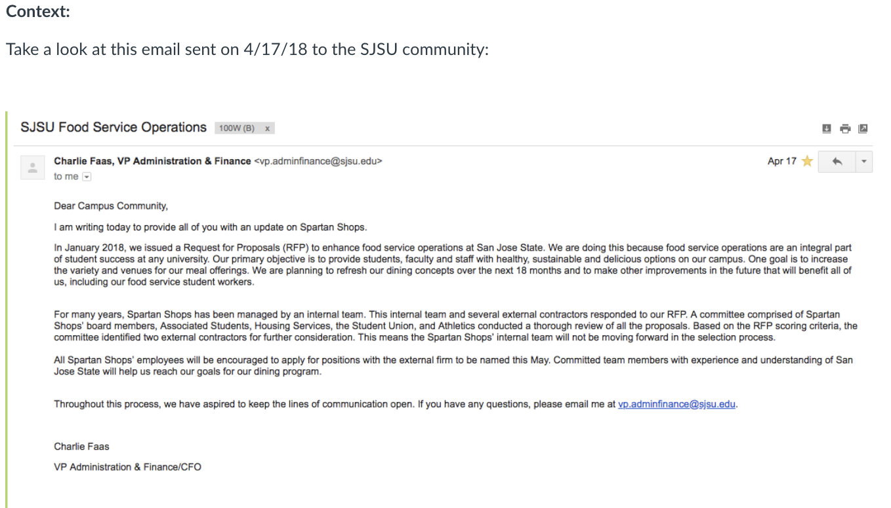

Just this month, it was announced that Chartwells (http://www.chartwellshighered.com/ ) will be the new campus dining contractor. Representatives hosted a series of on-campus Q-&-A forums this past week. For more info on the partnership: https://www.dineoncampus.com/sjsu/our-vision--commitment (Links to an external site.)Links to an external site.

Suppose that in the transition process, Chartwells is collecting written input regarding the campus dining experience and service. Your feedback is part of the preliminary research to better serve the SJSU community.
Compose a 2-paragraph message -- introduce yourself, your opinion and/or preferences of the student dining experience at SJSU, with sufficient examples and explanations to support your opinion. Be aware of your audience and purpose. Use the below heading:
From:
To:
Date:
Subject:
(short introduce about myself and opinion: 4 years experience in SU, This food court has various food options such as pizza, sandwiches, burgers, and some healthy options. The food court is just okay. It's always packed around lunch time so be prepared to wait a while. Even if you bring food and want to warm it up, expect an extra 30-45 mins of waiting in line for the microwaves, there are two microwaves located in the union. They have various tables and bar seating, but almost all of them fill up and it's hard to find a place to sit and actually eat. The tables outside can be kinda dirty and don't provide much shade on sunny days. The bright side, though, is that there's some more room now after the remodel. And the expansion is beautiful. The architecture is so modern and industrial chic. Plus, we finally have a Starbucks.

