At-Home Activity -PODCAST–Messages to and from Extraterrestrials?!?!
10 pts total = 7 Summary + 3 Original Comment

To receive credit for this Podcast Activity you must:

- Listen to/read/watch all of the following links.
- Write a one-half page, (typed, double spaced, 12pt font) summary of the topic. Reference these links. Summarize all the links combined in a half-page.
- Upload this to the d2l dropbox ‘Podcast Activity 2’.
- Post 1 original comment on the Discussion board on d2l. Comments must be at least three full sentences long. For example, do NOT write ‘Yes I agree’.
- You must upload your summary in the Dropbox first, then the Discussion will open.
- Use .pdf or .doc or .docx formats only. If we can’t open your file you will receive 0 pts.

See Schedule for due date.
__________________________________________________________________
- Stephen Hawking Warns Over Making Contact with Aliens; http://news.bbc.co.uk/2/hi/uk_news/8642558.stm (also https://www.theguardian.com/commentisfree/2010/apr/26/stephen-hawking-issues-warning-on-aliens)
- https://breakthroughinitiatives.org/initiative/1- $100 million to fund Breakthrough Listen! SH helped launch in 2015

Arecibo Message http://en.wikipedia.org/wiki/Arecibo_message 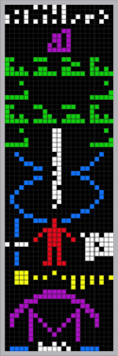

Voyager – The Golden Record http://voyager.jpl.nasa.gov/spacecraft/goldenrec.html 