Introduction
Imagine yourself walking into a 21st-century early childhood classroom in the United States. A group of chatty youngsters happily greets you at the door. Some are tall and lean, others are short and stocky. You squat down so that you are eye to eye with them. The first girl who hugs you is wearing thick glasses and hearing aids. The children are ethnically diverse—Latino, Black, Somali, Hmong. Most of them shout, "Good morning!" but a few chime in with "¡Buenos dias!" You greet each of them in their native language as they run into your arms for hugs. You notice a boy lingering on the outskirts of the group. He is attentive, but quiet, and he's not making direct eye contact with you or the other children. He appears to have something to say, but he can't seem to find the words.
Clearly, the children in the classroom represent different cultural backgrounds and have different levels of English-language skills. This imaginary classroom depicts the wide range of cultural diversity found in today's early childhood education programs. How can you, as a teacher, best incorporate your children's cultural experiences and their diverse language skills into the classroom learning environment?

This chapter will lay the foundation for early childhood teachers as they prepare to educate today's diverse student population. First, we will describe the recent rise in cultural diversity across the United States, especially among the preschool and school age population. Next, we define the key concepts of culture and cultural diversity, and discuss why they are important. Third, we describe the value of language in various cultures, its important role in teacher-child interactions, and how it affects teachers' relationships with culturally diverse children. Lastly, we discuss some ways in which early childhood educators can help prepare this upcoming generation of culturally diverse children to succeed in school.

1.1 Cultural Diversity Among Children Ages 0–8
Before we discuss the rising cultural diversity within the United States, we must understand the key concepts of culture and cultural identity. Culture consists of the social practices, beliefs, values, and behaviors that intentionally—and unintentionally—shape human communication, interactions, and preferences. Culture is evident in how humans do things, and it explains why we want (or feel the need) to do these things. Cultural heritage and traditions shape children's communication practices, interests in instructional activities, and classroom behavior.

We each have a cultural identity that can be defined by various demographic, geographic, religious, or social indicators, and people can belong to several different cultural groups. For example, a child may be culturally defined as an Israeli boy from an upper-income Jewish family living in New York City, or an early childhood teacher might culturally identify with Southern African Americans from the Pentecostal Christian denomination. People's cultural identities not only shape how they think, feel, and behave, but sometimes these identities also shape how others view them. For example, some people may have negative opinions about people with a cultural identity of a non-English-speaking immigrant working in a lower socioeconomic status job, such as a migrant farm worker. These negative opinions form the basis for prejudice and discrimination; we will talk more about prejudice and discrimination in Chapter 2.

Because culture is an integral part of human nature, cultural identity is an important aspect of children's and families' lives, and since the United States is becoming increasingly diverse, it behooves educators to learn to appreciate cultural diversity. An informed understanding of the differences (and similarities) between cultures, though, requires an understanding of what a culture is and the acknowledgement that all human beings are a product of their culture (Cole, 1992/1998). When teachers recognize how important their own culture is to themselves, they will be better able to appreciate the diverse cultural backgrounds of their students, and they will ultimately be better teachers to their students.

Factors Contributing to Cultural Diversity
According to data from the Children's Defense Fund (2012), in 2011 there were approximately 74 million children living in the United States, and nearly half of them (47%) had Hispanic, Black, Asian/Pacific Islander, American Indian/Alaskan Native, or multiracial backgrounds. The increasing racial and ethnic diversity is illustrated by the fact that in 2011, for the first time ever, more infants of racial and ethnic minority backgrounds were born in the United States than White, non-Hispanic infants. The factors behind the recent growth in U.S. cultural diversity include the increases in immigration rates from non-European countries, in the number of children from non-White race and ethnic groups, in students who are dual language learners, and in the number of children living in poverty.

Immigration
The number of children in immigrant families has more than doubled since 1980 (Crosby & Dunbar, 2012). Hispanics presently have the highest immigrant rate and, thus, they are the fastest-growing minority group in the country; as shown in Figure 1.1, the number of Hispanic children living in the United States tripled from 1980 to 2010 (Children's Defense Fund, 2012). Estimates say that at least 1 out of every 4 children is an immigrant; however, almost all of these children were born in the United States and have at least one parent who was born outside the United States (Crosby & Dunbar, 2012), which makes them second-generation immigrants, meaning they were born within the United States and are citizens. On the other hand, first-generation immigrants are people who were born in another country who migrate to the States, either as adults or as children.

Figure 1.1: Number of Hispanic Children in the United States in 1980 and 2010
As shown in this graph, the number of Hispanic children in the United States has more than tripled since 1980.
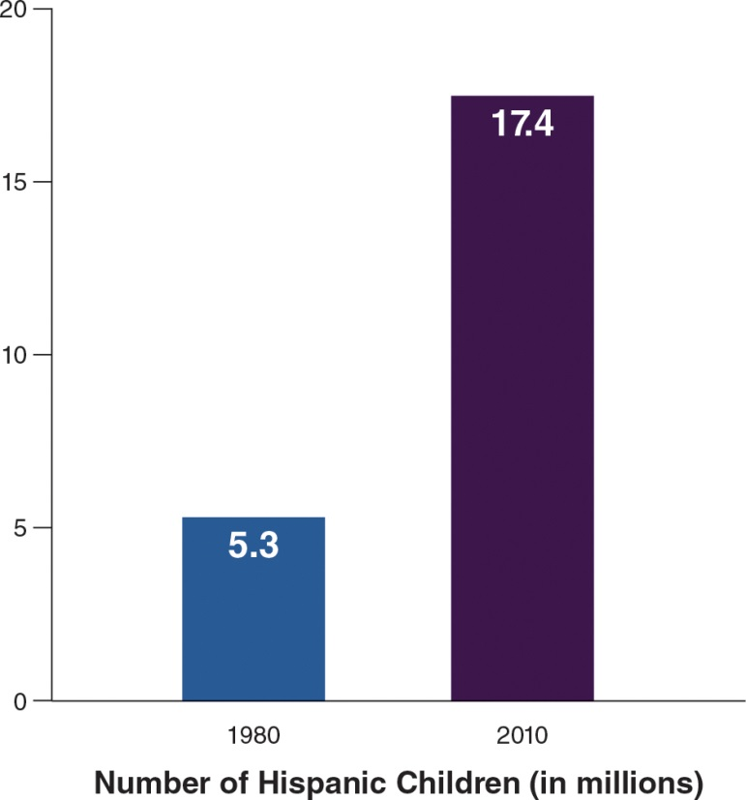
This rise in immigration means that there is a greater chance that more children in early childhood programs either have at least one parent not born in the United States or they themselves were not born in the United States. In Chapter 4, we talk in detail about immigrant families and how to build on these families' strengths and challenges when their children are enrolled in early education programs. The Global Issues feature, "Challenges Faced by Haitian Immigrant Children," previews some of the issues raised in Chapter 4.
Because recent trends in immigration are diversifying our population quickly, we need to look next at the ways this diversity is defined, such as in terms of race and ethnicity.

Race and Ethnicity
Parents are often asked to identify their child's race and ethnic category on various forms, such as the one shown in Figure 1.2. While checking a box on a form does not provide a complete picture of a child's or family member's cultural identity, people are typically affiliated with the racial and ethnic groups that they choose on such forms. In other words, people choose to indicate these aspects of their cultural identity because such categories have psychological and social meaning for them. Otherwise, they would opt to not identify with such categories.

Figure 1.2: Questions on Hispanic Origin and Race From the 2010 Census
What does the information requested on this census questionnaire tell us about the U.S. government's definitions of race and ethnicity?
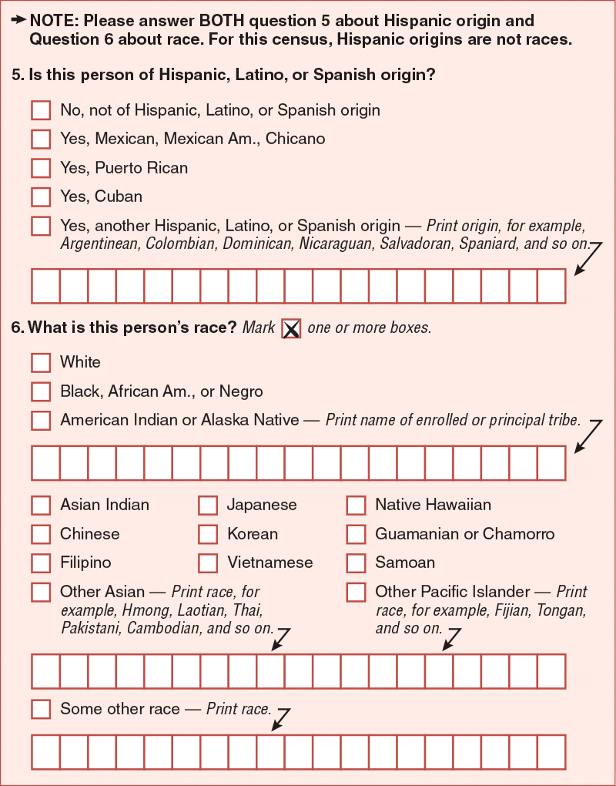
As anyone who has filled out such a form might know, there is always a limited number of options for race and ethnicity. The United States Census Bureau, for example, which is responsible for collecting and reporting demographic data about the nation's population, has defined the most prevalent race and ethnic categories. Figure 1.2 shows the options presented for Hispanic origin and race during the 2010 census. First, people are asked to indicate their ethnicity; ethnicity is defined as having a shared nationality, language, religion, or sociopolitical history (e.g. a group's exposure to conquest, slavery, or segregation). In other words, ethnicity is a broad cultural identifier that could describe multiple groups. Yet, the only choices for ethnic categories on the U.S. census are Hispanic versus Non-Hispanic; people of Hispanic origin can be from any racial background, and Hispanic origin refers to a heritage, nationality, or ancestral lineage.

The census also asks respondents to indicate their race; race is defined as a shared ancestral heritage that distinguishes groups of people based on physical characteristics that were once believed to be genetic or biological. On the census form, the specified racial categories include White, Black or African American, American Indian or Alaska Native, Asian, Native Hawaiian or Other Pacific Islander, or Some Other Race. When these ethnic and race categories are combined, they result in the following:

White, Non-Hispanic;
Black, Non-Hispanic;
Hispanic (All Races);
American Indian/Alaska Native;
Asian;
Native Hawaiian/Pacific Islander; and
Some Other Race (Humes, Jones, & Ramirez, 2011).
Despite the fact that the census describes its categories of people as "racial" groups, it is important to understand that these categories of people also represent "ethnic" groups.

The definitions of race in the United States have frequently and dramatically changed since the first census in 1790, and all these changes are based on public policies or population trends at different time periods, such as the legalization of slavery, the granting of citizenship rights, or the influx of new immigrants (Humes, Jones, & Ramirez, 2011). Such changes in the way society defines race were never—and still are not—based on biology. The Global Issues feature, "Scientists Were Wrong About Race," explains how for centuries, scientists drew inaccurate conclusions about the nature of race. Categorizing people according to racial groups has no basis in biological science, because all people are the same at the genetic level. Race is more accurately defined as a social construct that was created, and has been manipulated, over time in order to shape public will and deny certain groups of people rights.
Now that you have been introduced to the social and political history of race, you can more clearly see how race and even ethnicity are social constructs; the definitions of these words are based on the political battles and immigration trends at a given time. You can also understand why people may choose to define themselves using multiple terms across the various aspects of their cultural identities.

In this book, whenever possible, we will describe groups according to their ethnicity because, compared to race, ethnicity speaks more to one's cultural identity. Because ethnicity includes shared nationality, language, religion, and sociopolitical history, people can be described more specifically and across multiple aspects of their identity. Therefore, we might use specific terms such as Panamanian or Jamaican to describe children and families, rather than simply Latino or Black, respectively.

There are times, however, when there is a need to describe larger pan-ethnic groups that combine subgroups sharing a similar ancestral heritage, language, religion, or sociopolitical history, regardless of their nationality. In these cases, we will use terms such as White (e.g., people of European, North African, or Middle Eastern descent, regardless of country of origin), Black (e.g., people of African descent, regardless of country of origin), Asian (e.g., people of East Asian, South Asian, and Polynesian descent), and Native American (e.g., people whose ancestors originated in precolonial United States).

Dual Language Learners
Given the diversity of immigrants of different nationalities, it should not be surprising that 20% of the United States population speaks a language at home other than English (Johnson, Os, Drewery, Ennis, & Kim, 2010). The children within this population are referred to as dual language learners (DLLs)—children who are acquiring two or more languages at the same time. The term DLL can encompass other terms frequently used to describe students, such as Limited English Proficient (LEP), bilingual, and English language learner (ELL).

When working with DLLs, teachers have to remember that not all DLL families share the same experiences, national customs, or even dialect. There are variations in the home languages that families speak, the ages when children were first exposed to English, their fluencies in English and their other languages, and the degrees of the families' linguistic isolation (Espinosa, 2010).

In addition, there is wide variety across racial and ethnic groups in the percentage of the population that speaks a language other than English at home. Figure 1.3 shows that the majority of Asians and Hispanics speak another language at home besides English, as do many American Indians and Pacific Islanders. Whites and Blacks are the least likely to speak another language besides English at home.

Figure 1.3: Percentage of the Population Speaking Another Language at Home
What does this graph show you about the cultural makeup of the United States?
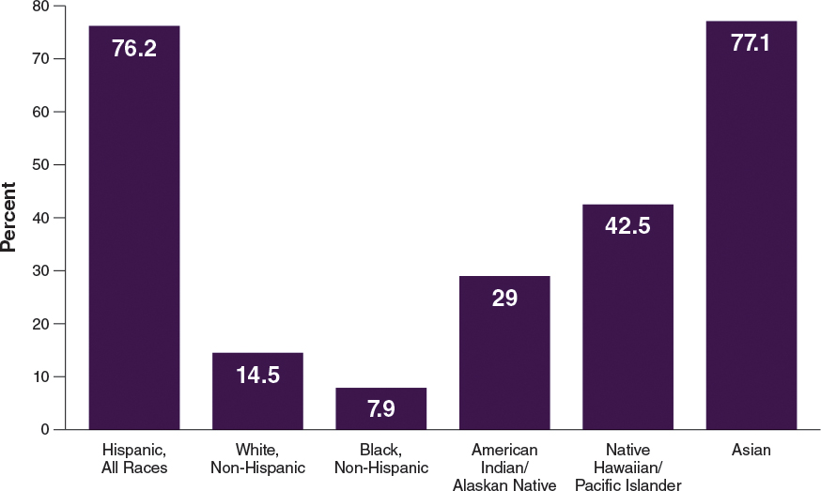
These differences across the racial and ethnic groups can illustrate why Spanish is the second most widely spoken language in the United States, and Chinese is the third. The Native American languages now spoken by large groups of people are Cherokee, Navajo, and Teton Sioux/Dakota (Estes, 1999, as cited in Westby & Vining, 2002); some Native Hawaiians also speak Hawaiian, the official language of the state of Hawaii along with English.

The U.S. census information about languages spoken at home only captures a fraction of the nation's language diversity because it does not include those families and children who speak a creole language. Creole languages (also referred to as pidgin languages or dialects) are formed by blending aspects of two or more languages; this blending most often arises when two or more groups of people are forced into contact with each other through colonization and conquest. For example, Haitian Creole is primarily based on 18th-century French and various African languages, as well as some English, Arabic, Portuguese, and Spanish. Creoles tend to be different in phonology, semantics, and syntax (e.g., verb tense and word order) from their parent languages. Creoles that U.S. teachers are most likely to encounter are Hawaiian Pidgin (Rivera et al. 2002), Haitian Creole (see Terrell & Jackson, 2002), and Jamaican Patois (Best, Tyler, Gooding, Orlando, &Quann, 2009; Washington, 2012); in addition, African American children might speak African American English Vernacular (AAEV) (Bailey, Baugh, Mufwene, &Rickford, 2013; Craig, Zhang, Hensel, & Quinn, 2009).

Worldwide, people often mistakenly judge creoles, dialects, or pidgins as the languages of the uneducated and the poor, and children who come to school speaking such languages are often told to "speak properly" rather than being given systematic, intentional language instruction that might help them transition more easily from creole to the standard language. However, culturally diverse children, especially Black children (Bland-Stewart, Elie, & Townsend, 2013), can benefit from modified instruction to accommodate their creole dialect differences that is similar to modified instruction for children who speak another language (Boutte & Johnson, 2013). For example, teachers might read stories in which the characters use dialect, and then have a conversation about how people speak differently depending on the situation they are in and the person to whom they are talking.

Poverty Status
While somewhat controversial, economic status is another factor by which our society is becoming more diverse. Figure 1.4 shows that the percentage of children now living in poverty has nearly doubled over the last decade (Kids Count, 2012b), with children aged 0–5 more likely to live in poverty than older children aged 6–17 (Children's Defense Fund, 2012). Early childhood teachers are likely to have some children in their classrooms who are living in poverty. They need to be aware of the specific financial needs of these children and their parents, such as the need for affordable housing in a safe neighborhood, and they need to understand how to work with the parents in a nonjudgmental and supportive way.

Figure 1.4: Change in Age-related Poverty Percentages From 1973 to 2010
According to this graph, how has the population affected by poverty changed since 1973?
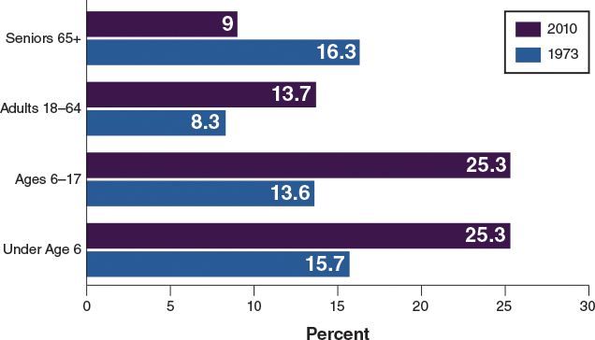
Unfortunately, the financial outlook for young children is getting worse over time: Over the past four decades, preschool children have become poorer while the financial situation of seniors 65+ has clearly improved (Figure 1.4). Seniors have access to public policy programs and incentives, such as social security and housing subsidies, that young children (and their parents) do not. Families headed by young adults are poorer than families headed by seniors, and young adult families are more likely to be raising young children than senior families.

The U.S. Poverty Threshold. What exactly is meant by poverty status, and how does living at or below the poverty threshold affect the early education care children receive? To answer the first part of the question, the U.S. poverty guidelines are defined by the federal government and adjusted yearly. Table 1.1 shows the poverty guidelines for 2012 based on family size. As you can see, the poverty threshold for a mother and her child is $15,130 per year (amounting to a wage of about $7.00 per hour), which means that in order to qualify for public policy programs geared toward families, a mother would have to be making no more than $15,130 per year. These eligibility requirements are exact, meaning families making only a few more dollars can be excluded from early education services (Children's Defense Fund, 2012).

Table 1.1: Poverty Threshold Guidelines for 2012
Family Size | 48 Contiguous States and District of Columbia
1 | $11,170
2 | $15,130
3 | $19,090
4 | $23,050
The poverty threshold is higher for Hawaii and Alaska.
Research shows that children living in urban and some rural areas are more likely to live in communities with concentrated poverty—poverty rates greater than 30%—than are children in the suburbs (Kids Count, 2012a). The communities that have high concentrations of children living in poverty also have a high concentration of immigrant children and of U.S.-born minority children, and this overlap indicates a strong connection between poverty, race and ethnicity, and immigrant status (Kids Count, 2012a). Figure 1.5 shows the percentage of children living in concentrated poverty by race/ethnicity.

Figure 1.5: Percentage of Children Living in High-poverty Communities
How might living in poverty affect children's learning? What additional factors might come into play for children also living in a high poverty community?
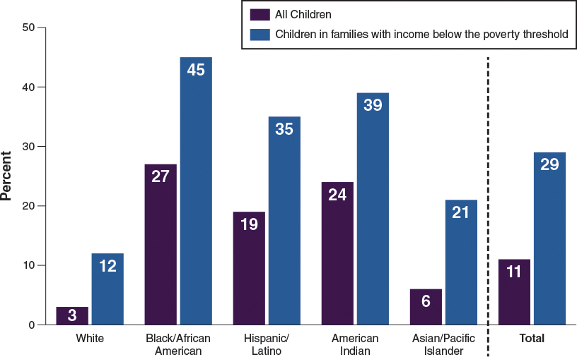
Children Living in Poverty Need Early Education. Living in poverty can disrupt children's growth and learning. Aber, Morris, and Raver (2012) explain that poverty is linked to health, academic, and social-emotional problems for children. Children who live in poverty often live in inferior housing conditions—for example, homes that have inadequate heating and cooling or that are near environmental pollutants like toxic waste dumps, congested highways, or airports—which can cause health problems like asthma and untreated allergies. In turn, these health problems cause them to miss more school. Families living in communities with concentrated poverty are also more likely to have difficulty paying for food, housing, and health care.

Children who live in concentrated poverty are more likely to attend lower-quality schools, have fewer resources, and less experienced teachers (Kieffer, 2008; Burdick-Will, Ludwig, Raudenbush, Sampson, Sanbonmatsu, & Sharkey, 2010). These school-level differences contribute to the achievement gap. Lastly, concentrated poverty is associated with high levels of chronic stress that lead to behavioral and emotional problems (Turner & Kaye, 2006).

Teachers must consider all these factors in combination when teaching children and working with their families. One early childhood program that has worked for decades to offset the problems that children and families in poverty face is Head Start.
Head Start: An Early Education Program Designed to Serve Children in Poverty. In his State of the Union speech in January of 1964, President Lyndon B. Johnson launched the War on Poverty. One of its components was a comprehensive child development program that would help communities meet the emotional, social, health, nutritional, and psychological needs of disadvantaged preschool children. Head Start began in 1965 as an eight-week summer program. Since then, it has provided services to more than 30 million children, from birth to age 5, and their families (U.S. Department of Health and Human Services, n.d.).

Head Start was most recently reauthorized in 2007 with several provisions to strengthen its quality, including alignment of Head Start school readiness goals with state early learning standards; higher qualifications for the Head Start teaching workforce; State Advisory Councils on Early Care and Education in every state; increased program monitoring, including a review of child outcomes and annual financial audits; and a shift from indefinite project periods to five-year grant cycles, within which programs are required to demonstrate that they are of high quality to avoid a competitive grant opportunity being made available within the community.

Head Start has a history of embracing ethnic, cultural, and linguistic diversity in the communities in which it operates. A key tenet of the program is to be culturally responsive to the communities and families served through local governance, such as family policy councils. To formalize its commitment to diversity, Head Start developed the Multicultural Principles for Head Start Programs in 1992 and incorporated it into their Program Performance Standards in 1996. The four elements of Head Start's overall philosophy in multilingual and multicultural programming are

building trusting relationships,
being sensitive to cultural preferences of families,
building bridges between cultures for both children and adults, and
acknowledging that staff and parents are in a true partnership.
Head Start has helped shepherd new programs by bringing attention to the importance of early education for children, especially children living in poverty. Head Start and similar programs have helped set the standard for quality while accommodating the cultural and linguistic diversity of children and families.
1.2 Global Access to Early Childhood Education
Globalization is the merging of worldviews and consumer products due to modern advances in transportation and telecommunications (like cell phones, the internet, and wireless technologies). One consequence of globalization is the sharing of values around the globe. One such value that seems to be spreading rapidly is the belief in the importance of early childhood education (ECE). There is consensus worldwide that early childhood education represents a promising strategy to mitigate the long-range effects of poverty and parents' limited education.
The mission of the international Organization for Economic Cooperation and Development (OECD) is to promote policies that will improve the economic and social well-being of people around the world by sharing information and policy suggestions with its 34 member countries. In its Education at a Glance 2012 report (OECD, 2012), the OECD highlights the importance of investing in early childhood education.

International results of early childhood education appear quite hopeful, indeed. Data from the Programme for International Student Assessment (PISA) confirms that 15-year-olds who attended early childhood education outperform their peers who did not attend, even after considering differences in students' socioeconomic backgrounds. The relationship between preschool attendance and 15-year-olds' performance is even greater for children enrolled in preschool for longer periods of time, for pupil-to-teacher ratios smaller than 20:1, and for countries that invest in per-pupil funding (OECD, 2010).

Because the report provides comparative information with other countries, we in the United States can get a sense of how we are competing globally when it comes to early childhood education. Unfortunately, in comparison to the other 34 member countries, the United States ranks near the bottom—at 28—in providing access for 4-year-olds to attend preschool. Only 69% of children in the United States attend preschool, whereas the OECD combined country average is 79%. In fact, in some countries, such as Belgium, France, Iceland, Italy, Norway, Spain, and Sweden, the enrollment rate exceeds 90%.

Clearly, efforts must be made within the United States to improve young children's access to early childhood education programs if we want to stay competitive with other countries in long-term education goals. Increasing access to early childhood education for children in the United States has implications for the ECE workforce and the value placed on early childhood, with potential implications for wages and benefits for ECE teachers.
1.3 How Culture Influences Language and Learning
Humans pass down their culture from generation to generation using artifacts (objects or tools) such as books, musical instruments, houses, and weapons. However, artifacts can also be intangible tools, such as spoken and written language, laws, religion, and rites of passage. The family is an important vehicle of cultural transmission. Culture is evident in outwardly observable things like the foods we eat, the holidays we celebrate, the way we dress, and the art we create. It is also apparent in the way we tell stories and express our feelings, in our beliefs about how to care for children and how families should operate, and even in our spiritual beliefs about God, nature, and life after death.

The Cultural-Context Framework
Cole (1992/1998) has proposed a cultural-context framework for interpreting child development that can be applied specifically to language and cognitive development. Cole's framework takes into consideration children's individual differences (e.g., their biological features, personality, and natural-born curiosity level) and their environmental experiences (e.g., participation in educational programs and the quality of such programs), which are the two factors research scholars commonly consider when investigating children's educational outcomes. Cole also considers children's cultural experiences (e.g., their family and community traditions).

Cole's framework is unique in that he believes educational outcomes are the result of children's individual differences and the quality of their educational experience being funneled through their cultural experiences, a process researchers refer to as mediation. Figure 1.6 compares the manner in which education outcomes are typically viewed and how they are viewed within the cultural-context framework. In the cultural-context framework, not only are children's individual differences and their education environments interacting, as they do in the typical model, but these two factors are also processed through children's cultural experiences. What this means is that children's cultural experiences are central to any interpretation of children's education outcomes. For example, when a child is asked to retell a story that a teacher has read in class, he will likely retell it using the vocabulary, grammar, and narrative style of storytelling that is typical of his culture (Curenton, 2006).

Figure 1.6: Typical View of Education Outcomes Versus the Cultural-Context Framework View of Education Outcomes
The cultural-context framework takes the children's culture into account as a major contributing factor of how they learn.
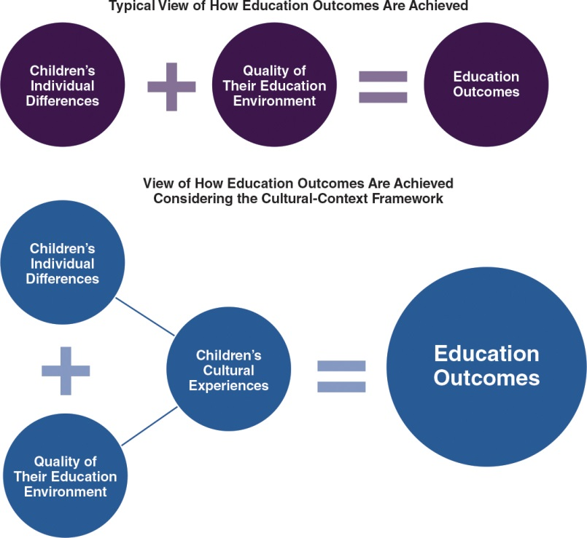
The cultural-context position is very similar to Rogoff's (1993) sociocultural theory on cognitive development, which states that individuals learn to solve problems within the context of cultural activities facilitated by more experienced and knowledgeable peers and adults. The sociocultural perspective acknowledges that children bring certain personal strengths and challenges to teaching interactions, such as voluntary attention, memory, and cognitive capacities, and these strengths and challenges provide the foundation for the education interaction because they can be influential in sustaining the interaction.

For example, teachers are more likely to spend more time talking to and teaching a child who is engaged in the lesson, who has the language skills to answer questions, and who asks additional questions. In fact, language, both conversations and literature, is the primary way teachers share cultural traditions and ideas with their students. The most important and efficient way in which humans have transmitted cultural traditions from generation to generation is through language. Therefore, we will spend time explaining how language is used as a cultural tool.

Language as a Cultural Tool
Language and culture are interconnected. Language is a cultural tool that children must master in order to function in society, and language is different from other cultural tools because it has the ability to create and transcend reality (Bruner, 1993). Oral language is the socially shared, culturally constructed, and rule-governed system of spoken communication that consists of receptive language skills (i.e., the ability to understand what has been said, or listening skills) and expressive language skills (i.e., the ability to use speech to convey meaning, or speaking skills). Written language is typically expressed through text that can be read or written; the abilities to decode, transcribe, and comprehend written text are literacy skills.

Oral language is the bridge to written language. According to one researcher, the most powerful preschool classroom predictor of children's later literacy skills is teacher instruction strategies that support extended conversation (Dickinson, 2006). Large-scale research using a socioeconomically and ethnically diverse sample suggests children's oral language skills at 3 years of age form the basis for their emergent literacy skills at 4½ years of age and for their actual reading ability at first grade (National Institute of Child Health and Human Development [NICHD], 2005). Research like this indicates that strong oral language in the preschool years is a significant contributor to children's emergent literacy, later reading, and academic outcomes.

Conversely, weak oral language skills elevate children's risks for later reading difficulties (Catts et al., 2002). Therefore, oral language skills, along with the well-researched code-based emergent literacy skills (e.g., letter recognition and phonological awareness), can be seen as a critical developmental domain associated with preschoolers' emergent literacy (NICHD, 2005; Storch& Whitehurst, 2002). See Figure 1.7 for specific oral language skills that overlap with literacy skills.

Figure 1.7: Relationship Between Oral Language and Literacy Skills
Understanding the relationship between language and literacy is critical for an early childhood education teacher who has students who speak multiple languages.
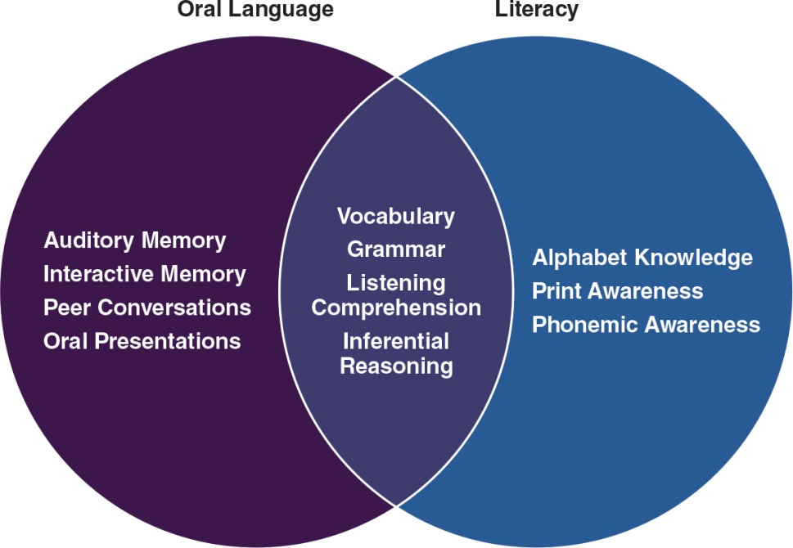
Language and Literacy Development for DLLs
From birth, children learn language through interactions with their family and community members. Through these interactions, they learn not only linguistic code (e.g., Spanish or English or Chinese) but also the pragmatic rules of communication (i.e., how to adjust their language based on the speaker's knowledge and how to ask questions). When working with culturally diverse students who are DLLs, additional aspects of language and literacy need to be considered (Table 1.2). For DLLs, it is critical that parents and other adults, including teachers, continue to provide rich interactions in children's home language because it builds a strong foundation that will advance children's ability to learn the second language.

Table 1.2: Classroom Strategies: Language and Literacy for DLL Children
 |  |  |  |  | Building DLL Children's Language Skills
Strategy |  |  |  | Rationale |  | Examples
Provide explicit, systematic instruction in vocabulary |  |  |  | Children require multiple exposures to words in order to develop a rich understanding of their meanings and different ways to use them. |  | Present vocabulary words in a thematic way, using themes such as soap or clothing  Read-alouds that include explanations of targeted vocabulary  Dramatic play organized around carefully chosen themes
Ensure that DLLs have ample opportunities to talk with both adults and peers and provide ongoing feedback and encouragement |  |  |  | DLLs need lots of opportunities to engage in social interactions with other children, but they also need support from adults as they develop the language skills they need to negotiate those interactions. |  | Pair DLL children with children who have strong English language skills, and don't group together children who speak the same home language  Provide opportunities for self-directed activities so that DLLs can choose activities that match both their interests and their language abilities  Encourage children to talk by providing prompts when they need help expressing themselves (e.g., "Ask Tia, 'May I please play with the bike now?'")  Use open-ended questions and find ways to extend conversation with DLLs (e.g., "Why do you like playing with this toy?")
Expose DLLs to rich language input |  |  |  | Exposure to rich language, such as through book reading or through teacher talk, enhances children's oral language development. |  | Provide ongoing dialogue on activities taking place in the classroom (e.g., discuss every step when transitioning from one activity to another)  Select books that have rich language and connect to children's home language and lives
Structure the classroom space and routine to provide scaffolding for DLLs' language learning |  |  |  | Routine and structure of the classroom will help DLLs know what they are to do and how they are allowed to behave. It will also expose them to a consistent language about specific things so they can connect words to activities. |  | Arrange the classroom to support each type of instructional activity (e.g., middle of the room is for whole group activities, corners of the room are for self-directed activities)
Encourage continued development in the home language |  |  |  | Children who have strong language skills in their home language are likely to develop strong language skills in their new language. |  | Encourage parents to talk and read to their children in their home language as a way of strengthening children's home language skills  Incorporate children's home language in the classroom through books, songs, and videos as much as possible
's
Building DLL Children's Literacy Skills
Literacy Skills
Strategy | Rationale |  | Examples
Design instruction that focuses on all of the foundational literacy skills | Some of the key foundation skills that children need to know to be prepared for kindergarten include alphabet knowledge, phonological awareness (e.g., recognizing rhyming words, recognizing beginnings of words, matching sounds to letters), and print awareness (e.g., recognizing parts of books, knowing direction of words is from left to right). It is critical for children to understand the relationship between spoken language and oral language. |  | Interactive storybook reading  "Pretend" reading and writing  Games and other activities to help children  identify the letters of the alphabet  Interactive experiences with language and  print through poems, nursery rhymes,  and songs
Recognize that many literacy skills can transfer across languages | A child with strong literacy skills in their home language will find it easier to develop these same skills in English. |  | Parents and teachers proficient in the  child's home language can use the home  language to teach rhymes and songs, play  word games, share storybooks, and tell  stories  Teachers can send books home with the  child in the child's home language to  encourage families to continue use of the  home language
Accelerate English literacy development by helping DLLs make the connection between what they know in their first language and what they need to know in English | Similarities between English and the child's home language can be used as a foundation for instruction because they are sounds and words children are familiar with. Children usually have the most difficulty when they encounter sounds that are present in English but do not occur in their home language, such as the vowels a, e, i, and u and the consonants j, r, v, and z, which are not common in Spanish. |  | Start with sounds and words that are  similar in English and the home language  For words more difficult for children  whose first language is not English, find  ways to connect them to their home  language
source: Adapted from Ford, K. (2010). 8 strategies for preschool ELLs' language and literacy development. © WETA. www.ldonline.com
Pragmatic Language Skills: Code Switching, Language Mixing, and Answering Questions
Pragmatic skills allow speakers to change their speech based on the situation or the conversation partner. It is typical for all speakers to adapt their speech to the specific social situations in which they find themselves. For example, we speak differently to children than we do to our bosses, and differently at parties than at city council meetings. However, when a speaker switches to another language or dialect, then that person is using the pragmatic skill of code-switching. Code-switching is the act of adapting the language or dialect that one uses in order to reflect the situation or language traditions of the conversation partners. Code-switching is used by children who speak more than one language or dialect, and it shows they are socially and linguistically adaptive. Understanding code-switching and other pragmatic skills is especially important when teaching DLLs.

Language mixing is another pragmatic skill common among DLL children. Language mixing means inserting single items from one language into the other. Espinosa (2010, p. 71) shares an example of language mixing when a Spanish-speaking child complains, "He is pegging me." In this example, the child does not know the English verb to hit, so he substitutes the Spanish verb of pegar, which means to hit, and then he conjugates it using English grammatical rules (by adding the –ing to the verb).

When a young child is language mixing, there are several ways in which a teacher can scaffold the child's developing language skills. First, if the teacher is bilingual herself and understands what the child is attempting to say, she can model the language for him in both English and Spanish by saying, "He's hitting you? In English, we say 'He is hitting me' and in Spanish we say 'Meestápegando.' You tell him, 'Please don't hit me.'"

If the teacher is monolingual, it will take more effort for her to figure out what the child is trying to say. She will have to rely on cues from the environment and what she sees going on between the children, and then she can ask, "Is he hitting you?" and in this way provide the English word that the child does not know. Then the monolingual teacher should still continue to add, "You tell him, 'Please don't hit me.'" It is important for her to model this phrase because it teaches the child language skills that can help him solve social problems.
As you can see from this example, DLLs receive more complex language interactions when they are interacting with bilingual teachers because these teachers are able to code-switch along with the child and because they are explicitly able to talk about vocabulary and grammar customs in both languages. Whether monolingual or bilingual, all teachers must seize the opportunity to attempt to decipher what the child means and to give him the English language skills to express himself.
Code-switching and language-mixing do not mean that children do not know the difference between the two languages. On the contrary, they are indications that children are becoming more sophisticated in their language understanding or language identity. For example, code-switching shows that children understand that they must adapt their speech to meet the needs of the listener, which is both a language and a social-perspective-taking milestone. Eventually, many bilingual children will learn how to use language mixing intentionally for dramatic emphasis when speaking or writing. For example, Sandra Cisneros, the well-known Latina author who wrote the House on Mango Street, uses language mixing to emphasize her characters' cultural and language heritage.
A third important pragmatic skill is recognizing social expectations about answering questions. This skill is important for DLL children, as well as other cultural minorities. For example, some ethnic minority children are socialized to be quiet when communicating with adults (Hwa-Froelich& Vigil, 2004); therefore, these children may not seem very talkative around adults. Children from Asian cultures may be unaccustomed to interacting with adults on a one-on-one basis because they directly communicate more often with other children than with adults (Cheng, 2002).
As another example, some Native American children may have particular problems with the abrupt question-answer format and timed responses of standardized testing (Robinson-Zanartu, 1996). Similarly, some African American children may have difficulty with the question-answer format because in their cultural tradition adults do not ask children questions to things that they already know the answer to, or what Heath (1983) referred to as test questions, such as "What word rhymes with tree?"
Building a Strong Foundation in the Home Language
Children who are provided with the opportunity to develop foundational skills in preschool such as language, problem solving, and social skills are likely to enter kindergarten ready to learn and follow direction (Ballantyne, Sanderman, & McLaughlin, 2008; NICHD, 2002; Ramey & Ramey, 2004). In order for DLL children to develop these foundational skills, the home language is a critical vehicle. The home language is the first language that children hear and learn, and, as a result, it is how they make meaning of the world and develop their knowledge. It is, thus, paramount that teachers and families of DLLs respect and support children's continued use of their home language, especially as they learn a new language and develop their skills.
Research shows that children learn best in their second language through instruction in their home language (Cummins, 1991; Paez& Rinaldi, 2006; Proctor, August, Carlo, & Snow, 2006). According to a Teachers of English to Speakers of Other Languages (TESOL) (2010) Position Paper on Language and Literacy Development for Young English Language Learners, language and literacy knowledge in one language serves as the foundation for the new language, and the use of the home language in the classroom. Moreover, use of the native language builds a connection between the home and school. Therefore, teachers should encourage families to talk and read with children in their home language. If parents do not have the literacy skills in their home language because of limited formal education, they should be encouraged to strengthen their skills through courses and support from agencies that support home language.
DLLs often need specific and explicit instruction in English vocabulary and need opportunities to hear and use the language throughout the day. Teachers of young DLLs need to seek ways to build children's vocabulary in the first and second language. This means that while parents continue to build children's vocabulary and language in the home language, teachers should seek opportunities to build children's language and vocabulary in the second language.
At home, DLL children should be exposed to rich language interactions through various methods, including talking, reading, and singing. At school, teachers can seek ways to use children's home language during classroom activities, such as through books and songs, but also seek ways to build children's second language by providing opportunities for DLL children to interact with adults and peers through reading, writing, and speaking. Table 1.2 provides suggestions of activities to develop DLL children's language and literacy skills.
Research shows that children learn best in their second language through instruction in their home language (Cummins, 1991; Paez& Rinaldi, 2006; Proctor, August, Carlo, & Snow, 2006). According to a Teachers of English to Speakers of Other Languages (TESOL) (2010) Position Paper on Language and Literacy Development for Young English Language Learners, language and literacy knowledge in one language serves as the foundation for the new language, and the use of the home language in the classroom. Moreover, use of the native language builds a connection between the home and school. Therefore, teachers should encourage families to talk and read with children in their home language. If parents do not have the literacy skills in their home language because of limited formal education, they should be encouraged to strengthen their skills through courses and support from agencies that support home language.
DLLs often need specific and explicit instruction in English vocabulary and need opportunities to hear and use the language throughout the day. Teachers of young DLLs need to seek ways to build children's vocabulary in the first and second language. This means that while parents continue to build children's vocabulary and language in the home language, teachers should seek opportunities to build children's language and vocabulary in the second language.
At home, DLL children should be exposed to rich language interactions through various methods, including talking, reading, and singing. At school, teachers can seek ways to use children's home language during classroom activities, such as through books and songs, but also seek ways to build children's second language by providing opportunities for DLL children to interact with adults and peers through reading, writing, and speaking. Table 1.2 provides suggestions of activities to develop DLL children's language and literacy skills.
1.4 Encouraging Cultural Diversity in the School Environment
The main goal of early childhood programs, according to the National Association for the Education of Young Children (NAEYC), is to support children's development and learning. Other goals include fostering children's school readiness, which is based on a mastery of age-appropriate skills across a combination of several developmental domains, such as academic, social-emotional, and health.

By the time children enter preschool, they have a wealth of knowledge about, and are proficient in, their home language traditions and cultures. For children from ethnic minority and language minority backgrounds, however, their family traditions and experiences are often different from the traditions accepted in the typical classroom within the United States. Early education teachers face special challenges when promoting school readiness among diverse student populations because some traditional K–12 school systems ignore or denigrate the cultural heritage and diverse skills that ethnic and language minority children bring into the classroom. So early childhood educators must contend with the challenge of preparing these children for the traditional K–12 school environment. Teachers must master the balancing act of actively encouraging cultural diversity within the classroom while at the same time helping students become familiar with—and comfortable—interacting in the culture of the school system.
Going Beyond Middle-Class, European American Cultural Traditions
Anglo-American Protestant traditions shape how the U.S. education system operates and how teachers are taught to teach (Spring, 2010). Such traditions emphasize individualism and independence, and scientific inquiry that takes the form of a linear and logical approach to problem-solving as the highest level of reasoning. However, many ethnic minority cultures instead value collectivism, interdependence, and a holistic form of reasoning that relies on shared knowledge and contextualized experiences. The distinctions between these two cultural traditions result not only in differences in how children might prefer to learn (e.g., working in groups versus independently) but also in how children express their knowledge (i.e., how they communicate what they know).

Although many of the values, historic traditions, and beliefs promoted in U.S. schools are those of middle-class European Americans (Spring, 2011), that does not mean that these values, traditions, and beliefs are superior to those of any other cultural group. The middle-class, European cultural standard dominates because a fraction of the U.S. population—Anglo-American, Protestant, affluent men—traditionally have held power and have thus influenced what people should believe, how they should behave, and who should have access to resources. As a result, the folk knowledge of who we are as Americans has been told from the point of view of this group. We will define an alternative approach to education, called multicultural education, in Chapter 3; for now, the Design an Activity feature, "Challenging Cultural Metaphors," provides a preview of how the philosophy behind multicultural education differs from traditional education.
Whenever teachers expose children to the rules, expectations, and rituals of the classroom, enculturation is taking place. Enculturation is the act of shaping a child's thinking and behavior to conform to a culture—in this case, the broader U.S. education system, which is based upon European American culture (Spring, 2010; York, 2006). This is especially true for early childhood education because the European American view of development is so entrenched in child development and child rearing practices. For example, this view assumes that autonomy and individuality should be fostered in children, whereas in other cultures, collectivism and family-centeredness are fostered.
Because young children and their families are regularly exposed to the enculturation process through their routine daily experiences with their early childhood program, they cannot help but begin to adopt the beliefs, values, and traditions of the program. Acculturation is the process of adopting the cultural traditions of the dominant group (i.e., European American).

If both the school and the family are exposing the child to the traditions, norms, and expectations of the dominant culture, there may be limited distress for the child. However, if the family is trying to maintain its cultural identity, the acculturation process may cause distress and discomfort for the children, as well as weaken the home-school relationship. Table 1.4 provides examples of types of distress caused by differences in the family's and the early childhood program's cultural traditions. Understanding these potential mismatches between the culture of the program and the child's culture can help teachers facilitate children's connection to the classroom environment.
To understand the challenges that families might face during the acculturation process, early childhood educators should reflect on their own cultural viewpoint. Review Table 1.4 and think about where you fall on these cultural model continuums; then consider how your culture affects your expectations and assumptions as a teacher. Teachers must realize that their own cultural heritage, even if it is from a culturally diverse identity group, affects how they view children's abilities and skills and, subsequently, how they interact with children. Often children who do not follow a teacher's expectations or ideas about child development are viewed as deficient or a deviant (Bernhard, 1995), and when they surpass the expectations, they are viewed as gifted.

Current research examines how early education experiences and adult-child interactions can have implications for how well children do during their transition from pre-K to kindergarten. Read the Spotlight on Research feature, "How Teachers' Perceptions of African American Boys Are Associated with their Transition to Kindergarten," to learn more about this study.
Developmentally Appropriate Practice Is Culturally Competent
NAEYC's original guidelines for developmentally appropriate practices in early childhood programs paid limited attention to culture (1997). In contrast, the current NAEYC position statement (2009) emphasizes the need for early childhood educators to understand "the values, expectations, and behavioral and linguistic conventions that shape children's lives at home and in their communities" (p. 10). Understanding the social and cultural contexts of the children in their class, the statement continues, will "ensure that learning experiences in the program or school are meaningful, relevant, and respectful for each child and family" (NAEYC, 2009, p. 10).

In the following sections, we describe two programs and how they have attempted to combine developmentally appropriate practice with cultural competence. Both of these programs were instrumental in shaping the United States' approaches to what is high quality, developmentally appropriate instruction.

Two Approaches to Culturally Relevant Early Childhood Education: Montessori and Reggio Emilia
The Montessori and Reggio Emilia teaching approaches have been noted for promoting culturally relevant instruction for diverse children because of their focus on individualization and incorporating the experiences of children—including their cultures and families.
The Montessori classroom is set up to allow children to work in groups or independently. Materials are kept in reachable spaces so children can make choices about what they want to engage in, such as in art and reading sections. Activities are designed to be completed in specific sequences and the materials are self-correcting so that children can work independently. The Montessori approach is individualized so that children lead their own learning, which encourages children's love of and engagement with learning. Montessori classrooms may have children of different ages (within an approximately 3-year range), with older children helping younger children master skills.

Montessori preschool teachers work with children on the floor or at tables, where they can observe the children's learning and offer assistance when they see that a child needs it; they also record children's progress and introduce lessons according to the children's needs. The key role of the teacher is to create a stimulating and enriching environment that encourages children's independent learning and ensures children's development.

The Reggio Emilia approach is similar to Montessori's in that children are regarded as leaders of their learning, and the role of teachers and adults is to guide children's exploration and critical thinking.

The infusion of the Montessori and Reggio Emilia approaches into our early education programs shows the strong influence of international culture. These two Italian approaches started because communities were seeking ways to improve the lives of children and families by ensuring that the early education programs were safe and nurturing for children and friendly for families. This meant that schools had to think about the things that made children and their families feel safe and loved, which required incorporating the cultures of families, including family histories and pictures, into all aspects of the program. These two approaches emphasize the need for teachers to be culturally competent and ensure that the classroom environment and instructional practices reflect the cultures and lives of children and their families.

Curenton, S.M., &Iruka, I.U. (2013). Cultural competence in early childhood education [Electronic version]. Retrieved from https://content.ashford.edu/

