Introduction
Eddie is a White preschooler with a genuine curiosity about everything. He was the first to ask how plants grow and how cars run. One day he asked Michael, an African American classmate, whether his skin was brown because he had drunk too much chocolate milk. Eddie was honestly attempting to make sense of what he observed: he noticed the pattern between the African American child bringing chocolate milk for lunch and having darker skin than the rest of the children in the class.

In situations like this, teachers have to think about how to guide such conversations between children. We do not want to stifle children's natural cognitive development process, and we do not want to make them feel ashamed about being curious and asking questions. The goal is to be able to provide children with accurate, yet developmentally appropriate, information about why they might be observing certain physical differences between children.

The purpose of this chapter is to build the cultural competence of early education teachers so they will be able to effectively teach young children with ethnic, language, and cultural differences, as well as examine the biases in their own teaching and perceptions. This chapter also explores how prejudice and bias may develop inside and outside the classroom, such as through the media, and ways to combat these prejudices and biases by building a more culturally inclusive classroom that affirms the principles of multicultural education.

2.1 Building Cultural Competence Among Early Childhood Educators
How can Eddie's question be answered so that he does not feel ashamed to ask more questions and Michael does not feel insulted and hurt? Some avenues that Eddie's teacher can take are to discuss the "science" of skin color: what skin is made of and why people have different skin colors—including people and children from the same ethnic and racial groups. The teacher can also ask the reverse question of whether Eddie's skin color is white because he drinks plain white milk or if his skin will turn brown when he drinks chocolate milk.

As the U.S. population becomes more diverse, young children will be asking more questions to understand how they are different and similar from the children and families around them. To determine the best approaches to address these types of questions, which children naturally have, teachers have to be culturally competent.

What does this mean? Being culturally competent is an ongoing and long-term process (Figure 2.1) that demands enthusiasm and curiosity about other cultures and a willingness to adapt educational practices to mirror the values and special characteristics of children and their families. Culturally competent teachers are able to effectively educate children and work with families from ethnic, racial, lingual, and cultural backgrounds that are different from their own. Within an educational setting, cultural competence means finding ways to infuse knowledge and appreciation of other cultures into daily practice. Being culturally competent is not a skill we are naturally born with, but everyone can learn this skill and get better at using it (Cross, Bazron, Dennis, & Isaacs, 1989; Whittman&Velde, 2002).

Figure 2.1: Developmental Stages of Cultural Competence
Cultural Competence can be thought of as a continuum, with several degrees or stages along the way. Where do you fall on the scale?
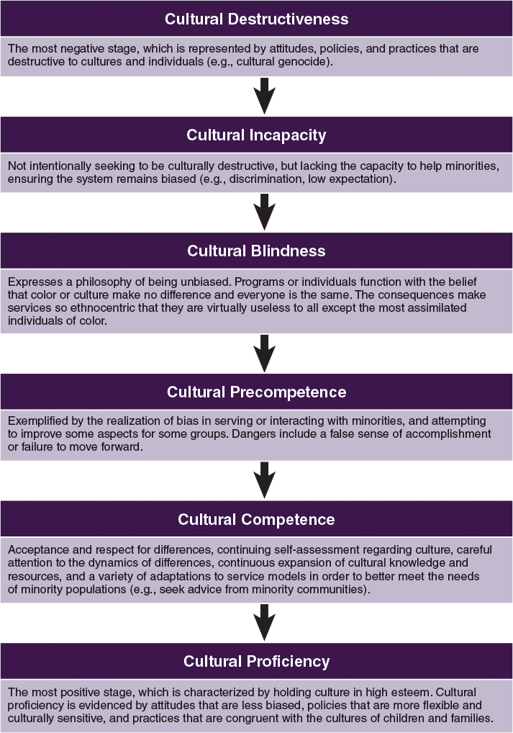
As shown in Figure 2.1, the first developmental stage is cultural destructiveness, which represents attitudes and behaviors that are typically destructive to cultures and individuals. One extreme example of this is cultural genocide, in which one group is trying to erase the presence of another culture. The period of Jim Crow segregation laws in the United States, when African Americans were dehumanized through various laws, also falls into this category. Cultural destructiveness often occurs in classrooms when children are prohibited from speaking their home language.

The last and most positive developmental stage of cultural competence is cultural proficiency, which involves the ability to respect and enjoy all cultures. Cultural proficiency is evidenced by flexible and culturally sensitive practices that take into account the cultures of children and families. Teachers display cultural proficiency when they are continually seeking ways to understand and incorporate various cultural practices and norms into all aspects of their classrooms and instructional practices. These teachers are aware of the culture of the classroom—how children may respond to that culture and how it may be different from their home culture—and they seek ways to bridge the gap. For example, if a teacher sees that the culture of the classroom is quite rigid, they may pursue strategies to increase flexibility in where and how children sit, as well as how children use time, because they have observed that some children benefit from additional movement, more peer-to-peer interaction, and less focus on structured segments of time.

Figure 2.2 is a self-test that helps teachers assess their areas of strength and weakness in cultural competence.

Figure 2.2: Cultural Competence Self-Test
The following self-assessment can assist teachers in identifying areas in which they can improve the quality of the classroom culture and environment to meet the needs of a culturally diverse population.
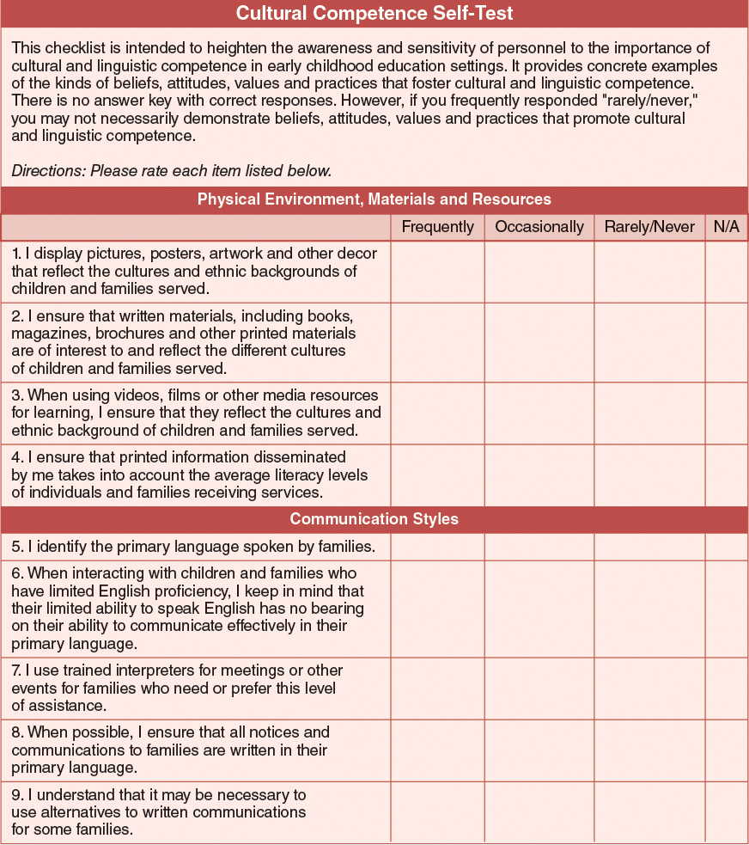
But how does a teacher become culturally competent? This will likely entail developing "certain personal and interpersonal awareness and sensitivities, developing certain bodies of cultural knowledge, and mastering a set of skills that, taken together, underlie effective cross-cultural teaching" (Diller &Moule, 2005). To build cultural competence, Diller and Moule (2005) propose six essential skills: (1) valuing diversity, (2) engaging in self-assessment and self-awareness, (3) assessing the culture of your organization, (4) understanding the history of cultural interactions, (5) institutionalizing cultural knowledge, and (6) adapting to diversity (Figure 2.3).

Figure 2.3: Core of Cultural Competence
Skills such as valuing diversity and being self-aware are necessary for developing cultural competence.
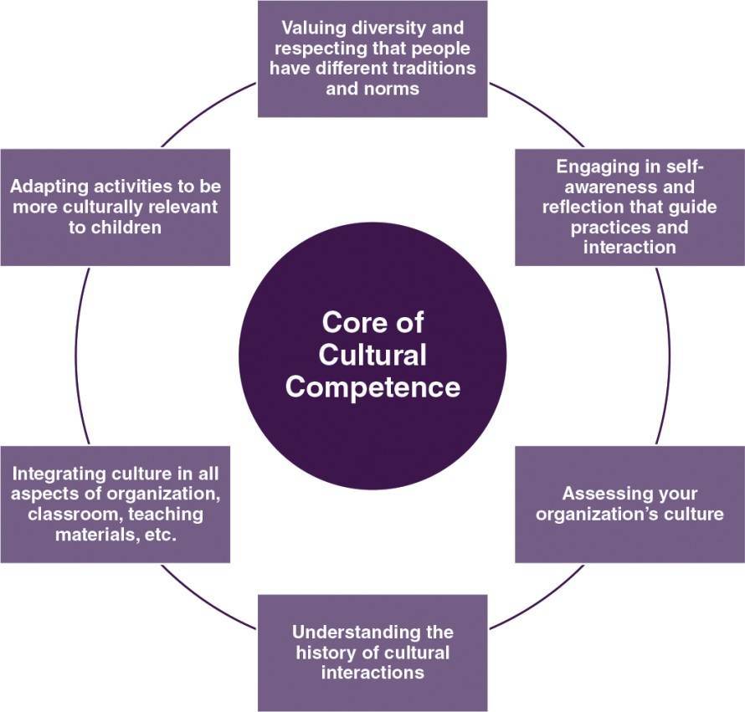
Valuing Diversity
This first skill means valuing and respecting different cultural, ethnic, and religious backgrounds and customs. Those who value diversity understand that people have different cultural traditions, which can result in differences in communication, traditions, and family structures. For example, a matrilineal culture is one in which family history is traced through the mother's ancestry. This is different from the patrilineal culture often seen in the United States, where family history is traced through the father's ancestry. In matrilineal cultures, a child's maternal uncle plays a central role in caretaking, while the father resides in another household. This uncle may have more of a relationship with the child than the father does, which is different from many mainstream U.S. families. In this type of family structure, only members of the mother's family may attend school events and meetings, and important conversations regarding the child involve the child's maternal uncle. Rather than assuming that a father is not around, a teacher should seek ways to determine whether there is a father or a father figure that should be engaged in the child's learning.

Other cultural variations are also seen in parenting. For example, in some cultures there are fewer parent-child verbal interactions because children are viewed as passive, which may be viewed as neglect through a Western, European American lens. Research has also noted that African American parents display more authoritarian parenting compared to White parents, who are viewed as more authoritative (Iruka&Barbarin, 2009). Authoritarian parenting has been characterized as controlling, punitive, harsh, and intrusive, with little warmth or sensitivity directed toward the child. In contrast, authoritative parenting has been described as sensitive, warm, and encouraging of autonomy, while also placing limits and expectations on children's behavior.
However, when African American parenting is viewed through a culturally sensitive lens, it is found that African American parents show a distinct type of parenting that can be called "tough love," which incorporates authoritarian and authoritative parenting (Brody & Flor, 1998; Iruka, LaForett, & Odom, 2012). This type of parenting is used to ensure that children are safe and prepared for their life as an African American in a society that is biased against them. Thus, valuing the cultural variations in individuals' lives helps teachers to better connect with families and the children they teach. Understanding how parents' life experiences shape their parenting styles can minimize judgment and ensure respectful collaboration.

It is also important to know that though there are similarities within racial or ethnic groups, there are also intracultural differences. This means, for example, that though African Americans may share many of the same historical and social experiences, they may differ along lines of region (e.g., north vs. south, rural vs. urban), gender, and social class. For example, consider a lower-income African American family living on the south side of Chicago, Illinois, and a higher-income African American family living in the suburbs of San Francisco, California. These two families may have different viewpoints about childrearing (e.g., levels of permissiveness, amount of structure). Teachers who value diversity work to understand the similarities and differences among children's and families' lives, regardless of their own ethnic, racial, or religious background, for the purpose of creating an environment that values the cultures children are immersed in at home.

One way to begin to value diversity is to learn about the cultures and lives of all the children in your classroom. This can entail asking every child what they did on Saturday or asking each family to share events they celebrate and how they do so. Being curious and proactive in exploring the cultures and customs of children and families in your program can strengthen the home-school connection and the relationships among teachers, children, and families.

Engaging in Self-Assessment and Self-Awareness
This second skill means understanding your own culture, including how your experiences, beliefs, values, and interests shape your culture. For example, a preschool teacher may have grown up in a two-parent, middle-class family that went to church every week and valued spending time with the extended family members who lived in the same neighborhood. This cultural background shapes the teacher and how she may interact with a child who is growing up in a low-income household with a single parent who describes herself as atheist. Awareness of your own culture and how it differs from others' can facilitate communication between teachers and children from different cultures.

Self-assessment also can lead to self-awareness about biases and stereotypes that you may hold about the groups to which you belong—and those you do not. Unexamined biases can show up in both obvious and subtle ways, such as the pictures and books that a teacher selects for the classroom.

One way to begin a self-assessment is to ask yourself what are the positive aspects (or perceived positive aspects) of your cultural or ethnic groups and then asking what are the negative aspects (or perceived negative aspects) of your cultural or ethnic groups. Follow this same process with other cultural and ethnic groups. What do you see as the positive and negative attributes of other cultural and ethnic groups? For example, you may view your group as hardworking and see that as a positive characteristic. However, if you view another group as less hardworking and always seeking a "handout," you may view children from that group as not being capable of working hard, and you may have low expectations of them. Being aware of how you see yourself and others will help you discern how certain expectations and behaviors influence interactions with and perceptions of others—especially children.

Assessing the Culture of Your Organization
In addition to assessing your own culture, it is also important to assess the culture of your organization, which may be incompatible with the cultures of some children and families you serve. For example, some early childhood programs have firm schedules, and children are expected to be present at specific times. In some cultures, exact time is not used or valued highly, so children's "tardiness" may not be seen as negative (Curenton, 2011).

Assessing the culture of your organization also includes assessing the culture of your classroom. You can begin by examining the materials of the program or classroom to determine if they are anti-bias and inclusive. Do the pictures and characters reflect the program's and the larger community's demographics? Do the events and activities draw from the many cultures represented in the program and the United States as a whole? Do any languages in the materials match the home languages of the children in the program?

Another area to explore is the climate of the classroom and program. This can be examined by exploring how much "talking" is allowed, by whom, and under what circumstances. Children may perceive that only adults and certain children are allowed to talk, which may send a message to them that their thoughts and voices are not important. It is important to acknowledge these communication patterns, whether they reveal individual children's voices being inhibited, or division due to children's ethnicity, gender, or some other attribute. Continuous examination of classroom and program culture, which may unduly impact children's experiences, is one way of becoming culturally competent.

Understanding the History of Cultural Interactions
Historically, Native Americans and African Americans have experienced racism, discrimination, and oppression from members of the dominant White American culture. These experiences are embedded within the larger Pan-American culture, and have collectively fostered generations of mistrust between these groups and White Americans. This mistrust can manifest itself in many ways, even today. For example, a Native American teacher may perceive that her perspectives are often ignored by her White program director in favor of the points of view from her White colleagues. A White teacher may feel isolated from her African American colleagues because she is not invited out with them for lunch and often is not part of their social conversations. Understanding the history of cultural interactions can help in ensuring that individuals do not feel that they are being insulted or excluded.

Similarly, understanding the history of cultural discrimination and oppression in the United States will provide background for teachers to help them understand that some parents hold prejudice and biases against certain groups and, thus, may be teaching their children negative stereotypes. In such situations, teachers must strike a balance between respecting families' beliefs and feelings, while ensuring that all the children in their classroom are engaging respectfully with each other, regardless of their ethnic and cultural backgrounds.

Institutionalizing Cultural Knowledge
A core part of cultural competence is integrating knowledge about culture into all aspects of the early childhood education program and its classrooms—from books and materials to activities and interactions. Representations of cultural groups should go beyond stereotypes to show groups in both historically traditional activities as well as modern day activities; for example, photographs can show Native Americans as judges and doctors, as well as participants in traditional ceremonies. Similarly, images of Black males should expand beyond their roles as athletes and entertainers to include the vast array of occupations they hold, from president to teacher.

Teachers can take advantage of professional and education opportunities that expand their cultural competence. Through increased knowledge and cultural competence, one can begin to provide suggestions and guidance to colleagues, as well as program administrators, about the importance of ensuring that the program is valuing diversity, engaging in self-assessment and self-awareness, assessing its own culture, understanding how history may influence interactions among staff, and seeking ways to integrate cultures into all aspects of the program.

Teachers may also be able to influence institutional cultural knowledge by engaging in conversations regarding racial, ethnic, and language diversity with coworkers and seeking ways to learn about the different cultures of the families of the program's staff. One avenue is monthly retreats or meetings at which the school community, including teachers and staff, share interesting aspects of themselves and their cultural traditions and history. Another avenue is teachers sharing with each other the best strategies they have found to ensure that their classrooms and instructions are culturally meaningful for all the children in the classroom. Retreats and meetings can also include families in order to learn about their cultural traditions.

Adapting to Diversity
The sixth skill for becoming culturally competent focuses on adapting activities to fit the cultures of children in the classroom. This entails finding ways for children to experience a variety of cultures unfamiliar to them, as well as integrating their cultural and familial traditions into all aspects of the classroom. For example, learning centers can incorporate clothing, food, and artifacts from a variety of places. Books in the classroom can include different racial, cultural, and religious groups, as well as different types of families, such as gay, lesbian, and interracial families. Beyond ensuring that the materials are culturally relevant and meaningful for all children, teachers can also adapt to the diversity of their student population by asking for ideas from children.

The goal of cultural competence is to ensure that children's lives and cultures are integrated into all aspects of the classroom to enhance their learning and engagement. In addition, beyond race, ethnicity, and culture, children are also diverse in their interests and learning styles. Thus, ascertaining children's individual perspectives, learning styles, and cultures of origin can help teachers ensure they are meeting the cognitive and emotional needs of all the children in their classroom.

2.2 NAEYC's Framework for Cultural Competence in Early Childhood Classrooms
In 1995, NAEYC published a position statement emphasizing that linguistic and cultural diversity is an asset that should be nurtured in education environments. In this statement, NAEYC charged early childhood programs with creating education environments that respect diversity, recognize children's emotional ties to their families, and promote second language acquisition coupled with efforts to preserve the home language. In order for culturally and linguistically diverse students to develop, early childhood professionals must be culturally competent.

In order to help programs improve their use of culturally competent practices, NAEYC started the Pathways to Cultural Competence Project, an ongoing process of developing multiple and various solutions to improve practices in early childhood programs. Because changes must happen at the individual and at program levels, this project focuses on helping teachers and program directors reflect on which of their practices are culturally competent and how to go about improving them. The activities reflect the six characteristics of cultural competence shown in Figure 2.3. Program directors and teachers are provided with checklists covering eight concepts related to culturally competent practices. Table 2.1 presents the eight concepts with examples of the checklist's practices for each one.
NAEYC (2010) suggested four guiding principles for program directors and teachers as they worked on the checklists. These four guiding principles are

Teacher Reflection—(a) reflect on how your individual values, beliefs, and practices regarding children's learning are influenced by aspects of your own personal culture and linguistic experience and (b) reflect on how the program where you work is influenced by culture and language.
Intentional Practice—(a) identify shared childrearing goals with families; align your classroom decision-making and practices with these goals and (b) plan ahead to address potential language or cultural barriers.
Strength-Based Perspective—(a) acknowledge that you can learn from families (b) recognize that diversity enriches and provides depth to the overall learning experience (c) understand that different does not mean dysfunctional (d) respect and support the preservation of children and families' home languages, cultural backgrounds, and childrearing beliefs, goals, and practices and (e) incorporate aspects of children's cultural and linguistic backgrounds in daily learning activities by demonstrating strengths that exist across cultures.
Open, Ongoing, Two-Way Communication between teachers and families—(a) ensure that families have opportunities to give you input rather than solely being recipients of information and (b) plan ahead to address language barriers. (NAEYC, 2010)
In addition to its Pathways to Cultural Competence Project, NAEYC also examined how its standards for developmentally appropriate practices incorporated culturally relevant practices. Among NAEYC's 10 broad standards of best practices for such topics as curriculum and physical environment, there are 417 accreditation criteria, approximately 31 of which are related to diversity (e.g., "Teachers and families work together to help children participate successfully in the early childhood setting when professional values and practices differ from family values and practices," and "Children are provided varied opportunities and materials to build their understanding of diversity in culture, family structure, ability, language, age, and gender in non-stereotypical ways.") (NAEYC, 2012a, p. 3). See the Spotlight on Research feature, "Can You Find the Diversity-Related Items?" for a chance to compare these criteria to your ECE experiences.

A team that visited 127 early childhood programs in 2009 found that cultural competence criteria were infused in many aspects of NAEYC standards for developmentally appropriate practices serving young children (NAEYC, 2012a). Furthermore, the team found that some cultural competence-related criteria and indicators are more challenging to incorporate than others (e.g., "Children are provided varied opportunities to gain appreciation of art, music, drama, and dance in ways that reflect cultural diversity"), and some are more likely to present barriers to achieving NAEYC accreditation (e.g., "As a part of orientation and ongoing staff development, new and existing program staff develop skills and knowledge to work effectively with diverse families"). This suggests that many teachers may not get access to professional development that improves their cultural competence and working with diverse families.
2.3 Culturally Inclusive Classrooms
The outcome of becoming a culturally competent and proficient teacher is the creation of a classroom where all children feel valued, respected, and heard. An inclusive classroom considers the multiple identities of children, which include their physical abilities and characteristics, gender, age, family structure, race/ethnicity, and language. Children and families should see their lives and experiences represented throughout the classroom environment through things like decorations, materials, books, and activities. Children should also have opportunities to share their thoughts and feelings through interactions with teachers and other adults and peers in the classroom.
Culturally Inclusive Adult-Child Interactions
Research finds that adult-child interactions, a key way to ensure that classrooms and programs are inclusive, are critical for children's development and learning (Burchinal et al., 2008). The key areas of adult-child interaction found by Pianta, LaParo, and Hamre (2008) include emotional support, classroom organization, and instructional support, which is observed through the Classroom Assessment Scoring System (CLASS) used in all Head Start programs.

Emotional support is seen in a positive classroom climate where children respect and enjoy interactions with adults and their peers, teachers are aware and responsive to children's academic and social needs, and teachers are interested in children's points of view and interests.
Classroom organization is important because orderly classrooms provide the best opportunity for children to learn. Features of well-organized classrooms include effective behavior management to ensure that students are productive and the use of a variety of learning formats to engage children.
Instructional support is key to children's learning in that it is the process teachers use to build children's deeper learning, including their cognition and language. Instructional support features include concept development, which is teachers' use of activities to promote higher order thinking, feedback and encouragement to extend children's learning and thinking, and language modeling, which is teachers' facilitation and encouragement of children's language development.
There has not been much research specifically about language and adult-child interactions. However, TESOL (2010) developed a position statement on language for dual language learners (DLLs) 3–8 years old. Their rationale was that DLLs have a challenge in learning in a monolingual English class. Language is the means for instruction, interaction, and overall functioning in an early childhood environment. Strategies that teachers can use in interacting with DLLs include

using their home language as much as possible, especially when beginning a new lesson, which can ensure that the children feel emotionally supported in the classroom.
providing DLLs with different modalities to learn, such as observing, touching, listening, talking, and interacting. Children are not able to learn much when they are only listening and sitting still; they have to learn through play and interaction. The classroom organization needs to provide different ways for DLLs to be engaged in the classroom.
giving children time to understand, rather than assuming that all children who are English language learners will learn English at the same time; they each have different skills and different exposure to the English language. Scaffolding and individualizing children's learning experiences are types of instructional support.
Culturally Inclusive Environments and Activities
The physical environment can ensure that classrooms are culturally inclusive. An inclusive classroom environment—inside and outside—has developmentally appropriate and diverse materials and toys to meet the needs of all children in the classroom, including children with special needs. Further, the environment should be rich and stimulating; children should see a variety of pictures, including ones related to their lives and cultures, as well as feel and touch an array of natural materials, such as different textures of hair—straight, curly, or kinky.

Activities constructed for children should be developmentally appropriate and focus on the whole child in the four broad areas of cognitive, socio-emotional, creative, and physical development. These activities should also promote cultural inclusivity; they should bring the objectives of the curriculum and lesson plans alive for children by relating them to their lives. For example, if the theme is clothes, how can you incorporate cultural diversity while also building children's cognitive, socio-emotional, creative, and physical skills? Children can draw an outfit someone in their family would wear; or they could think of words for pants, dress, and shirt in other languages.
2.4 Dealing With Cultural Misunderstandings, Racism, and Bias
One aspect of cultural competence is recognizing and appropriately dealing with cultural misunderstanding. In our opening vignette, we talked about Eddie, who was curious about whether chocolate milk was the reason for Michael's skin color. What if Eddie spoke more negatively about other attributes of his African American classmates, such as their hair, clothing, or the way they speak?

How Racism Operates
Racism operates through stereotypes and prejudice. Stereotypes are generalizations about the typical characteristics of a group related to their race, gender, nationality, sexuality, religion, region, or some other characteristic. Stereotypes lead to prejudice, a preconceived judgment or opinion, usually unfavorable, that is based on a person's membership in a social group. Examples include the assumptions that girls should only enjoy playing with "girl" toys (e.g., dolls, kitchen settings) and that Black boys will be violent and disruptive. Stereotypes and prejudice can then lead to discrimination—making a distinction in favor of or against a person based on the group, class, or category to which that person belongs rather than on individual merit.
Children can learn racist stereotypes from societal icons and images, from their family, and even from the media. For example, Tatum (1997) describes a research project in which one of her students asked White preschoolers (3- and 4-year-olds) to draw a picture of a Native American. Most of the children did not know what a Native American was, but when the researcher rephrased the request and asked them to draw an Indian, all the children produced an image of a person wearing feathers, and many drew the person acting aggressively and holding a knife or tomahawk. When children were asked how they knew this was what an Indian looked like, the children explained that they got this information from cartoons.

The traditional way that we have been taught to view racism is as intentional acts of malice performed by individuals with negative attitudes, beliefs, and stereotypes about ethnic minorities that cause their prejudice and bigotry; this is active racism. Passive racism, on the other hand, consists of subtle acts, such as laughing when a racist joke is told (telling a racist joke would be active racism); accepting an omission of people of color from the curriculum; letting exclusionary hiring practices go unchallenged; or accepting a special favor that you know is due to your race (Tatum, 1997). Passive racism can also be seen when children do not intervene or bring to the teacher's attention situations in which children are being excluded because of specific characteristics, such as skin color, hair, accent, or ability. In today's society, most of us are guilty of passive racist acts, more so than active racist acts.

Recognizing Racism and Prejudice, Discrimination, and Bias in the Classroom/Program
Racism is a cultural problem that affects all of us. Typically, we think of racism as interpersonal transgressions between individual people or groups of people, such as one person using a racial slur against another or a young child not wanting to share toys with peers who don't look like her. However, those interpersonal transgressions are only one level of racism, and in fact, this level of racism happens much less often than it did in the past.

The level of racism that is more prevalent today is called institutional racism. Institutional racism is defined as a system of advantage and disadvantage based on race or ethnicity. We are all affected by institutional racism because it is part of our national history, societal customs, and cultural traditions. It is expressed in cultural messaging and institutional policies and practices that advantage members of a certain race(s), typically Whites or people of European descent. In order to understand institutional racism, we must think about racism as systematic oppression that has been institutionalized in society through cultural icons, ideological narratives that present "whitewashed realities," and systematic privilege (Adams, Biernat, Branscombe, Crandall, &Wrightsman, 2008).

White Privilege
In societies where there is institutional racism or systematic oppression, there are beneficiaries of these discriminatory practices. The systemic advantage that people in the White racial group enjoy is called white privilege. White privilege is described as unearned rights, advantages, and favors that are bestowed on people for their membership within the White racial/ethnic group. Peggy McIntosh (2001), a feminist scholar from Wellesley University, in a famous article called "Unpacking the Knapsack," explores how she as a White woman experiences white privilege. She describes white privilege as

an invisible package of unearned assets which I can count on cashing in each day, but about which I was "meant" to remain oblivious. White privilege is like an invisible weightless backpack of special provisions, maps, passports, codebooks, visas, clothes, tools and blank checks. (p. 188)

In her discussion of white privilege, McIntosh notes that often people focus on the disadvantages of various groups based on race, ethnicity, sexuality, religion, income, or language, rather than on the privileges and advantages experienced by people in power—namely, White people and men. McIntosh developed a list identifying some of the daily effects of white privilege in her life. See the Cultural Reflection feature, "What Privileges Do You Enjoy?" which offers an opportunity to consider how privileges of membership in powerful groups affect your classroom and program.
Spotting and Addressing Bias in the Classroom
There are many areas and aspects of the early childhood environment where prejudice, discrimination, or bias can be spotted—and rectified. They can occur in interactions between children, between children and staff, between staff and families, and between staff in the program. Detailed below are some of the places where biases may occur in your classroom or program and examples of possible actions to address the bias.

Language and Interactions—Some language can be viewed as prejudicial, such as lumping people into groups (e.g., "All Black people are . . . ," "Hispanics are always . . . ," "Boys are always . . . ," "White people always . . . ," "Poor people are always. . ."). In interactions with children, we may encourage stereotypical behavior, such as boys being allowed to play only with "boy" toys. In another example, a sense of exclusion and bias may result when some children are discouraged from speaking in their home language but other children are allowed to converse in their "made up" language. Similarly, some families may be put at a disadvantage if written information is sent home only in a language that they do not understand. Some of the ways to address these situations include
immediately bringing attention to situations where groups are being lumped together;
encouraging and actively engaging boys in playing with "girl" toys, and vice versa, such as using the cooking utensils to make breakfast for mom or asking a girl to play an action hero;
allowing children to speak in the language they are most familiar and comfortable with, even if it is a language you don't understand, and asking children to share some words in their home language; and
finding out the families' preferred language and method of communication, and using a variety of modalities to communicate with parents, including phone, texting, or video chatting.
Environment and Organization—Teachers need to also consider the messages that are being sent by the configuration of many aspects of the classrooms, such as girls being in the front of the class or line and the boys in back of the class or line, or the child in a wheelchair being placed on the side of the classroom for the whole day. Other aspects of the classroom environment that may create bias include stereotypical images in classroom materials (e.g., White doctor, Black athlete, Latina maid). Some of the ways to address these challenges include
ensuring that children have the opportunities to engage with children from diverse backgrounds by changing their seating and order of lining up throughout the school year;
paying attention to how children are configured in all aspects of classroom functioning to avoid sending messages that certain children are more special because they are always in the front;
being creative in how the classroom can be configured (many early childhood programs have a circle set up or stations to ensure that there is no front, side, or back); and
seeking ways to diversify images that children see so that they are not stereotypical.
Staff and Leadership—The first thing that children and parents see when they come to the program are the staff. Lack of diversity in staff (in terms of gender, race, ethnicity, and age) fails to convey that a program values diversity—as does a program in which the janitor is the only minority staff. Some of the ways to address lack of diversity in your classroom or program, even if you don't have responsibility for hiring, include
inviting individuals from the community and family members to be part of the classroom or program in a meaningful way, such as leading classroom activities or mentoring children;
when hiring opportunities come up, ask families and community members for potential applicants for the position; and
if you are in a position to hire, ensure minorities are not hired only for certain positions (e.g., janitor or teaching assistant).
Activities and Materials—Materials and activities are the primary vehicles through which teachers impart information to children. For children to be engaged in the materials and activities, they have to be connected with their experiences, including their culture. Some activities can disadvantage children, such as children who have physical difficulty (e.g., challenge with fine motor skills) or are non-English speakers (requiring responses in English only), and class materials may be limited in the images they portray. Ways to address these challenges include
ensuring that all classroom activities can be adapted so that all children can participate;
allowing children to respond nonverbally, such as pointing, and responding to them nonverbally; and
seeking ways to diversify the materials in the classroom by looking at online and library resources, asking colleagues for recommendations, asking families and community members for recommendations, and going to local bookstores that cater to the needs of the community.
Assessments—Often, children are assigned to certain programs, classrooms, or groupings due to the assessments they take. Teachers often assess children to determine what children know and what children are learning throughout the school year. However, assessments may be biased against children in various ways, such as focusing on children's verbal language rather than other aspects of communication, not accepting children's responses when they are not Standard American English, using only scores from standardized measures (e.g., Bayley or Peabody Picture Vocabulary Test, which are standardized tools to assess young children's cognitive and receptive language), or focusing on only one aspect of children's learning and development. To avoid potentially disadvantaging some children, some action steps to take include
assessing multiple aspects of children's development, including their expressive (i.e., ability to communicate) and receptive (i.e., ability to understand) skills,
valuing rather than penalizing children when they use language that may not be viewed as proper English but is part of their culture (e.g., African American English Vernacular),
assessing children in their home language, and
not solely using standardized measures, which may not have included a diverse sample when generating items for the test.
Impact of Prejudice and Discrimination on Children's Development
It is a common belief that children's innocence allows them to be oblivious to the prejudice and racism that exists in society. "Children are color-blind," it is often claimed. Unfortunately, this is not true. An experiment by Dr. Kenneth Clark and his wife, Dr. Mamie Clark (1939), shows the stereotype and prejudice held by children based on skin color. In the classic Clark Doll Experiment, Black children were asked to choose between a Black and a White doll that were the same, except for the skin color, along several attributes. Children were asked to do the following:

"Show me the doll that you like best or that you'd like to play with,"
"Show me the doll that is the 'nice' doll,"
"Show me the doll that looks 'bad,'"
"Give me the doll that looks like a White child,"
"Give me the doll that looks like a colored child,"
"Give me the doll that looks like a Negro child,"
"Give me the doll that looks like you."
Most children thought the White doll was nicer than the Black doll.

In 2005, Kiri Davis repeated the Clark Doll Experiment in Harlem as part of a short film called "A Girl Like Me." She asked 21 children who were from Black and Latino backgrounds, and 71% told her that the White doll was the "nice" one. In this video, she also talks about how Black girls see themselves and how others see them. In 2010, CNN asked developmental psychologist Margaret Beale Spencer to repeat this experiment with two groups of Black and White children: 4- and 5-year-olds and 9- and 10-year-olds. To see how these children understand race and skin color, watch "Inside the AC360 Doll Study".
Together, these three studies demonstrate that institutional racism still exists and that it has been affecting children's views of Blacks and other minorities for at least the past seven decades.
The Negative Effects of Stereotyping
As early as 4 or 5 years old, children have stereotypes about their group and other groups that they think others may share. Researchers have also found that African American and Latino children are more likely to know more stereotypes about their group than White and Asian children—often, the stereotypes are about intellectual ability and work ethic (McKown&Strambler, 2009). Negative stereotypes may limit children's academic achievement and social interactions by giving them subtle messages that they are not smart enough or valuable enough to be in higher quality schools (e.g., those with better facilities and materials) than their peers. Social psychologists Steele and Aronson (1995) coined the term stereotype threat for the anxiety people feel in a situation where there is the potential to confirm a negative stereotype about their racial or cultural group; this anxiety can interfere with academic achievement.

Girls sometimes shy away from anything involving math or science (to avoid the threat of not being smart enough in those subject areas) or they underperform when confronted with situations involving math or science.

In the case of social interactions, researchers Brown and Bigler (2005) theorized that the more children know about stereotypes and prejudice, the more likely they will view situations in a racialized way. For example, if a child holds the belief that White people do not like Black people, then he may see a situation where a Black child is being reprimanded by a White person as an act of discrimination. Perception by children that they are not good because of their race, gender, religion, or some other characteristic can also have an impact on their interactions with peers and adults, their engagement in the classroom, and subsequently their school success.

Sometimes even a positive stereotype about a group can have negative consequences for children, such as the stereotype that all Asians are smart. If an Asian American child has a learning disability, she may be viewed as lazy or "less than" because she is not meeting an expectation about Asian children. If the child believes this stereotype, she may have a negative perspective about her skill and ability, such as not persisting when learning to read or problem solve.

The Development of Prejudice in Children and Strategies for Dealing with It
Even though children tend to have a positive worldview, they are very intuitive and systematic about how they process information about the world. In early childhood, children's ability to sort objects that are similar and different increases; we even foster this ability through activities and conversations about what things are similar and different. So it is only natural that children observe similarities and differences among people. Bigler and Liben (2007) argue that it is a natural part of children's cognitive development to classify people based on observable similarities and differences like skin color, hair texture, eye shape, or sex. The physical characteristics of racial and ethnic minority children are often noticed more than those of White children; when minority children are fewer in number in the classroom, their differences stick out more.

Once children make these categorizations, it is again a natural part of their cognitive development to generate reasons for why these differences and similarities exist. This can be seen in the opening vignette of Eddie who held a genuine curiosity about whether drinking chocolate milk was the reason for his African American classmate's skin color. In situations like this, teachers have to think about what to do and how to guide such conversations between children.

First, teachers must recognize and understand the natural developmental progression of racial, ethnic, and national prejudice that occurs in children. Based on the findings of over 100 international (mostly European and U.S.) research studies from the last several decades, Raabe and Beelmann (2011) report that overall prejudice toward ethnic and racial minorities increases during early childhood (ages 2–7) and then begins to drop off during middle childhood and adolescence; Figure 2.4 illustrates these developmental changes.

There are some interesting caveats to their work, however. First, the decline in prejudice seen in middle childhood is only evident when children are asked to openly and consciously report their biases; a decline in prejudice is not evident when children are acting in an unconscious manner, such as when they fail to choose playmates that are from different racial or ethnic groups. Second, Raabe and Beelmann (2011) note that ethnic and racial minority children show an increase in prejudice during middle childhood; some researchers believe this may be due to the earlier experiences of discrimination and victimization these children experienced (Verkuyten& Thijs, 2002). Understanding the developmental changes in prejudice can help early childhood teachers determine potential areas to address with younger children to minimize prejudice and bias that children are likely to experience or be exposed to over time.

Figure 2.4: Developmental Change in Prejudice
According to this graph, prejudice peaks at ages 5–7 and then drops off until ages 14–16.
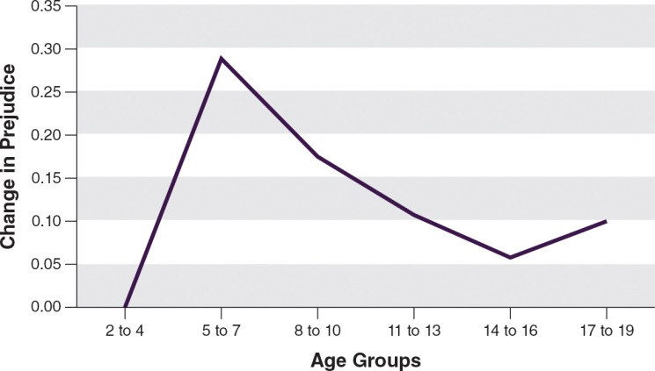
So, given that prejudice peaks in early childhood, early childhood teachers need to use classroom strategies to decrease prejudice in young children. Table 2.2 describes a few strategies that are based on a body of research (Bigler&Liben, 2007; Raabe&Beelmann, 2011). These strategies build teachers' competence while also exposing children to different cultures. The first is for teachers to examine and seek ways to address their own biases and prejudice by, for example, immersing themselves in other cultures and then sharing what they learn with the children in their classroom to broaden their experiences and images of various cultural groups. See the Real World Dilemma feature, "Parent-Teacher Conference About a Racial Slur," for ideas about how to defuse and positively address situations that occur between children in the classroom.

Table 2.2: Strategies to Reduce Prejudice in Young Children
Table 2.2: Strategies to Reduce Prejudice in Young Children
Strategy | Suggestions for Classroom Activities
Critically and honestly examine your own biasesand prejudices and work to get rid of them. | - Talk with colleagues from different ethnic and cultural backgrounds about  their experiences and feelings.  - Immerse yourself in other cultures in order to learn more that you can  share with children and broaden your own horizons.
Elevate the status of minority groups. | - Read books that depict characters from lower status ethnic minoritygroups.  - Speak positively of cultural events and traditions that are aligned with  minority groups.  - Speak positively of obvious ethnic differences between children.
Plan for regular contact between children fromdifferent ethnic and minority groups. | - Work with program administrators to ensure the classrooms have ethnic,  racial, and language diversity.  - Bring volunteers or special guests into the classroom, such as police  officers and faith-based leaders, who are ethnic or racial minorities and  who occupy positions of power and prominence in the community.  - When children are paired with their peers, try to ensure ethnic, racial  and linguistic diversity within each group or pair.
State your expectations about anti-bias. | - Verbally communicate the classroom norms regarding being equitable and  treating everyone fairly.  - Positively communicate that differences between people are good and  that we are all supposed to look different.  - Create a sense of community within the classroom; show that the children  are all the same inside by talking about feelings and thoughts that they allshare.
Source: Based on Bigler, R.S. (1999) & Raabe, T., & Beelmann, A. (2011)

2.5 Media Portrayals of Diversity
Although parents and other family members are an important source of young children's beliefs about difference, media is increasingly another source. Young children now have access to many kinds of media, including cable/satellite television, Internet, smartphones, tablets, computers/laptops, video games, and videos and movies. Consequently, the NAEYC has issued guidelines for children's use of interactive media. In addition, teachers must also be aware of media's power to reinforce stereotypes and look for ways to use it instead to affirm diversity.

The Role of Media in the Lives of Children
A study by the Henry J. Kaiser Family Foundation (Rideout, Vandewater, &Wartella, 2003) found that not only did young children (age 0–6) have access to television and other media options (such as computers), they also used them often. As shown in Figure 2.5, as many children under 6 years of age play outside as use screen media. This study also found that children spent more time watching television (65 minutes) than being read to/reading (39 minutes).

Figure 2.5: Typical Use of Media for Children, Ages 0–6
This graph shows that young children use a large array of media; however, many also spend time playing outside.
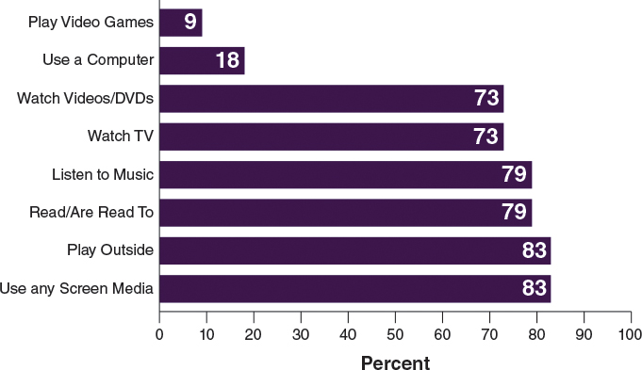
A recent study conducted by AVG, a global security software maker, discovered that more young children know how to use a computer and smartphone apps than how to tie their shoes. According to information from 2,200 families from the United States, Canada, United Kingdom, France, Italy, Germany, Spain, Japan, Australia, and New Zealand, 58–77% of 2- to 5-year-old children know how to play a basic computer game (AVG, 2010). Additionally, over a quarter of children know how to open a web browser.

These findings suggest that children's technology skills are advancing rapidly. However, many early childhood educators have advised that media, especially television, should be restricted, so that young children can build their physical and social skills with plenty of opportunities for hands-on learning, playing outside, and connecting with other children. Many educators also worry that technology is limiting children's artistic and creative side, as well as their language and cognitive skills. Some even worry that technology may change children's brain development and how they learn.

But the biggest concern may be what children are watching. Some content helps children learn words, letters, think, and cooperate with other children, but children also learn bad words and behaviors from screen media. The problem is that technology is part of the 21st century; it cannot be avoided.

On the plus side, technology, such as websites and computer programs, that shows how children in other parts of the world live can help children and staff become more culturally competent. Through texting and video chatting, technology can also provide a means for families and teachers to communicate and share ideas, and it can provide translation for teachers and parents. Technology can also help teachers to share children's accomplishments in a timely fashion with parents through video diaries and pictures. Just as important, assisted technology, when used appropriately, is a powerful way to empower children with disabilities and to enable them to be engaged with both the teacher and the other children. Table 2.3 lists a few pros and cons of technology for young children. Do you have others to add?

Table 2.3: Pros and Cons of Technology for Young Children
Pros | Cons
Offering different ways to learn | Learning negative things (e.g., aggressive behaviors)
Learning new things earlier (e.g., educationalapps, educational shows) | Advertisements affecting behavior and eating (e.g., link to high obesity)
Learning new language or subtle ways ofcommunicating | Spending less time on stimulating activities, such as reading and interacting
Connecting with families across the world | Diminishing critical thinking skills

NAEYC's Statement About Technology and Interactive Media
To address early childhood educators' concerns about interactive media, NAEYC (2012b) developed a joint position statement with the Fred Rogers Center for Early Learning and Children's Media at Saint Vincent College in 2012, entitled "Technology and Interactive Media as Tools in Early Childhood Programs Servicing Children from Birth through Age 8."

In this statement, interactive media is defined as "digital and analog materials, including software programs, applications (apps), broadcast and streaming media, some children's television programming, e-books, the Internet, and other forms of content designed to facilitate active and creative use by young children and to encourage social engagement with other children and adults." As Curenton, Piotrowicz, and Rendon (2013) point out, "Like all human tools—such as language, vehicles, medicine—[interactive media] can be used constructively and in moderation for the betterment of society, but used incorrectly or irresponsibly they can be a scourge." Thus, the challenge is how to safely, responsibly, and effectively use these tools to enhance children's development.

NAEYC and Fred Rogers Center developed six key recommendations for early childhood programs:
Select, use, integrate, and evaluate technology and interactive media tools in intentional and developmentally appropriate ways, giving careful attention to the appropriateness and the quality of the content, the child's experience, and the opportunities for co-engagement.
Provide a balance of activities in programs for young children, recognizing that technology and interactive media can be valuable tools when used intentionally with children to extend and support active, hands-on, creative, and authentic engagement with those around them and with their world.
Prohibit the passive use of television, videos, DVDs, and other non-interactive technologies and media in early childhood programs for children younger than 2, and discourage passive and non-interactive uses with children ages 2 through 5.
Limit any use of technology and interactive media in programs for children younger than 2 to those that appropriately support responsive interactions between caregivers and children and that strengthen adult-child relationships.
Carefully consider the screen time recommendations from public health organizations, such as the American Academy of Pediatrics for children from birth through age 5 when determining appropriate limits on technology and media use in early childhood settings. Screen time estimates should include time spent in front of a screen at the early childhood program and, with input from parents and families, at home and elsewhere.
Provide leadership in ensuring equitable access to technology and interactive media experiences for the children in their care and for parents and families.
In addition to following the NAEYC guidelines, educators in multicultural centers and classrooms need to remember that not all children have access to interactive media. Most children in the United States have access to television, but many children do not have access to computer and Internet at home or in their community. Therefore, teachers should find out from families whether they have a computer or some way to access the Internet from their home, especially if teachers suggest websites or computer programs to supplement children's learning.

How Media Promotes and Prevents Discrimination
Before using any digital app or game in a multicultural classroom, teachers should evaluate whether it is developmentally appropriate, culturally relevant, and free of bias, just as they evaluate pictures, books, and activities.

The Impact of Negative Stereotypes in Media
The media, especially television, play a role in the stereotypes that children form and the prejudicial attitudes they have toward individuals. Ethnic minority children and children from low-income homes watch more television than children from higher income and White families (Roberts, Foehr, Rideout, & Brodie, 1999); however, few prime time television shows portray African Americans, Latinos, Asian Americans, or Native Americans, and when shows, including news programs, do include them, they are typically portrayed in a negative or stereotypical manner (Brunette, Mallory, & Wood, n.d.; Dixon, 2008; Gilens, 1996). The exception is educational and child-focused shows, such as Sesame Street (McKown&Strambler, 2009), that include children with disabilities and non-English speaking children, as well as multiracial families.

Some stereotypes are positive, such as the "computer whiz" Asian, the "athletically gifted" African American male, the "spicy" Latina, and the "CEO" White male. However, as discussed earlier in this chapter, stereotypes, regardless of whether they are positive or negative, minimize the diversity among individuals and within groups. Negative stereotypes are particularly demeaning because they devalue the purpose and worth of an individual.

Studies have shown that media—television, for example—can influence children's racial stereotypes and perceptions (Zuckerman & Zuckerman, 1985). In one study with elementary children, it was shown that White children who watched more violent television believed that Black children were less competent and obedient than White children, which may be due to the fact that Blacks are often portrayed as violent and aggressive, as well as unintelligent (Zuckerman, Singer, & Singer, 1980).

Just as children learn new words from watching television, they are also capable of learning other things through media, such as attitudes about certain groups (Persson& Musher-Eizenman, 2003). To combat the negative impact of media on young children's attitudes and beliefs about specific groups, positive role portrayals of minority group members are needed. In the meantime, teachers can find ways to use media constructively and selectively.

Using Media Positively to Enhance Learning and Promote Cultural Diversity
Even considering the dangers of media, they have vast potential to enhance learning and promote cultural diversity. Sesame Street and similar educational programs typically portray children from diverse backgrounds and families and with different abilities and languages. These programs show that children from different backgrounds can get along. Because one form of learning is through observation and mimicking, these educational shows may provide schemata for children to mimic when interacting with children who are different from them. Children not only mimic bad words and behaviors, but they also mimic good behaviors, such as sharing, showing affection, and reading. See the Design an Activity feature, "Evaluate a TV Program," for questions that can help you analyze the explicit and implicit messages and models of a television program or video.

Media can also help children explore other cultures, regions, and countries. For example, teachers can take their preschoolers on a virtual trip to another country or another part of the United States. They can also talk with children about the way things are done in this place: the food, the clothing, how children go to school, what school is like. The media can also be used to create a learning story. Studies show that television programs and videos that directly address specific racial problems or conflicts and model effective solutions can "positively influence children's racial knowledge, attitudes, and preferences" (Graves, 1999, p. 721). For example, a video clip can be created with children in the classroom addressing issues of bias, such as re-enacting a situation in which children use hurtful racist words and resolving it.

However, media alone is not enough. Addressing children's stereotypes and prejudice about subgroups requires multiple and varied experiences that are interactive and explicit rather than a one-time event. For example, exposing children to 30–45 minutes of activities, movies, art projects, reading, and discussion every day for 30 days focused on a specific subgroup (e.g., famous Hispanic inventors, African American Civil Rights leaders, Native American authors) may be more beneficial in minimizing children's stereotypes and prejudice about a certain group than just a one-day or one-time event (Persson& Musher-Eizenman, 2003).

Reference
Curenton, S.M., &Iruka, I.U. (2013). Cultural competence in early childhood education [Electronic version]. Retrieved from https://content.ashford.edu/

