Complete Forum #9 - Looking at Homo neanderthalensis!
1616 unread replies.1616 replies.
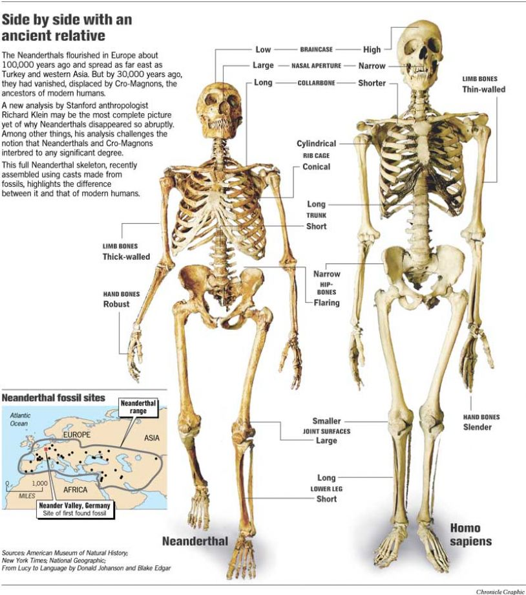
If you spend even a small amount of time researching the controversy regarding whether or not modern populations are the genetic descendants of Neanderthals, you’ll quickly learn how contentious this idea remains. There is a fascinating side note to recent research (based on comparative genetic investigation of the human genome and the Neanderthal genome) that suggests Neanderthal had full language and speech capability – an enormous change from the time when I was a student and this was a hotly debated topic at professional meetings. The crux of the argument about the relationship of Neanderthals to modern humans boils down to these two questions:
(1) Were Neanderthals an evolutionary side branch gone extinct without significant contribution to modern gene pools?
(2) Were Neanderthals an immediate ancestor of modern people who interbred with emerging Homo sapien populations?
The richest human fossil and archaeological records are in Europe and western Asia, so we know more about Neanderthal morphology and behavior than any other archaic human population. Our current interpretation of Late Pleistocene fossil and archaeological evidence is conditioned by the long history of (good and bad) research on the subject of early humans. Our view of Neanderthals has changed considerably since their initial discovery. Check out these sites for a quick look at some interesting ideas about Homo neanderthalensis:
http://www.pbs.org/wgbh/nova/evolution/neanderthals-us.html
(Links to an external site.)Links to an external site.http://news.bbc.co.uk/2/hi/science/nature/8660940.stm
(Links to an external site.)Links to an external site.http://archaeology.about.com/od/neanderthals/fr/Decoding-Neanderthals.htm
(Links to an external site.)Links to an external site.http://news.nationalgeographic.com/news/2010/05/100506-science-neanderthals-humans-mated-interbred-dna-gene/ (Links to an external site.)Links to an external site.
THE TASK:
- Read this one-page information sheet about forensic facial reconstruction.
(links on the left to learn more) http://www.anthropology.si.edu/writteninbone/facial_reconstruction.html (Links to an external site.)Links to an external site.
- Browse this list of websites that feature Neanderthal facial reconstructions from reputable and knowledgeable (5 points)
http://peabody.yale.edu/exhibits/fossil-fragments/fossils/neanderthal-reconstruction(Links to an external site.)Links to an external site.
http://www.bbc.co.uk/news/science-environment-19960748
(Links to an external site.)Links to an external site.http://newswatch.nationalgeographic.com/2008/09/17/neanderthal_woman_is_first_rep/
(Links to an external site.)Links to an external site.http://www.daynes.com/en/reconstructions/neanderthal,2.php
(Links to an external site.)Links to an external site.http://arc-team-open-research.blogspot.com/2012/08/facial-reconstruction-of-neanderthal.html (Links to an external site.)Links to an external site.
- Visit the following website and write a brief report on research that strikes you as interesting. (15 points)
http://www.pnas.org/search?submit=yes&y=0&fulltext=Neanderthal&x=0&format=standard&hits=80&sortspec=relevance&submit=Go (Links to an external site.)Links to an external site.
- Your post should be a minimum of 100+ words - please cite any resources used. (5 points)
- Leave substantive* comments on THREE (3) other student posts – select ones who wrote about different examples than you selected. Use this as an opportunity to learn what they have to share. (5 points each)
student 1: The article I most interested in that is about how scientists recreated the Neanderthal man. For now, the Neanderthal genome is an abstract string of billions of DNA letters stored in computer databases. His skull is the largest and most complete ever found. Furthermore, the discovery of his leg and foot bones was hugely significant. Many of his teeth were still attached and this helped Viktor Deak determine the shape of the face. The final stage of creating the replica was to add head and body hair. Here the team looked to previous research which revealed that many Neanderthals were redheads. In addition, it is very difficult to make the model of hair since each strand punched individually into the replica.
Work Cited:
“Return of the Neanderthals.” National Geographic, National Geographic Society, 18 June 2016, news.nationalgeographic.com/news/2013/03/130306-neanderthal-genome-extinction-cloning-hominid-science/.
student 2: Facial reconstruction used to identify a particular individual is challenging. Way more challenging than trying to reconstruct an anonymous face. What I mean by that is if you are getting your CSI on and trying to identify a particular crime victim from a skull it’s a pretty daunting task. However, if you are a forensic Anthropologist and trying to reconstruct what a representative of Neanderthals looked like you aren’t trying to nail down a specific person but instead trying to get a representation of what an individual from that species could have looked like.
For the research, I would like to share with the class about Neanderthal exploitation of marine mammals in Gibraltar. Recent isotopic studies on Neanderthals suggest that they were heavily dependent on meat from herbivorous terrestrial mammals, whereas Upper Paleolithic humans had a much broader resource base, including regular access to fowling and aquatic resources. However, isotopic analyses on Neanderthal bones from coastal environments should also be performed to test this contrast further. Grayson and Delpech showed that Neanderthals and Upper Paleolithic humans did not show significant differences in hunting and butchering behavior in the material studied. Similarly, we have observed that the human occupation levels at Gorham's Cave, first occupied by Neanderthals and then by Upper Paleolithic humans, do not show distinct differences in faunal composition. Marine mammals are present in occupation levels associated with Neanderthals at both Vanguard and Gorham's Caves and occur in Upper Paleolithic human occupation levels in Gorham's.
Work Cited:
Stringer, C. B., et al. “Neanderthal exploitation of marine mammals in Gibraltar.” Proceedings of the National Academy of Sciences, National Academy of Sciences, 23 Sept. 2008, www.pnas.org/content/105/38/14319.figures-only.
student 3: From the PNAS website link provided, I decided to choose Separating "us" from "them": Neanderthal and modern human behavior. After some reading, I learned several things. Neanderthals was a big controversy. People did not know what to classify them as because their appearance were similar to apes and so it did not seem fit to have them be a Homo sapien, but they were too “brutishly primitive” to be considered having a modern human behavior. There are a lot of surprising things about the Neanderthals. They adapted and so their cranial were suited for high mobility and hunting close up. Places such as the Vanguard and Gorham caves showed that they had more modern strategies than expected. They found that Neanderthals were not too different from humans in a handful of ways. They apparently were barefoot or wore light footwear only, but they still tried to exploit their resources. Their excavations show that they tried to take advantage of all the resources they could ranging from anything small to marine to even seasonal base. For example, they used marine mammals, mollusks, and fish. It was apparent that Neanderthals had similar and modern practices with modern humans. Interestingly enough, with such similarities, it is unknown as to why and how Neanderthals went extinct.
Shipman, Pat. “Separating ‘‘Us’’ from ‘‘Them’’: Neanderthal and Modern Human Behavior.” PNAS, 23 Sept. 2008, www.pnas.org/content/105/38/14241.full.pdf?sid=dc38c657-43a0-42da-abe3-e49041e76743.
3 hours ago
REQUIREMENTS

