In this activity, you will get to champion two very different sources of energy. You will examine the pros and cons of both a renewable and a nonrenewable source of energy available to us today. Based on what you have learned from the Module Notes and other readings both in this module and additional resources you have located, you can build a convincing argument for each of the sources you select.
Completing this activity will assist you in mastering Module Level Outcome 3.
First:
1. Go to the website U.S. Energy Facts Explained (Links to an external site.)Links to an external site. from the U.S. Energy Information Administration
- On the left side of the page, there is a table of links for “Nonrenewable energy sources” and “Renewable energy sources”
- Select one energy source from the nonrenewable list and one energy source from the renewable list. Open the link and read the information on the first page carefully. Then, scroll down towards the bottom of that page and click on the link in the right corner (with the >>) to find additional information you will need. For example, I chose “Heating Oil” from the non-renewable list. I then scrolled down and clicked on “Where Our Heating Oil Comes From >>” and continued paging through “Factors Affecting Heating Oil Prices.” I will need some information from each of these sections to make my presentation to the town council informative and convincing. Any fuel you select will have several sub-pages to read. See the example below.
- You may want to print these pages, or you can take careful notes.
2. Find any additional reliable resources on the topics you selected either from our module readings or your own research.
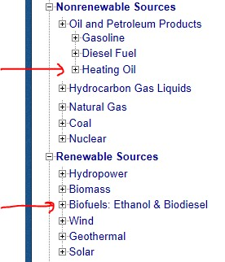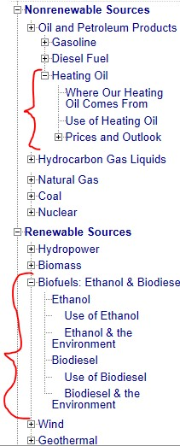When you arrive at the website, you will see the table of links on the left. If you select “Heating Oil” and “Biofuels”, the table will expand to their sub-pages, as shown on the right. Some sub-pages will have additional sub-pages (for example “Prices and Outlook”).
Next, post to the Discussion Board:
- Use the information you gathered to write a presentation for the town council in the town where you live, or some other chosen location, about these two energy sources.
  - Give the location and name of the town, and be aware of the culture and environment of the locality—e.g., desert towns most likely will not be interested in hydroelectric power.
  - Analyze the positives and negatives (or pros and cons) of energy sources for decision making at the community level. Think about the cost, environmental impact, and scalability of the technology, as well as the future of the town and the energy source.
  - Which would you recommend the town invest in today? Why? Which would you support for the town to invest in in 2025? Why?

