3.1 What Is a Specific Learning Disability?
A specific learning disability (SLD) is a disorder in one or more of the basic psychological processes (i.e., thinking, problem solving, remembering) used in receiving, understanding, storing, and responding to information. It affects the academic skills of a student, so students with an SLD may struggle with reading, writing, spelling, mathematics, listening, or speaking—or with more than one of these skills.

Defining SLD
Struggling with writing or listening, or with math or reading, does not necessarily indicate that a student has an SLD. In fact, at some point, almost every student will struggle with one of these skills. It is when the difficulties are severe enough to interfere with learning in the classroom that a student may be diagnosed with an SLD.

A student cannot be diagnosed with an SLD if his or her difficulty mainly stems from visual, hearing, or motor disabilities, rather than disorders in psychological processes. Unlike some disabilities, such as deafness or physical disabilities, an SLD is not visible. This makes it more difficult to know which students may have an SLD.

Students with SLD must have average or above average intelligence (i.e., a student with SLD cannot have an intellectual disability). The student's SLD, however, inhibits acquisition of new knowledge or skills and contributes to performance below that of students without an SLD.

A student with an SLD needs to access information in a different way than students without SLD. Researchers have demonstrated that students with SLD benefit tremendously from small-group or individualized instruction (e.g., Swanson, 2001; Vaughn, Gersten, & Chard, 2000). However, even with effective instruction, an SLD does not disappear; a student can learn to successfully adapt, but there is no "cure."

As you will learn throughout this book, many students have more than one disability. The most prevalent comorbid disability (a disability that occurs at the same time) for students with SLD is Attention-Deficit/Hyperactivity Disorder, or ADHD (see Chapter 5). Almost half of students with SLD also have a diagnosis of ADHD (Pastor & Reuben, 2008).

SLD and IDEA 2004
In IDEA 2004, which includes SLD as one of 13 disability categories, specific learning disability is defined as "a disorder in one or more of the basic psychological processes involved in understanding or in using language, spoken or written, which disorder may manifest itself in the imperfect ability to listen, think, speak, read, write, spell, or do mathematical calculations." To have an SLD under IDEA 2004, students must demonstrate difficulty in one or more of the following areas:

Oral expression—the ability to express your thoughts and needs by talking; for example, asking questions in class or talking with a student at lunchtime.
Listening comprehension—the ability to understand information presented orally; for example, answering an oral question or lining up at the door when the teacher verbally prompts.
Written expression—the ability to express thoughts and needs by writing; for example, writing a persuasive essay or answering questions by writing.
Basic reading skill—the ability to understand the relationships between letters, sounds, and words; for example, using knowledge of letter sounds /c/ /a/ /t/ to sound out the word cat or recognizing that a makes different sounds (e.g., apple is different from ate).
Reading comprehension—the ability to understand information presented in text; for example, explaining the action of a sentence or retelling a story after reading it.
Mathematics calculation—the ability to perform mathematical tasks with operations; for example, solving 24 + 57, or 1 1/4 – 1/2, or 129 ÷ 13, or counting to 100 by 3s.
Mathematics reasoning—the ability to solve mathematical problems presented within different contexts; for example, solving word problems or understanding geometric proofs.
As you can see, SLD are categorized into difficulties in language, reading, and mathematics skills. Those related to reading are the most often diagnosed (Fletcher, 2005; Wanzek& Kent, 2012).

According to IDEA 2004, students cannot be diagnosed with an SLD if the root cause of their difficulty can be pinpointed to one of the following:

Visual, hearing, or motor disability (e.g., deafness, visual impairment, spina bifida)
Intellectual disability (i.e., low intellectual functioning)
Emotional disturbance (e.g., anxiety disorder, conduct disorder)
Cultural factors (i.e., the student's cultural background is quite different from the school, and the student has not had many opportunities to learn within the school's culture)
Environmental or economic disadvantage (e.g., the student has moved schools four times in a school year, or the student lives in extreme poverty with little access to food, or the student was involved in a car accident and missed 60 days of school)
Limited English proficiency (i.e., the student's first language is not English, and the student is still learning English)
Some schools use more formal terms to describe SLD. The following are names for disabilities that might fall under the category of SLD:

Dyslexia: A language and reading disability that causes students to struggle with reading and writing.
Dyscalculia: A mathematics disability that causes students to struggle with understanding mathematical concepts and completing mathematical tasks.
Dysgraphia: A writing disability that causes students to write illegibly.
Dysphasia or Aphasia: A disorder related to difficulties understanding spoken language and poor reading comprehension that causes students to struggle with communication and understanding.
Central Auditory Processing Disorder: A disorder of processing and remembering tasks that are related to language.
Visual Perceptual or Visual Motor Deficit: A deficit related to reversal of letters, inability to copy, or losing place in text.
Prevalence of SLD
SLD affects approximately 5% of school-age students (National Center for Education Statistics, 2011). Some researchers (Geary, 2004; Shalev, 2004), however, believe the rate to be slightly higher, because diagnostic criteria for SLD vary by state, which leads to a wide variability in the reported number of students with SLD in schools (approximately 3% in Kentucky to almost 9.5% in Rhode Island). IDEA 2004 now allows Response to Intervention (RTI) as an alternative method of SLD diagnosis, and policymakers and researchers believe this may lead to a decrease in the percentages of students diagnosed with SLD, particularly as teachers use more evidence-based practices.

Boys are diagnosed with SLD more often than girls (see Figure 5.1); this is likely due to identification methods (Siegel &Smythe, 2005). For example, Siegel and Smythe (2005) tested a large number of students over several years. The number of boys and girls who performed low on the academic assessment was the same. In schools, however, where tests are administered to determine SLD status, boys may have a more difficult time with the tests—or perhaps teachers are more likely to notice boys struggling with an academic task because they often "act out" more than girls (Limbrick, Wheldall, & Madelaine, 2011).
3.2 How Has the SLD Field Evolved?
Until the middle of the 20th century, students with SLD were often considered to be lazy and underachieving; some students were categorized as having mental retardation (intellectual disability). Some of these students were educated in special schools or institutions, but many were excluded from any school at all. In the late 19th century, the initial work with students with learning disabilities centered on students who demonstrated average intelligence but struggled with reading and writing—in other words, those with SLD.
One of the earliest pioneers who differentiated learning disabilities from mental retardation (now called intellectual disability) was a German physician, Adolph Kussmaul. Kussmaul was the first physician to write about signs of heart disease and diabetic comas, and he also developed an interest in language disorders. In 1877, he wrote about patients with an inability to form sentences and patients with "word blindness" who could read and speak but not understand spoken language (Lawrence, 2009).

Another German physician, Oswald Berkhan, described patients with difficulty reading and comprehending text in 1881. Six years later, another German physician, Rudolf Berlin, formally coined the term dyslexia after he worked with a patient who demonstrated normal intelligence but could not read or write. At the turn of the 20th century, others (e.g., William Evans Bruner, James Hinshelwood, and W. Pringle Morgan) wrote about students with apparent learning disabilities and methods to help such students (Courtad& Bakken, 2011).

In the United States, with the introduction of compulsory school attendance in the first half of the 20th century, teachers were faced with teaching a wide variety of students in the classroom. They noted that some students who seemed to be of average intelligence had great difficulty learning. In 1963, Samuel A. Kirk first used the term learning disabled to describe students who struggled with reading and language and required special education (Danforth, Slocum, &Dunkle, 2010). This recognition of learning disabilities spurred the founding of the Association for Children with Learning Disabilities, which later became the Learning Disabilities Association of America, an important advocate for the education of students with learning disabilities.

The Children with Specific Learning Disabilities Act of 1969, which became part of the Education of the Handicapped Act of 1970, formally defined learning disabilities and mandated that schools provide special education services to students with learning disabilities. The definition was as follows: a disorder in one or more of the basic psychological processes involved in understanding or in using spoken and written language. These may be manifested in disorders of listening, thinking, talking, reading, writing, spelling, or arithmetic. It was not until the passing of PL 94-142 in 1975, however, that federal legislators recognized specific learning disability (SLD) as a separate disability category in the law that governs how schools provide services to students with special needs.
3.3 What Are the Characteristics of Students With SLD?
Each student with an SLD has his or her own set of difficulties. Some students may struggle only with reading or language, while others may struggle with reading, mathematics, and spelling (Hanich, Jordan, Kaplan, & Dick, 2001; Mather, 2003). Students with SLD may also exhibit nonacademic difficulties that relate directly or indirectly to their academic difficulties.

Challenges With Reading
Students with an SLD may struggle with a wide variety of skills that contribute to success with reading. Students may not understand that letters make sounds. They may have difficulty decoding, blending, rhyming, pronouncing words, differentiating homophones, increasing their reading rate, or comprehending text. Students may also have difficulty remembering words and the meanings of words, as well as interpreting punctuation (Bryant, Bryant, & Hammill, 2000; Jiménez- Fernández, Vaquero, Jiménez, &Defior, 2011; Williams & Lynch, 2010).

Understanding that letters make sounds. Students may not understand that the letter a makes a specific sound—and in English, it makes several different sounds. For example, the a in apple sounds different from the a in made.
Decoding. Students with difficulties decoding have difficulty with phonemes, the smallest units of sound that a word can be broken into. (The word dog for example, has three phonemes: /d/ /o/ /g/). As a result, they often struggle with sounding out words.
Blending. When students have difficulty combining letter sounds or phonemes into words, they struggle with what is referred to as blending. For the word dog, students need to take the /d/ sound and combine it with the /o/ sound and combine that with the /g/ sound.
Rhyming. Students may have difficulty knowing that pan rhymes with can and man. Rhyming is a fundamental skill in reading and spelling because it helps students understand patterns. For example, if a student understands that pan, can, man, and tan all rhyme, she should be able to decode these words and spell them fairly easily.
Pronouncing words. Students may struggle to pronounce words, whether they are simple, such as dog, or more difficult, such as extermination.
Differentiating homophones. Students may confuse homophones (e.g., their, there, they're) and have trouble with their meanings and spellings.
Increasing reading rate. Students with an SLD may read at a much slower rate than others. Their reading may sound choppy and fragmented, and the slower rate may cause difficulty with comprehension.
Comprehending text. Students have difficulty understanding the meaning of words, sentences, and paragraphs. When asked to explain the main idea of a paragraph, students may not be able to tell the who, what, when, where, and why of the paragraph. Poor comprehension may be due to a lack of fluent oral reading skills, silent reading skills, or both.
Remembering words. In reading, many words, such as the, that, and around, appear often in text, so it is best for students to memorize and recognize these words on sight—which is why these words are called sight words, and avoid wasting time sounding them out. Some students struggle with remembering sight words, which causes slower rates of reading and comprehension.
Remembering the meaning of words. Students may struggle to recall the definitions of words, and this causes difficulty with comprehension.
Interpreting punctuation. Students may overlook periods or other end punctuation. This can make it hard to understand what is being read.
Challenges With Oral Language
Students with an SLD may experience difficulty with skills related to oral language, such as expressing ideas, sequencing, structuring words and sentences, and memorizing facts.

Expressing ideas. Some students understand a concept or know an answer but exhibit difficulty explaining it orally. For example, a student may have written an essay explaining the parts of a cell, but not be able to explain cell parts when the teacher asks in class.
Sequencing. Students might have trouble placing events in a proper sequence. They might tell stories out of order or with major parts missing.
Structuring words and sentences. Students may have difficulty with grammar when they speak. They may leave off (or add on) endings to words (e.g., saying "I pass the football" instead of "I passed the football").
Memorizing facts. As information is presented orally or within text, students may struggle to memorize facts or definitions.
Challenges With Writing
Students with an SLD may exhibit difficulty with tasks related to writing. They sometimes experience difficulty writing by hand (in particular, with reversals of letters and numbers), establishing effective posture and grip of writing utensil, increasing their speed of writing, and copying. Students can also struggle with encoding, structuring sentences, and organizing written words or ideas.

Writing by hand. Students may struggle to print or use cursive letters. For example, some students use an inappropriate combination of uppercase and lowercase letters. Students may also have difficulty keeping letter size uniform or writing legibly. These problems may be a sign of fine motor problems, which require specialized instruction. Students may write letters and symbols backwards (e.g., b for d or 2 for 5).
Establishing effective posture and grip. Students may exhibit strange body posture and hand position when writing with a pencil or pen.
Increasing their speed of writing. Students with writing difficulties may write considerably slower than students without writing difficulties. Like difficulty with letter formation, this may be a sign of fine motor problems.
Copying. Students may have difficulty copying onto paper what a teacher has written on the board or is displaying on a document camera.
Encoding. Spelling words may be difficult for some students. Encoding involves either spelling words by sight or spelling by breaking a word into phonemes.
Structuring sentences. Some students may struggle to reproduce common sentence structure or word order. For instance, they may write "Dan goes to the store" as "Dan to the store goes." Students may omit words and use poor grammar when they write.
Organizing written words or ideas. When writing on a piece of paper, students may struggle to write on the lines (see Figure 3.1) or keep their writing centered on the paper. Again, this is a possible sign of fine motor problems. Students may also struggle with the organization that goes into writing a paragraph or a story (e.g., topic sentence, developing sentences, closing sentence).
Figure 3.1: SLD and Handwriting
This student has an SLD and struggles with writing. Notice how many of the letters are formed backwards and how the student has difficulty writing in a straight line. This student's brain is likely sending mixed messages with regard to letter shape and writing.
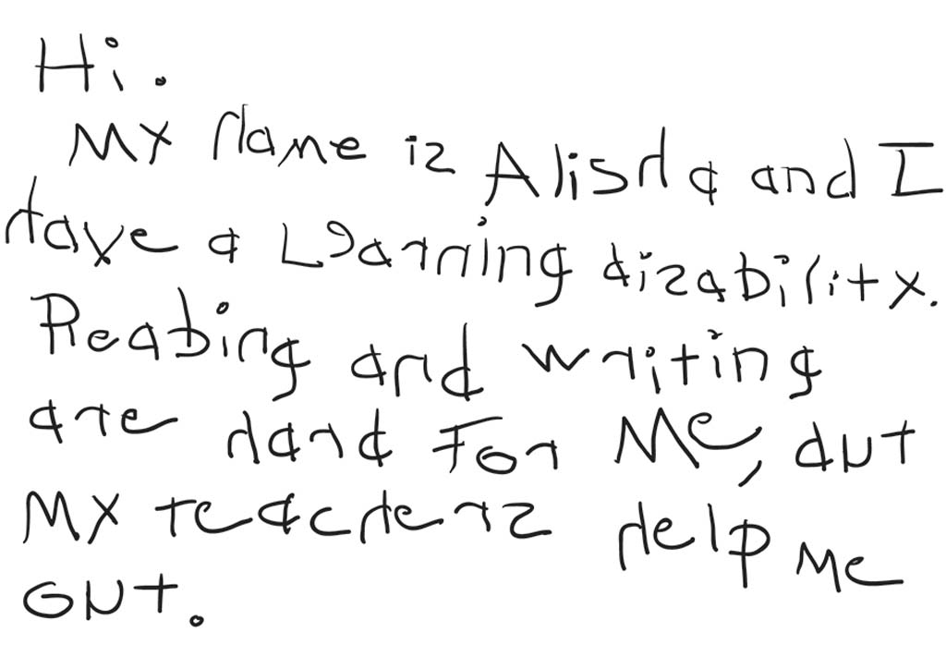
Challenges With Mathematics
Students with an SLD could have trouble with mathematics tasks, such as counting, understanding symbols, writing numbers and symbols, recalling basic facts, understanding place value, solving word problems, organizing work, and increasing the pace of work (Auerbach, Gross-Tsur, Manor, &Shalev, 2008; Wadlington&Wadlington, 2008).

Counting. Students may have difficulty counting. Some students may not know the proper order for counting (i.e., 1, 2, 3, 4, 5, 6, 7, 8, 9, 10), while other students may miscount (e.g., saying "2, 4, 5, 6, 7"), double count (e.g., saying "1, 1, 2, 3, 4"), or not understand that counting helps shows an amount of a set (e.g., saying "1, 2, 3, 4. There are 3 items altogether").
Understanding symbols. Some students may have trouble with symbolic thinking; for example, they may not understand that 2 represents two items and is written as two. Some students may struggle with connecting second to 2. Students may also misinterpret operational symbols (e.g., +, –, ?, ÷), leading to difficulty with solving mathematics problems.
Writing numbers and symbols. Students might have difficulty knowing how to write the number symbols. Some students reverse numbers (e.g., 2 for 5 and 6 for 9), which can cause a myriad of difficulty. Some students might have trouble turning larger numbers presented orally into written numbers (e.g., writing "six hundred five" as 6005).
Recalling basic facts. Students who struggle with mathematics often have difficulty memorizing and recalling basic facts (e.g., 7 + 8, 12 – 7). When students have to take time to figure out or count the answer to a basic fact, it diminishes their capacity to solve more complex mathematics problems.
Understanding place value. Students may not realize that the same 10 number symbols (0–9) can be used to represent any number, so they struggle with numbers greater than 9. Students may also not understand regrouping where "carrying" or "borrowing" is necessary (e.g., knowing that 10 ones is the same as 1 ten), which leads to computation difficulties.
Solving word problems. Students can demonstrate difficulty in solving word problems, or mathematical problems embedded within text. Many students struggle with the reading and comprehension of the text. Some find it tricky to understand which numbers and information are relevant and which operations are necessary to answer word problems.
Organizing work. When students do not properly line up numbers for computation as they write them, the disorganization can cause mistakes. In Figure 3.2, 12,397 + 4,203 will be easier to solve in Example B than in Example A because the numbers have been properly spaced and aligned.
Increasing the pace of work. Students with an SLD may work mathematics problems at a much slower rate than students without an SLD.
Figure 3.2: SLD and Organization of Math Work
Nonacademic Challenges
Just as many typical students have problems with reading, writing, spelling, mathematics, listening, or speaking at some time during their schooling, many, if not all, students exhibit one or more nonacademic characteristics that make learning difficult at some time during their school career. These characteristics include cognitive, social, emotional, and behavioral characteristics. Students might have problems with attention, organization, or frustration, for example. When these characteristics are displayed on a consistent basis and combined with some of the academic difficulties discussed, then a student may be said to have an SLD.
Nonacademic characteristics that students with an SLD may exhibit:

Distracts easily; for example, student stops working when another adult walks into the classroom.
Has a short attention span; for example, student only focuses on a task for a few minutes.
Has difficulty adapting to change; for example, student struggles when switching from a geography lesson to a mathematics lesson.
Is restless or impulsive; for example, student fidgets or leaves seat frequently.
Has difficulty listening and following directions; for example, student forgets teacher directions to (a) put backpack away, (b) get out homework, and (c) start journal entry.
Gets frustrated easily; for example, student stops working when a task is difficult, or student circles answers on a difficult test without trying to answer each item.
Has difficulty knowing left and right; for example, student walks the wrong way in library after librarian says, "Detective novels are on the right."
Has poor eye-hand coordination; for example, student struggles with placing coins in specific coin slots on a game.
Has delayed or immature speech; for example, student uses a "baby voice" when answering questions.
Has immature expressive language; for example, student can't answer basic questions about a story.
Is disorganized; for example, student's locker is disheveled, and the student cannot find appropriate materials.
Has difficulty finishing assignments on time; for example, student consistently finishes tasks after the rest of the class.
Has poor social skills; for example, student has difficulty making friends.
Has difficulty with self-regulation; for example, student struggles with completing a five-step task on his own.
During the evaluation of a student for a possible SLD, the evaluation team needs to make sure that the cause of the student's difficulty is a specific learning disability and not another disability. For example, most of the characteristics of ADHD are nonacademic characteristics of people with SLD. Because almost half of students with an SLD exhibit inattentive or hyperactive characteristics of ADHD, the evaluation team cannot assume the student does not struggle with attention issues as well as learning difficulties.
3.4 What Are the Causes of SLD?
An SLD may have a number of causes. The brain, heredity, and the environment may all play a role. Scientists and researchers have not determined which of these factors is the most salient and whether an SLD is caused by one factor or a combination of factors.

The Role of the Brain
Researchers have determined that the brain plays a role in SLD. For example, in Finland, students with learning disabilities and their siblings (without an SLD) participated in MRI brain scans. The siblings of students who had an SLD had more brain abnormalities than non-siblings without SLD (Mannerkoski et al., 2009). This study indicates that some brains are wired in ways that contribute to SLD. Multiple studies have demonstrated differences in the brain activity of students with an SLD versus without SLD (Davis et al., 2011; Kucian et al., 2006; Landi, Mencl, Frost, Sandak, &Puch, 2011; Simos et al., 2006).

Most researchers believe that an SLD is caused by malfunctions in the way that the brain receives, stores, retrieves, and produces information (Rissman, 2010). These four ways the brain interacts with information can also be referred to as input, integration, memory, and output.

Figure 3.3: The Brain
The brain is a complex system that helps us receive, store, retrieve, and produce information. While scientists know that different parts of the brain have different functions, they have not pinpointed the parts of the brain related to SLD.
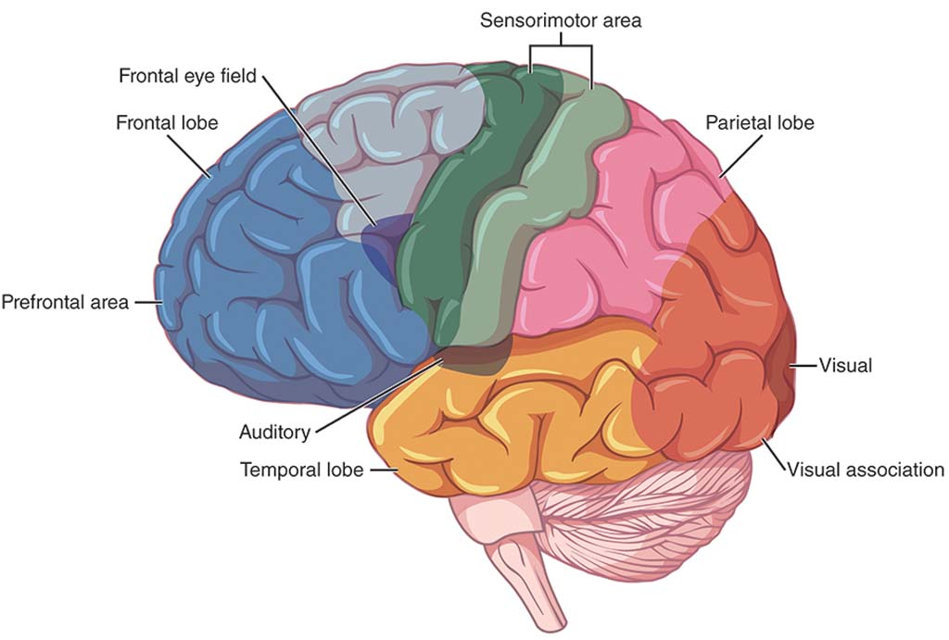
Input involves information coming into the brain, and perception is how information is interpreted in the brain. Most often, information is delivered to the brain via sight (visual perception) or sound (auditory perception). Students with an SLD may struggle with the perception of one or both of these types of input. Students who struggle with visual perception may find it hard to distinguish between different symbols. For example, a student may understand g to be p or q. They may also have difficulty focusing on the words on a page. Students who struggle with auditory perception may demonstrate difficulty with interpreting the phonemes or sounds of words. They may also become overwhelmed by too many sounds occurring at the same time.

The second way the brain interacts with information is integration—it stores and organizes that information. Remembering information in a sequence is much easier than trying to produce it haphazardly. Some examples of sequences that you know are the alphabet, the days of the week, or the multiples of five.

Students with an SLD may struggle with sequencing and organizing information. They may lose or misplace items or finish assignments late. Students with an SLD may also have difficulty with abstraction, which can affect their social interactions. As just one example, these students may find it tricky to understand when something is a joke or when a pun is used.

Three types of memory help students store and retrieve information. The first is working memory, which involves the brain working with small pieces of information. When completing a computation problem, for example, the brain may keep basic facts and knowledge about a regrouped 10 in working memory. The second kind of memory is short-term memory, in which the brain keeps information for a short amount of time, without transitioning it to long-term memory. For example, a student remembers four digits of a phone number just in time to dial the number. The student probably cannot remember the four digits five minutes later. The third kind of memory is long-term memory, where the brain stores information for future use. For example, a student remembers his home phone number and uses this information when sharing the phone number on college applications or with friends.

The fourth way the brain interacts with information is output—how a person provides information from the brain. One type of output is language output. Students with an SLD may find it difficult to think of an answer and find the correct way to provide that answer at the same time. Another type of output is motor output. Students who struggle with motor output may have trouble with writing, coloring, or using scissors.

The Role of Heredity
Research shows a strong genetic component of SLD. Parents who struggled with a learning disability are more likely to have a child with a learning disability (Landerl& Moll, 2010), and researchers of siblings and twins have confirmed this link by showing that siblings and twins have a greater likelihood of having an SLD if their sibling has one (Del'Homme, Kim, Loo, Yang, & Smalley, 2007; Kovas&Plomin, 2007). Scientists and researchers are only just beginning to understand the specific genes and factors that may contribute to SLD. Over the next few decades, they will likely discover a lot more about the connection between heredity and SLD.

The Role of Environmental Factors
Environmental factors that may contribute to SLD include the following (Courtman&Mumby, 2008):

Malnutrition—for example, a mother is malnourished when pregnant, and the baby's brain does not develop appropriately, or a student does not receive proper nutrition during important growth stages.
Chemicals or toxins in the environment—for example, a student ingests lead paint, which may cause nerve or brain damage.
Radiation—for example, a student is exposed to radiation, and the radiation may cause brain damage.
A mother's excessive alcohol or drug use during pregnancy—for example, a mother drinks too much alcohol, and the baby does not develop in a typical manner.
Anything that deprives the brain of oxygen—for example, a baby's umbilical cord accidentally gets wrapped around the baby's neck during delivery, and the lack of oxygen causes damage to nerves and the brain.
Second-hand smoke—for example, excessive smoke in the house causes damage to a child's brain.
Poor instruction in school (see the RTI section later in this chapter)—for example, an ineffective teacher only showed movies during class time and did not cover any of the sixth-grade standards in science.
3.5 How Are Students Diagnosed With SLD?
The first indicators that a student in the general education classroom might have an SLD are often persistent difficulty with academic tasks and performance below grade level. As in all special education evaluation procedures, the general education teachers, school administrators, or parents or guardians can request that the identification process begin.

If personnel from the school suggest an evaluation, it must take place within 60 days of referral. This prohibits schools from delaying identification. Parental consent must be obtained within those 60 days, before the evaluation takes place; if a parent or guardian does not grant consent, a school district can initiate due process procedures to circumvent the parent's consent refusal. A team of school officials then evaluates the student using a variety of data sources to determine if an SLD is present. The process can follow either the IQ/achievement discrepancy model or Response to Intervention (RTI).

IQ/Achievement Discrepancy
Before IDEA 2004, all students with learning disabilities were identified using an IQ/achievement discrepancy formula (see Chapter 1). Students needed to demonstrate a "severe discrepancy" between their intellectual ability and their actual achievement in the classroom.

As discussed in Chapter 1, critics of the discrepancy requirement claimed that schools were waiting too long (i.e., sometimes years) to identify students with learning disabilities, resulting in the waste of precious time for providing quality special education instruction. Critics also charged that some students were misidentified as having an SLD (due to assessment bias) when the students did not have learning disabilities (Kavale, Spaulding, & Beam, 2009). For example, students with English as their second language may have been misidentified because they scored lower on an assessment in English than they would have scored on a assessment in their native language (Fletcher & Navarrete, 2003; Sullivan, 2011; Waitoller, Artiles, & Cheney, 2009). Not all researchers, however, agree that the IQ/achievement discrepancy model is a bad idea (Kavale, 2005). For example, once a student is referred for an evaluation, the IQ/achievement model allows psychologists and teachers to identify students quickly, and students can receive appropriate special education services soon after testing and diagnosis. With this model, however, students are often not referred for evaluation until they have been in school for several years.

If schools choose to use the IQ/achievement discrepancy model, four criteria must be met before determining whether a student has an SLD (Restori, Katz, & Lee, 2009).

The school must establish a discrepancy between the student's cognitive ability and academic achievement. Most often, cognitive ability is determined through an intelligence test (e.g., Stanford-Binet Intelligence Scale, Wechsler Intelligence Test for Children, Woodcock Johnson Tests of Cognitive Skills). Academic achievement is assessed through a standardized achievement test (e.g., Comprehensive Test of Basic Skills, Iowa Test of Basic Skills, Stanford Achievement Test, Woodcock Johnson Tests of Achievement).
After the tests are administered, the school determines whether a discrepancy exists between ability and achievement. A discrepancy is noted by examining the standard scores on the assessments. Generally, a discrepancy of 1.5 or 2 standard deviations or 15–25 standard scale points is used (Kavale, 2005). States vary in their definitions of discrepancy.
The school must determine whether the student requires special education services.
The school must ensure that the student does not meet exclusionary criteria. This means that the student's SLD cannot be the result of a sensory disorder, intellectual disability, emotional disturbance, disadvantaged background, or inadequate instruction.
If all four of these criteria are met, a student can qualify for special education under IDEA 2004.

Response to Intervention
Some states require schools to use Response to Intervention (RTI) (sometimes called Responsiveness to Intervention) as the method of SLD identification, whereas other states leave the decision between RTI and the IQ/achievement discrepancy model to individual districts (Zirkel& Thomas, 2010). If the state does not mandate the method, then schools and districts choose the model that makes the most sense for their students and teachers. For example, some schools may not have the additional resources necessary (e.g., extra teachers) to implement RTI.

Because RTI is a relatively new initiative, the way that educators conceptualize and interpret it will no doubt change drastically over the next decade or so. It is not exclusively a special education initiative—it is an education initiative that combines general and special education because teachers from both areas collaborate to provide appropriate tiers of services to students (Hazelkorn, Bucholz, Goodman, Duffy, & Brady, 2011).
The core idea of RTI in assessing disabilities—in this case SLD—is that determination of a disability is made by seeing whether a student responds to quality instruction (Mellard, McKnight, & Jordan, 2010). RTI mandates that evidence-based practices be used at every level to ensure that poor or inadequate instruction is not the reason a student is identified with a disability. RTI also emphasizes early intervention. Proponents of RTI claim the model does not wait for students to fail (Fuchs & Fuchs, 2007). It can be used in elementary, middle, or high school, but it is most common at the elementary level.

Typically, RTI is used to determine whether a student has an SLD in reading, mathematics, or writing. RTI can be used, however, to determine whether a student has other kinds of disabilities—for example, a behavioral disorder—that warrants special education services. See Chapter 4's discussion of identifying behavioral difficulties with RTI.

RTI Tiers
A typical RTI model incorporates three tiers (Lembke, Garman, Deno, &Stecker, 2010)—as shown graphically in Figure 3.4—though some models incorporate more (Fuchs & Fuchs, 2006).

Tier 1 In the typical three-tier model, Tier 1 (also called Primary Intervention) takes place in the general classroom. At Tier 1, the general classroom teacher implements evidence- based practices or interventions. Teachers test all students in the classroom using a progress monitoring measure—a quick test given every week or two to better monitor students' progress in the classroom. Students who score below a specific cut-off are deemed to be "possibly at risk." This select group of students is then given progress monitoring measures for a longer period, usually for 6 to 10 weeks.
Figure 3.4: RTI Tiers
This triangle is often used to describe RTI. At the bottom, or widest part of the triangle, is primary intervention. The middle is secondary intervention, and the top is tertiary intervention. As the triangle gets smaller, the percentage of students receiving that type of intervention shrinks.
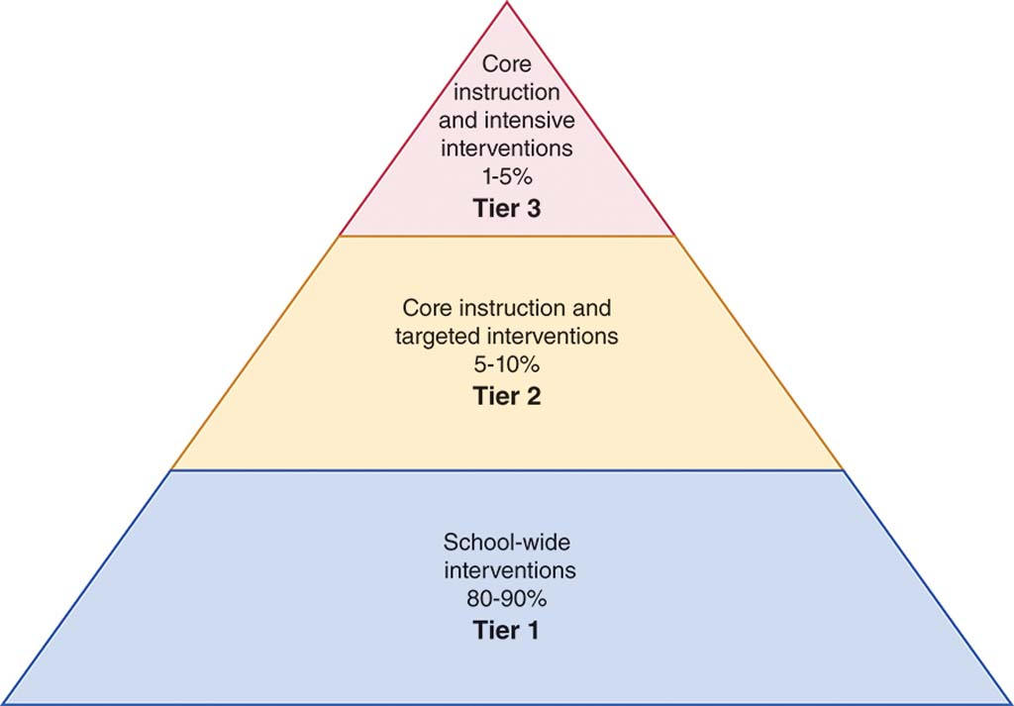
The goal of the monitoring is to determine which students demonstrate response at Tier 1 and which students demonstrate nonresponse. Response is determined by student growth (i.e., slope) and end scores, as shown in the graphs in Figure 3.5. The student's slope indicates whether a student's scores are increasing, flat, or decreasing. End scores are the scores students should reach in order to demonstrate adequate learning. Students who demonstrate response (i.e., adequate slope and adequate end score) to the instruction in the general classroom (i.e., Tier 1) stay in Tier 1. Students who demonstrate nonresponse (i.e., inadequate slope and inadequate end score) begin to receive additional Tier 2 instruction.

Figure 3.5: Progress Monitoring Graphs
Graphs can be used to show two students' progress in Tier 1. Student 1 has demonstrated response, via an adequate slope and end score, at Tier 1. The threshold for adequate slope is provided by the company that produces the progress monitoring measure. (For example, adequate slope for this student may be one word each week.) Student 2 has not demonstrated adequate response because their slope and end score are below expected levels. This student will begin to participate in Tier 2 tutoring.
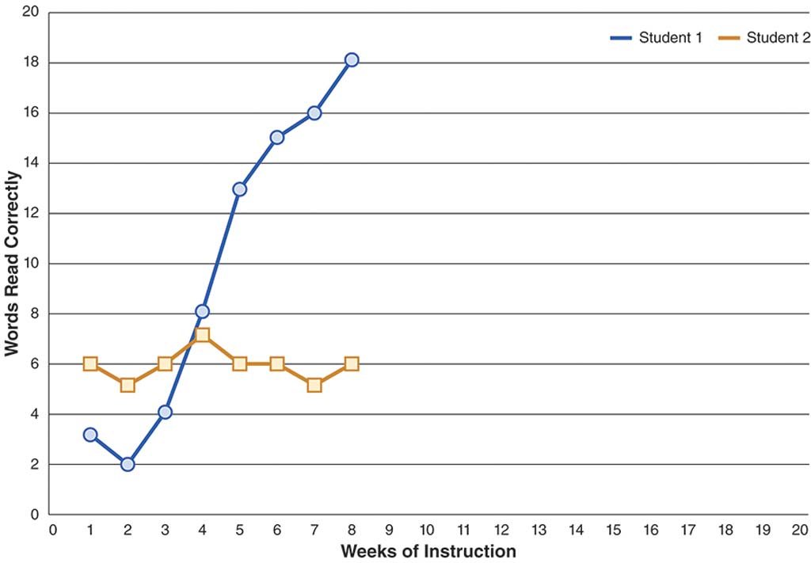
Tier 2 Tier 2 (Secondary Intervention) is for students who did not demonstrate adequate response to Tier 1 instruction. These "nonresponders" will receive instruction that often involves small-group tutoring that occurs several times a week over a period of 8–20 weeks during the school year (McKenzie, 2009). The small-group instruction is typically conducted by a general education teacher, a special education teacher or paraprofessional, or a reading or mathematics intervention teacher. A paraprofessional is an aide or assistant who knows how to work with students (and they have often received certification as a paraprofessional), but this person is not a certified teacher.

The instruction uses evidence-based practices and takes place during school hours. Many schools set aside "intervention" time for Tier 2 tutoring (Lembke et al., 2010). For example, a school may dedicate 30 minutes at the end of the school day for various interventions for groups of students. Often, students continue to receive Tier 1 instruction while participating in Tier 2 tutoring.

Each student's progress is monitored to determine response. Students who demonstrate response to Tier 2 instruction move back to Tier 1. Students who demonstrate nonresponse at Tier 2 move into Tier 3.

Tier 3 In many RTI models, Tier 3 (Tertiary Intervention) takes place in a special education setting (Fuchs & Fuchs, 2007). Between Tier 2 and 3, the student is evaluated, and an IEP is developed for the student. The special education teacher conducts Tier 3 services, and evidence-based practices are used to help the student meet IEP goals. The teacher monitors the student's progress towards those goals.

Progress Monitoring
As you learn more about the three tiers in RTI, it becomes obvious that monitoring a student's progress at Tiers 1, 2, and 3 is important because it helps determine "response" within an RTI model. As most RTI models are trying to determine whether a student has an SLD in reading or mathematics, progress monitoring measures in those areas are most prevalent. Writing and spelling, however, can also be assessed using progress monitoring.

A progress monitoring measure is a brief assessment of a student's growth in reading, mathematics, writing, or spelling competency. Some of the measurement tests are administered to a classroom of students, while others require administration to an individual student. Progress monitoring measures should be relatively easy to score, and often, software or internet programs assist with the scores.

In an RTI model, progress monitoring measures are administered weekly (if not more often) to provide a sensitive measurement of a student's progress over time. Every measure should have multiple versions that assess the same topic. In this way, students are assessed on the same skill set (e.g., fourth-grade mathematics problems), but do not have a chance to memorize the measure.

Regardless of the progress monitoring measure used, teachers score the measure and compile the scores to determine response. Generally, at least eight measures (and often, more) should be administered before calculating the slope of a student's score. Either the company that produces the measure or the school itself provides typical slope and end scores that determine response and nonresponse.

Reading In reading, several progress monitoring measures are available (see Figure 3.6). Measures that assess a student's letter, sound, or sight word knowledge are typically used at kindergarten or first grade. Another type of reading measure assesses a student's reading fluency (e.g., Passage Reading Fluency, Oral Reading Fluency) while a third assesses a student's reading comprehension (e.g., Maze Fluency).

With Passage Reading Fluency and Oral Reading Fluency, students read text aloud, and the teacher marks words that are read incorrectly or skipped. The student's score indicates reading fluency. With Maze Fluency, students read a passage silently. In the passage, the student is presented with three word choices after approximately every 7–10 words in the passage. The student has to choose the word that makes sense in the passage. Teachers choose the type of assessment to monitor progress according to the student's grade level and reading ability.

Figure 3.6: Progress Monitoring in Reading
These worksheets are some examples of many possible ways to monitor a student's progress in letter identification.
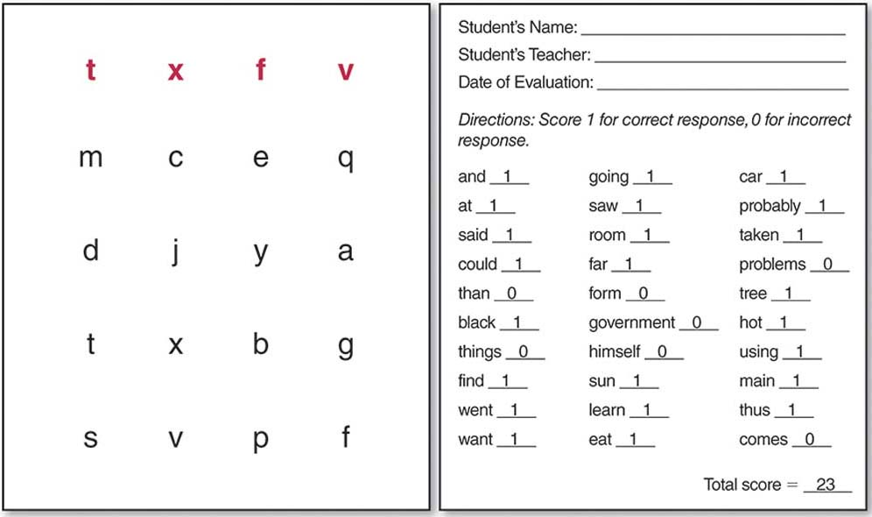
Mathematics Several progress monitoring measures of mathematics are also available. (Some of these are displayed in Figure 3.7.)Measures assessing number identification (e.g., asking, "What number is this?"), comparing numbers (e.g., asking, "Which is bigger: 7 or 2?"), ormissing numbers (e.g., requesting, "Say the missing number: 4, 5, __, 7") are often used at kindergarten or first grade. Measures assessing astudent's computation skills or application of computation skills are used across grade levels. At middle or high school, students use algebraprogress monitoring measures.

Figure 3.7: Progress Monitoring in Mathematics
There are many ways to monitor student progress in mathematics—as these examples show, a simple worksheet can bethe measurement tool. The worksheet on the left assesses number identification and the one on the top right assessesa student's ability to produce a missing number in a series.

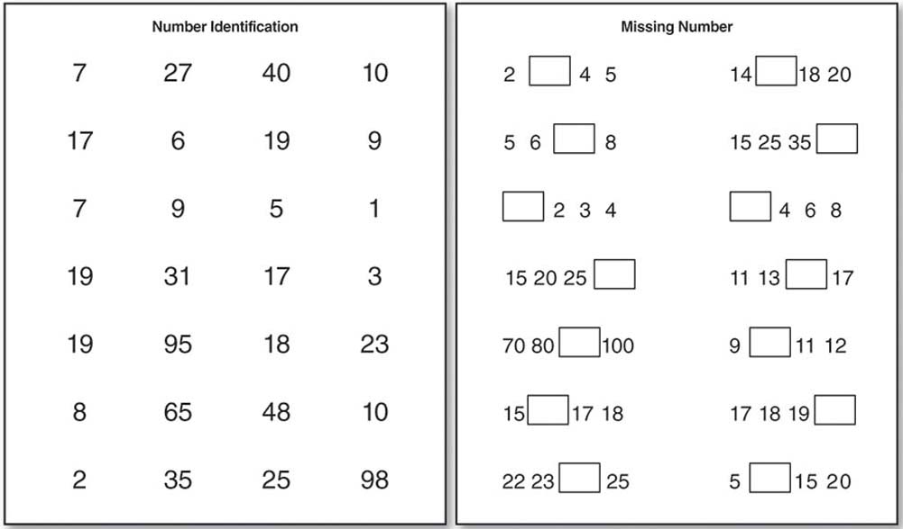
Writing and Spelling To monitor student progress in writing and spelling, teachers provide prompts to students. The students write in responses to the prompts, and the teachers assess the spelling or writing. Teachers often score for correct or incorrect letter sequences (for spelling) or correct or incorrect word sequences (for writing). Correct sequences give the student credit for each letter or word correctly written to the next letter or word. For example, cat has four correct letter sequences marked as ^c^a^t^. Because c is the correct first letter, the student gets credit for one correct sequence. The c and a should be next to one another, so that's another correct letter sequence. Cat spelled cot would only have two correct letter sequences (i.e., ^c¯o¯t^).

Evidence-Based Instruction
Chapter 1 introduced the concept of evidence-based practices, the instructional techniques that have been shown to lead to improved student outcomes. The evidence for this should have been gathered in high-quality research studies. A core principle of RTI is ensuring that evidence-based practices are used across Tiers 1, 2, and 3 in the education of students with SLD.

When Are Students Diagnosed?
Students can be diagnosed with an SLD at any point in their education, but because SLD involve tasks that are primarily learned in school, students typically are not diagnosed until they have begun formal schooling. Frequently, diagnosis occurs during elementary school, particularly once standardized testing begins. Less commonly, an SLD first becomes evident in middle or high school. Researchers have found that students may develop an SLD in reading later than expected (Compton, Fuchs, Fuchs, Elleman, & Gilbert, 2008) or when learning a foreign language (Sparks, 2009).

Unfortunately, some students with an SLD move through the public school system without ever being properly evaluated and provided with appropriate services. To avoid this problem, teachers must frequently monitor progress and provide aligned support when students show persistent academic difficulty. Documentation of ongoing student performance and corresponding interventions is essential to initiate the identification process. This information can help an evaluation team determine whether academic struggle is indeed related to a learning disability so that appropriate help can begin.
3.6 How Does an SLD Differ Across Grade Levels?
Students with an SLD vary in terms of strengths and needs, depending upon the age of the student. Many students with an SLD are not identified until elementary school, but some young children may receive services in preschool settings. At the secondary level, teachers need to prepare students to transition into life beyond high school.

Early Childhood
Most young children do not participate in academic activities that indicate the presence of an SLD to a teacher, but there are some other warning signs that may indicate such a disability. Young children at risk for an SLD may start speaking later than other children. They may struggle with understanding directions. These children may also have difficulty with fine-motor skills, such as holding a pencil. Sometimes, the children will struggle with gross-motor skills, such as walking or standing. When interacting with other young children, children with an SLD may demonstrate a lack of appropriate interaction or response to others.

As outlined in IDEA 2004, districts and schools may choose not to identify a child with an SLD at such an early age. If an evaluation team, however, determines that the child would benefit from early childhood special education services, a preschool or school-sponsored program can provide those services to a child under the category of developmental delay.

A child may have a developmental delay when the child does not meet typical developmental benchmarks, such as gross- and fine-motor skills or speech and hearing skills. Only students from age 3 through 9 can be categorized as having a developmental delay. After the age of 9, the IEP team should determine whether the student does indeed have a disability and whether special education services should be continued.

Elementary School
In elementary schools, students with an SLD often exhibit difficulty learning to read, write, and perform mathematical computations. When learning to read, students with an SLD may struggle to attach meaning to words and break them down into manageable parts. They may have trouble understanding letter/sound correspondence and lack the strong vocabulary important for developing written expression. Students with SLD may struggle to organize their ideas, focus on a topic and clearly present it, and use conventions of writing to support their topic. They can also show difficulty in mathematical fluency and basic problem solving.

By elementary school, impairments in the working memory of students with an SLD can lead to trouble storing and accessing information. Having to spend additional effort to retain and apply past knowledge increases the cognitive load (i.e., memory functioning) required. As a result, students may experience high levels of frustration and respond by withdrawing, shutting down, or acting out (e.g., throwing a pencil or getting out of a seat) when they find material overwhelming.

Teachers must plan proactively to minimize the frustration students with an SLD often experience. Scaffolding support for students throughout instruction can help students be and feel successful on small tasks. With scaffolding, teachers provide a lot of student support in the beginning, and then they lessen this support as students become more confident with a task. This support both builds student confidence and allows the teacher to identify where understanding breaks down.

Secondary School
Most characteristics of elementary students with an SLD are also true of secondary students, who continue to struggle with remedial skills and foundational knowledge, making success in mastering grade level content even more challenging. In addition to ensuring students acquire any missing prerequisite skills, teachers must also ensure that these students make adequate progress in their grade-level classes.

One important difference between elementary and secondary students with an SLD is their ability to advocate for their own education. Secondary students can and should actively participate in the IEP process. While some elementary students may participate in IEP meetings, the secondary students must start to take ownership for their school and postsecondary decisions. They can do this by going over their starting academic levels, current and future goals, the progress they have made towards their goals, and the actions that led to their success. Students also should understand and be able to explain what having a learning disability means and how it affects academic performance.

Transition
With the right support and intervention, students with an SLD can experience success throughout their schooling. This includes success in a variety of postsecondary avenues, including college and career. Depending on interest, personal goals, and past academic achievement, students with SLD can have the same options as their nondisabled peers. Teachers have a critical role in ensuring all students receive the appropriate instruction to achieve academically. This is especially important for students with SLD, who often require additional academic support. Additionally, teachers should seek to broaden student understanding of possible career options. Students may be unaware of post-secondary options available to them, and increasing this knowledge can help focus and prepare students for this major life transition. This process can be challenging for students with disabilities and their family members (Smart, 2004), making appropriate school support essential.
Students with SLD can learn to manage their individual needs and advocate for appropriate academic supports. College and university campuses often provide services for students with disabilities, and students with SLD are eligible to receive accommodations and modifications on assignments and testing.

It is important that post-secondary students with SLD seek out appropriate services, as they may not be as apparent as in K–12 schooling (Cawthon & Cole, 2010). Until high school graduation, students with SLD are assigned a primary special education teacher or "case manager" who oversees the creation and implementation of the IEP. After graduation, however, these students need to become their own "case managers." This important shift in responsibility requires purposeful planning and support in the years leading up to graduation, and is referred to as transition planning.

Transition planning officially begins when a student turns 15, often coinciding with the beginning of high school. At this time, a transition plan becomes part of the IEP to ensure that the academic programming that students engage in aligns with long-term goals. As part of the IEP, transition plan decisions reflect input from the student, special educators, general educators, family members, and often the guidance counselor. Considering multiple perspectives in this process improves the comprehensiveness of the transition plan. For example, a student may be unsure of what they would like to do after graduation. Family members and teachers may be able to highlight student strengths for a guidance counselor to recommend potential jobs or areas of study. This collaboration helps ensure that students enroll in the appropriate courses and take advantage of aligned opportunities throughout high school. The purpose of a transition plan is not to prescribe what a student will do after graduation, but to ensure that students with disabilities are able to access and select from as many post-secondary opportunities as possible.
3.7 How Do I Teach Students With SLD?
General education teachers need to know how to use appropriate accommodations or modifications to help students with SLD meet and exceed their classroom and IEP goals. Some general strategies are useful for teaching students with SLD, and specific strategies can help in teaching reading, writing, mathematics, and the content areas (e.g., science, social studies).

General Strategies
Across preschool, elementary, and secondary levels, teachers can use general principles for teaching students with SLD. Some examples include the following:

Teach goal-driven lessons; for example, a student follows steps to successfully complete a specific task (e.g., adding suffixes, writing a personal narrative, conducting a science experiment, multiplying decimals).
Provide explicit instruction and modeling; for example, a teacher demonstrates a skill with students and then students practice that skill with the teacher.
Break larger concepts and skills into manageable tasks; for example, a teacher teaches a unit on Europe by first focusing on geography.
Include meaningful repetition and practice; for example, a teacher has students complete a variety of review activities across the school year related to division of fractions.
Ask targeted questions; for example, a teacher asks specific questions, such as, "What elements make up water?" or "How did the characters become friends in this story?"
Give feedback frequently; for example, as a student reads aloud, the teacher helps the student with each mispronunciation.
Constantly analyze and use data to problem solve; for example, a teacher uses progress monitoring data to determine if a student is responding to instruction.
Increase instructional time; for example, a teacher uses the 10-minute break between lunch and art class to conduct a reading lesson.
Teach in small groups; for example, a teacher breaks students into smaller groups to provide focused instruction.
Implementing these principles requires constant monitoring of progress to ensure that the teacher is taking the most influential actions to lead to desired student outcomes.
Teaching organizational skills to students with SLD can further increase their likelihood of success. Helping students create organization systems can help them more readily access past information, improve completion of class assignments and homework, and build valuable habits and traits to prepare for future academic and career opportunities.

Instructing students on how to advocate on their own behalf (i.e., self-advocacy) is another way to increase their success. Students should know their rights under IDEA, what information is written in their IEP and how this contributes to their success, and the services they are entitled to. This information, along with a clear academic purpose, can help students know what to advocate for in their schooling.

Teachers need to motivate students with SLD in a way that instills confidence, since many students with SLD lack self-confidence or develop anxiety about academic work. Sometimes having a student work with a partner (instead of alone), work alone (instead of with a partner), choose what book to read or which problem to complete, or break a large assignment into chunks can improve confidence. (Many of the principles of differentiation work well for improving student confidence; see Chapter 2.)

Focus on the positive; discourage students from saying negative things, such as "I'm not good at math," so they can leave negative attitudes about subjects behind. Often, students hear negative comments about reading or math abilities at home from older siblings or parents. Students may develop learned helplessness if they are repeatedly exposed to negative feelings and thoughts related to learning and school. For example, if a student struggles with math facts and keeps performing badly on tests, the student may start to believe that he will not be able to improve his math skills at all. To combat learned helplessness, communicate with family members about building the student's self-confidence.

For good examples of lessons that employ appropriate strategies for teaching students with SLD, Vaughn, Wanzek, Murray, and Roberts (2012) have put together a teacher-friendly document in conjunction with the Center on Instruction. They focus on designing and delivering effective instruction for students with SLD.

Strategies for Teaching Reading
The general strategies just discussed apply to teaching reading, writing, and mathematics to students with SLD. In addition, teachers can implement some effective practices that are specific to reading (Wanzek& Kent, 2012; Watson, Gable, Gear, & Hughes, 2012). Reading instruction for students with SLD should be strategic, targeted, and based on initial diagnostic data. Strategic instruction means the teacher has planned when to teach certain topics so the students build upon previously learned knowledge. Targeted instruction means the teacher should focus on one or two important concepts or skills before moving to the next lesson. Relevant diagnostic information should take into account student's initial academic level and actual grade level to inform long-term and daily lesson plans. Reading instruction should include phonemic awareness (i.e., understanding individual sounds called phonemes), phonics (i.e., using phonemes to read and write), high frequency sight words (i.e., words that are difficult to decode such as "the," "down," and "because"), vocabulary words, and comprehension strategies.

Decoding skills, using phonemes to decipher words, are important to fluent reading and the resultant comprehension of text. Providing phonics instruction aligned to current reading level, repetition of high frequency grade level sight words, scaffolded instruction, and practice with appropriate text can improve a student's ability to read text fluently and with ease. Knowledge of letter-sound correspondence and the skills of chunking and blending speech sounds can help students decode or "sound out" unknown words.

Pre-teaching of key vocabulary words in a text is another effective strategy. This allows students to understand the meaning of both the word alone, and, when encountered later, its use in the text, which ultimately leads to stronger comprehension. Explicit teaching of vocabulary can be done in several ways. Teachers can help students learn and retain meaning by using mnemonic devices, picture prompts, and physical motions when introducing vocabulary words. Students can be asked to identify word definitions and practice using the word in ways that result in meaningful, rather than rote, repetition. When choosing which vocabulary words to pre-teach, teachers should identify words that are important to the text's central meaning and that will improve general spoken and written expression.

Strong readers use comprehension strategies (i.e., making connections, predicting, visualizing, questioning, and summarizing) to understand and create meaning out of text. Students with SLD can benefit from explicit instruction on these commonly-used reading comprehension strategies. These strategies should be first taught in isolation, and then used frequently to teach literary elements of a text (e.g., character traits, plot, setting, etc.).

Table 3.1: Comprehension Strategies
Strategy | Explanation | Example
Making connections | Student makes connections between textand the student's self, another text, or thestudent's world. | "When the girl lost the race, that reminded me of a time I saw  Atrackperson at the Olympics fall during a race.He was sad  just likethe girl in the storywas sad."
Predicting | Students guess what happens next in thetext and then check to see if their prediction comes true | "I'm thinking the astronauts will fix thehole in the space ship's  engine and beable to re-enter the Earth's atmosphere."
Visualizing | Students create mental images to betterunderstand text. | "I am imagining baby bear walking up thestairs to her  bedroom tofind Goldilockstucked into a tiny bed with a  blue quilt."
Questioning | Students ask questions (that they answer)to understand text. | "Who, What, When, and Where?"
Summarizing | Student tells the main points of text intheir own words. | "This story was about Ethan. He wanted askateboard, and  his Mom told him heneeded to save money to buy the  skateboard. Ethan raked leaves andmowed grass, and then  he bought hisskateboard."

Comprehension instruction should occur at a student's current reading level. Students should be able to fluently read a text and spend their energy understanding its meaning rather than decoding words. Some students with SLD are on an instructional reading level that is significantly below their current grade level. For example, a fourth-grade student may only be able to read fluently at a second-grade reading level; thus, the student needs to practice using comprehension strategies independently with materials at the second-grade level and with teacher support on materials at or closer to fourth-grade level. Teachers might support these students by reading text aloud so students can practice the skills on grade-appropriate material. Students can also participate in cross-grade tutoring (e.g., a fourth-grade student reads with a first-grade student) to help improve the reading and comprehension skills of the student with an SLD.
Strategies for Teaching Writing and Spelling
Like students with reading difficulties, those who struggle with writing and spelling require specific instruction. Research in writing shows that self-regulated strategy development (SRSD) is a helpful approach for increasing the writing skills of students with SLD (Sandmel et al., 2009). Because writing is an individual task, self-regulation can help keep students on track and checking their work (Graham, Harris, & Hebert, 2011). Teachers using SRSD show students how to monitor their own writing progress by following prompts and checking their writing.

Students who struggle with writing often find it difficult to generate the content for writing or to appropriately revise what they have written. SRSD makes the brainstorming process to generate content and the actual writing much more accessible for students with an SLD. It consists of six basic stages of instruction. Teachers activate background knowledge, discuss the strategy, model it, help students memorize the strategy, provide supported practice, and provide independent practice (Mason, Harris, & Graham, 2011).

Activate background knowledge. Teachers learn how much students already know about a topic, and they remind students of important writing strategies they already have learned.
Discuss the strategy. Teachers discuss a specific writing strategy, such as POW or TREE.
Model it. Teachers show students how to use the strategy for writing.
Help students memorize the strategy. Teachers help the students memorize the strategy and figure out when the strategy can be used.
Provide supported practice. As students write, teachers support their efforts and provide real-time feedback.
Provide independent practice. Students write and receive teacher feedback after the writing occurs.
In their writing activities, students can use several mnemonics to remember the components of SRSD: POW, WWW, and TREE.

POW: Pick my idea, Organize my notes, Write and say more.

WWW: Who, When, Where

TREE: Topic sentence, Reasons, Explain, Ending

Students need to learn how to apply the chosen strategy (e.g., POW, WWW, or TREE) for each of the main types of writing (often classified as narrative, expository, and persuasive). They also need instruction on how to improve their writing by making more effective word choices and by learning appropriate revision techniques. When teachers teach writing through SRSD's six principles, students with SLD find it easier to approach a task that is usually difficult.

Another basic component of good writing is the correct spelling of words. Many students with reading or writing SLD struggle with spelling. As it has in other academic areas, explicit instruction has proven to be effective for improving the spelling skill of students with SLD (Sayeski, 2011). This instruction should include studying and practicing spelling by saying the word, writing and saying the word, checking the spelling, tracing and saying the word, and then writing the word from memory. It is important that teachers provide corrective feedback at each point that students make a spelling mistake.
Peer tutoring in spelling is helpful. Peer tutoring occurs when students (i.e., peers) are paired together to work on academic tasks. When educators structure peer tutoring, they often pair a stronger student with a weaker student. The students work together in a structured way (i.e., one student is the tutor and the other is the tutee). Students switch roles throughout the peer tutoring session. With peer tutoring, feedback can be provided immediately, so spelling errors are corrected and the student learns from the mistakes.

Mnemonics and rules can also be helpful when improving spelling skills. For example, if a student cannot remember how to spell "because," the student can use the mnemonic "Big Elephants Can Always Understand Small Elephants." To remember how to spell "bodily," a student could learn the rule that "y" always changes to "i" when adding a suffix. Teachers need to focus on important rules, however, and limit the number of rules students are responsible for learning.

Tips for the General Classroom
Use MORE:

Monitor student understanding and academic achievement.
Organize instruction that is clear and that logically scaffolds understanding.
Reinforce students' ability to advocate for what they need in the classroom.
Explicitly state all directions for what and how students should complete tasks.
Strategies for Teaching Mathematics
In mathematics, instruction for students with SLD needs to focus on developing both conceptual and procedural knowledge (Miller & Hudson, 2007). Procedural knowledge deals with the steps necessary to complete a problem, such as 307 – 179. Conceptual knowledge deals with understanding concepts necessary to complete a problem. Researchers believe that explicit instruction that incorporates the concrete-representational-abstract sequence is beneficial for students with mathematics SLD (Kroesbergen, Van Luit, & Maas, 2004; Miller & Hudson, 2006; Witzel, Riccomini, & Schneider, 2008). Explicit instruction focused on strategies has also proven beneficial (Iseman&Naglieri, 2011; Xin, Jitendra, &Deatline-Buchman, 2005).

The concrete-representational-abstract (CRA) sequence helps students connect concepts to procedures. The "concrete" involves explaining a new concept with hands-on materials. Math manipulatives are hands-on tools (e.g., fraction tiles, bean counters, or algebra tiles) that students can use to understand concepts. The concrete materials give students an opportunity to touch and manipulate math problems with the hope that this manipulation will help students understand abstract concepts.

At the "representational" stage in the concrete-representational-abstract sequence, students work with pictures or drawings of the concrete materials to help in their transition away from the "hands-on" and toward problems on paper. Tallies or shapes can be drawn on paper. Many images can be copied from the internet and printed out for student use.

At the "abstract" stage, students should be solving problems written with numbers and symbols on paper. If the students participated in appropriate practice at the concrete and representational states, working in the abstract should be easier. Note that the CRA sequence does not have to be practiced sequentially. For example, teachers often practice with students using manipulatives (i.e., concrete) and then show them the problems using numbers and symbols on paper (i.e., abstract).

To increase a student's procedural knowledge in math, students need to have problems broken into steps. One way to teach multiple steps is through strategy instruction, which involves teaching students a strategy, or set of steps, to solve certain problems. Mnemonics help students remember strategies, as do simplified steps. Strategies are often used for mathematical problems that involve multiple steps or types of mathematics. An example of a mnemonic strategy that may help students solve a computation problem is the DRAW strategy.

Discover the sign. (Determine the math operation.)

Read the problem. (Read the problem silently or aloud.)

Answer. (Figure out the answer.)

Write the answer.

In addition to the teaching strategies mentioned above, students need to develop fluency with counting and basic facts. Students should be able to fluently count forward (from any starting number) and understand that counting tells you the amount of a set. Students also need to develop fluency with the basic facts, the set of 390 addition, subtraction, multiplication, and division problems that, when memorized, make solving all higher-level math problems easier.

Lots of authentic practice activities are helpful with developing fluency with the basic facts. The best approach is to practice facts with the student in a way that immediate, corrective feedback can be provided if the student makes a mistake. Practice on paper is not that helpful if the student's mistakes are not corrected in a meaningful way. Flash cards are helpful for practice, as are computer-based activities that allow students to practice facts through various games. Teaching students strategies (e.g., counting forward) is also a good way to increase fact fluency (Powell, Fuchs, & Fuchs, 2011).
Strategies for Teaching in the Content Areas
Many students who have SLD in reading, writing, or mathematics find that those disabilities affect their performance in content areas (e.g., science, history, geography). Most of the general strategies and skill-specific strategies outlined for teaching reading, writing, spelling, and math should benefit students who experience difficulties in content classes.

Peer tutoring can also be used when students are assigned readings in science or history classes. Both the stronger and weaker students who participate in peer tutoring benefit from the one-on-one interaction and, often, students explain concepts to other students in more meaningful ways than a teacher can.
An emotional and behavioral disorder is a disorder in which a student exhibits atypical behaviors. These behaviors may affect the student's academic performance. The following sections highlight common disorders and conditions that fall under the umbrella term of EBD and discuss the prevalence of EBD.

Defining ED and BD
Students with emotional disturbance (ED) typically exhibit behavior that is considered inappropriate, unusual, or excessive. In recent years, behavioral disorder (BD) has become more commonly used to describe students with emotional and behavior difficulties because some educators and health care professionals believe it has more positive connotations than ED. This disability category also is commonly referred to as emotional and behavioral disorder (EBD). The rest of this chapter will refer to ED and BD as EBD (except when the topic is the category of ED, as defined by IDEA 2004).

Students with EBD typically exhibit behavior that is atypical and extreme. Usually these behaviors are unexpected and in violation of societal and cultural norms. The students may exhibit difficult behaviors consistently or sporadically, but the difficulties persist over time.

Students with EBD require specialized support to increase their behavioral and emotional skills. Sometimes, these students can receive this support in the general classroom; sometimes their needs are better met in another setting. Many students with EBD struggle with self-regulation, the act of monitoring one's own behavior and learning to control it or act in specific ways.

Types of EBD
A variety of disorders can fall under the category of EBD. To begin sorting out the wide range of issues that can be grouped together in this category, consider some of the more common emotional and behavioral psychiatric disorders outlined by the Diagnostic and Statistical Manual of Mental Disorders, Fourth Edition, Text Revision (DSM-IV-TR). This is the leading guidebook for the diagnosis of psychiatric disorders (American Psychological Association, 2000). Although these are medical categories, not educational ones, they do describe some of the many problems of students that fall under the EBD label in education.

Powell, S. R., & Driver, M. K. (2013). Working with exceptional students: An introduction to special education [Electronic version]. Retrieved from https://content.ashford.edu/

