Introduction
Bianca, a 3-year-old Spanish and English bilingual preschooler who recently emigrated from the Dominican Republic, has joined Ms. Tonia's classroom this week. Bianca's parents have described her as shy, and they explain that she misses her abuela (grandmother) dearly. Bianca and her abuela had a strong relationship, and this is the first time she has ever been away from her for an extended period of time. Ms. Tonia overhears Laura, another student, asking Bianca, "Why do you sound like that? Why are you wearing a sweater when it is warm inside? Why do you like to eat fried bananas?" Bianca looks like she is about to cry. Ms. Tonia knows that Laura is showing natural curiosity and that she is interested in befriending Bianca. How can Ms. Tonia help Bianca and Laura develop a friendship?

In this chapter, we will focus on immigrant families and children and the role that early care and education programs and teachers can play in ensuring that their challenges, strengths, and experiences are considered in the classroom and across instructional practices. Key instruction practices and strategies that enhance immigrant children's learning and development and promote home-school partnerships will also be discussed.

4.1 The Changing Face of U.S. Families
Our nation is becoming more diverse, and recent trends in immigration are the most important driver of U.S. diversity. As shown in Figure 4.1, the percentage of immigrants in the United States has waxed and waned over the last century, but has steadily grown in the last 30 years. More specifically, Figure 4.2 shows that the number of immigrants in the United States has increased by 9 million over the past decade, while the number of unauthorized immigrants—individuals who entered the United States illegally or are staying longer than permitted—has slowed down during the same period (Pew Research Center, 2013).

We are a nation of immigrants, as well as, in the case of African and Native Americans, captive and conquered people. All areas of the United States experience different levels of immigration; the majority of immigrant children reside in California, New York, New Jersey, Florida, Nevada, Hawaii, Texas, Massachusetts, Illinois, Arizona, and New Mexico (Hernandez, 2004; Iruka&Gárcia, 2012). However, over the past decade, there have also been large increases in southern states' immigrant populations. The national average change in population from 2000–2011 has been a 29.8% increase in immigrants; however, five southern states—Alabama, South Carolina, Tennessee, Arkansas, and Kentucky—have seen the greatest increases in immigration, with 75%–93% increases (Migration Policy Institute, 2013). Immigrant families may be attracted to these states potentially due to low cost of living, job opportunities, better education, and low violence and crime rates. However, the experience of being an immigrant in these states presents different challenges, given that state governments and residents are not accustomed to providing education, health, or social services to this population. For more information on immigrants by state, you can visit the Migration Policy Institute website.

Figure 4.1: Immigrants as a Percentage in the U.S. Population, From 1900 to 2010
The percentage of immigrants in the U.S. population was highest at the beginning of the 20th century, and it saw a decline from 1920 to 1970. In the past 30 years, we have seen a doubling of the percentage of the population of immigrants in the United States.
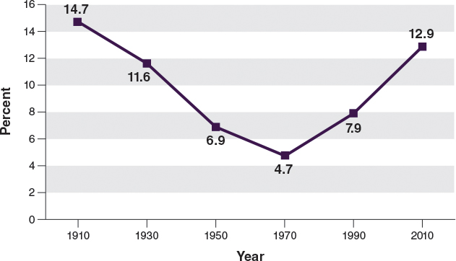

Washington, D.C.: Center for Immigration Studies.
Figure 4.2: Immigration Trends
The number of immigrants in the United States increased by almost 10 million between 2000 and 2011.
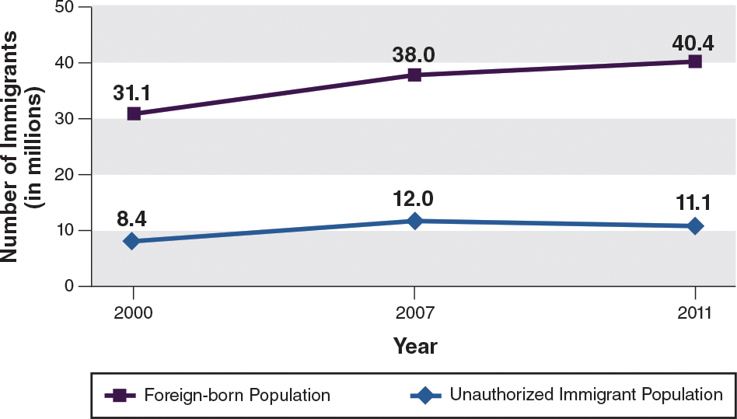

U.S. Immigration Policy
When and why a family immigrated to the United States has an impact on the child's development and learning; it even affects whether the child attends an early childhood program. A child whose family emigrates to the United States for economic opportunity or seeking asylum, which is a special form of protection from a foreign government (sought by political activists, refugees, and whistleblowers, for example), may have no family connections when the family first arrives. In comparison, a child whose family emigrated to the United States 70 years ago may have generations of family members and networks in the United States and in his family's home country; in fact, this particular child may not identify himself as an immigrant because he, and his parents, were born here, but his family's culture and traditions, such as its religious and holiday practices and celebrations, may still be based on those from his family's home country.

Typically, when such children have a family history of immigration and they are from one of the pan-ethnic groups in the United States, they are still considered part of an ethnic or cultural minority, even though they are not first-generation immigrants ("foreign-born")—or even second-generation. So you will better understand these differences in immigrant lives, we present a brief history of U.S. immigration.

Defining the Waves of Immigrant Populations
In the 1700s, the early immigrants from England, France, Germany, and other countries in northwestern Europe came to the United States in search of economic opportunities and political freedom, yet they often relied upon the labor of African slaves working on land stolen from Native Americans (Ewing, 2012). These northwestern Europeans then mistrusted and mistreated later immigrants who came from Italy, Poland, Russia, and other parts of southeastern and western Europe during the 1800s. Subsequently, European immigrants have in turn mistrusted and mistreated the most recent wave of immigrants from Latin America, Asia, and Africa who have come to the United States in the 1900s and 2000s.

Although the recent wave currently makes up our largest group of immigrants, it is important to understand that their level of emigration, and the time period for immigration, is, and has always been, lower than the level of emigration for Europeans (Ewing, 2012). Throughout the course of history, the vast majority of U.S. immigrants have been people of European descent; thus, the fact that European Whites are the majority of the U.S. population is due to immigration policies within this country.

Restrictions on Immigration
The tight restriction on immigration began in 1875 with a law that banned the importation of Asian laborers and prostitutes and immigration of foreign criminals to the United States (Ewing, 2012). In 1921, the United States created immigration quota laws that excluded Asians and Africans and favored northern and western Europeans over southern and eastern Europeans. In 1965, the Immigration and Nationality Act abolished the national origins quota system and replaced it with a preference system that focused on immigrants' skills and family relationships with U.S. citizens and residents (Ewing, 2012).

Although there remained some policies and practices that limited immigration into the United States, there was also an economic need for immigrants. As men were drafted during World War II, the United States. experienced a shortage of farm workers. This resulted in the influx of agricultural workers from Mexico in 1942. Many of these workers who were in the United States for several years or longer put down roots and had children. It was expected that these immigrants would return to their country or apply for legal status after this temporary employment; however, the cost and process of becoming a legal immigrant was cumbersome for many of these poor, uneducated workers.
The federal government launched "Operation Wetback," rounding up and deporting about one million Mexican immigrants, as well as some legal immigrants and U.S. citizens of Mexican descent (Ewing, 2012). Children's lives were disrupted, either because they were separated from their parents or they were sent back to a country they did not know. This trauma for children in their early lives affected how they connected with adults and peers and how they behaved in the classroom, including generating a fear of change and a need for strict routines (Androff et al., 2011; Brabeck, 2010).

Policies limiting immigrants continued with the Immigration Reform and Control Act (IRCA) of 1986 (Ewing, 2012). The purpose of the IRCA was to allow unauthorized immigrants to apply for legal status, punish employers who knowingly hired unauthorized immigrants, and increase funding for border security and enforcement. In 1996, three laws passed that had a devastating impact on immigration. These laws did the following: (a) expanded the definition of aggravated felony, retroactively allowed deportation of those with nonviolent offenses, expedited the deportation of individuals without formal hearings, established multiyear bans for re-entry into the United States, and enhanced border security; (b) restricted immigrants from gaining access to public benefits, such as Medicare and Social Security, for ten years; and (c) expedited the removal of individuals suspected of terrorism, allowed detention and deportation based on "secret evidence," and created a more stringent criteria for granting asylum (Ewing, 2012). The September 11, 2001 terrorist attacks created an additional layer of immigration control by linking it with national security. This singled out individuals from Muslim, Arab, and South Asian countries.

Though the U.S. immigration policies have tried to control illegal immigration, U.S. employers have encouraged it, implicitly and explicitly, by continuing to rely on illegal immigrants as a low-wage labor force. This conflict between law and economics has led some localities and states, such as Arizona, to institute laws that allow police officers to be "de facto immigration agents" and arrest any suspected unauthorized immigrants.

Families Facing the Threat of Deportation
Children in families living under fear of deportation are likely to have challenges in relation to attachment, sleep, anxiety, and other emotional problems (Brabeck&Qingwen Xu, 2010). The families themselves are less likely to provide the consistent and responsive environment that children may need, including interaction with schools and teachers (Leidy, Guerra, & Toro, 2012). Often, immigrating to the United States means leaving some loved ones behind due to costs and restrictions on how many people from a family can travel, as was the case with Bianca in our opening vignette.

To minimize retraumatizing children in these situations, early childhood programs and educators need to provide safe and nurturing environments for children. This may entail providing individual time or ways for children to share how they are feeling, and finding ways for other children to empathize with the child through story books that talk about how people feel when they have to leave their home or "favorite" relative behind. Programs and teachers can also be clear in their communications with parents and families that their role is to support families and not to be an "enforcer" of immigration laws. ECE programs can ascertain how they can be further supportive through focus groups and conversations with families (this is discussed further in Chapter 5).

Who Is an Immigrant?
Thinking about the children in your class, who would you consider an immigrant? Would it be a child who moved to the United States three years ago? What about a child with a mother whose family has been in the United States for 100 years and a father who arrived to the United States five years ago? Recall in Chapter 1 that an immigrant was defined as either first-generation or second-generation. First-generation immigrants are children who have immigrated to the United States themselves, and second-generation immigrants are children whose parents immigrated.

Here is an example, Peter and Jill emigrated to the United States as a young married couple, and they brought their older daughter, Sarah. As the years went by, Peter and Jill had two other daughters, Stephanie and Michelle, who were born in the United States. In this example, Peter, Jill, and Sarah would be classified as first-generation immigrants, and Stephanie and Michelle are U.S. citizens who would be described "socially" as second-generation immigrants. The reason they are defined "socially" as immigrants is because legally, the two daughters are not immigrants at all; they are U.S. citizens. Thus, second-generation immigrants are immigrants that have only a cultural, ethnic, national, or familial tie to another country, yet they are actually legal U.S. citizens. People who are "social" immigrants typically have very strong emotional ties to their country.
4.2 Characteristics of Immigrant Families and Children
We all probably know individuals who were born in a different country and have lived in the United States for decades, and maybe have even obtained U.S. citizenship, who still consider themselves immigrants. Knowing whether a child is a first-generation or a second-generation immigrant may help determine how the child and her family have acclimated to and are familiar with U.S. culture. It may also provide a clue about the child's home language and learning style, as well as knowledge about U.S. customs and traditions. Knowing children's connections to their family's native country, including traditions and values, helps teachers develop a relationship with the child, and also helps the child acclimate and navigate American customs and norms, including the expectations of the classroom and interacting with peers.

Country of Origin, Education Level, and Socioeconomic Status
There are many differences among immigrants who relocate to the United States, including their country of origin, education level, extended family, and support networks in the United States. Immigrants are less likely to have a high school education than natives, though immigrants and U.S. natives are comparable with respect to college degrees. This means that there are groups of immigrants who are less educated and others who are highly educated. Immigrants from Asia, Europe, and Africa are likely to be of higher income and more educated compared to their Mexican counterparts, which means they are more likely to be able to support themselves without social services.

Figure 4.3 shows immigrants by the regions of the world from which they come and by decade. The largest numbers of current immigrants are coming from Mexico—almost 12 million out of 40 million total (Camarota, 2012). In addition, 53% of immigrants came from Mexico and Latin America (e.g., Central America, South America, and the Caribbean). While the percentage of immigrants from Mexico has decreased from 33% to 29% from 1980 to 2010, the percentage of immigrants from South Asia, the Middle East, Africa, and Europe has increased. The top immigrant-sending countries in the past decade have been Mexico, India, China, the Philippines, El Salvador, and Guatemala. This immigration pattern means that you will likely have children in your classroom who are from Latin America and speak Spanish.

Figure 4.3: Percentage of Immigrants by Region and Year of Arrival in the United States
Mexicans make up the largest immigrant population in the United States, followed by immigrants from East Asia. While immigrants from Mexico have remained stable over the past decade, there has been an increase in immigrants from countries in Africa, Asia, and Europe.
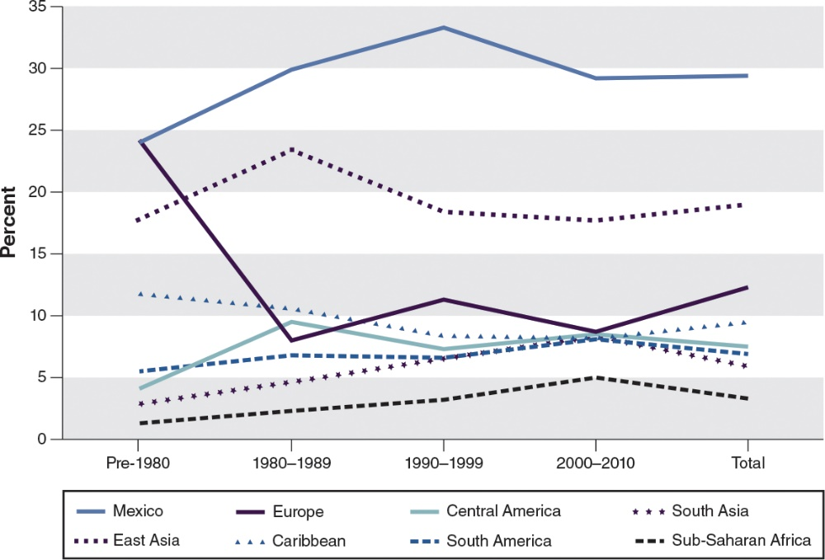

Being sensitive to the needs of children from immigrant families requires understanding the resources and values their families have, such as their education level and employment skills, as well as their challenges. Research has found that the socioeconomic status (SES) of the family—which includes parental education, employment status, income, wealth (such as owning a home)—and the richness of the language environment at home have an effect on children's school readiness and future school success (Mistry, Biesanz, Chien, Howes, & Benner, 2008). About 28% of immigrants 25 to 65 years of age have not completed high school, compared to about 7% of U.S. natives. However, there is only a 4% difference between immigrants (29%) and U.S. natives (33%) who have a bachelor's degree or higher. Overall, immigrant families earn an average of $10,000 less than U.S. natives ($44,000 vs. $34,000) (Camarota, 2012, p. 20).

This income difference may mean that immigrant parents are not able to provide their children with high quality early education experiences. Parents may also have to work multiple jobs, which can limit their time with their children. More importantly, the income difference may increase the likelihood of children from immigrant families living in poverty, needing public assistance, and potentially being exposed to crime and other trauma. National data shows that over 32% of children of immigrants are likely to be in poverty, compared to 19% of children of U.S. natives (Camarota, 2012, p. 27).

The majority of immigrants who are living in poverty are from Honduras, Mexico, Guatemala, Haiti, and the Dominican Republic (poverty rates range from 20%–33%). In contrast, immigrants from the Philippines, India, Germany, the United Kingdom, Poland, and Canada are less likely to live in poverty (poverty rates range from 5–9%). Overall, immigrants from Asia, Africa, and Europe are less likely to be in poverty than those from Mexico and Latin America. This suggests that though immigrant families are more likely to have less education and to live in poverty than U.S. natives, this does not apply to all immigrants.

The biggest reason for many immigrants relocating to the United States is economic opportunity. Employment not only provides income for families, but it also exposes immigrant families to U.S. culture. Though immigrants are concentrated in certain industries, such as farming, housekeeping, construction labor, and butchering, they also work as computer programmers, engineers, and physicians. However, since the majority of immigrant families work as laborers and have nonstandard hours, teachers should consider how communication and interaction with families may be limited or varied because of the work schedules and stress families experience. Further, the stress of the work environment and hours may also affect parents' styles and interactions with their children.

As a sign of acculturation and middle-class SES, over 52% of immigrants are homeowners, compared to 68% of natives. While home ownership is a sign of integration and economic success, immigrant families are more likely to live in overcrowded conditions than U.S. natives. The U.S. Department of Housing and Urban Development defines a household as overcrowded when there is more than one person per room. Approximately 13% of immigrants, especially immigrants from Mexico and Central America, are considered to be in overcrowded households. This is in comparison to 2% of U.S. natives (though Asian and Hispanic American natives are considerably higher at 7%) (Camarota, 2012).

Overcrowding is a concern for the well-being of young children when they do not have a dedicated space to play, learn, or do homework. A lot of noise may prevent children from concentrating and focusing. Children may not have dedicated space for sleeping or resting, which can lessen their ability to focus while in school.

The vast majority of immigrants coming to this country are hard-working and eager to become part of the fabric of American life. However, many immigrant families face major stressors and challenges. Those immigrants who come to the United States with little income and education and limited English work multiple low-paying jobs, live in dangerous neighborhoods, and use social services such as food stamps, if they have the proper documents, while learning the culture, language, and norms of their new country. This may mean that children do not spend a lot of time with their parents, they may not experience consistent child care arrangements, and they may feel anxious because of the lack of familiarity with the sounds, smells, and language.

Even with the challenges faced by immigrant families, national data shows that the longer immigrants are in the United States, the less likely they are to be in poverty and lack health insurance and the more likely they are to own homes. These are key indicators of economic progress (Figure 4.4).

Figure 4.4: Indicators of Success by Length of Time in the United States
The longer immigrants are in the United States, the more likely they are to own a home, have insurance, not live in poverty, and not use any welfare program.
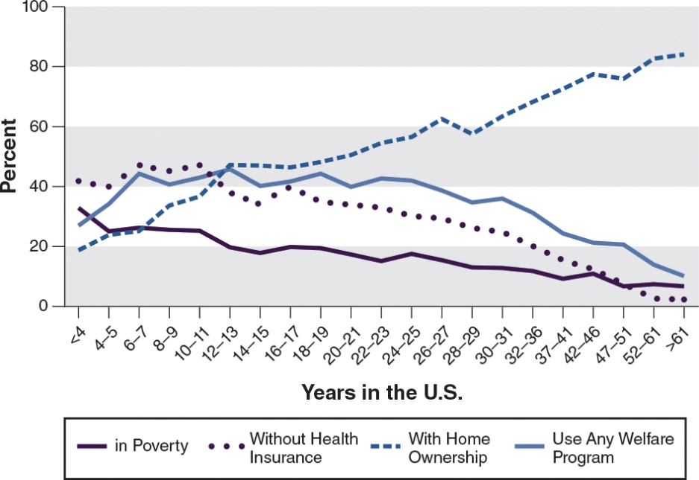

However, the use of welfare programs, such as cash and food assistance and subsidized housing, particularly during the initial decades living in the United States, indicates that many immigrant families are not secure in their living conditions, even though they may not be living in dire poverty. These unstable living conditions, often found in poor and working families, and possibly due to lower educational attainment, household income, and language ability, may cause food and housing insecurity. Food and housing insecurity occur when adults or children perceive that hunger and homelessness are quite possible if just one factor changes—e.g., the loss of a job or the loss of food stamp benefits—because there are few or no other options to replace the lost income or benefits.

These family insecurities have been associated with poor outcomes for children (Eckenrode, Rowe, Laird, & Brathwaite, 1995; Rose-Jacobs et al., 2008; Simpson & Fowler, 1994). Food and housing insecurities can affect children's mood and attention. A child who is hungry, who is living in a temporary shelter, or who is continually moving may find it a challenge to concentrate and engage in classroom activities and may display signs of anxiety or problem behavior.

Approximately 34% of immigrants do not have health insurance compared to 14% of U.S. natives, with this number being higher for Hispanics and African Americans (Camarota, 2012, p. 42). Further, over 50% of immigrants from Guatemala, Honduras, Mexico, and El Salvador have no insurance, in contrast to less than 10% of immigrants from wealthier countries, such as Germany, Japan, and the United Kingdom. The lack of health insurance may mean that immigrant children are unable to get adequate health care, which may prevent them from attending school regularly, and this may hinder their learning and their socio-emotional development. It may also mean that children's health issues, such as fever and asthma, as well as vision, hearing, and dental problems, may not be addressed soon enough—if at all—which can have serious consequences.

Failure to meet children's health care needs and ensure they get proper nutrients and vitamins can harm their brain development, especially during the critical periods of young childhood. Though programs such as Head Start provide health screenings and dental care, ECE teachers and programs can connect families to organizations that assist with providing health insurance for children, as well as ensuring that families have access to a regular doctor.

Language Proficiency of Immigrant Families and Children
Immigrant families' familiarity and comfort with the English language varies, as does that of their children. Some of the families are likely multilingual, meaning they speak three or more languages. The majority (97.8%) of immigrants from English-speaking countries, such as the Caribbean countries of Jamaica and Trinidad and Tobago, as well as the United Kingdom and Guyana, are likely to report that they speak English well, and 85% of African, Asian, and European immigrants speak English (Camarota, 2012, p. 39). In contrast, almost 50% of immigrants from Spanish-speaking countries, such as Guatemala, Honduras, Mexico, and El Salvador, report that they do not speak English well or at all. The longer immigrants are in the United States, the more likely they are to speak English very well (Figure 4.5).

Figure 4.5: English-speaking Ability and Length of Time in the United States
The longer immigrants are in the United States, the better their ability to speak English. However, about 20% of individuals who have been in the United States for over 60 years still report not speaking English only or very well.
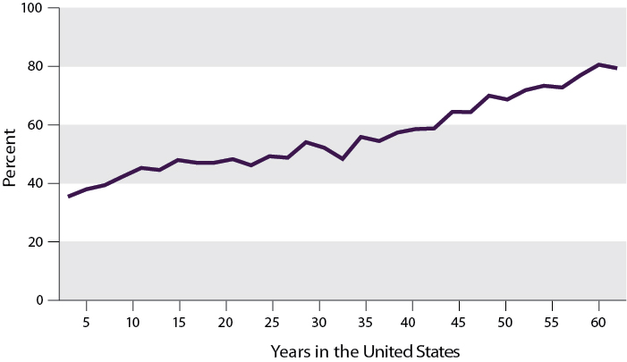

Approximately 21% of school-age children are from immigrant households and almost 80% of these children speak a language other than English (Camarota, 2012). Lack of fluency in English may limit parents' ability to find employment, because English is a requirement for most jobs. Children who do not know English may have difficulty interacting with teachers, other adults, and peers in the classroom, as well as engaging in classroom activities and lessons without accommodations for their language. Though the ability to speak English makes it easier to succeed in the United States, whether in preschool or the workplace, it is not beneficial for children to lose fluency in their home language or dialect. Research indicates that different parts of the brain, such as those for spatial awareness and problem solving, may develop more when children learn different languages (Thomas & Johnson, 2008). Strategies by which teachers and family members can maintain and value home languages for the benefit of children's learning were discussed in Chapter 1.

Comparison of Immigrant Children to U.S.-Born Children
In comparison to their White U.S.-born peers, immigrants show a disadvantage on several key indicators of children's health and well-being (Hernandez &Napierala, 2012; Iruka&Gárcia, 2012): Lower rates of health insurance coverage, lower attendance in early education programs, lower rates of high school graduation, lower household incomes, and higher poverty rates. However, immigrant children show better outcomes compared to their U.S.-born peers from the same ethnic/racial group and socioeconomic status, a characteristic known as the immigrant paradox. For example, Black and Latino immigrant children have better outcomes related to child health indicators, such as being less likely to be born at a low birth weight or with chronic health problems, and they are more likely to be breastfed (Crosby & Dunbar, 2012). Although De Feyter and Winsler (2009) found that children of immigrants scored lower than their U.S.-born peers from the same racial/ethnic groups on academic outcomes, Crosby and Dunbar (2012) report that this is not true when comparing Black immigrants with U.S.-born Blacks in the area of classroom behaviors and academic skills. When socioeconomic status indicators, such as family income, are accounted for, Black immigrants actually outperform even White natives in such skills as reading.

The Child and Youth Well-Being Index (CWI), funded by the Foundation for Children Development, is the most comprehensive measure of how well America's children are faring (Hernandez &Napierala, 2012). This index includes measures of family economic well-being (levels of poverty, employment, family income, health insurance), health (rates of infant mortality, low birth weight, mortality, child health, obesity), safe/risky behavior (rates of teen birth, cigarette smoking, use of alcohol or drugs, being a victim of crime, being a crime offender), educational attainment (reading and math test scores), community engagement (rates of high school dropout, preschool enrollment, achieving a high school diploma, achieving a bachelor's degree, voting), social relationships (single parent households, mobility), and emotional/spiritual well-being (rates of suicide, religious attendance, importance of religion). This information can help ECE teachers determine how well the families in their classrooms and program are doing compared to other children in areas such as health insurance and living in a poor household.

Presented below are some summary statistics for the well-being of children of immigrant families in comparison to children from native families, based on the CWI (Hernandez &Napierala, 2012).

Achievement Scores. The National Assessment of Educational Progress (NAEP, also known as our "Nation's Report Card") does not collect data on whether children are from immigrant families, but by using the term "Dual Language Learners" as a proxy for children from immigrant families and "English Only Learner" as a proxy for children from native families, one can approximate the level of immigrant children's achievement and learning compared to their native peers. NAEP distinguishes students who are performing at or above the proficient level for their grade in reading and math from students who are performing below grade level. Results from the 2011 NAEP assessment indicate that fewer Dual Language Learners than English Only students were proficient in the fourth-grade reading and math tests (Figure 4.6). This low achievement may be linked to the participation rates of immigrant and DLL children in pre-K programs or to the quality of programs children are likely to attend (Hernandez, 2004; Vandell, Belsky, Burchinal, Steinberg, & Vandergrift, 2010).

Figure 4.6: Academic Proficiency in Reading and Math by Language
For a number of reasons, dual language learners, many from immigrant families, have lower academic achievement in reading and math compared to children learning only English.
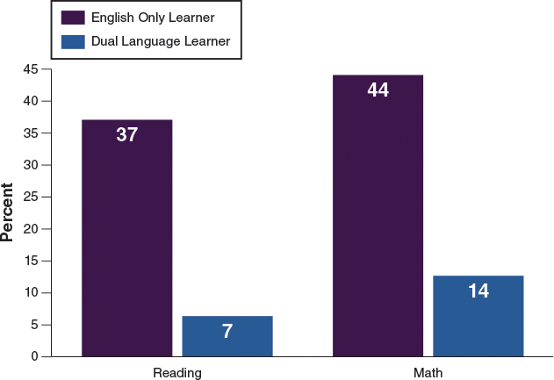

Family Income and Poverty Rates. The median family income in 2010 for immigrant families was 29% lower than for U.S.-born families. This translates to a median income for immigrant families of approximately $41,500 compared to U.S.-born families at $58,862. This discrepancy in median income exists despite comparable employment; it is also related to the poverty rates of children in immigrant families compared to children in U.S.-born families (30% vs. 19%). These poverty rates are high for both groups.

Overall Child Well-Being. Children in immigrant families experience a somewhat lower level of overall well-being than children with U.S.-born parents—99 vs. 103 points. This lower general well-being is due to specific factors, such as immigrant children's lower health insurance coverage, reading and mathematics test scores, preschool enrollment, high school graduation, and median family income, as well as higher poverty rates than U.S. natives. These life challenges have implications for children's learning and development.
4.3 Immigrant Families' Strengths and Unique Needs
To make progress, immigrants need social capital, the collective or economic benefits derived from the cooperation between individuals and groups. Indicators of social capital include education, economic resources, and language ability, as well as networks that improve the lives of families and children. People with networks can tap into them when they need a job or want to get their child into a better school. Think about how the networking site LinkedIn® works. One connection leads to others who may have access to employment or other helpful information. Teachers and schools and other institutions can help build immigrant families' social capital by providing opportunities to connect with other immigrant families and U.S. natives.

Family Networks as a Strength
Oftentimes, people immigrate to locations where they have family or close friends that can support them economically, at least temporarily, and help them adjust to their new surroundings. To minimize the isolation of leaving family behind, many immigrants relocate to areas of the United States where they can connect with individuals or other families from their native country
In Hispanic cultures, the term familismo denotes the close kinship and ties within immediate and extended families. A high value on family is also common in other cultures. You often hear Black immigrants, and also native-born Blacks, refer to non-blood relatives as cousins, sisters, aunts, or uncles; anthropologists call this fictive kinship. This type of kinship provides families with social capital, which are opportunities and resources to help them become economically self-sufficient, as well as offering emotional support and deeper social relationships, which is often helpful to prevent the negative effects of isolation.

Strong family ties are key survival mechanisms for all families, but especially for immigrant families. Many share housing because they are seeking ways to help one another while also pooling resources (e.g., money, food) and support (e.g., child care).

Though overcrowding has drawbacks, as mentioned earlier, shared housing also has some protective benefits. Some studies have found that being surrounded by family can protect against depression and isolation because it provides individuals with security and minimizes the impact of stress (Kawachi& Berkman, 2001).

The importance of family ties and bonds for immigrant families is represented in the low rates of divorce among certain immigrant groups and the fact that children of immigrant families are more likely to live in two-parent households compared to U.S. natives (Hernandez, 2004).

Funds of Knowledge: Incorporating Culture in Environment and Instruction
The term funds of knowledge (FoK) is an anthropological term first coined by Wolf in 1966; it means "resources and knowledge that households manipulate to make ends meet in the household economy. These include caloric funds, funds for rent, replacement funds, ceremonial funds, and social funds" (Hogg, 2011, p. 667). Researchers from the University of Arizona recognized the importance of this concept in school settings and with minority children, particularly immigrant children in the United States. In order to indicate its implication for minority families, Moll and Greenberg (1990) defined FoK as "the essential cultural practices and bodies of knowledge and information that households use to survive, to get ahead, or to thrive" (p. 321).

Thus, immigrant children and families have knowledge and resources that teachers can use to support children's learning. For example, some of the immigrant parents in your classroom may have expertise in a skill like hunting. This skill could be used to teach students different parts and types of animals, as well as how human body parts differ from animals'. In other words, families can contribute "intellectual resources" to classroom instruction and provide resources to teachers "to draw on student experiences and priorities in schooling, thus validating student knowledge and life values, and enabling them to scaffold student learning from the familiar" (Hogg, 2011, p. 667).

To learn about these family resources, teachers can conduct home visits that focus on learning and observing family rituals. During these visits, teachers can also observe how parents and children communicate, how children communicate with their siblings or other children in the household, how families deal with challenges, what children enjoy doing, children's roles in the family, and rituals and routines of families. The Cultural Reflection feature, "Exploring the Funds of Knowledge of an Immigrant Family," will give you a chance to see how this works.
Needs and Challenges of Immigrant Families
Along with their many strengths and resiliencies, immigrant families have unique needs and challenges. They may not understand some subtleties of the U.S. English language, including sarcasm, even if they come from an English-speaking country. This may create difficulties and misconceptions during interactions. Beyond language, there are also potential differences in caregiving and parenting, such as whether children should always obey all adults without disagreeing or whether children learn best from listening rather than doing.

Many of the types of jobs open to immigrants (e.g., farming, housekeeping) are low wage. This leads to immigrants making less per hour than their native counterparts, so often they need more than one job. Low-paying jobs also often require working varying shifts, including overnights, weekends, and holidays. These types of jobs are hourly and do not provide insurance or benefits, such as sick or vacation hours (Ortiz, 2002), resulting in immigrant families taxing their bodies, health, and minds. Low-wage jobs are likely one reason that children of immigrants are more likely to live in poverty than children of native families (23% vs. 14%) (Camarota, 2012, p. 27).

There are further implications of working low-wage jobs, including the stress of not being able to engage with children's early education programs and communicate regularly with teachers. (See the Real World Dilemma feature, "Children of Migrant Workers.") The child's cognitive and emotional development may be affected by the parents' stress level and unavailability to support their learning and emotional health. In turn, this may have an effect on the child's relationships and interactions with the teacher and peers in the classroom. Studies have shown that parents who face economic difficulties are less sensitive and nurturing, which is associated with children's lower cognitive and emotional outcomes (Cabrera, Shannon, West, & Brooks-Gunn, 2006; Iruka, LaForett, & Odom, 2012).
4.4 Programmatic and Instructional Practices and Considerations for Immigrant Children and Families
ECE programs and teachers can effectively support immigrant children's and families' integration into U.S. society. Based on Vesley and Ginsberg's (2011) framework, Table 4.1 summarizes the roles of early education programs and teachers in potentially minimizing the challenges and future disparities experienced by immigrant families and children.

Table 4.1: Ways That Early Childhood Education can Minimize Disparities for Immigrant Children
Value | Description
Economicfunction | - Availability of affordable, quality ECE allows both parents to be employed outside of the home,  Providingmore economic stability, potentially reducing the poverty rates.  - Increase in economic stability would also support more positive and engaged parenting practices,  as wellas strengthen health and emotional well-being.
Educationalfunction | - Early education programs that are of high quality with developmentally appropriate practices  are associated with positive outcomes for children's reading, math, and language skills, as well as  socio-emotional outcomes.  - Language skills are particularly important as many immigrant children often reside in households  whereparents have limited English proficiency.  - These early cognitive outcomes are associated with better school outcomes and graduation rates  andchildren being able to better integrate into U.S. society.
Social function | - Early education environments help children learn how to interact in the United States.  - Early education teachers can help immigrant families integrate into U.S. culture through their  relationships with the families.  - Early education programs and teachers can bridge the cultural gap between immigrant families  and otherfamilies by providing opportunities for connecting through specific events and meetings.
Source: Adapted from Vesley, C. K., & Ginsberg, M. R. (2011). Exploration of the status of services for immigrant families in early childhood education programs.
Washington, DC:National Association for the Education of Young Children.

In their NAEYC report focused on ways to strengthen ECE programs for immigrant families, Vesely and Ginsburg (2011) identify four core principles that support immigrant families: (1) increasing the availability of high-quality ECE to immigrant families, (2) programs building relationships with and understanding immigrant families, (3) strengthening immigrant parents' identity development as well as representation and advocacy in the local community, and (4) programs providing ongoing ECE staff development and well-being. We will discuss these principles one by one in the following sections.

Providing Access to Quality ECE Programs for Immigrant Families
ECE programs and staff can be instrumental in ensuring that immigrant families and their children have access to high-quality experiences. Staff can connect families to community programs that service immigrant families; offer to visit and talk with families about their programs and classrooms; and post information at specific events, locations, and online community forums.

ECE programs and staff can also ask immigrant families of children in the program to provide information to other families in their network about their ECE programs, as well as talk about how their child's high quality ECE program benefits them and their child. This information sharing will likely minimize the reluctance that some immigrant families have about using ECE programs, because their reluctance may be due to their lack of understanding and ability to access high quality programming in their communities.

In addition to increasing the number of immigrant families that can access high quality ECE programs, early childhood educators must also be educated about social services in the community. Recommendations for ECE teachers and programs are provided in Table 4.2.

Table 4.2: Recommendations for Providing Access to Quality ECE Programs for Immigrant Families
Setting | Practice
Classrooms | - Teachers understand what high-quality ECE and developmentally appropriate practices are.  - Teachers consistently consider how their classroom quality may be improved.  - Teachers use available resources to improve quality.
Programs | - Program staff provide outreach to and education of parents of young children.  - Teachers across all classrooms in a program are convened to discuss best developmentally  appropriatepractices for working with immigrant families.
Community | - High-quality programs (center- or home-based) are developed in all communities.  - Programs develop relationships with local public schools.  - Programs partner with immigrant-serving organizations to enroll families in programs.
Source: Vesely, C. K., & Ginsberg, M. R. (2011). Exploration of the status of services for immigrant families in early childhood education programs.
Washington, DC: NationalAssociation for the Education of Young Children.

Building Relationships With Immigrant Children and Families
Researchers have found that parents are very interested and invested in their children's ECE experiences; they welcome and seek out opportunities to discuss their children's progress with their teachers, but teachers receive little guidance or preparation for working with immigrant children and families (Tobin, 2009). As discussed earlier, the reasons often given for immigrant children's lower achievement are their language ability, poverty, lack of motivation, and family challenges. "Committed and dedicated teachers may truly believe in, and despair of, their students' perceived constraints," says education professor Linda Hogg, "but tragically this deficit theorizing mindset ultimately leads to expectation and acceptance of low academic achievement" (2011, p. 666).

Researchers have challenged this deficit perspective by asking teachers to self-reflect on how their biases and cultural experiences may affect the experiences they provide for children, and how they can incorporate children's cultures in their school experiences (see the Cultural Reflection feature, "Checking Our Biases"). Teachers need to become involved in and aware of the lives and resources of immigrant children and their families.
For ECE programs and teachers to be most effective with children and families, there has to be a foundation of trust, which emerges from a strong relationship. That is, in order for children to experience the rich benefits of the classroom, they have to feel comfortable and engaged. Similarly, families must also feel comfortable and value the work of ECE programs and teachers. For example, immigrant families may view the "play-based child-centered approach" of many high quality ECE programs as antithetical to how they view schooling (Tobin, 2009).
Programs that have found success in building a strong connection with immigrant families and children started this relationship before school started, during the enrollment or registration period. During these early periods, as well as during orientation or Open House, program staff can learn more about families and children, a common practice with Head Start programs. This not only allows programs and teachers to learn about the child and family, but is also an opportunity for families and children to learn about the program and perhaps meet the teacher for the upcoming school year. The relationship between families and children and teachers and programs can be further strengthened through conversations during pick-up or drop-off times or through specific periods during the school year.

In some ECE programs such as Head Start, family support specialists are linked to specific families. They usually have a human service background, such as social work or psychology, and their role is to support families (e.g., providing support for health, employment, education, housing) and to support the teacher in developing a strong relationship with the family and child. This means that family support specialists spend time in the classroom observing and interacting with the children, as well as time in the home with families. This helps them provide information to the teacher about how to build a closer relationship with the parent and child, as well as make the classroom environment and instruction more culturally relevant for the child.

Other methods to develop a strong relationships with immigrant families include home visits, which allow teachers to learn more about parents' routines and traditions and potentially trigger ideas for materials and activities for the classroom; parent-teacher meetings; and workshops that can be geared toward immigrant families' needs with information gathered through surveys, focus groups, or informal conversations. Recommendations for ECE teachers and programs are provided in Table 4.3.

Table 4.3: Building Relationships with Families
Setting | Practice
Classrooms | - Teachers and family service workers have daily interactions with individual parents.  - Teachers incorporate artifacts provided by families into the classroom décor and curriculum.
Programs | - Program has family service workers on staff.  - Home visits are conducted by both teachers and family service workers.  - Materials for families are translated.  - Staff diversity is promoted in order to better understand the linguistic and cultural needs of parents.
Community | - Programs are centrally located in immigrant neighborhoods.  - Individuals from the neighborhood are hired and trained to work in the program.  - Teachers are encouraged to participate in community activities (e.g., cultural festivals).
Source: Vesely, C. K., & Ginsberg, M. R. (2011). Exploration of the status of services for immigrant families in early childhood education programs.
Washington, DC: NationalAssociation for the Education of Young Children.

Empowering Immigrant Families Through Leadership Opportunities
Head Start programs have a parent policy council that governs and monitors the programmatic practices of programs and classrooms. Parents are the leaders of this council. Though other ECE programs do not have this structure, other leadership and governing roles can be provided to families through the advisory boards or committees that likely exist. These leadership opportunities can provide a way for immigrant parents to gain a better sense of how the ECE program functions, and they also provide an opportunity to incorporate their culture into the program.

Leadership avenues are also a way for families to advocate for their children, which is empowering. In addition to the information about social services, ECE programs and teachers can help families learn how to navigate social service agencies and other institutions (e.g., public schools, clinics, and immigration), further empowering families. Immigrants can use these experiences to advocate for themselves and their children, as well as other immigrant families and children. Recommendations for ECE teachers and programs are provided in Table 4.4.

Table 4.4: Recommendations for Empowering Immigrant Families
Setting | Practice
Classrooms | - Parents and families are encouraged to observe and help in classroom. Staff meet with parents about  goals for themselves and their children.  - Teachers and staff take time to learn about parents' everyday lives, including employment,  economicsituation, assets and constraints, social networks, and political participation.
Programs | - Provide a structure whereby teachers and staff can come to understand each family's unique  situation (e.g., through home visits or regular conferences focusing on the whole family).
Community | - Programs create links with or house other community programs (health care, social services) to  provideservices to immigrant families.

ECE Staff Development
A key part of ECE staff development is to ensure that the demographics of ECE staff match the demographics of children and families served, or at least include staff who have some credibility with the community. When it is not possible to have a diverse staff represent the program, parents and other members of the community can serve as resources for the ECE program and teachers. They can begin by volunteering in the program and classrooms, so they become accustomed to the structures and expectations. Ideally, these parents and community members can be trained to be employed by the program as teachers, assistant teachers, family specialists, and directors.

Having a diverse staff can help in many ways, including developing the relationships among teachers and families and children and understanding cultural norms and traditions (e.g., cultures where women are not allowed to talk or be around men who are not their relatives). A diverse staff can also help with language and communication challenges, such as teachers needing a translator to communicate with parents and children.

In addition, cultural competence of all staff must be developed, regardless of their cultural or ethnic backgrounds. Cultural competence is particularly important for teachers to ensure that their instructional practices and approaches are culturally relevant and meaningful for all children, especially for children from immigrant families. This means going beyond the notion of having a "doll of color"; it means using books, music, and artifacts that represent children's culture and asking parents about things they do at home that can be incorporated into classroom activities (i.e., investigating and employing their funds of knowledge). Recommendations for ECE teachers and programs are provided in Table 4.5.

Table 4.5: Recommendations for ECE Staff Development
Setting | Practice
Classrooms | - Program provides in-classroom mentoring and coaching using a master teacher.  - Program provides co-teaching among teachers of diverse backgrounds.
Programs | - Program provides all staff and teachers with adequate time away from children for reflection.  - Teachers receive trainings on various issues, including race, implementing curriculum with ELL children,  second-language acquisition, utilizing the local social welfare system, understanding what different  documentation statuses mean for immigrant families.  - Program provides language, communications skills, and cultural competence training for staff.
Community | - Other community programs collaborate with ECE programs to teach staff how to find local services for  families.  - Local universities and colleges collaborate with ECE programs on pre- and in-services, as well as  ongoingevaluative research of programs.
Source: Vesely, C. K., & Ginsberg, M. R. (2011). Exploration of the status of services for immigrant families in early childhood education programs.
Washington, DC: NationalAssociation for the Education of Young Children.

REF
Curenton, S.M., &Iruka, I.U. (2013). Cultural competence in early childhood education [Electronic version]. Retrieved from https://content.ashford.edu/

