5.1 What Is ADHD?
This chapter discusses a disability that is not a separate category under IDEA 2004: ADHD. It is one of the more prevalent disabilities in schools today (Stolzer, 2007). This section presents the formal definition of ADHD and discusses the difference between the terms ADHD and ADD. It highlights how IDEA 2004 defines ADHD and how prevalent it is in students.

Defining ADHD
Students with Attention-Deficit/Hyperactivity Disorder (ADHD) typically exhibit some combination of inattention, hyperactivity, and impulsivity. A student displaying inattention might have trouble focusing on a task for an extended period of time, be easily distracted, or struggle with paying attention to details. Hyperactivity might be seen in class as a tendency to fidget and have difficulty staying seated for reasonable amounts of time. A student who exhibits impulsivity may speak at inappropriate times or have difficulty waiting for his or her turn.

Displaying inattention, hyperactivity, or impulsivity does not necessarily indicate that a student has ADHD. In fact, most students occasionally show one or even all of these behaviors. Any student may daydream or jump out of their seat and run to the window to see something outside. Any student may grab a marker from another student or talk fast and appear jittery. However, when these difficulties are severe and persistent enough to interfere with regular activities, the student who exhibits them may be diagnosed with ADHD.

ADHD and IDEA 2004
ADHD falls under the IDEA 2004 category of Other Health Impairment (OHI). For a student to qualify for special education services under IDEA 2004 in the OHI category, the student must exhibit an academic deficit related to ADHD and exhibit characteristics of ADHD.
ADHD is one of the more commonly identified disabilities that falls under OHI. Other disabilities that may fall under the OHI umbrella include diabetes, epilepsy, and Tourette syndrome (although some schools categorize Tourette syndrome under EBD). Students with ADHD spend most, if not all, of their time in general education classrooms. Thus, a typical general education teacher will likely teach many of these students in his or her classroom (Ambalavanan&Holten, 2005).

Students with ADHD may have either an IEP under IDEA 2004 or be covered by the Americans with Disabilities Act and have a 504 plan. Each school forms its own criteria and uses them to decide whether a student with ADHD receives services under IDEA 2004 or Section 504. Teachers use these plans as a guideline to determine appropriate accommodations or modifications. Most students with ADHD, however, do not have many accommodations or modifications listed in their IEP. Instead, accommodations or modifications are most often in the form of a Functional Behavior Assessment (FBA) and Behavior Intervention Plan (BIP).

DSM-IV and ADHD
Medical professionals often use the Diagnostic and Statistical Manual of Mental Disorders (DSM-IV) to diagnose; it provides another definition of ADHD (American Psychiatric Association, 2000). The DSM-IV outlines the three subtypes: ADHD predominantly inattentive type, ADHD predominantly hyperactive-impulsive type, and ADHD combined type (Larsson, Dilshad, Lichtenstein, & Barker, 2011). Students with the predominantly inattentive type struggle with inattention without major difficulties with hyperactivity and impulsivity. Students with the predominantly hyperactive-impulsive type struggle with hyperactivity and impulsivity without major difficulties with inattention. Students identified with ADHD combined type exhibit both inattentive and hyperactive-impulsive characteristics. See Table 5.1 for some examples of each type of characteristic as described by the DSM-IV.
Prevalence of ADHD
ADHD affects approximately 3–10% of school-age students (Ambalavanan&Holten, 2005). Because the criteria for diagnosing and delivering services to students with ADHD vary considerably by state, there is a wide variability in the percentage of students diagnosed with ADHD in school classrooms from state to state (anywhere from 3–15%).

Boys are more often identified with ADHD—in fact, up to three times as often—than are girls (Bruchmüller, Margraf, & Schneider, 2012; Barkley, 2006). However, boys generally exhibit more hyperactive characteristics of ADHD, while girls exhibit more inattentive characteristics (Abikoff et al., 2002). This difference may be one reason why males are diagnosed more often: Hyperactivity is usually more apparent and distracting to adults, whereas inattention is not as obvious or bothersome.

Interestingly, African-American students tend to be diagnosed less with ADHD than Caucasian students (Mandell, David, Bevans, & Guevara, 2008). However, African-American students tend to be over-diagnosed with EBD, which probably indicates that schools tend to categorize students (with the same behavioral characteristics) differently based on racial category. Researchers have also discovered that the younger students (by age) in a classroom may be identified more often than older students in the same classroom (Zoëga, Valdimarsdóttir, & Hernández-Diaz, 2012). Perhaps younger students take longer to learn behavior patterns in a typical classroom.
5.2 How Has the ADHD Field Evolved?
Behaviors that educators and medical professionals now associate with ADHD have been highlighted in medical literature for at least the last 200 years. While "bad parenting" was sometimes blamed, some early physicians did believe that the difficulties their patients had in performing certain tasks stemmed from brain anomalies.

An early description of ADHD may be found in a children's poem, "The Story of Fidgety Philip," published in 1845, by German psychiatrist and author Heinrich Hoffman. The boy in the poem cannot sit still at the dinner table, and fidgets despite his parents' requests to stop. At the beginning of the 20th century, an English doctor, George Frederic Still, described young boys with behavioral difficulties that he believed were due to differences in their biological makeup—specifically, in the brain. Still's work, along with that of others, such as the physician William James, was vital in explaining that the behavior of some children was not a moral failing on the part of parents.

In 1934, Eugene Kahn and Louis Cohen published a study in the New England Journal of Medicine that described patients with impaired attention, impulse control, and self-regulation. Soon after, in 1937, Charles Bradley produced evidence that linked a stimulant drug to the reduction of symptoms for children with behavior difficulties. As more and more researchers worked with these children and tried to find medications to assist with their daily functioning, the term minimal brain dysfunction began to be used to describe their condition. Another term, hyperkinetic syndrome, emerged in the 1950s to describe brain function that is overactive or overwhelmed.

As previous chapters have explained, the 1960s and 1970s were a time of tremendous growth in understanding disabilities, including ADHD. In 1968, the DSM-II recognized ADHD as an actual disorder, hyperkinetic reaction of childhood. The terms Attention Deficit Disorder and, later, ADHD were coined in the 1980s (Brown, 2006).

Attention Deficit Disorder (ADD) is an outdated term. When people use the term ADD, they are usually referring to ADHD predominantly inattentive type. Some adults prefer the term ADD, since they do not experience hyperactivity as much as children and adolescents do, but this chapter will refer to the disorder as ADHD.

In the last few decades, much of the research on ADHD has focused on learning more about the chemicals in the brain that receive and transmit signals (neurotransmitters), understanding the role of medication in helping to control ADHD, determining how to better assess students with behavioral difficulties, and learning how to best teach students with ADHD. These topics will all be covered in the remainder of this chapter.
5.3 What Are the Characteristics of Students With ADHD?
The inattention, hyperactivity, and impulsivity of people with ADHD can emerge in a variety of ways. Table 5.2 lists the common characteristics of ADHD identified by the Centers for Disease Control and Prevention (CDC).

Table 5.2: Common Characteristics of ADHD
Inattentive characteristics | Hyperactive characteristics | Impulsive characteristics
Has difficulty paying attention | Is in constant motion | Frequently loses necessary items
Makes careless mistakes | Is unable to stay seated | Is unable to play quietly
Daydreams | Squirms or fidgets | Acts and speaks without thinking
Doesn't seem to listen | Has difficulty following through | Has difficulty taking turns
Is easily distracted | Talks out of turn or too much | Interrupts others
Is forgetful
Has difficulty organizing information

Of course, not all children (or adults) who exhibit these qualities have ADHD. In fact, for a diagnosis, students must exhibit inattentive or hyperactive-impulsive characteristics more frequently than is observed in other students of the same age.

How do educators differentiate ADHD? There are three governing principles outlined by the DSM-IV that all must be in place for a student to receive a diagnosis of ADHD:

A student must exhibit characteristics (i.e., inattentive and/or hyperactive-impulsive) for a sustained period of time (six months or more) and in multiple settings (e.g., at home and in school).
The behaviors must be disruptive to the classroom or home environment.
Some of the inattentive, hyperactive, or impulsive behaviors must have been manifested before the student was 7 years of age.
When students exhibit the behaviors that are characteristic of ADHD, it is important to rule out extenuating factors. For example, a student who has recently experienced a sudden death in the family or who is coming to terms with his parents' divorce might act in atypical ways. It is also important to rule out other medical reasons (such as seizures or depression) that may cause students to appear to have ADHD.

Many students with ADHD are also diagnosed with other disabilities, such as SLD (see Figure 5.1). In fact, the rate for comorbidity (i.e., the likelihood that a student has two or more disabilities rather than just one) with ADHD is as high as 50–60% (Jensen et al., 2001). ADHD can occur alongside behavioral disorders, such as Oppositional Defiant Disorder (ODD), conduct disorder, bipolar disorder, anxiety disorder, depression, or Tourette syndrome (Takeda, Ambrosini, deBerardinis, & Elia, 2012). Some students with ADHD may also have Autism Spectrum Disorder (Grzadzinski et al., 2011), or be considered gifted (Foley-Nicpon, Rickels, Assouline, & Richards, 2012).
Figure 5.1: Comparison of Students With ADHD and SLD
The number of students with ADHD, with SLD, and with both is compared with the total number of school-age students. Note that the number of boys diagnosed with ADHD, SLD, or both is higher than the number of girls diagnosed with either disability.
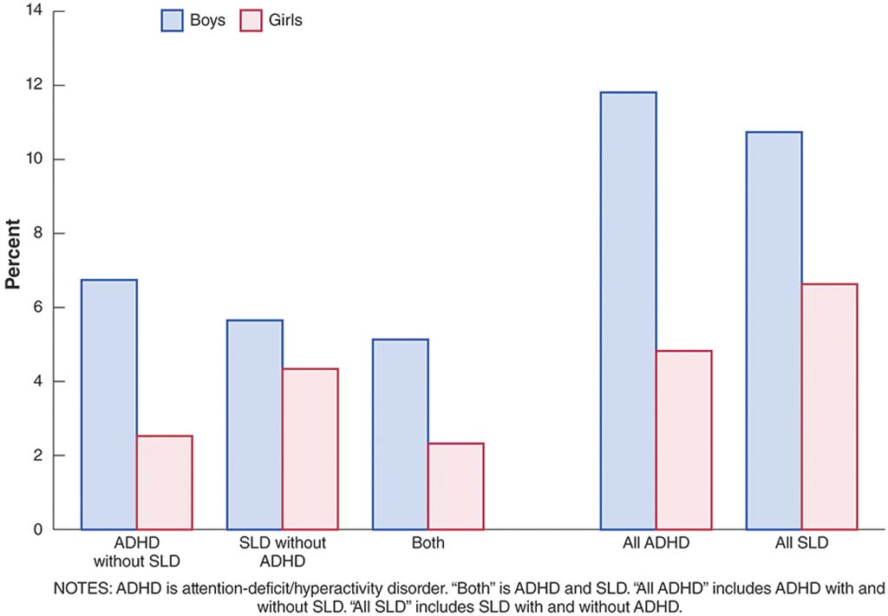
5.4 What Are the Causes of ADHD?
Researchers have not identified a primary cause of ADHD. They believe that it is probably related to a combination of biology, genetics, and the student's environment (Larsson et al., 2011; Thapar, Cooper, Eyre, & Langley, 2013). As technology improves over the next few decades, researchers will be better equipped to understand how these causes work and combine to affect students with ADHD.
The Role of Biology
Many researchers hypothesize that students with ADHD are either missing specific neurotransmitters or that the actions of these neurotransmitters are faulty. When neurotransmitters are not working as normal, the information processing system of a student's brain has difficulty handling new information. In other words, the "hardware" in the brain has trouble organizing new information, so the brain becomes overloaded and shuts down.

Indeed, brain scans of students presented with a difficult or distracting task show marked differences between students with and without ADHD. Students with ADHD often show a decrease in brain activity compared with students without ADHD. Before the difficult or distracting task, all students demonstrated similar patterns in brain activity.

It is well-established that the brain is involved in the intake and processing of information; what may be less obvious is that the rest of the body is also involved. Many students with ADHD experience sensory overload (i.e., too many noises or too much visual activity in the classroom). They may focus on the music playing in the background or the busy collage on the wall instead of focusing on the task at hand.

Genes also appear to play a role in the likelihood of a student developing ADHD (Thapar et al., 2013). While no single gene has been identified as responsible, approximately one-third of students with ADHD have a sibling with ADHD, and approximately half of students with ADHD have a parent with ADHD (Freitag, Rohde, Lempp, &Romanos, 2010; Polderman et al., 2007). The role of genetics in ADHD is further complicated by the fact that about half of students diagnosed with ADHD in school will outgrow their ADHD characteristics by adulthood (Garnier-Dykstra, Pinchezsky, Caldeira, Vincent, &Arria, 2010; Martel, von Eye, &Nigg, 2012).

The Role of the Environment
Quite a few environmental factors have been linked to ADHD (Thapar et al., 2013). Several causal factors may occur during gestation. For example, mothers who smoke or engage in substance abuse may have babies with an elevated risk of ADHD (Graham et al., 2013). Babies born premature or at a low birth weight may also have a higher risk of ADHD. After birth, malnutrition or other dietary factors—such as too much sugar or fatty acids—could possibly be risk factors for ADHD. In addition, researchers hypothesize that some students with ADHD may have had exposure to pesticides or lead (Thapar et al., 2013).

Some researchers believe that family dynamics may contribute to students developing ADHD. For example, if parents and students experience hostility or anger toward one another on a constant basis, or if students are abandoned or feel unsafe in their environment, this may put them at a higher risk for ADHD.
5.5 How Are Students Diagnosed With ADHD?
Like some other disabilities, ADHD is diagnosed by medical professionals or clinicians using DSM-IV criteria or using parent and teacher rating scales along with observations of the student (Rushton, Fant, & Clark, 2004). No test exists for diagnosing ADHD. The professionals may gather checklists, rating scales, and observations from teachers and other school staff members to aid in the diagnosis.

Teachers and school staff can talk with parents about the possibility of their child needing to undergo an evaluation for ADHD, but the official diagnosis must come from a medical professional or clinician (i.e., medical doctor, psychiatrist, or psychologist). Often, parents discuss their concerns with a pediatrician or family physician, who then refers the family to a clinic for professional screening for, and diagnosis of, ADHD.

Checklists
Medical professionals use a checklist of characteristics, along with information in the form of anecdotal evidence and behavioral observations from parents, caregivers, teachers, or other school professionals, to thoroughly evaluate a student. This evaluation usually takes weeks or months to complete because data about the student's behaviors have to be gathered over time and from a variety of sources. If the screening is conducted properly, it is not possible for a student to walk into a clinic or doctor's office for the first time and receive an ADHD diagnosis.

As you learned, ADHD is divided into three categories: ADHD predominantly inattentive type, ADHD predominantly hyperactive-impulsive type, or ADHD combined type. Refer to Table 5.2 for a checklist of characteristics divided into inattentive, hyperactive, and impulsivity categories.

Rating Scales and Behavioral Observations
Rating scales, such as the widely-used Conners test or the Barkley Scale, provide one of the more common ways to gather information from teachers, parents, or even individual students when they exhibit characteristics of ADHD.

There are three versions of the Conners test: one for parents or guardians, one for teachers, and one for students who are old enough to rate themselves (i.e., middle- or high-school students). Parents, teachers, or students fill out the form and rate the student's behavior by answering multiple-choice questions. The Barkley Rating Scale also involves parents and teachers filling out different versions of a questionnaire about the frequency of difficult behaviors of the student. The information from these tests and scales, if gathered properly, can aid doctors or clinicians in a diagnosis of ADHD. They should never depend on just one rating scale or source, however, to determine whether a student has ADHD; a proper diagnosis should have documentation from multiple sources.

Behavioral observation is also useful in information gathering for a diagnosis of ADHD. Teachers, parents, or other trained professionals may observe students in different settings (e.g., in the classroom and at after-school workshops). In a behavioral observation, the observer notes whether and how often certain behaviors occur. This information can be used to aid medical professionals in their diagnosis.

A boy at a desk looks off to the side, away from a teacher writing on a blackboard.
Wolfgang Flamisch/Corbis

Diagnosing ADHD before school age can be difficult; it may be hard to determine whether the student's inattention or hyperactivity and impulsivity is due to ADHD or to being young and inexperienced in social cues and norms. However, ADHD students can be identified earlier than the age of 5 if they exhibit very severe symptoms of ADHD.
When Are Students Diagnosed?
ADHD is often diagnosed near the end of the early childhood period, during preschool or kindergarten. Around age 5, many students begin to exhibit characteristics common to ADHD as they start school and learn the new routines associated with the structured setting of the classroom. Starting school involves learning how to follow directions and how to act in group settings, and if students are not used to school expectations, they may display some of the inattentive, hyperactive, or impulsive characteristics of ADHD (Anderson, Watt, Noble, &Shanley, 2012).

However, this does not mean they have ADHD. If a student comes from a home where lots of physical activity is encouraged, it may take the student a while to learn how to not run around the classroom all the time or jump out of her seat when an adult enters the room. Once students become familiar with the classroom rules and expectations, their classroom attention and behavior should improve. Those students who do not show improvement may have ADHD.

Most students with ADHD are diagnosed around second or third grade, or between the ages of 8 and 10. At that time, they are expected to work more independently and are held more accountable for their schoolwork. When these expectations are placed upon those students whose brains find it difficult to process new information readily, they may begin exhibiting characteristics of ADHD. Students may have displayed ADHD characteristics for a few years, but they were not as noticeable during their participation in the larger-group activities of preschool or kindergarten as they are in a more "academic" setting.
5.6 How Does ADHD Differ Across Grade Levels?
Teaching strategies for students with ADHD show some similarities across grade levels, as well as some differences. For example, all students may benefit from classroom management and organization techniques, but these techniques may have to be amended based on the student's grade level.
Early Childhood
ADHD is often diagnosed near the end of the early childhood period, during preschool or kindergarten, when students are first asked to participate in and finish tasks, follow directions and rules, sit quietly, and control their movements. Students who have a harder than average time sitting still or transitioning from one activity to another may be showing symptoms of ADHD. For instance, teachers may ask students to move from an art center to the carpet area for story time, and students with ADHD may act out or refuse to follow directions because they find it difficult to leave one task to do another. Many of the teaching strategies highlighted later in this chapter are appropriate for very young students with ADHD.

Elementary School
Most students diagnosed with ADHD will be identified in the elementary grades. Students in this age group may experience difficulties related to spending hours in a classroom during the school day. Students may struggle with inattention to classroom material and hyperactive or impulsive behavior in groups.

When teaching elementary school students with ADHD, it is helpful to present lessons in smaller groups. This allows the classroom teacher to better differentiate instruction and monitor on-task behavior. To differentiate, teachers tailor assignments or materials to the individual student to ensure that the student is getting the most out of the lesson. Peer tutoring, delivering lessons in an explicit manner and at a brisk pace, and using a variety of instructional tools for conceptual understanding are all methods that are known to be helpful in teaching elementary-aged ADHD students (Harlacher, Roberts, & Merrell, 2006). When teaching in an explicit manner, teachers provide direct and focused instruction on a topic area. The teacher helps the student by guiding the student through material and providing many opportunities for feedback and discussion.

Keep in mind that many students with ADHD are hypersensitive to sights and sounds. Think hard about whether to show a presentation with many graphics or a movie with lots of music and noise. Allowing students to have some choice of topics to study (or how to study certain topics) can also be helpful, and tends to help motivate a broad range of students. Activities that are "hands-on" are also more compelling for these students. These kinds of activities include conducting a science experiment with bacteria samples in petri dishes and learning fraction concepts through dividing pizzas.

Teachers need to remember that in-class and homework assignments may take students with ADHD much longer to complete accurately than the typical student. The practice of sending home unfinished classroom activities or work to be completed as homework is not usually effective for students with ADHD. If these students demonstrated difficulty completing an assignment in the classroom with teacher monitoring and feedback, they will probably also struggle with completing this assignment at home. This will only add to their frustration—and that of their parents.

Secondary School
The transition from middle to high school can be difficult for any student, and particularly so for someone with ADHD. First and foremost, expectations from teachers at the secondary level are different than those at the elementary level. Students are expected to be much more responsible for themselves and their learning. They must show up to the correct classroom at the right time, keep track of their academic materials and assignments, and take notes on class material in a way that will help them score well on assessments. Second, secondary students are experiencing numerous physical and emotional changes that can lead to changes in the manifestation of their ADHD. For example, students may become less hyperactive but more impulsive.

Many of the teaching approaches highlighted in Chapter 2 are helpful for secondary school students with ADHD—for example, using explicit instruction, involving students in peer tutoring, and using differentiation. It also may also be helpful to collaborate with the students themselves to find solutions to their educational problems. High school students frequently complain that they are not treated or respected like adults are, so teachers may want to involve them in decisions about what, how, or when they study for a certain topic.

A teacher with high expectations for students, who does not treat them like elementary students but instead provides opportunities for them to take on new responsibilities and exercise autonomy, will contribute to their self-confidence, which in turn can improve behavior. Teachers should assume students can handle certain tasks until they prove otherwise.

Transition
Secondary students with ADHD will also have transition plans to ensure that high school courses and support services align to postsecondary goals. In addition to specifying the effective instructional practices listed in this chapter, transition planning can help students, family members, and educators prepare for ongoing success. These plans can help set up support that continues after graduation from high school. Transition plans should include appropriate service providers, including social services and mental health counselors. Strategic planning increases the likelihood that students with ADHD will complete high school and successfully transition to college or career opportunities.

Individuals with ADHD can absolutely be successful in colleges and careers with the appropriate resources and support. Gaining insight about ADHD, managing behaviors, and utilizing sources of support can all help students achieve (Meaux, Green, & Broussard, 2009). Meaux et al. (2009) outline the following recommendations for postsecondary students with ADHD:

Gain insight about ADHD
Learn from experience
Seek information
Acknowledge difficulties
Open up for support
Manage life and behavior
Be accountable
Learn from consequences
Set alarms and reminders
Take prescribed medication
Engage in self-talk
Stay busy and schedule activities
Utilize sources of support
Parents
Friends
Teachers/Tutors
Academic support and disability services
5.7 How Do I Teach Students With ADHD?
Effective teachers at all grade levels make their classroom environments and practices more conducive to students who struggle with inattention, hyperactivity, or impulsivity.
As mentioned, many of the teaching techniques (such as explicit instruction and peer tutoring) that are effective for students with SLD and emotional and/or behavioral difficulties have also been proven to be effective for students with ADHD. In addition, the use of strategies related to classroom organization and delivery of instruction can provide an optimal learning environment for all the students in the general education classroom.
Teachers should keep in mind that the biggest challenge that students with ADHD face in the classroom is their tendency to be easily overwhelmed or frustrated, either by their environment or by the tasks they are being asked to perform. The characteristics of students with ADHD may lead to classroom behaviors like the following:

Making careless mistakes on assignments
Daydreaming during lectures
Keeping materials and desks unorganized
Only paying attention during "fun" activities
Not following directions and rules
Turning in assignments unfinished
Causing disruptions in class
Classroom Organization
Appropriate organization of the classroom is crucial in reducing the stress an ADHD student feels in the typical, busy classroom (Carbone, 2001). The teacher should make sure that all aspects of instruction are well organized, from the way the classroom functions to the arrangement of furniture and the materials within it. Good classroom organization also extends to helping students bring order to their assignments and providing schedules to follow.

An organized classroom will help students focus on classroom tasks (e.g., taking notes from a lecture, participating in group instruction, completing a book report), minimizing distractions that could lead students astray. An organized classroom also enables the teacher to focus on quality academic instruction without having to spend time on redirecting student attention or correcting off-task behavior.

Functional Organization: Routines, Procedures, and Classroom Rules
Effective functional organization of a classroom involves the establishment of routines and procedures. These provide structure to the classroom and the school day. They help students understand expectations for behavior. A routine might be as basic as one that involves students walking into the classroom at the beginning of the school day and turning in their homework:

Walk into the classroom quietly.
Walk to your locker.
Take your homework assignments out of your backpack.
Place your homework assignments in the green bucket.
Place your backpack into your locker.
Walk to your assigned desk.
Sit at your desk and begin your morning work.
This routine provides a framework for students in terms of classroom behavior. Teachers could have a procedure for getting materials from the art center for a painting project, breaking into partners to proofread a narrative, or returning library books to the school library.

Teachers should provide explicit instruction and modeling for routines and procedures (Jacobson & Reid, 2010), and students should have opportunities to practice them while the teacher provides feedback. They are important ways to guide students throughout the day. With established routines and procedures, students know how things in the classroom operate and thus are less likely to be distracted from the main focus of the academic task by the logistical details of getting it done.

Functional classroom organization also includes the creation of classroom rules that apply to all students. These rules should be positive and brief, with clearly stated consequences for not following them. Ideally, there is a set of rules for the entire school, as this consistency helps ADHD students understand the expectations in every classroom, not just their homeroom. Rules for elementary and secondary students may differ slightly, but the underlying concepts are the same (Figure 5.2). Rules are stated positively, are applicable across various school situations, and help students understand school expectations.

Figure 5.2: Classroom Rules
Rules for a second-grade classroom (left) and for a tenth-grade classroom (right) reflect similar expectations for student behavior. Both sets of rules are positive and age-appropriate.
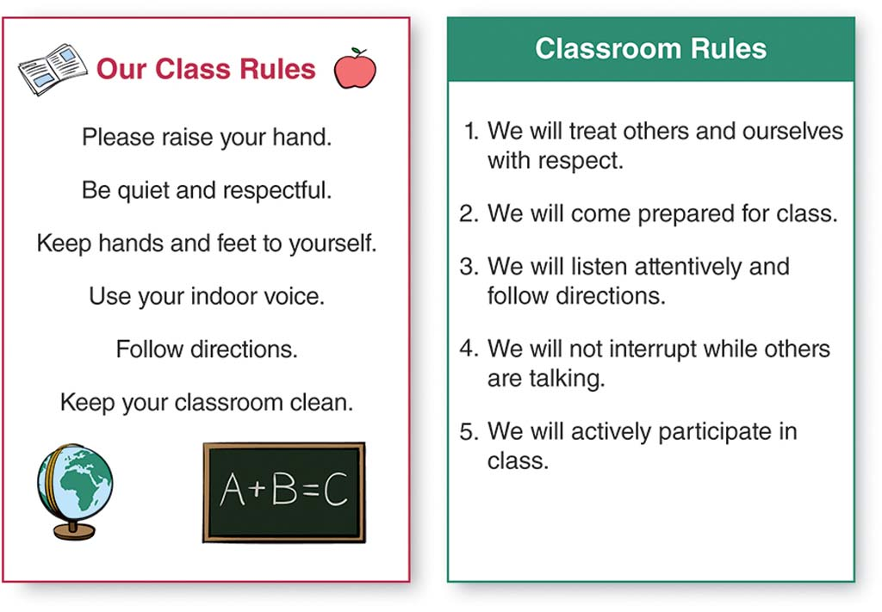
Organization of Space
Appropriate organization of the classroom space is also important for students with ADHD (Carbone, 2001). Cluttered walls or bulletin boards, for example, can easily be distracting. Classrooms should have meaningful posters and wall hangings, but teachers should keep them to a minimum. Meaningful posters and hangings include things that are important to current classroom instruction or that outline classroom rules and expectations. Content that has not yet been introduced in class, on the other hand, is likely to pull students away from lessons in progress.
Both elementary and secondary teachers should also pay attention to the placement of student desks and work areas. All students should be able to see the teacher at all times without having to turn around in their seats. If there are tables in the classroom, teachers will have to arrange them in such a way that all students can focus on the teacher without strain.

Carbone (2001) suggests placing desks in rows because rows help students avoid the distractions of being seated at a table. If students can focus on the teacher (and the teacher can focus on each student), there is less opportunity for distraction and off-task behavior (see Figure 5.3 to consider seating options). Many secondary classroom teachers do place student desks in rows, and elementary teachers may also find it helpful.

Figure 5.3: Elementary Classroom Seating Options for a Student with ADHD
In this floor plan for a kindergarten classroom, the star indicates the seat for a student with ADHD. What do you think about this choice of seat? What would you do to change this as a classroom teacher?
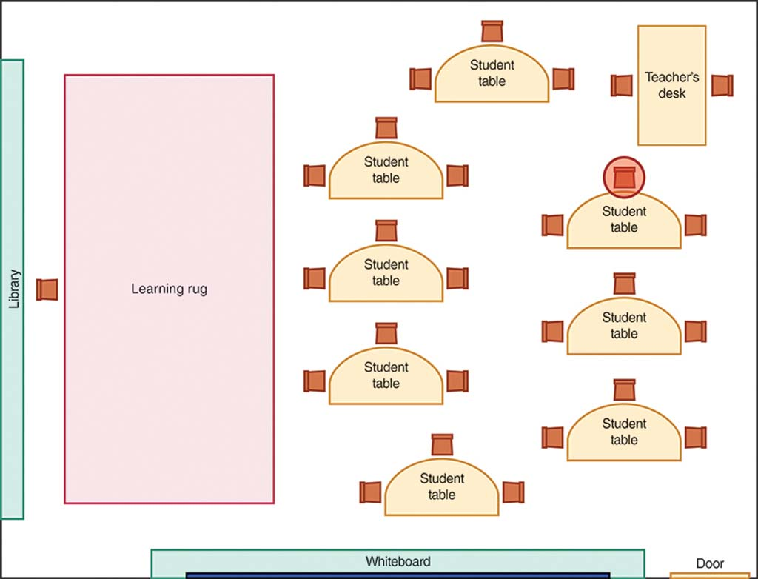
Regardless of whether student desks or tables are in rows, groups, or some other arrangement, teachers should always assign all students, not just those with ADHD, to work spaces. A student with ADHD will benefit from having an organized work area. Teachers can suggest the use of different colored folders for each class period for secondary students. They can encourage elementary students to place plastic boxes or tubs in their desk to hold small items like pens, pencils, and erasers.

To help elementary students who fidget with writing utensils or scissors, the teacher should store these items in an accessible area that is not within the student's immediate reach. Teachers should also keep the student's workspace as clean and free of distraction as possible, avoiding extraneous and overly decorated items (as shown in Figure 5.4).

Figure 5.4: Overly Colorful Nameplate
This nameplate is less than ideal for a student with ADHD. It begs for student distraction, with its U.S. map, colorful patterns, and busy charts. A student may spend time tracing the states when all she really needs to see is how to write the letter J. Would this distract you if it were on your desk?
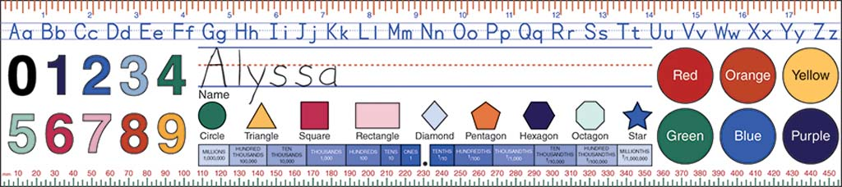
Organization of Assignments
Many strategies to help students organize their assignments may help students with ADHD in writing, reading, or mathematics. For example, students may have difficulty solving multi-digit computation problems in mathematics (e.g., 5,462 x 23) because they cannot keep their work organized on the page. Students may have trouble keeping the numbers in columns or writing their numbers small enough for their workspace. Teachers can show them how to use graph paper to keep the place value of numbers intact and organized (see Figure 5.5). Turning lined notebooks sideways helps with organization, as well, because the (now) vertical lines of the notebook paper can help students organize their columns by place value (i.e., ones, tens, hundreds, thousands, etc.).

Figure 5.5: Computation Examples
By using graph paper, students can keep each number in the right place. This strategy enables students to organize their work and make fewer mistakes.
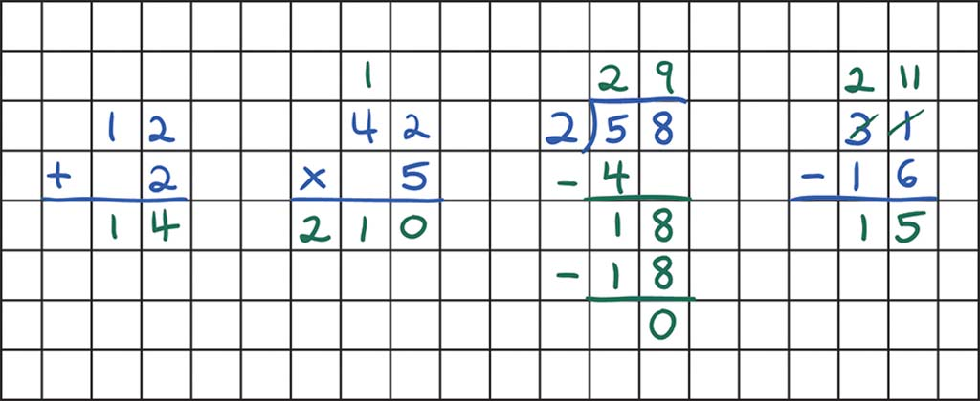
Teachers can encourage students to use plain bookmarks as they read to help them focus on the text line by line. For writing assignments where handwriting is not the focus of the lesson, students with ADHD may find it easier and less frustrating to type their assignment.

In assigning work, teachers should consider whether it is reasonable to ask students to complete 10, 20, or 50 problems. Often, students with ADHD can demonstrate mastery of a skill by completing just 10 problems of 30 on a worksheet. Students with ADHD may need longer assignments to be broken into smaller, manageable pieces. This may also be true for other students, as well. For example, when middle school students in an American government class are asked to write an essay on interest groups that influence politics, a teacher could break the assignment into the following parts:

Investigate different types of interest groups. List the types of interest groups. Provide three examples of each group.
Investigate different ways in which these interest groups can influence political policy. Use a graphic organizer to explain five ways political policy is influenced by these interest groups.
Choose three specific interest groups for your research report. Make sure they have enough in common that you can develop a thesis statement about the methods they use to influence American political policy.
Develop an outline or graphic organizer that includes a thesis statement for the introduction, supporting details about how the groups influence policy in each body paragraph, and a concluding paragraph.
Write a five-paragraph essay as the first draft of your report.
Further details and examples can be provided in class discussions about the assignment, as needed. The student turns in each part of the assignment before proceeding to the following step. The teacher provides timely feedback and guidance to the student to ensure success on each part of the assignment. By breaking an assignment into parts, the individual tasks may not appear as daunting as an assignment that states, "Write a five-paragraph essay on how interest groups influence American politics." Students also feel a sense of accomplishment with the completion of each step.

The Importance of a Schedule
Like other students with disabilities, students with ADHD may function better in the classroom when they are aware of the daily schedule. A visual or written schedule placed in a prominent place in the classroom, in the student's daily planner, or on the student's desk can be tremendously helpful (Figure 5.6). If the student works with a specialist at certain times during the school day, these appointments should be listed on the student's schedule.

Some elementary grade teachers use pictures of clock faces with the hands pointing to the appropriate times for each different activity during the school day. This strategy is especially helpful for students who have difficulty reading the analog classroom clock.

Figure 5.6: Sample Schedules
A schedule for a first-grade classroom hangs in the classroom (left), and a smaller copy could be taped to a student's desk. A schedule for an eighth-grade student (right) will be unique to the student, so it is taped into the student's daily planner.
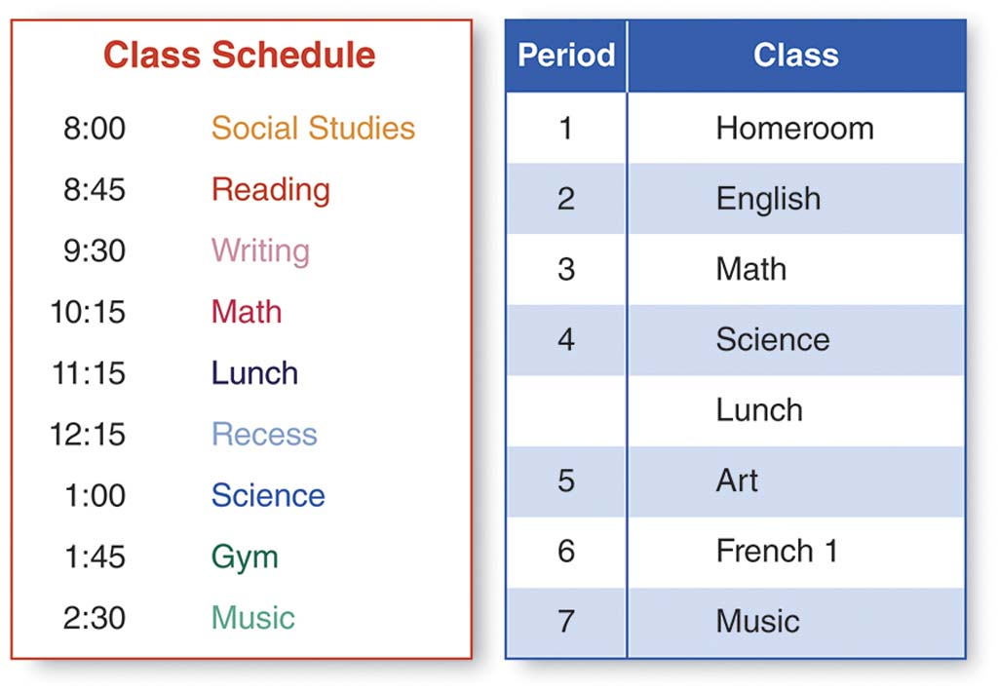
Delivery of Instruction
As discussed in Chapter 2, instruction for students with disabilities should be explicit. In other words, the instruction should be clear and concise, with many opportunities to check for student progress and understanding (Gremillion& Martel, 2012). This is important for students with ADHD because students may have fewer opportunities for inattention or hyperactivity/impulsivity if they are actively engaged in the academic lesson. Effective instructional delivery techniques include prioritizing subjects, making sure students participate in the lesson, modeling, providing adequate breaks, and encouraging self-monitoring (Jacobson & Reid, 2010).

Prioritizing Subjects
Teachers of students with ADHD should prioritize the subjects according to the best times to teach them. For example, reading instruction is usually best in the morning, when students are fresh and ready to learn, rather than, say, the last 45 minutes of the school day after students have just returned from a physical education activity. The end of the day might be better suited for review activities or checking homework because these activities require less concentration and focus than learning new academic content.

Students at the middle or secondary school level who switch classrooms multiple times per day usually have their longest attention span at the beginning of any given period. Teachers, then, should use the beginning of a period to deliver new and important content. Tasks for which full attention is less crucial, or that offer a social element that can refocus attention—such as reviewing homework or completing a group assignment—are better left until the end of the class period, when student attention begins to wane. Teachers should be mindful that students with ADHD may need to switch between tasks at frequent intervals.

Ensuring Participation and Modeling
Teachers should provide frequent opportunities for students to actively participate in a lesson to engage them and monitor understanding and involvement. This participation may be in the form of signaling a thumbs up, raising a hand to answer a question, completing a problem on a white board, discussing an idea with a partner, or echo reading. Echo reading involves a teacher or student reading a sentence or passage and then another person (or the class) repeating the same sentence or passage. The more opportunities students have to interact with and respond to the teacher, the less likely they are to lose focus.

Teachers should also model a concept or skill and practice it multiple times with the student before asking the student to complete an assignment independently. When modeling, the teacher works through a problem or shows students how to complete a task. This helps alleviate student frustration and decrease behaviors that are reactions to frustration. For example, if the teacher asks the students to use a graphic organizer to write a persuasive essay, the teacher can model how to fill in the graphic organizer—with the students—before asking students to fill in their own graphic organizer with a partner or on their own.

Providing Breaks and Releases
Even with organized and effective delivery of instruction, students with ADHD may need brief breaks from the classroom to release their hyperactive or inattentive tendencies (i.e., have some "down time"). Some students may need a quick stretch break at the completion of each academic task. This stretch break may be established as a classroom routine so that it is not distracting to other students, or teachers may find that all students benefit from taking these breaks.

Students with ADHD may find it helpful to draw or doodle as an outlet for their energy. If this drawing is not distracting to the rest of the class, teachers should allow it to occur. Some students may find it helpful to have a squeeze ball to squeeze and release multiple times during tasks. This technique can help eliminate hyperactive behavior and help the student focus.

Teachers and students should become aware of triggers that lead to hyperactive or impulsive behavior and develop signals and routines to use when the student needs a break from the current activity or assignment. For example, if a student is feeling antsy and needs to get out of his seat and stretch, he can raise his hand. The teacher can then nod to signal that the student can move to the back of the classroom to stand for a few minutes. While this might be distracting to some teachers, developing a routine for stretching or standing is better than having a student jump out of his seat and disrupt the entire class.

Many students with ADHD, in fact, may find it difficult to sit for long periods of time. Some elementary schools allow students to sit on exercise balls, which require the student to focus on balance rather than squirm around (Harlacher, Roberts, & Merrell, 2006). This practice is less frequently used at the secondary level, when students switch classrooms throughout the day.

Encouraging Self-Monitoring
As discussed in Chapter 2, encouraging students with disabilities to self-monitor their behavior is an important step in fostering autonomy and ownership of their learning and success (Johnson, Reid, & Mason, 2011). Having students use checklists is one way teachers can help students monitor their own progress in completing tasks or following classroom rules. In addition, a student may stay more focused on an academic or behavioral task if she has a written checklist or set of directions that accompanies verbal directions. Students with ADHD may have difficulty focusing on a long set of verbal prompts, and a visual or written reminder will help them.

Checklists for academic tasks can help students with ADHD break down assignments into manageable parts (Figure 5.7). Checklists for behavior (Figure 5.8) can also be helpful. At the secondary level, students may use more complex checklists.

Students with ADHD may also benefit from learning problem-solving strategies as discussed in Chapter 4 (Jacobson & Reid, 2010). The strategy D.I.R.T. (Define the problem, Identify choices, Reflect on choices, Try it out) helps students with EBD and students with ADHD (Cook, 2005). Problem-solving strategies can help students monitor their own behavior and improve student attention to academic tasks (Iseman&Naglieri, 2011).

Figure 5.7: Sample Checklist in a Writing Classroom
A checklist can help keep students focused in a sixth-grade writing classroom. The student answers questions that lead to the completion of a written assignment with an introduction, body, and conclusion. The color coding in the checklist corresponds to the original instruction provided by the classroom teacher on writing different types of paragraphs and serves as a reminder to the student.
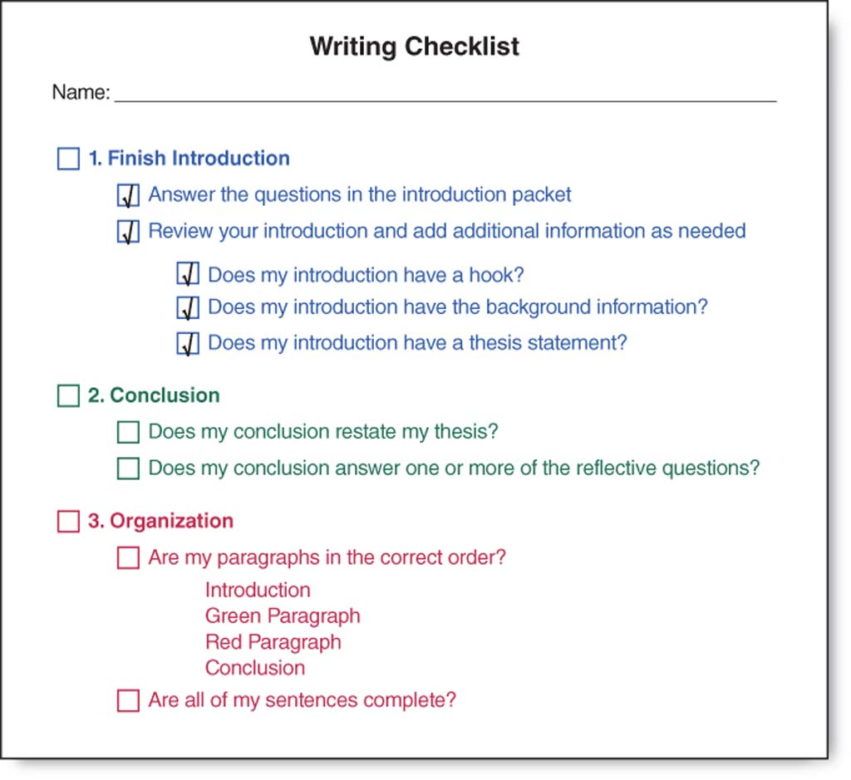

Figure 5.8: Behavior Checklist
A student-generated checklist reminds the student to listen and raise his hand. The student has indicated that he canearn stickers for sitting at his desk, reading independently, raising his hand to use the bathroom, participating in whole-class instruction, and cleaning up after snack time. At the bottom the student has shown the reward he will earn forfour stickers—computer time.

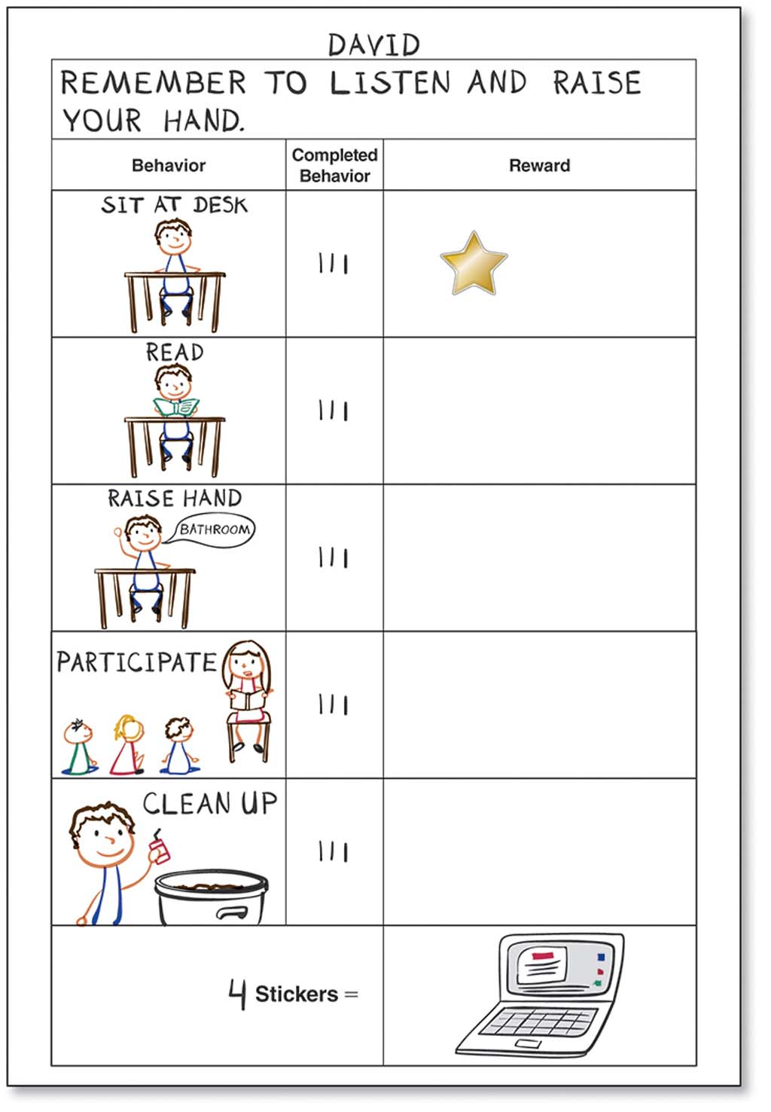
Another way to help students monitor their behavior is through the use of a timer that beeps at set, intermittent points. When the timer beeps, students check their behavior and ask themselves questions targeted to their own goals, such as "Am I in my seat?" or "Am I paying attention?" The questions differ based on the student and the situation.

References
Powell, S. R., & Driver, M. K. (2013). Working with exceptional students: An introduction to special education [Electronic version]. Retrieved from https://content.ashford.edu/

