Introduction
Natasha has been a Head Start teacher for almost three years, and she really enjoys interacting with the families; she tries hard to find ways to involve them in the classroom, such as having parents be a classroom aide for a day, chaperone field trips, or provide supplies and snacks. Even with all of her outreach to families, she is still a bit frustrated that many fathers are not involved—and some even seem hostile or indifferent to her attempts to involve them. For example, David, a recently divorced father who does not come to school often, told her, "You don't understand my life, and asking me to bake cookies and cut paper does not make me want to come to this classroom."

How can Natasha begin to get more fathers involved in the classroom? How can she provide support for David's son during this time of major family transition?

In this chapter, we will discuss the diversity of and changes to the structures and living situations of American families. We will discuss what it means for early education teachers when a child in their classroom comes from a single-parent, male-headed household; has two mothers; is raised by a grandmother; or has a mother in prison. We will discuss how family culture, including traditions and communication style, influences children's development, learning, and interactions and relationships with adults in their lives—including teachers. The final section of this chapter will discuss how a teacher can foster family and community engagement in a way that is culturally meaningful and sensitive.

5.1 The Changing Structure of American Families and Communities
Chapters 1 and 4 focused on the diversity of children and families in the United States, including immigrant families. Just as there has been a change in U.S. racial and ethnic demographics in the past 50–60 years, there has also been a change in the American family— or what is considered a "family." According to the U.S. census, a family is a group of people who are related by birth, marriage, or adoption, but social scientists have broader definitions of families that are not necessarily dependent on biological or legal relations. For example, they might define a family as a group of people who are emotionally connected and committed to the development and care of one another.

The Rise of "Nontraditional" Families
The "nuclear family," consisting of a married mother and father and their biological and/or adopted children, has long been considered the "traditional" family. However, in the last half of the 20th century, economic factors and changes in views of marriage and love have led to many different kinds of families. Women no longer have to marry for economic reasons; many can now choose whether they want to be married (Coontz, 2005). Many people now marry or live in cohabitating households for emotional reasons—love—and they divorce or separate for emotional reasons— lack of love.

This flexibility and acceptance of choice has resulted in more single-parent, gay and lesbian, grandparent, step-family, non-relative, and nontraditional households (Organisation for Economic Cooperation and Development, 2011). As shown in Figure 5.1, over the past 50 years there has been a decrease in two-parent families and an increase in single-parent families, especially female-headed households, for all children. There are also racial and ethnic differences in the types of families that young children are likely to live in. As shown in Figure 5.2, less than a third of African American or Black children are likely to live with two married parents, compared to 85% of Asian American children.

Figure 5.1: Living Arrangement of Children From 1960 to 2012
While the majority of children live in a two-parent household, since the late 1960s there has been a significant increase in single-parent, female-headed households.
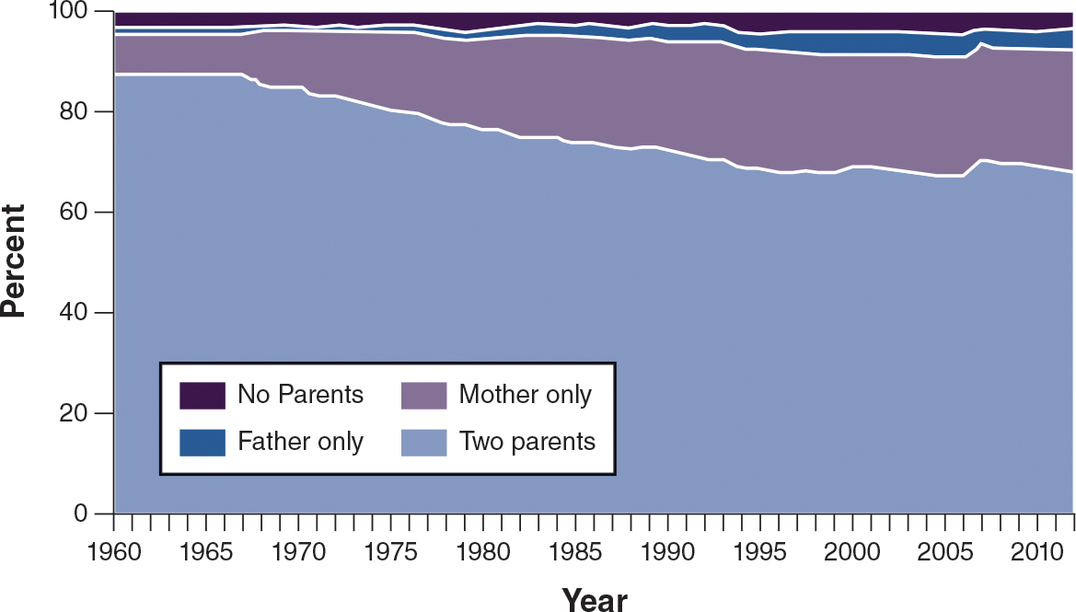
Figure 5.2: Living Arrangements of Children by Race and Ethnicity in 2011
Asian children are most likely to live in a traditional family setting with two married parents, while only one–third of African American children live in a two-parent family.
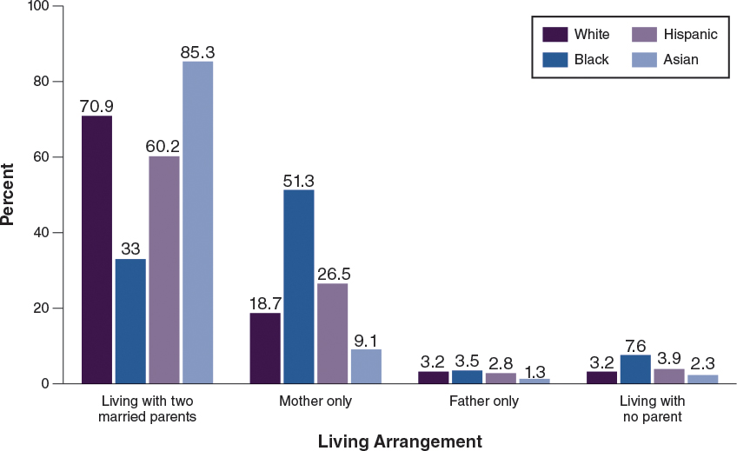
Single-parent families, gay/lesbian, and step-families are also becoming more common, but the collection of data for these types of families are not as precise as other types of families (Brown, 2004). For example, if a child lives with a biological father who has remarried, then her living arrangement will still be captured under "living with two married parents," rather than with a step-family. In a blended family (step-family), either one or both parents have children from a previous relationship. Children from a step-family may live with one biological parent and visit their other biological parent, or they may live with each biological parent for a period of time. Thus, the arrangements of blended families vary.

Reflecting the Diversity of Nontraditional Families
In their brief, entitled, "Creating Welcoming and Inclusive Environments for Lesbian, Gay, Bisexual, and Transgendered Families in Early Childhood Settings," Burt, Gelnaw, and Lessner (2010) stress that though teachers may have a personal discomfort with, general bias against, or negative assumptions about the LGBT community, or have a moral/religious belief about homosexuality being improper, it is important that teachers perform the duties of their job by teaching and interacting with all families in a respectful and inclusive manner. Children from all different types of families view their own families in comparison to their peers' families and what they see in books or on television. Consequently, it is important that the books and artwork in classrooms reflect the diversity of the children's families.
The family type can also affect how early educators and families collaborate to support each child's development, even in the school environment and materials that are provided. The nuclear family is still assumed to be the norm in many ways. For example, when families enroll children in school or early childhood programs, the forms often ask for mother's and father's name and offer only one line for contact information, based on the assumption that the child has two parents who live in the same home. A mother who has had her child through sperm donation may feel uncomfortable with the assumption that there should be a known father in her child's life, and she may see the program and its teachers as potentially insensitive and non-inclusive.

The variety of today's family structures should be reflected in how early childhood programs engage families during enrollment and throughout the school year, the materials and visuals used by the program and in learning activities in the classrooms, the types and timing of events held for families, and communication with families.

Ways that early childhood teachers can show sensitivity to the diversity of family structures include the following:

Forms. Ensure that forms asking about family information do not assume a mother and father who live in the same home. Provide space for information about the child's family and primary caregiver without assumptions about relationships and the structure of the household.
Communication. When communicating with a child's caregiver, do not assume a specific family type. Use of the term "family" instead of "mother and father" may be most appropriate.
Eliciting feedback about family needs. Focus groups with specific types of families (e.g., single mothers/fathers, adoptive parents) can help to ensure that the program is being inclusive and respectful and to determine unique challenges within the different types of families. For example, a single father may have thoughts about how the program may be more responsive to his needs as they differ from those of single mothers.
Ways to support diverse families and children in the program and classroom include the following:

Materials. Ensure that materials and visuals represent diverse families. This may require adapting materials, such as making new pictures to replace standard pictures. Songs that exclude some types of families can be revised or adapted to be more inclusive. Storybooks can be chosen to portray a variety of family types.
Interactions. Discuss similarities and differences among families, focusing on the uniqueness, value, and importance of different kinds of families. These classroom interactions can occur through children's story-telling, drawing and posting pictures, etc. Ensure that children and staff do not negatively discuss children who come from different types of families.
Questions. Find out from children who they consider to be their family, such as who takes care of them most of the time.
Differences in Outcomes Among Family Types
Though nontraditional families are no longer as stigmatized as they once were, studies have shown that family types are associated with differences in outcomes for children. Children who reside in single-parent households, for example, are more likely than children in two-parent households to exhibit poor outcomes, especially problem behaviors.

Researchers suggest several reasons that some family types, especially single-parent, female-headed households, may be correlated with negative child outcomes: youth, limited education, lack of parental resources, parental mental health problems such as higher rates of depression or stress, poor relationship quality between child's parents, lower parenting quality, and lack of father involvement (Carlson & Corcoran, 2001; Iruka, 2009; Lansford, Ceballo, Abbey, & Stewart, 2001; Waldfogel, Craigie, & Brooks-Gunn, 2010). Compared to two-parent households, single-parent households are less likely to have resources—namely income, books, clothes, and extracurricular activities. These families are also more likely to live in poorer school districts and neighborhoods, which means that children will likely be attending lower quality elementary schools and early childhood programs.

Poorer parenting quality is strongly associated with limited resources, stress, and feelings of depression. Single mothers are more likely to report depression than married mothers, and depression often results in parents being less emotionally available for their children; however, single mothers are not necessarily insensitive or inattentive to their child's needs.

Examination of other family structures, such as adoptive and step-families, shows some minimal differences in terms of father engagement, family cohesion, and child externalizing problems compared to two-parent households, but there were no differences in children's well-being and relationships or parental well-being and relationship (Lansford et al., 2001).

Supporting Nontraditional Families
Early childhood teachers should seek to determine the stressors that families may be experiencing and how they may impair children's cognitive and socio-emotional well-being. For example, highly stressed families may not return forms or phone calls in a timely fashion, volunteer in the classroom, engage in learning activities sent home, or attend school events or meetings. Though it is important to understand how family structure is associated with parenting behaviors and child outcomes, including parents' engagement in children's learning, it is even more critical to focus on the sensitivity and quality of interactions between children and their parents (Lansford et al., 2001; McLanahan, 1983); these are things that early childhood teachers and programs can strengthen and improve upon.
In the opening vignette Natasha, a preschool teacher, has a communication incident with a father who is going through a divorce. This father is facing drastic changes in his life, including having to move out of the family home and no longer being able to see his child every day. These life changes have resulted in anxiety, stress, anger, and isolation, which have damaged his relationships with friends, coworkers, and now his son's teacher. The change in the family structure is likely to lessen his involvement and engagement in his child's school.

Some things that Natasha can do for him, as well as other parents who do not seem to be involved or engaged, include the following:

At the first meeting, or at any meeting with parents, Natasha can find out the best form of communication, including use of technology, such as text, Skype®, or e-mail, and the frequency of communication that is most comfortable for them.
Natasha can determine from parents the best time for meetings or home visits, such as evenings or weekends. She should also find out if parents have any conflicts that will prevent them from attending school events; for example, if they are working multiple jobs or are unable to take time off to attend school events.
Rather than focusing on the parents' attendance at school functions, Natasha can focus on what they are doing at home to support their child's learning. Natasha can provide additional support with supplemental activities and ideas. Such an offer would likely have shown the father that Natasha cares about the development of his child and is willing to help in any way possible.
Natasha can make sure that she reaches out to both the mother and father during classroom communications, and that the parental involvement activities she plans include things fathers are likely to be interested in.
The Effects of Poverty
Chapter 1 explains how poverty and economic hardship limit families in various ways, including access to materials and resources like food, clothing, adequate housing, and health care. Poverty also limits children's access to high-quality elementary schools and early care and education programs, as well as to academically-enriching community institutions such as libraries and museums. They miss out on stimulating and rich experiences that enhance their language development and preparation for school.

If families do not have the economic ability to live in more advantageous communities, the children may be subject to chronic stressors that harm them physically, emotionally, and socially. Though many poor urban communities provide resources to families, such as clinics, social service agencies, and schools, many of them are also prone to violence and other traumatic experiences (Beyers, Bates, Pettit, & Dodge, 2003; Brooks-Gunn, Duncan, Klebanov, &Sealand, 1993; Duncan, Brooks-Gunn, & Aber, 2000). Being a victim of violence or witnessing violence (Dahlberg, 1998) is likely to lead to anxiety and other psychological issues for both adults and children (Graham- Bermann& Seng, 2005).

Children who live in poor and disadvantaged communities are also more likely to be exposed to health hazards, such as toxic materials in substandard buildings (e.g., lead paint, asbestos, mold), which can have dire health and cognitive effects, including development of learning disabilities and asthma (Aber, Bennett, Conley, & Li, 1997). Living in a poor and disadvantaged community can also mean children are less likely to receive proper nutrition and health care, which can limit their attendance in the early childhood classroom, which in turn limits their readiness for school.

Early childhood teachers and programs can play a key role in diminishing some of the negative effects that poor families and children experience. In addition to providing education, health and nutrition services, some Head Start programs help families manage stressors (Curenton, McWey, & Bolen, 2009) through parent support groups and referrals to mental health agencies. Programs and teachers can provide services to support families' well-being and self-sufficiency, as well as an environment where children feel protected, safe, and stimulated through a variety of nurturing learning activities and sensitive interactions.

Although not every child from a low-income household lives in a poor community or a family with unmanageable stress, it is important for early childhood educators who work with children from low-income families and other disadvantaged families to be aware of children's emotional state and any life events that may affect children's normal routine. For instance, if the family structure has changed due to a separation or divorce or new family members, if the family has moved to a new home, if the primary caregiver's work hours have changed, or if the child has witnessed violence, these events may impair the child's functioning and feeling of safety. Behavioral signs include feelings of anxiety before and after school, less energy, limited concentration or attention, frequent absences, and moments of outbursts.

Early childhood teachers can communicate with parents about potential changes in the family that may cause changes in the child's functioning. Figure 5.3 provides examples of questions to ask caregivers about factors that can affect children's functioning.

Figure 5.3: Life Events Scale
A questionnaire like this one can shed light on potential reasons for changes in a child's behavior at school.
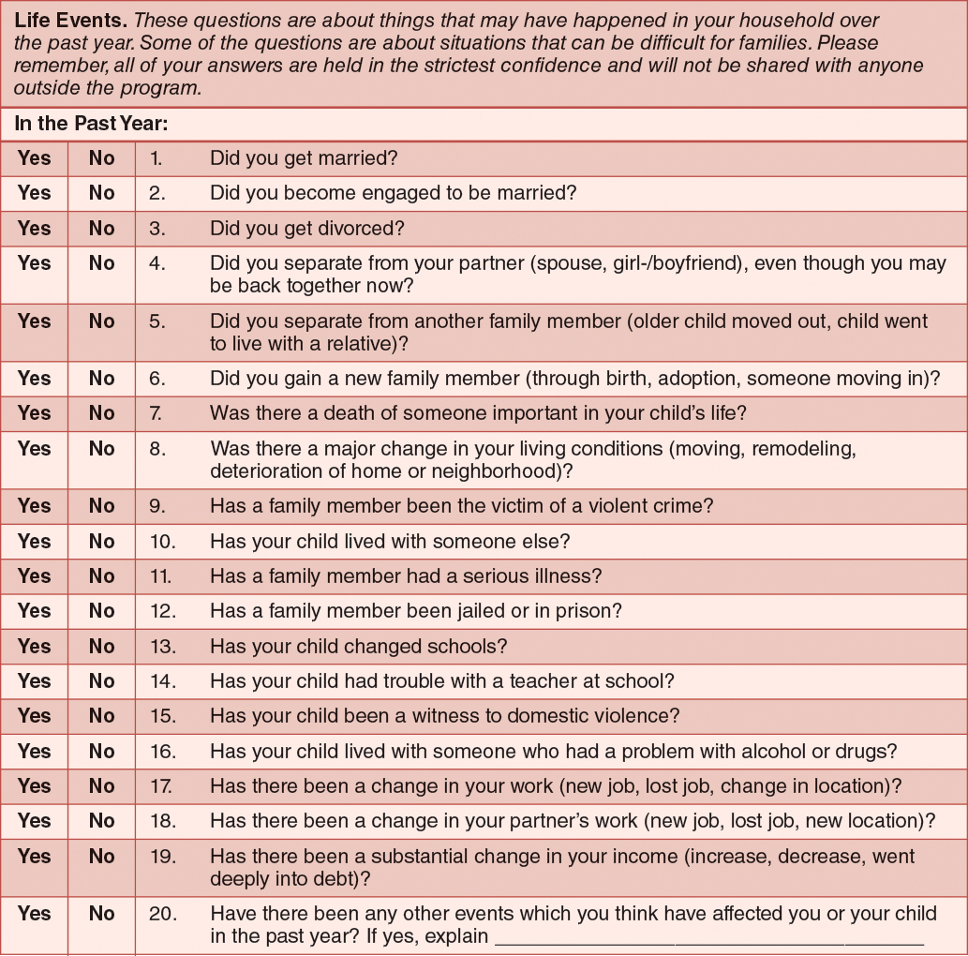
2007.
The Real World Dilemma feature, "The Case of Undocumented Students," describes a particular type of family in poverty and some of the stressors that can exacerbate the problems of poverty.

Real World Dilemma: The Case of Undocumented Students
Undocumented students are those who live in the United States illegally, with or without their parents or guardians. Approximately 1.5 million, or 15%, of undocumented immigrants are children (Gonzales, 2007). Over two-thirds of undocumented students are from Mexico or Latin America, but the next largest group of undocumented students are from South or East Asia.

Children under the age of 5 may be U.S. citizens themselves, but live with families who are undocumented. In situations such as this, the child may be legally able to attend the program, but the family may be unable to meet the expense, particularly if members are having difficulty finding employment because of their documentation status. What can teachers and programs do in this case? How can they help families access resources and funding to ensure children attend high-quality programs?

In Section 5.3, we will discuss how early education teachers can support parents' social capital and network by providing access to information, services, and resources. In the case of undocumented families, teachers can find out which agency is able to help parents, especially those in immigrant families, find financial support for full-time childcare. They can also find out from other families which contacts and resources have been helpful to secure financial support for their childcare needs.

In some instances, families may not need financial support, but instead a sense of safety and security that their documentation status will not be released or used against them. In one example from East Harlem, New York, a partnership between an Early Head Start/Head Start program and a local precinct was formed. This was prompted by the need to strengthen the relationship between Mexican parents and the local precinct to address community safety. The parents initially did not want to get involved because of deportation fears. However, through two-way collaboration and the help of Head Start programs, parents took tours of police precincts, and police spent time in the Head Start programs in non-threatening ways. Further, the Head Start program and police held community forums to educate families about their rights, and parents organized trainings for police to be sensitive to the needs of the community.

Since undocumented parents are unlikely to engage with community agencies and organizations, including social services, collaborations like these can help ensure that young children from undocumented families receive access to services. To read more about this example and ways early childhood programs can support undocumented families and children, see the Harvard Family Research Project.
5.2 Cultural and Racial Socialization
Parents instill values, morals, and ethics in their children through many mechanisms. Parents decide how, when, and why children are exposed to certain things and what these things are. All parents, whatever their ethnic or heritage groups, adopt a cultural model of parenting that includes the goals, ideology, values, and beliefs of their particular cultural group (Super & Harkness, 1986).

Many ethnic minority parents choose to instill pride in their ethnic culture and history (Crowley &Curenton, 2011; Hughes, 2003; Hughes et al., 2006), called cultural socialization. Cultural socialization practices are deliberate or implicit parenting practices and interactions that teach children about their ethnic/cultural heritage and history; these practices encourage the sharing of cultural customs and traditions and that promote children's cultural, racial, and ethnic pride (Hughes et al., 2006).
There are many ways that families culturally socialize their children, including discussions about important historical and cultural figures (e.g., Rosa Parks, Martin Luther King, Jr., Sacajawea, Cesar Chavez, Geronimo). Families may also expose children to cultural traditions and celebrations (e.g., Cinco de Mayo, Martin Luther King Holiday, El Dìa de losMuertos [Day of the Dead], Caribbean Festival, CalleOcho Festival, Pow- Wows, Chinese New Year), and visit their ancestral homeland and extended families. Exposing children to aspects of their culture by attending family events, such as weddings, and community events reinforces cultural traditions, beliefs, and values, as well as the language of the culture.

On a daily basis, ethnic minority families might engage in cultural socialization by exposing children to culturally relevant books, music, art, and stories; by eating ethnic foods; and by using their home language. Parents differ to the extent with which they may engage in activities that promote cultural pride, depending on the relevance of their culture in their life experiences, the child's age and gender, current events, and other issues in their life.

How Families Protect Their Children From Discrimination
Because some parents from certain "racial" groups understand that society may have negative stereotypes about their group and because their group has first-hand experience with institutional oppression, discrimination, and prejudice, they may focus not only on ensuring that the child has a positive view about their group and themselves, but also that the child has the social and emotional tools to confront discrimination. Parents and guardians, especially in racial minority families, often try to protect their children from discrimination and bias that they have directly or indirectly experienced. This is often called "preparation for bias."

One of the things that families do to prepare children for bias include sharing information about how their group has had a history of being oppressed and denied opportunities through individual and institutional actions, such as segregated facilities or internment camps. Families may also share current events, such as the shooting of unarmed Black males or the Border Patrol's detention of individuals who look Latino. Such events may propel parents to prepare children for potential bias and similar treatment by police officers and authorities.

Bias preparation activities that parents engage in vary, based on the child's developmental level, age, and gender, as well as parents' experiences and comfort with discussing negative, and potentially traumatic, events with their children. Especially with young children, bias protection often takes the form of encouraging children to do well in school and be well behaved (Suzzio, Robinson, &Pahlke, 2009).

Racial Socialization
Several studies have found that African Americans have a specific cultural model of parenting referred to as racial socialization (Hughes, 2003; Hughes & Chen, 1997; Hughes & Chen, 1999; McAdoo, 2002; Suzzio, Robinson, &Pahlke, 2009), "in which values and ideologies about freedom and equality are intertwined with the short-term goal of teaching children about their heritage and the long-term goal of rearing healthy children who are resilient enough to thrive in a racist society (Crowley &Curenton, 2011, p. 2)."

Racial socialization includes multiple dimensions: (a) providing children with the social and emotional tools they need to confront bias and discrimination, (b) teaching children to have pride about their cultural heritage and history, and (c) teaching them about the commonalities (and sometimes differences) among other ethnic groups (Hughes, 2003; Hughes & Chen, 1997; Hughes & Chen, 1999). Parents communicate racial socialization ideals through conversations (e.g., specifically those concerning equality or justice, discrimination, stereotypes, and cultural heritage), modeling their own behavior to their children, and exposing children to cultural history, artifacts, and traditions (Murray &Mandara, 2002; Thornton, Chatters, Taylor, & Allen, 1990). Children whose parents report using racial socialization techniques have stronger cognitive skills (Caughy, O'Campo, Randolph, & Nickerson, 2002), a more positive sense of self (Murray & Brody, 2002; Tantum, 2004), and fewer behavior problems (Caughy, O'Campo, &Muntaner, 2004).

Instilling Ethnic Pride
An example of a child who has positively internalized messages about racial socialization, particularly as it relates to instilling a positive self-image, is Shemeca, a 3-year-old, who clutches her chocolate brown baby doll during sociodramatic play, and who proudly exclaims, "I'm a pretty brown girl like Princess Tiana!" Shemeca's statement is an expression of her ethnic pride and self-esteem, and as many African American parents know, instilling this type of ethnic pride in one's child is no small feat. Recall the Clark Doll Experiment that was described in Chapter 2, which found that African American children favored White dolls over Black dolls. African American parents, as well as minority researchers, interpret children's preference for White dolls as an indication of negative self-esteem and negative attitudes toward themselves and their group.

One of the challenges African American mothers report facing is instilling a positive self-image in their children, particularly girls (Crowley &Curenton, 2011). For example, one mother's concern centered on stereotypical notions of beauty, which are primarily defined by a White standard:

Representation in the media in terms of females is something that we struggle with. Because I know [that in] some Mocha [moms' families], the Disney Princess does not exist in their households . . . [I mean not] any of the Disney Princesses [because none of them are African American] . . . They are all Caucasian females . . . [But]this year, . . . they are supposed to introduce their first African American princess (pp. 9–10).

This mother refers to the Disney Princess Tiana (the same character represented by Shemeca's doll), and based on the popularity of the products tied to the movie The Princess and the Frog, it appears that many families see the appearance of Princess Tiana as a positive; she shows children that Black women (and girls) can be princesses too.

Handling Situations of Discrimination and Bias
Young children experience discrimination and bias. For example, Crowley and Curenton (2011) relate a story that one African American mother, Melissa, shared to explain what her son experienced at school:

The rule at their school is that four kids can be on the tire swing at once. So, [my son] tried to get on the tire swing and [another] boy told him that the tire swing was only for people with light skin. [My son was told] to go . . . with [two other children] who are the only African American children in the class besides [my son]. The reason why this is disturbing to me is, one, the [two other African American children], they were not even trying to get on the tire swing, and two, there are other ethnicities in the class who have brown skin, but they are not Black and he did not mention them. So, I feel like this little boy has a lot more going on, where he knows what he is saying (p. 8).

In seeking some type of resolution to this incident, Melissa reached out to the teacher and explained what had happened. The teacher, in turn, spoke with the parents of the young boy who had originally told Melissa's son that he was banned from the tire swing due to the color of his skin. What transpired next, however, upset Melissa even further. When the offending child's parent called Melissa at home to apologize, he said, "Well, I am really sorry that this [incident] happened to us." In Melissa's mind, this father took no responsibility for the racist action itself, instead painting it as an incident that unfortunately inflicted damage equally on both of the parties. Her heart, consequently, remained painfully broken for her son (Crowley &Currenton, 2011, p.8).

Though the teacher appropriately notified the parents of their son's inappropriate behavior, the teacher should have also followed through with Melissa to ensure that the matter was appropriately addressed with the boy's parents. Considering the seriousness of the behavior, the teacher should have also had a conversation with the boy's parents to reiterate the importance of respect and the value of diversity.

How Teachers and Programs Can Enable Cultural Socialization
The 2005 NAEYC Code of Ethical Conduct states: "Above all, we shall not harm children. We shall not participate in practices that are emotionally damaging, physically harmful, disrespectful, degrading, dangerous, exploitative, or intimidating to children." This means that early childhood programs, teachers, and staff must ensure that the history, traditions, and values of all children and their families are respected and, most importantly, integrated into the curriculum and experiences of the classroom.

As part of meeting this Code of Ethics, early education professionals must partner with families to understand their heritages, traditions, values, morals, and viewpoints. Even if some of a family's values and viewpoints—about issues such as religion, sexuality, or politics—conflict with those of the program or an individual teacher, the ethical responsibility of early childhood programs and staff is to create a safe and nurturing place for children to grow and for families to feel supported and respected. This requires understanding, valuing, and incorporating parents' cultural practices into the program so children feel valuable and validated as human beings.

The Cultural Reflection feature, "Religion as a Source of Cultural Diversity for Children," provides an opportunity to consider how learning about religions might be incorporated into the classroom.

Cultural Reflection: Religion as a Source of Cultural Diversity for Children
Religion transcends race, ethnicity, and language. As an exercise in observing cultural diversity throughout many aspects of our lives, select and research one of the world's major religions (e.g., Christianity, Buddhism, Hinduism, Judaism, Islam). In what ways can you find and express the diversity within this religion and its believers, as well as the elements that its believers tend to have in common? Addressing the questions below will help teachers explore the cultural diversity within and across religions and incorporate it into classroom instruction and activities. For example, classroom activities can focus on various aspects of a religion or spiritual group, such as language, ritual, dress, celebration, location, and so on.

Reflection Questions:

Are the race and ethnicity of individuals who practice this religion homogeneous or heterogeneous? In what ways are they physically similar or different?
Do all the individuals who practice this religion come from the same country?
Do all the individuals who practice this religion speak the same language?
Do all the individuals who practice this religion wear similar clothing or is dress flexible?
Do all the individuals who practice this religion attend the same location, use the same materials, adhere to the same religious holidays or celebrations, perform the same rituals, attend at the same day and time?
As emphasized by Banks, teachers go through stages of transforming their curriculum and classroom instruction to be culturally relevant and anti-bias (Banks & Banks, 1993). These stages begin with acknowledging the inherent bias of curriculum that includes only the perspective of the majority culture—namely, European Americans—and devalues others, including some information about diversity during specific times (e.g., activities and readings during Black or Hispanic History Month). They end with a curriculum that is truly transformative, in which cultural diversity is integrated in all aspects of the instruction and environment, and issues are addressed explicitly. This process of transforming the curriculum and teaching provides a way for all children to feel valuable and connected to instruction, and it also supports parents' goal of instilling cultural pride in their children.

Teachers can show respect for families' traditions and values by inviting family members to develop and participate in classroom lessons and activities and provide ideas for events and trips that engage children, teachers, and staff in the families' traditions. However, culturally competent teachers who are aware of their students' cultures not only provide such "special event" opportunities, but they also integrate students' cultures and traditions into all aspects of the classroom by means of visuals, books, events, activities, and interactions with the children. Doing so ensures that children and families feel that their cultures and traditions are valuable and worth experiencing.
Teachers should strive to avoid minimizing children's cultural traditions and heritages. This can sometimes occur by simple omissions, such as when teachers do not ask children and families about their celebrations or inquire about the books and other materials they have at home that show people from their culture; or by not considering their family traditions and home experiences when planning activities or trips. Teachers are not expected to know everything about every culture, but they are expected to treat children as individuals, and part of a child's individuality is his or her traditions and culture. And, of course, at the most basic level, cultures should not be minimized or disrespected by showing stereotypical or negative imagery of them (e.g., "black face," Native American war bonnets, subservience).

Early childhood teachers can support parents' preparation for bias through developing relationships with families and understanding the fears and concerns parents have for their children. These conversations can happen not only during home visits and conferences, but also through focus groups with families about their goals for their children.

In their work helping administrators, staff, and teachers understand how schools can form a stronger relationship with African American and Latino families in order to find ways to respect and integrate their cultural heritage and traditions, Gillanders, McKinney, and Ritchie (2012) helped schools and teachers gather data from parents through focus groups and surveys. First, a series of focus groups were conducted with African American and Latina mothers. A facilitator was matched to each group based on their race and ethnicity; an African American facilitated the African American focus group, and a Latina facilitated the Latino focus group. In the first session, they focused on key goals that parents had for their children and how they and the schools supported those goals.

The second session focused on understanding what families did at home to support their children's learning and development, including some of their daily routines and what they did to promote their culture. The third session focused on the relationships between schools and families, including the types of invitations parents received, challenges inherent in the ways the schools communicated and interacted with them and their child, and strategies schools can use to better partner with minority families.

From these focus groups, schools and teachers were able to understand the goals and priorities for families; what families were doing at home that they could support or integrate into school activities; cultural traditions and practices in the home; ways to effectively interact and communicate with families; and strategies to incorporate into the programs, schools, and classrooms.

As one example, the Latina mothers, mostly from Mexico, wanted more opportunities for networking with each other and more opportunities for their children to engage with each other because they felt a bit isolated. The mothers mentioned the joy they and their families often felt during soccer games while living in Mexico, so they suggested a soccer team, which the school implemented the next year. The soccer team served multiple purposes: It provided an activity that diverse children and families could engage in, allowing the Latina mothers to connect and network, and it brought an aspect of their lives in Mexico into their child's current life in an American school and community.

The information from the focus groups also resulted in schools developing more effective home visits and professional development sessions that focused on how to communicate clearly about children's performance. These types of focus groups, and the potential they have to lead a school to develop a more culturally competent community, can ensure that mothers like Melissa and their children are not re-traumatized by the actions of schools and parents with limited information about subtle instances of racism and prejudice.

Language and Other Means of Cultural Socialization
Though activities, food, and celebrations are important, language remains the key method parents use to transmit cultural information. Language plays a role in cultural transmission in a variety of ways. First, each cultural group has a specific language with which it communicates. Within these languages, there are dialects and variations that provide information about education, region, and family of origin.

For example, African American English Vernacular (AAEV) is often discussed as a single language that many African Americans use as a subculture, but the use of this vernacular varies by part of the country, level of acculturation, and socio-economic status. African Americans' use of AAEV is a communication style that provides a way for them to identify and connect with each other on a deeper level due to shared experiences in the United States (Ogbu, 1999; Thompson, Craig, & Washington, 2004).

In addition to use of home language or dialect, parents transmit cultural information to children through communication practices such as listening, talking, telling, watching, showing, exposing, and involving in activities (Cheshire, 2001). These socialization practices provide information to children about traditions, customs, roles, expectations, and rules about social engagement. Children learn a lot about their culture from listening to older adults, such as elders, who are the oldest members of a cultural group and hold substantial historical and contextual knowledge about it. They are often highly respected because of their extensive knowledge about their group's history.
Through listening, children often learn moral and practical guidelines, including the value of not burning bridges, cherishing family, and being spiritual as a coping mechanism. In some cultures, children's questions and speech provide another way of transmitting information. Through talking with parents, children receive information about their culture and traditions. Through asking questions, children learn why some traditions exist and why some are more valued than others. However, in other cultures, children are often expected to listen and observe rather than talk as a way to learn.

Language is also a vehicle to transmit the "culture" of an early childhood program. Teachers use language to communicate the classroom's culture, particularly how they expect children to behave, including interactions with teachers, adults, and peers. For example, some classrooms have a culture in which adults are referred to by their first names; in others, adults are referred to as "Ms." or "Mr." In some programs, the culture allows children to speak in their home language; in others, children are encouraged to use only Standard American English.

The culture of the classroom is not an expression of a wrong or right way, but expectations for how children should behave and relate to others. See the Cultural Reflection feature, "What is Your Communication Style in the Classroom?" to gain more insight into your communication style in the classroom.

Cultural Reflection: What is Your Communication Style in the Classroom?
We all have a particular way of communicating. Some people primarily communicate explicitly and directly; others communicate primarily through providing exposure and experiences. Some communicate differently based on the setting (at home vs. at work), the social role (student vs. boss), or the degree of familiarity (stranger vs. family member).

Imagine it is Monday at 10:00 a.m., and you have fourteen 3- to 5-year-old children who are still full of energy and who have just started preschool. You are trying to corral them into picking stations to play at. Some are timid, some are boisterous, and others are confused. You have conducted home visits with many of the children, with the exception of three who were just admitted into your classroom. You know some of the children from the neighborhood and attending local churches and community events. Others you know because you had their siblings.

How will you communicate the schedule and rules of the classroom to the children? Below are some questions to help you think about your communication style and what information and approaches affect your communication style with children.

Reflection Questions:

How can you use your knowledge about each child, such as the child's level of familiarity with preschool or their language skill?
How does knowing some of the children's family members in a more intimate way, such as through community events and church services, affect how you communicate with them?
How does children's demeanor, such as their boisterousness or anxiousness, affect how you communicate with them?
Do you think communicating by showing or by pointing out examples of what children should be doing helps them follow directions, or is there a benefit to letting them figure it out? What are the reasons for your answer?
Is your communication style similar to the style you have observed their families use to communicate with them? If it is similar, how do you think the children will react? If it is different, how do you think the children will react?
Because young children may be negotiating different cultures at home and at school, it is critical that the teacher's expectations be expressed clearly, and not be contradictory or confusing. For example, for a child who is the oldest in the household and expected to be somewhat independent and autonomous, a classroom that is rigidly structured with limited opportunities for independence may be a challenge. A classroom where children are expected to express their thoughts will be difficult for those who live in homes where they are expected to listen to the adults and only respond when they are addressed. When there is a conflict between messages in the different settings, a child may display disregard for the teacher's expectation, potentially harming the child-teacher relationship, and subsequently the child's experience in the classroom.

Home-school partnership and communication enables teachers to learn not just about cultural traditions and beliefs, but also about practices and expectations that may be different in the two settings. This cross-setting partnership helps minimize the conflict of behavior expectations and values that children experience in the two settings.

As discussed in Chapter 4, there are ways to incorporate family resources and culture into classroom instructional practices, such as using children's home language as part of the curriculum (Bohn, 2003). This information can be gathered through natural observations and parent-teacher communication during home visits, pick-up and drop-off, teacher conferences, school and community events, and so on. This can help parents and teachers understand how the "cultures" in the different settings may complement and contradict each other, which can be problematic for children's adjustment and learning.
5.3 Fostering Family Engagement
One of the biggest challenges you will face as an early childhood teacher is encouraging your students' family members to be actively involved and engaged. Teachers are often frustrated when parents do not return forms or participate in program activities. It is natural for teachers to be frustrated by what they view as parents' lack of engagement in their child's education and learning, but teachers need to consider the challenges many families face and devise ways to adapt to the diversity of families.

Common Barriers to Engagement
Many parents today, especially those who are low-income and single, are highly stressed by balancing working and caring for children. Some of the hardest groups to engage in the classroom are not only low-income single parents—and parents who are working multiple jobs or doing shift-work in which their work hours change daily or weekly—but also families who have multiple children and families who have limited English skills. Table 5.1 describes barriers to parents' involvement, especially low-income and DLL parents, and strategies to overcome these barriers.
Table 5.1: Parent Engagement: Barriers and Solutions
Barriers | Strategies to Overcome Barriers
Barrier 1: School staff and teachers' bias and  stereotyping ofparents, especially low-income and  non-English-speaking parents,as not wanting to be involved or  lacking the  ability to beinvolved. | - Provide staff and teachers with cultural sensitivitytraining.  - Encourage reciprocal communication that allows parentsto  become partners in decision making rather than justrecipients,  such as making decisions about class trips andevents.
Barrier 2: Parents' lack of  English proficiency | - Provide all communication to parents in their preferred  language and seek out help from parents and other  program staff for bilingual support during interactionswith parents.
Barrier 3: Parental education level | - Provide alternative forms of home learning activities thatare not  solely dependent on parents' literacy skills (e.g.,story-telling,  drawing).  - Teach parents how to advocate for their children within  the school system.
Barrier 4: Mismatches between the school and home cultures | - Provide a curriculum that focuses on the child'scomprehensive  development, not just academic schoolreadiness skills.  - Recognize the cultural strengths of families and their  home environments.  - Modify activities to meet the cultural strengths offamilies.
Barrier 5: Logistic issues, such as work hours and transportationissues,that make it difficult for parents to become involved. | - Provide meetings that are convenient for the parents'schedule,  and, when possible, seek ways to providetransportation and child  care for children, such asthrough enlisting help of staff.

Overcoming Barriers
We do know that families attend school events under certain conditions. Specifically, Jor'dan, Wolf, and Douglass (2012, p. 22) found that parents are more likely to come if:

they helped plan the activity,
someone they know or cares about has asked them to attend (more than once),
they feel positively about the content or purpose of the event,
they feel like it is important that they be there,
they have transportation,
they promised to attend the activity with someone else,
they feel like their contributions are valued,
their children can come with them, and
there's dinner!
It is also important to provide translators for families whose first language may not be English. In some instances, events can even be held in the families' home language with translators provided for English-speaking families. In addition to building empathy for non-English-speaking families, this reversal of "power" also sends a message that one group of family is not more important.
Teachers and programs are more likely to garner participation from parents if they encourage two-way communication regarding how parents should be engaged. Many teachers and schools have a compliance model of parent engagement, meaning they send home information and requests and expect parents to comply with these requests, without question and in the specified time period (Espinosa, 2010). In this model, communication is one-way, from the teacher to the parents, and the teacher is in power, in that she has set the time frame for compliance and she has chosen the topic of the interaction.

An alternative model is the reciprocal model of parent engagement in which both teachers and parents are viewed as capable of sharing information and making requests (Compton-Lilly, 2003). In this model, communication is two-way and power is shared; parents are just as free to submit requests and set time frames as teachers are. The heart of this model is the belief that all families have something to contribute, and teachers must look for creative ways to involve their children's families.

To improve family engagement, NAEYC initiated the Engaging Diverse Families (EDF) project to (a) develop a research-based definition of family engagement, (b) identify exemplary family engagement practices in early childhood programs, and (c) share what was learned about the field of early care and education by assembling a tool kit of materials to help programs more effectively engage families in children's early learning. They identified six principles that lead to successful family engagement practices (Table 5.2). For example, one of the principles is shared decision making. To meet this principle, parents and teachers can set goals for children at home and school. For example, if the goal is to improve children's enjoyment of book reading, teachers and parents can share ideas about how best to meet this goal (e.g., selection of books, routines for book reading).
Table 5.2: Principles and Practices of Effective Parent Engagement
Principle | Practices
Programs and teachers invite families toparticipate in decision making and goalsetting for their child. | - Teachers and families jointly set goals for children's education and learning  both at home and at school.
Teachers and programs engage families in  two-way communication. | - Strategies allow for both school- and family-initiated communication that  istimely, continuous, and respectful.  - Conversations focus on a child's educational experience and families'  experiences, as well as on the program.  - Communication takes multiple forms and reflects each family's language  preference.
Programs and teachers engage families inways that are truly reciprocal. | - Programs and families benefit from shared resources and information.  - Programs always invite families to share their unique knowledge and skills  and encourage active participation in the life of the school and classroomlessons.  - Teachers seek information about children's lives, families, and communities  and integrate this information into their curriculum and teaching practices.
Programs provide learning activities for thehome and in the community. | - Programs use learning activities at home and in the community to  enhance each child's early learning.  - Programs encourage and support families' efforts to create a learning  environment beyond the program.  - Programs provide information about community resources and events that  support learning in the home.
Programs invite families to participate inprogram-level decisions and wider advocacyefforts. | - Programs invite families to actively participate in making decisions about the  program, such as about hiring and schedules.  - Programs invite families to advocate for early childhood education in the  wider community, such as at public forum and business events.
Programs implement a comprehensiveprogram-level system of family engagement. | - Programs institutionalize family engagement policies and practices and  ensure that teachers, administrators, and other staff receive the support they  need to fully engage families.  - Teachers and staff are rewarded and recognized for their effective family  engagement practices.
Source: NAEYC. (2012). About the engaging diverse families project. http://www.naeyc.org/familyengagement/about. Copyright © 2012 NAEYC® .
Reprinted with permission.

The NAEYC EDF project identified 10 exemplary programs across the country. One of these is Sheltering Arms, in Atlanta, Georgia, comprising over 16 early education programs (NAEYC, 2012).

Head Start Parent, Family, and Community Engagement Framework
It is also instructive to examine Head Start's Parent, Family, and Community Engagement Framework (U.S. Department of Health and Human Services, 2011). The goal of the framework is to provide a "road map" for programs and their staff to support family well-being, strong relationships between children and parents, and ongoing learning and development for parents and children. The eventual outcomes of the framework are that children will be ready for school and their learning will be sustained through elementary school. The parent and family engagement outcomes and specific strategies to reach the outcomes are presented in Table 5.3.
Using Technology to Involve Families
As the country becomes more technologically savvy, there are many ways to engage families, especially families from ethnic and linguistic minorities who are less involved with their child's program. Mitchell, Foulger, and Wetzel (2009, pp. 46–48) provide tips for involving families through Internet-based communication.

Create a website. This can be used to embed a calendar, family handbook, newsletters, announcements, permission slips, and volunteer lists.
Post photo stories on the website. Photos can help parents focus on how their children learn and what children enjoy doing in the classroom (be sure to secure written parental permission before posting photos of the children).
Create a family response link or form on the website to elicit comments, questions, and feedback. This is a good strategy for inviting families to monitor and comment on their child's progress. Families can complete a short online form to provide comments and questions and e-mail them directly to the teacher.
Provide at-home educational activities on the website. Teachers can provide links to additional resources and activities to extend children's learning in the home with family support.
Send individual e-mails to share positive information about a particular child's activities and accomplishments. Use e-mail for positive information and meet face-to-face to share challenges children are facing at school.
Communicate logistical information through group e-mails. E-mails, which should be in the family home language, can be used to communicate about drop-off and pick-up, as well as remind parents about program events and parent-teacher conferences.
Establish and moderate a family discussion forum. The purpose of a discussion forum is to offer a place where families can share their thoughts and questions. As the forum moderator, teachers can instigate discussion, but work toward families becoming the major contributors. Check the forum regularly to highlight important points, pose follow-up questions, and delete contributions that are inappropriate.
Combatting the Digital Divide
The access and use of technology may be challenging for some families, especially those who are not English speakers. The phenomenon of some individuals and families having access to technology and others not having access due to disenfranchisement and disempowerment is known as the digital divide (Banister & Fischer, 2010).

Research points to low-income and minority populations having less access to technology, as well as being unable to use technology in a meaningful way to support collaboration or learning. Thus, while technology provides ease in communicating with families, early education teachers and programs must recognize the challenges that may exist for some families.

Mitchell and colleagues (2009, pp. 48–49) offer these tips for families that do not have a computer or are not comfortable using one.

Ensure families have access to technology. Continue to communicate through traditional methods to ensure that families without access receive all communication. Programs or teachers with support from program directors can seek funding from various public and private sources to secure laptop computers that families can check out for home use or keep (e.g., HP Technology for Teaching Grant Initiative).
Provide opportunities for families to increase their technology skills. Provide orientation to the classroom website during Open House or teacher-parent conferences. Provide information about community resources that can assist families in strengthening their technology skills.
Set aside time for technology-based communication. Teachers need time for training, maintaining a website, keeping information on the site current, and preparing regular communications. This may require seeking training or hiring a consultant, which can be provided through professional development or quality enhancement funds. (Also, see Chapter 2 about how to use technology to enhance children's learning.) Program staff can also visit the NAEYC Technology and Young Children Interest Forum website for more information.
Use alternative modes of communication. Don't assume that all parents are comfortable communicating through technology, regardless of language ability. Provide options for communicating that do not rely on digital technology, including paper newsletters. Continuously monitor whether information being sent to families through the web, e-mail, or cellphone is being received and understood by all families. (Adapted from Mitchell, S., Foulger, T. S., & Wetzel, K. [2009]. Ten tips for involving families through internet-based communication. Young Children, 64(5), 38–45. © 2009 NAEYC® . Reprinted with permission.)
Inviting Parents Into the Classroom
The first part of engaging families in the classroom and program is getting them to come to the program and classroom. Even though the family has chosen the early education program, many programs and teachers still report difficulty getting families to accept their invitations (some of the barriers were listed in Table 5.1). Programs and teachers must capitalize on parents' first visit or during Open House—the first interaction parents have with the programs and staff.

This means that teachers and programs have to be explicit when communicating with families that parents are expected and always welcomed to visit the program and classroom. Parents must not get a sense that they are only allowed in certain parts of the buildings, such as being allowed only in the front office or conference room, but not in the classroom, or allowed only in the classroom during certain periods of the day, without a clear explanation. All communications should be worded so that families understand that invitations are not limited to mothers or whomever is perceived to be the child's primary caregiver.

Parent-teacher conferences, as well as home visits, are often the time when parents and teachers are likely to communicate the most, especially about children. These are opportunities to strengthen the home-school connection and minimize confusions for children about expectations in various settings. Though the gaps between home and school can't always be alleviated, it is important to understand what they are. Some suggestions are provided below about how best to use the parent-teacher conferences as an avenue to ascertain information about family and cultural practices.

When setting up the parent-teacher conferences or home visits, present them as an opportunity for teachers and parents to learn more about each other and ways to make children's experiences in the classroom more meaningful and nurturing.
During the conference or home visit, ask parents to share with you any information you should know about their family, including routines, practices, and cultural traditions and history.
Teachers can also find out what parents think their child likes about school, the teacher, and other adults and peers and if there are ways to make it better. In addition, the teacher can also ask what the parents like about the school, teacher, and staff, and what can be done to improve their experiences. Teachers can ask if there are specific barriers or challenges due to their race, ethnicity, culture, language, or other aspects of their lives.
Teachers can also ask parents how best to partner and engage the parents when there are challenges with the child, as well as how they view their roles and the teacher's role in the child's education and learning.
Teachers should also plan future conferences and visits ahead of time to show that continued communication is expected, and the parents' time is valued.
In addition, families should be invited to visit the program and classroom consistently and continuously during the year—not only during certain times, such as the beginning and end of the school year. Not all family members may know the expectations or the rules, especially if there has been a change in the structure of the family or the child came in during the middle of the year. Parents should not be invited to the classroom only when there is bad news, but also when there is good news to share, regardless of its importance (e.g., reporting that the child has been reading, being helpful, consoling a peer).

For families who do not feel comfortable visiting the program or classroom, a personal invitation may be helpful, directly from the teacher, from the child, through another parent from the class, or through a parent from the same community. In addition, for parents who have a particular skill or talent, a personal invitation to share their talent may increase their likelihood of coming to the classroom at all. Invitations should not just be to have parents "around," but to facilitate the important contributions to the classroom that they can make, beyond cutting paper, buying supplies, or bringing snacks.

Some meaningful parent involvement can include asking parents to lead sessions for other parents based on their assets and strengths (e.g., financial literacy, managing child behavior, advocating for services for children with special needs) or leading some aspects of the classroom activity, such as working one-on-one with a child or co-developing and leading an activity.

Getting Fathers Involved
When we think of a child's primary caregiver, we often think of the mother. This is even more the case for many minority children, especially African American children, because they are less likely to live with two parents. However, even children who do not have a father in the home may have a significant male figure in their life (Fagan & Iglesias, 1999; Greene & Moore, 2000; Sarkadi, Kristiansson, Oberklaid, &Bremberg, 2008).

Studies show that having both mothers and fathers involved and engaged in children's learning and development is beneficial for children's cognitive, language, and emotional development from the early years into the later years, with outcomes such as better verbal skills, higher IQ scores, higher proficiency in problem solving, and better behavior (Pancsofar& Vernon-Feagans, 2006; Tamis-LeMonda, Shannon, Cabrera, & Lamb, 2004). Father involvement is also associated with children enjoying school, graduating on time, and being less likely to be expelled or suspended. All these benefits result in children having a better quality of life in adulthood, including having higher economic and educational achievement and career success, as well as better psychological health (Allen & Daly, 2007).

Fathers play a unique role as parents. For example, fathers ask more "where" and "what" questions that require children to think and say more, developing children's verbal language and vocabulary (Allen & Daly, 2007; Shannon, Tamis-LeMonda, London, & Cabrera, 2002). Even fathers' rough-and-tumble play with children is shown to help children regulate their behavior and emotions (Paquette, 2004). Many fathers also support the mental health of children by being emotionally supportive and available for children's mothers. When mothers have an emotionally supportive partner, they are more available and sensitive to children's needs. Thus, fathers and other male figures are important for children's overall development.

In many early childhood programs there are few males who are directors, teachers, or staff (Figure 5.4). If they are part of the program, especially large programs, they are likely the directors or custodial staff. Few teachers are males, and even fewer are minority males. This may send an unintentional message to children that males, including fathers, do not care about learning or consider school to be important.

Figure 5.4: Racial Distribution of Male Educators in Schools
Male teachers, particularly those of Hispanic or African American descent, are relatively uncommon in early childhood environments.
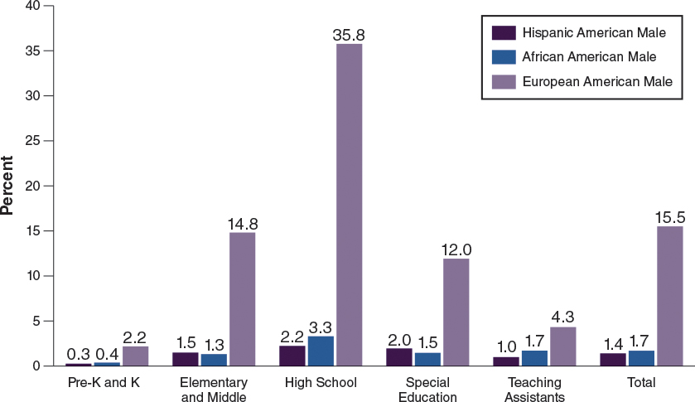

There are several strategies that programs and teachers can use to encourage father involvement and engagement, especially minority fathers:

Seek out more male teachers when the opportunity arises. Though hiring is not within the purview of teachers, they are often asked about potential individuals to hire. During these opportunities, they can provide insight on the value of a diverse staff, including addressing gender disparities. Men engage children, especially boys, differently than women do in the classroom. Men also provide a different perspective. Seeing male teachers and administrators may make fathers and other men more comfortable getting involved in the program and in the classroom.
Be male-friendly. Similar to being child-friendly, consider the nature of an environment and interactions that encourage father engagement, such as posting pictures that include fathers who participate in field trips and school events; partnering volunteer fathers with male staff (beyond help with moving furniture and disciplining children); getting their thoughts on classroom activities, routines, and events; and engaging them with certain children.
Have a "Father-Child Day." This type of event will provide a specific time for children to spend with their fathers, showing fathers what they are learning in the classroom and allowing them to observe their child's learning directly. In addition, this event will encourage and support the father-child bond, crucial to many aspects of children's development. This day can also be used to encourage fathers to come to the classroom to participate in the lessons, such as by leading circle time.
Dad Coffee Time with Director. Staff should create opportunities for fathers and other significant males to provide feedback about the program and how their engagement and involvement can be supported by program staff. Teachers can suggest to program directors that providing specific opportunities for all fathers across the program to share their thoughts can be beneficial for teachers in partnering and collaborating with dads of the children in their classroom.
Dad/Male Support Groups. Programs can provide opportunities and space for fathers to come together to discuss their struggles and challenges and form relationships with each other. This support can also enhance their involvement in the program and engagement in their child's learning.
Design an Activity: Male- and Father-Friendly Environment
How would you know whether your classroom is male-friendly and father-friendly? Take this checklist and see how male- and father-friendly your classroom and teaching practices are. If you check "No" for any of the responses, consider what you can do to make your classroom more male- and father-friendly.

My Classroom and Classroom Practices . . .

Yes No
Include fathers in classroom activities.
Offer programs or activities for fathers.
Provide programs and activities for dads that focus on the strengths of dads.
Use activities, materials, individual tasks, and group exercises in classrooms that appeal to fathers.
Offer parenting classes that use father-specific curricula and educational materials.
Involve fathers in decision making and deliver programs and activities that target dads.
Periodically survey fathers to determine their needs, concerns, and interests related to the program and their child.
Offer or support special events that celebrate fathers.
Invite fathers to participate in all classroom activities (e.g., classes, groups, parties, childcare, field trips, outings, celebrations, and other events).
Award/honor fathers for involvement in the classroom and in the lives of their children.
Source: © California State PTA. All Rights Reserved.
Encouraging Social Support and Networking Among Families
Among the many benefits of engagement in family traditions are deeper connections with family and friends and in the growth of networks and social support. Children from families with strong cultural identity have been found to be better adjusted and have better academic outcomes (Caughy, Nettles, O'Campo, &Lohrfink, 2006; Halgunseth, Ispa, & Rudy, 2006). This indicates that children who feel connected to others are more likely to feel unconditionally loved and accepted, boosting their confidence and self-esteem.

Studies show that deep family ties can minimize stress, depression, insecurity, and isolation, which are often of particular concern for minority groups with a history of oppression and disenfranchisement (McKay, Atkins, Hawkins, Brown, & Lynn, 2003; Mulvaney-Day, Alegrìa, &Sribney, 2007). Shared characteristics such as race, ethnicity, home language, religion, and nationality make people more likely to connect with each other. This relationship can provide information, access, and resources to a family, and in some instances alleviate burdens. Networks can reduce stress by sharing information as simple as the cheapest grocery for the best food, the best childcare provider in the community, how to get into the right classroom, and tips to access more social services.

Early childhood programs and teachers are in an excellent position to enhance families' social supports and networks by (1) providing the infrastructure for meetings, such as a facility, food, and childcare; (2) knowing the unique gifts, strengths, and needs of families and children in the program; and (3) facilitating relationships among them. Specifically, some programs can provide a free space where parents can informally meet. Informal meetings between parents can occur at times that are most convenient for them, rather than for the school and school staff. If the program does not have space available, it can reach out to community agencies for specific spaces for parents to meet.

Programs and teachers can also contact community agencies to get food and other materials. Teachers often conduct surveys to find out what families need or information they are seeking. Teachers can also find out the gifts and skills that families have, such as family members who can paint, cook, teach music, make toys, fix appliances, decorate homes, or speak multiple languages. Because families have different types of jobs in different sectors, they also have different networks and information. These resources can be valuable in many ways to other families and children, as well as to the program, through providing new experiences for children and families and building lifelong connections and networks.
5.4 Leveraging Community Resources to Support Children's Learning
In addition to providing a high-quality, safe, nurturing, and educational environment for their children and caring for children while their parents work, there are several other ways in which early childhood programs can support families, as Epstein (2001) explains. For example, teachers and programs can educate parents about child development and how to arrange home conditions to support early learning. Programs and teachers can also support families by coordinating resources and services from the community so that families are better able to take advantage of them.

Communities have a lot to provide to families and early childhood programs, and teachers can play a role in connecting families to resources. This is especially important for families who are new to the area, including new immigrants, who are often isolated and may not be aware of resources they can access.

Early childhood programs serve as the settings, but teachers play a critical role in providing this information to families. In work conducted with early childhood programs in New York City, Mario Small (2006) found that early childhood programs are institutions that are resource brokers. This means that early childhood programs, and teachers within these programs, possess ties to businesses, non-profits, and government agencies rich in resources, which can provide families with access to these resources. In some urban communities, beauty salons or churches serve as a hub or central location for health-related information and services, jobs, educational opportunities, and naturalization services (Small, 2006).

Early childhood programs are unique resource brokers in many ways. First, they often serve families who live in the community. They are based in different sectors: for-profit vs. non-profit, privately- vs. publicly-funded, religious vs. secular. Thus, they have varying relationships with government agencies and businesses. Most importantly, a childcare program is often capable of being a full-service community agency that can "broker" information, direct services, and goods to families. Families can receive information about nutrition, child health, housing, and education, and this information is often free. Through their early childhood programs, families may also be able to access free or low-cost services, including health and dental care, special education services (e.g., speech therapy), substance or drug abuse counseling, legal counseling, work training, housing support, and English classes. Programs can also help families receive free goods such as meals, tickets to cultural events and institutions (e.g., circus, theater, museum), educational toys, and scholarships.

Being a resource broker requires that programs and staff know what is available in the community, have multiple relationships with various organizations and agencies, know the needs of families and children, and are able to align family and child needs with community resources. In instances where programs do not have knowledge about community resources—or resources are inadequate in the community—programs can facilitate connection between families. This means they can broker relationships and networks between and across families. Families in the program can support each other by serving as bridges to much-needed information, services, and goods.

REF
Curenton, S.M., &Iruka, I.U. (2013). Cultural competence in early childhood education [Electronic version]. Retrieved from https://content.ashford.edu/

