6.1 What Are Speech and Language Impairments?
Students receive services for SLI more than any other disability except for SLD. This section discusses the difference between a speech impairment and a language impairment. It presents the definition for SLI as outlined by IDEA and discusses the prevalence of SLI in schools in the United States.

Defining SLI
Speech and language impairment (SLI) refers to a group of disorders that affect a student's speech or language skill and development. Language refers to the systems that people use to communicate with each other; it also refers to the meanings of words, and how words are assembled into meaningful thoughts. It can be oral (spoken), written, or even gestural. For example, in the United States, the gestural language of a "high five" usually signals "Congratulations!" Speech, which refers to the oral aspect of language, is how people express ideas or thoughts through sounds. Speech is the main form of communication for people around the world.

A language impairment is a disorder that affects how people understand or use words. This can mean that they have difficulty understanding what people say (receptive language) or that they have difficulty constructing thoughts or ideas (expressive language), or both. Receptive language refers to how people organize and understand information provided through oral, written, or visual means. Expressive language refers to how people construct the words, symbols, or gestures they want to communicate to others. A speech impairment is a disorder that affects the production of sounds and words.

The category of SLI incorporates a wide variety of difficulties, including difficulties related to articulation (pronunciation), fluency (flow of speech), voice, and language (which includes putting words and sentences into meaningful forms). Students with SLI may experience difficulties with speech or language, with approximately half of diagnosed students experiencing both (Seeff-Gabriel, Chiat, &Pring, 2012).
In the field of medicine, SLI often falls under an umbrella category called communication disorders or communicative disorders (as do hearing difficulties; Chapter 10 discusses hearing impairments in detail, as they have their own IDEA 2004 category.) Evaluations or diagnoses from medical professionals may use the term communication disorder, but schools will use the term SLI.

Students with SLI may have academic skills that are below average, average, or above average, but researchers have demonstrated that they often perform below students without SLI on assessments of intelligence, language, and literacy (Ferguson, Hall, Riley, & Moore, 2011). The effects of an SLI on educational outcomes vary and are dependent upon the student's specific difficulties. For some students, the impairments do not hinder learning new material or participating in classroom activities. Other students with SLI, however, have difficulty with working memory, which influences how they process information and store knowledge. Evidence of a strong association between SLI and problems with working memory continues to grow (Montgomery, Magimairaj, & Finney, 2010).

Other students may have difficulty understanding new material or participating in class. Reading difficulties are common because of the connection between language and reading (Pennington & Bishop, 2009). If students struggle with understanding spoken language (i.e., what words mean) then it can be difficult to understand the meaning of words read on the page. Students may also have difficulty with speech and with communicating through language, and speech difficulties can contribute to reading difficulties (Gosse, Hoffman, &Invernizzi, 2012). The need for support depends on the degree to which the impairment affects the ability to succeed in the general education curriculum setting.

SLI and IDEA 2004
Speech and language impairment is one of the 13 disability categories under IDEA 2004. The passage of PL 94-142 in 1975 mandated that to be eligible for special education services related to SLI, students had to be "speech impaired" (Triano, 2000). Because of the 1997 reauthorization, however, IDEA 2004 considers SLI to be a communication disorder: "Speech or language impairment means a communication disorder, such as stuttering, impaired articulation, a language impairment, or a voice impairment, that adversely affects a child's educational performance."

Note that for students to receive special education services for SLI under IDEA 2004, the impairments must adversely affect educational outcomes, such as reading or mathematics performance. If a student's academic performance is not adversely affected by the SLI (e.g., the student's only difficulty is with speech), it is possible for the student to receive special education accommodations under Section 504.

Once students are identified with SLI, the school assigns a speech-language pathologist (SLP) or other certified specialist to provide instructional services. Most school districts employ SLPs to help students diagnosed with SLI because they are trained to work specifically with these impairments. Additionally, some families send their children to work with an SLP outside the school day.

If SLI is the student's only disability, the SLP is considered to be their primary service provider and is responsible for ensuring that annual IEP goals are achieved. If a student has multiple disabilities that affect educational performance, a special educator may be considered the primary service provider and work in collaboration with both the general education teacher and the speech-language pathologist.
Regardless of the IEP arrangement, all educators must collaborate and communicate regularly about student strengths, needs, and academic progress. Instructional services provided by the SLP should be reinforced both in the classroom and at home. For example, if a student has difficulty pronouncing the /r/ sound, the parents and the teacher should employ the same techniques as the SLP to remind the student about the /r/ sound and provide opportunities to practice it.

Prevalence of SLI
SLIs affect approximately 3% of, or more than one million, school-age students. Boys tend to have slightly higher rates of SLI than girls (Viding et al., 2004).

About 6% of students with an SLI experience a reading SLD, as shown in Figure 6.1 (Gosse et al., 2012). In fact, students with SLI share many characteristics of students with dyslexia (Robertson, Joanisse, Desroches, & Ng, 2009). A small percentage of students with SLI may be diagnosed with other disabilities, such as autism, intellectual disabilities, ADHD, EBD, or SLD (Cleland, Wood, Hardcastle, Wishart, & Timmins, 2010; Pinborough-Zimmerman et al., 2007).

Figure 6.1: Comparison of SLI and SLD
The percentage of school students with SLI has remained relatively constant since 1977. The percentage of students with SLD rose dramatically until 2001 and has begun to decline with new methods of identification of SLD, such as RTI.
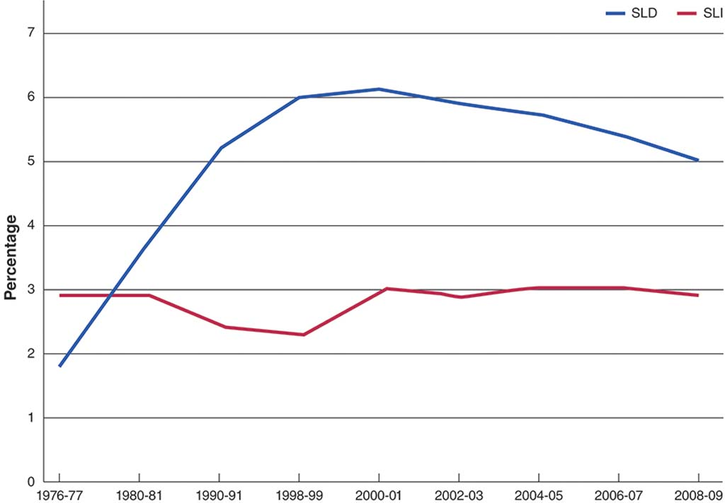
6.2 How Has the SLI Field Evolved?
Speech and language difficulties have been reported almost since the beginning of recorded history. Thousands of years ago, young men in Greece and Rome were taught oratory skills to improve public speaking, and tongue exercises were developed to help those with speech difficulties. In medieval times, physicians suggested treating the throat or removing excess saliva from the mouth. In the 16th century, Hieronymus Mercurialis noted that speech impediments could be influenced by anxiety about speaking, and suggested methods for overcoming the problem.

By the 18th century, physicians had learned more about how the human body produces speech, which led to medical treatments for those with speech and language difficulties. In the 19th century, therapists like Alexander Graham Bell—the inventor of the telephone and also a speech therapist—offered lessons to help people with speech and language difficulties.

In the late 19th century, Samuel Potter, a stutterer, wrote about and suggested treatments for different types of speech disorders. Some of his treatments included repeating the alphabet, placing vocal organs in proper positions, and regulating oxygen flow. Edward Wheeler Scripture followed a few years later with a book on stuttering and lisping.

To help students with speech difficulties, Margaret and Smiley Blanton published a book on speech for parents and teachers in 1920. This book recommended speech training for all students during the school day, regardless of whether they had a speech difficulty. As more therapists began providing treatment in the United States for people with SLI, Edward Lee Travis and his colleagues formed the American Speech Society in 1925; this is now the American Speech-Language-Hearing Association.
Throughout the 20th century, more research about speech and language difficulties was carried out (Duchan, 2010). Therapists began recognizing a larger number of specific types of speech and language difficulties, and they suggested many different therapies to help.

Over the last 50 years, standardized assessments and diagnostic routines relating to speech and language have been developed to assist with the diagnosis of SLI. Degree programs for certified and professionally trained speech-language pathologists (SLPs) have also become more prevalent.

The certification of more SLPs, along with the passing of special education laws, has meant that more students can receive the speech and language services they need (Katz, Maag, Fallon, Blenkarn, & Smith, 2010). In fact, because so many students require the services of SLPs and there are not enough SLPs to provide the services, speech-language pathology assistants (SLPAs) have become more prevalent in schools. An SLPA implements interventions with students while supervised by an SLP.

In the last few years, medical technologies have provided greater insight into speech and language production, and researchers have developed and tested therapies and interventions for people with SLI (Baker & McLeod, 2011; Cirrin et al., 2010). For example, a medical professional might use different instruments (e.g., nasometry or electromyography) to understand bodily functions related to speech. An SLP might use evidence-based practices to improve the speech patterns or language skills of a student with an SLI. The SLP might use nonspeech movements, such as massage, cheek puffing, or icing to improve the speech of students (Lass &Pannbacker, 2008).
6.3 What Are the Characteristics of Students With SLI?
The term SLI covers a wide range of disorders related to speech and language; therefore, students with SLI may display many different characteristics. In general terms, students with SLI may experience difficulty following directions or understanding and participating in a conversation. They may struggle with the pronunciation of words and the production of language, and may experience difficulty at school, where communication and learning traditionally rely mainly on the expression of ideas through speech and language.

The National Dissemination Center for Children with Disabilities describes four major areas of difficulty for students with SLI. The first three areas deal with speech difficulties:

Articulation difficulties, which involve problems with the pronunciation of sounds. One type of articulation difficulty is a lisp, which means /s/ and /z/ sounds are pronounced incorrectly. Many toddlers and young children have difficulty with /l/ and /r/ sounds as they are learning to speak. When the difficulty persists past the age of 5, a student has an articulation difficulty.
Fluency difficulties, which involve a student's flow of speech. A struggle with fluency involves the disruption of the speech pattern because specific sounds and words are difficult to say. Students may repeat or slowly pronounce words, or they may skip difficult sounds or words entirely. Stuttering is an example of a disorder that affects speech fluency. When a student stutters, they repeat or "get caught on" certain sounds (e.g., "I l-l-l-like ice cream").
Voice difficulties, which involve pitches of sound when speaking. Students may speak too loudly or too softly. They may sound hoarse, breathy, or nasal.
The final area deals with language difficulties:

Language impairments, which involve difficulty with communication. Students with language impairments have trouble expressing their wants and ideas, understanding new information, following directions, and understanding the written or spoken word. Students may pause when speaking to find the "right" word (Smith, Hall, Tan, & Farrell, 2011).
So, speech impairments affect how students make sounds and words. Language impairments affect how students understand language and communicate their thoughts and ideas.

Speech Impairments
Speech sound disorders involve the faulty production of sounds and sound patterns. Motor speech disorders usually involve how the face, mouth, and brain work together to create speech. Speech sound and motor speech disorders can cause articulation, fluency, or voice difficulties. Students with speech impairments may have difficulty imitating the speech of others, and their own speech may be difficult to understand or interpret. They may be anxious when speaking because it is difficult for them. Students with speech impairments often experience language impairments because of disruptions with speech (Finneran, Leonard, & Miller, 2009).

Speech sound disorders are more common than motor speech disorders. Here are a few of the most prevalent types:

Articulation disorder. Students with articulation disorder have difficulty making sounds. When saying syllables or words, students may substitute one sound for another (easier-to-produce) sound, add a sound, or take out a sound. For example, a student may say "the rabbit ran" as "the wabbit wan." As young children develop speech, almost all have difficulty with articulation. When that difficulty continues past the time students start kindergarten, they may require support to improve their articulation. Teachers, however, need to ensure that the student actually has an articulation disorder rather than speaking a regional dialect or English as a second language. English language learners are often over-identified as having an SLI (Kapantzoglou, Restrepo, & Thompson, 2012). A trained professional, such as an SLP, can help determine the difference between an articulation disorder and a dialect or accent. Often, as students improve their knowledge of English, it becomes clear whether the student has a disorder.
Phonological process disorder. Students with a phonological process disorder make patterns of errors when producing sounds. This disorder is related to how the brain communicates. Often, the student's tongue produces sounds incorrectly, but in a way that other sounds are produced. For example, say the sound /g/ as in the word "gut." Your tongue touches the inside of your mouth, all the way in the back. Now, say the /d/ sound. Where did your tongue touch the top of your mouth for /d/? Now, say the /g/ sound again, but touch your tongue to the top of your mouth a little further forward than you did for /g/ before. What you said probably sounded more like /d/ than /g/. Students with phonological process disorder may switch the sounds for /k/ and /t/ as well. They may also have difficulty with blends of two consonants. They often say the first of the two consonants and drop the sound of the second consonant. "Trick" becomes "tick," and "drip" becomes "dip," for example.
Stuttering (also called dysfluency). When students stutter, they get "stuck" on a syllable or word, and they repeat it several times. Stuttering falls under speech sound disorders, but it also may classify as a dysfluency disorder. Some stutterers say "um" or "uh" frequently while they are preparing to say a word. For some students, stuttering has little to no effect on speech. For others it can be a major stumbling block for participation in school and life activities. Some examples of stuttering include, "P. . .p. . .p. . .please," "The. . .the. . .the dog," or "I want. . .uh. . .uh. . .uh chocolate ice cream."
The following are a few of the most common motor speech disorders:

Childhood apraxia of speech (CAS). Apraxia is the inability to perform a movement (in this case, speech) even when the brain and body understand what needs to be performed. Students with CAS struggle with saying sounds, syllables, or words. Usually, they want to say something, but their brain and their body parts (e.g., mouth or tongue) have difficulty with the coordination of the speech. Students with CAS typically understand language (i.e., what is being said), but they have trouble speaking as they respond to the language. CAS is different from stuttering in that stuttering is a difficulty with creating speech and CAS is a difficulty with the language that goes into speaking. In other words, students with CAS can articulate words; they just have a hard time finding the "right" words to say.
Dysarthria. Students with dysarthria typically have a neurological impairment that causes difficulty moving the muscles of the face and mouth. The muscles may be too weak or slow to produce speech. These students may also have difficulty breathing, which contributes to difficulty with speech. Students may speak at a slow rate or appear to whisper or mumble. Voice quality may be hoarse, nasal, or breathy. Some students may have experienced a traumatic brain injury (TBI), while others have a disease (such as Cerebral Palsy or Muscular Dystrophy) that contributes to the dysarthria.
Orofacial myofunctional disorders (OMD). Students with an OMD have difficulty with the control of their tongue, which may cause difficulty with speaking. The tongue may move forward in the mouth too much while the student is speaking, which causes difficulty in the production of speech. For example, try to say the word "sink" with your tongue sticking out of your mouth. Did you say "think" instead?
When a student struggles with a speech impairment, whether it is a speech sound disorder or motor speech disorder, the student often demonstrates atypical classroom behavior. For example, the student may not participate in classroom discussions or volunteer to answer questions because they do not want to speak aloud. If teachers are not aware of the speech impairment, they may perceive the student's lack of classroom participation as disinterest or a lack of knowledge.

Language Impairments
Unlike a speech impairment, which may affect just one part of an individual's speech, a language impairment typically affects all aspects of an individual's language (Archibald, Joanisse, & Edmunds, 2011). Language impairments can be divided into two categories: expressive and receptive.

Expressive language disorder. An expressive language disorder affects how students produce verbal and written language. Students typically have difficulty communicating thoughts and feelings in a coherent manner. They may find it hard to put words in the right order to form grammatical sentences, or they may use words in inappropriate contexts. They may have difficulty with verb agreement and using proper tenses (Leonard, Miller, & Owen, 2000). For example, a student might say "The cat lick his paw" or "Last week, Marta bring a frog to class."
Receptive language disorder. A receptive language disorder affects how students understand what other people are trying to say. Students may struggle with understanding directions or participating in conversations.
Mixed expressive-receptive language disorder. Often, students struggle with both expressive and receptive language (Nickisch& von Kries, 2009). Students have difficulty understanding language and communicating with language.
In discussions of language impairment, you may hear or read the term aphasia, which refers to difficulty remembering words or remembering how to read and speak. Aphasia often occurs after an older person has experienced a stroke or some other type of brain or neurological injury, but young students can experience it as well, especially after an accident. With aphasia, a student may not be able to find the "right" word to say. For example, she might say, "I want to play that game with the red and black pieces—you know, that game. What's it called?"

Voice disorders affect the sound of a student's voice. Usually, the unusual qualities in a student's voice indicate a condition affecting the student's vocal chords (larynx) or trachea (wind pipe).
6.4 What Are the Causes of SLI?
Different types of SLI have differing causes. One common cause for an SLI is a hearing impairment, because of the role hearing plays in understanding language and speech. Other contributing factors include a variety of diseases, disorders, and deficits within the brain. Sometimes, the causes remain unknown.

The Role of Hearing Impairments
Hearing impairments are the most common causes of speech and language difficulties (Keilmann, Kluesener, Freude, & Schramm, 2011). When a student has a hearing impairment, he or she has difficulty hearing and discriminating between sounds. Students may have mild or moderate hearing loss, such that sounds sound softer. They may have severe or profound hearing loss, such that sounds can only be heard with technologies or not at all.

Hearing impairments affect SLI because hearing others speak influences much of our early speech development. Children learn to speak by mimicking sounds their parents and others make. If the child doesn't hear these sounds properly, it can cause a delay in speech and language.

The Role of the Brain
In the 19th century, a French physician named Paul Broca conducted an autopsy on a patient who could understand language but had severely limited speech; he found damage to the man's left frontal cortex (see Figure 6.2). After seeing similar patterns of damage in other patients, Broca concluded that this area of the brain helped produce language. This part of the brain is now referred to as Broca's area. Several years later, Carl Wernicke, a German physician, discovered another part of the brain related to language understanding. Wernicke's area, as it is now called, is located in the back of the left temporal lobe.

Figure 6.2: Broca's Area and Wernicke's Area
Information comes into the brain and travels to Wernicke's area, one of the areas involved in how the brain makes sense of the language. Information then travels to Broca's area, which is involved in the process of responding. When students have damage to either Wernicke's area or Broca's area, the student may experience difficulties with speech or language.
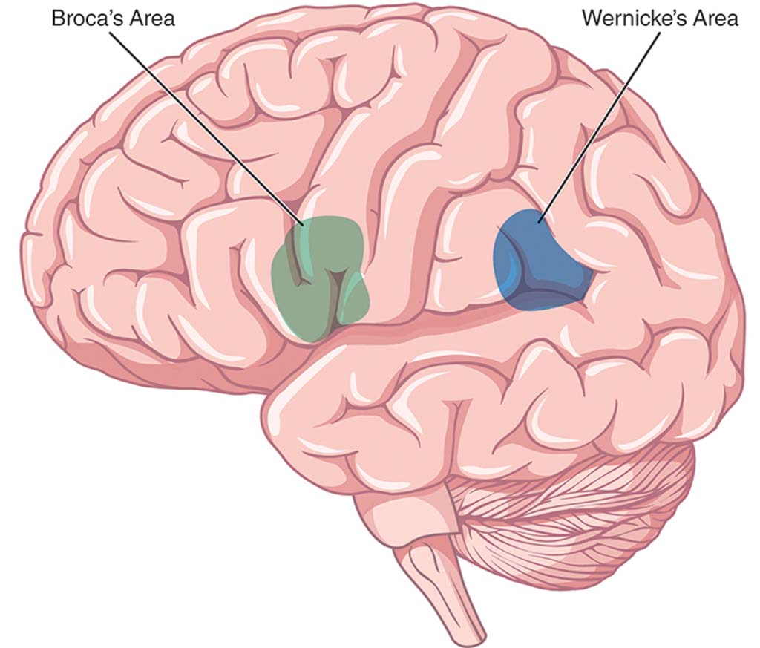
Today's research reveals more about how specific areas of the brain control the comprehension and output of language (Badcock, Bishop, Hardiman, Barry, & Watkins, 2012). An individual's brain may be involved in difficulties in the production of speech and language or in the motor skills required for speech. For example, parts of the brain may be damaged or connections in the brain may not be working in a typical manner. The brain may be misfiring and sending incorrect signals to the student (Preston et al., 2012).

The Role of Genetics
Genetics may play a role in SLI (Pruitt, Garrity, &Oetting, 2010). Studies of twins have found that when one twin has a speech or language impairment, there is a 40–75% chance that the other twin will have an SLI (Viding et al., 2004). Students with a parent with an SLI have an increased risk of also having an SLI (Pruitt et al., 2010).

Research indicates that the development of language and speech, as it is tied to the brain, is directly related to genetics. That is, brain development and function tends to be similar from parent to child. If a parent has a difficulty with speech and language that is related to brain function, then his or her children are more likely to, as well.

Other Factors
Some students experience SLI because of another disease or disorder. For example, students with Muscular Dystrophy lose muscle control, including control of the tongue, which contributes to difficulty producing sounds and words. Students born with a cleft palate, even if it has been repaired, may still have a difficult time producing sounds and words.

Voice disorders may be caused by excessive or inappropriate use of the vocal chords. For example, students who scream or yell excessively can damage their vocal chords. The inhalation of toxins, such as cigarette smoke, may contribute to vocal difficulties as well.

Other environmental factors, such as allergies or ear infections, can contribute to hearing difficulties, that can, in turn, contribute to an SLI. Additional environmental factors linked to SLI include abuse, neglect, or malnourishment. These factors may contribute to abnormalities in brain development or function, which may cause an SLI.
6.5 How Are Students Diagnosed With SLI?
If a teacher suspects that a student may have an SLI, the teacher should refer the student for evaluation with a trained professional, such as an SLP. The SLP and other medical professionals can conduct appropriate assessments and provide an appropriate diagnosis. Teachers do not diagnose SLI.

When Are Students Diagnosed?
Many teachers recognize SLI during preschool or elementary school, but students can be diagnosed at any time during their school career. Many delays in speech and language development can be identified within the first few years of a child's life. Other difficulties in understanding and expressing language do not become evident until students begin to learn to read and write.

Once students exhibit persistent difficulties with speech or language, the evaluation process should be initiated. The longer children go without services, the less likely they will be to improve their abilities to understand and produce language.

Parents and teachers can sometimes have difficulty deciding when a child's speech and language issues are something he or she will "grow out of," and when the difficulty is something that needs to be brought to the attention of an SLP. Parents may attribute speech difficulties to "baby talk" long after the child should have outgrown the speech patterns. The rule of thumb is that most students should outgrow speech and language difficulties before they enter kindergarten.

The Diagnostic Process
The official evaluation for, and diagnosis of, SLI comes from a certified SLP or other certified therapist or professional, typically early in a child's education. Family members or teachers who notice difficulties indicative of an SLI may refer the student to the school or district's SLP (Lindsay, Dockrell, Desforges, Law, &Peacey, 2010). If a school or district does not employ an SLP, the district must pay for an evaluation from an outside center or SLP. Medical professionals, such as doctors, may diagnose SLI as well.
The diagnostic process for SLI may be inconsistent from school to school or clinic to clinic (Dollaghan, 2011). Each SLP may employ their favorite diagnostic measures and processes. However, there are some commonalities in the steps for evaluation and diagnosis used with most students. For example, three sources are typically used in an evaluation: a parent report, a teacher report, and observation by a trained professional (McLeod & Harrison, 2009).

Before an SLI assessment occurs however, an audiologist (i.e., hearing specialist) or an Ear-Nose-Throat physician or specialist should conduct a hearing evaluation to help rule out or clarify the role that hearing loss may have in the student's speech or language difficulties.

Informal and Formal Observations
Once a hearing assessment has been conducted, the next step is for an SLP to gather more detailed information from parents and teachers about the speech or language difficulties of the student. The SLP may also conduct informal and formal observations of a student's speech and language skills. In a formal observation, the SLP may conduct a set of activities with the student to elicit specific responses related to speech and language. For example, "This is a ball. Say ball. This is a rabbit. Say rabbit." The SLP may ask students to follow specific directions; name colors, numbers, letters, or common objects; or sing songs and rhymes. In an informal observation, the SLP may observe the student playing with a parent or peers to determine how the student speaks and whether the student understands language. Informal observations are often used with younger students, while formal observations are often used with older students.

The information obtained helps the SLP determine which diagnostic tests may be appropriate to administer to the student.

Assessment Activities
The SLP then administers a battery of assessments and has students engage in activities to determine the source of difficulty. The assessor first may administer an oral mechanism examination to check for weakness of the lips, jaw, tongue, or teeth. He or she may also evaluate how well the student's mouth moves in different directions. To evaluate sound production, the SLP may ask the student to say specific sounds or mimic sounds and sound patterns.

The SLP may ask the student to speak and will then count the number and types of dysfluency in the student's speech—that is, how many breaks or pauses occur in a student's speech. Additionally, the SLP may examine the student's rate of speech. To determine difficulties with language, the SLP may administer assessments of oral language comprehension and production.

A medical professional may conduct an anatomical evaluation of the mouth and face to determine whether the larynx or tongue may be contributing to speech or language difficulties. Dentists or orthodontists may notice or assist in the detection of anatomical abnormalities in the student's mouth.
6.6 How Does SLI Differ Across Grade Levels?
Instructional support for students with SLI, like support for all students with disabilities, varies depending on grade level. Regardless of age or ability, however, instruction at every grade level should promote stronger language skills and strengthen specific areas of weakness, according to the individual child's needs.

Early Childhood
SLI may first become evident as infants begin to respond to adult communication. Early childhood language includes babbling speech sounds (e.g., "ba" and "ga") and exhibiting clear responses to direct communication from adults (e.g., a baby turning to look at his mother when she calls his name). As young children progress, they begin mimicking the speech patterns of their parents and repeating basic words (e.g., "bye" and "ball"). Children then begin to speak words to communicate meaning, and eventually combine words to form simple sentences (e.g., "I want cookie").

At any point during this speech and language development process, delays can be observed. Some delay in speaking and responding to communication may be within normal range, but when significant difficulty is observed past recommended developmental benchmarks, the child may have an SLI
Like all students with disabilities, students with SLI benefit from early intervention. Interventions for SLI can either be child-focused or environment-focused. Child-focused intervention targets a specific behavior within the child, while environment-focused intervention seeks to alter the setting or behaviors of others who interact with the child on a regular basis (Pickstone, Goldbart, Marshall, Rees, &Roulstone, 2009). The earlier that parents or teachers can identify the need for early intervention, the better the outcomes may be for the student. Some students may be referred for early special education services. For many students, speech and language services may be provided by an SLP during pre-school or pre-kindergarten. Some students may receive services in a clinic setting even earlier, if necessary. The earlier that speech or language services can be delivered to the student, the quicker any impairments can be improved or remedied. Students can be identified under IDEA 2004 with an SLI, or students may be identified under the category of developmental delay and receive appropriate services in this manner.

Interestingly, many young students with speech difficulties do not believe they have a speech difficulty (McCormack, McLeod, McAllister, & Harrison, 2010), so if these students can receive speech services before they catch on to their difficulty, they may avoid developing negative feelings about speaking.

Elementary School
Early intervention for SLI is particularly important as students begin learning to read and write in early elementary school. Students with SLI can benefit from small-group, explicit instruction that focuses on recognizing and memorizing patterns in speech sounds, word parts, and sentence structures. With explicit instruction, the teacher or another trained therapist or specialist provides focused instruction on specific topics necessary for the student's speech or language development. Students may need meaningful repetition and practice with the elements of speech and language. Additional practice and frequent feedback on language assignments may help students with SLI improve their word recognition and processing speed.
Promoting social communication is key at this stage of a child's education. In elementary school, students with SLI will become aware of their impairment and the difficulties they face understanding and communicating with others. Teachers can plan positive interactions and opportunities for students to share their ideas with others. Structuring activities for students to demonstrate their strengths can build their confidence in their ability to interact with peers and adults. Allowing, or even requiring, multiple modes of communication, such as pictures or storyboards, can increase student interactions.

For elementary students with speech impairments, work with an SLP or other certified specialist is imperative. The general teacher should collaborate with the SLP to coordinate reinforcement and support in the general classroom that is complementary to and builds off speech services. For example, if the SLP is working on phonological awareness (PA) with a student, it is important for the general education teacher to reinforce PA skills in a similar manner.

Secondary School
Most progression of language ability occurs early in a student's education, and by the time students enter late middle or high school, many of their language habits and abilities are solidified. In fact, the percentage of students receiving SLI services in high school is often drastically lower than students receiving services in elementary school. If adolescent students with SLI do receive services, it is often in shorter increments than elementary age students. However, significant academic gains are still possible for secondary students. A focus on building speech and language confidence and skills should continue into secondary education for students with SLI.

An in-depth understanding of student strengths and weaknesses can help teachers design specific interventions for targeted skills. Secondary school students should have an understanding of their progress to date and future goals for improving expressive and receptive language ability. Continued emphasis on building confidence is important to help students realize their potential.

Adolescent students with SLI may perceive their academic and social abilities to be lower than students without any language impairment. Hughes, Turkstra, and Wulfeck (2009) studied perceptions of executive function in students with SLI; executive function is associated with goal-oriented behavior, including memory, control, and self-monitoring, and it is essential for language-based academic and social tasks for secondary students. Hughes et al. (2009) found that both adolescents with SLI and their parents tended to rate their executive function (i.e., attention, planning, flexibility, etc.) more negatively than students and parents of students without SLI.

Transition
Secondary students with SLI will have a transition plan as a part of their IEP. Post-secondary transition plans vary among students with SLI and are created by the IEP team, including the student, family members, special education teacher, SLP, general education teachers, school counselor, and other service providers, as appropriate. Students who plan to transition to higher education and most careers must be able to effectively read, comprehend, and express their ideas in oral and written form. Post-secondary students with SLI need be able to advocate for their individual needs so that their speech or language impairment does not impede academic and social performance. Additionally, students need to be well aware of the accommodations and resources necessary for their continued success.

For students with multiple or severe disabilities, IEP and transition goals may include functional life skills. This will likely include learning to communicate basic needs, such as using the bathroom, through speech or assistive technology. Such skills are critical to future quality of life, and should be addressed in secondary IEP goals and transition plans.

Once they exit the K–12 school system, it is unlikely that adults with SLI will receive targeted intervention in speech or language. Adults with SLI may show poorer communication, academic, educational attainment, and occupational outcomes than adult peers without speech or language impairments (Johnson, Beitchman, &Brownlie, 2010). However, adults with SLI can be successful in college and career, especially with the appropriate support systems in place.
6.7 How Do I Teach Students With SLI?
Students with SLI should receive speech and language services from trained professionals. The role of the classroom teacher is supportive and collaborative.

Collaboration With an SLP
An SLP often provides appropriate services for students with an SLI, although other certified staff members (e.g., SLPAs, audiologists, vocational specialists, occupational therapists, or physical therapists) may contribute to providing speech and language services (Richburg &Knickelbein, 2011). Depending upon the student's IEP, the student may receive intensive therapy (e.g., four or five times a week) or periodic therapy (e.g., once a week; Bellon-Harn, 2012). SLPs may conduct a wide range of therapies and activities tailored to the student's disability. Most often, SLPs work individually with students because each student requires an individualized speech or language program.
Consultation between the SLP and the student's family is important so that the family is aware of instructional methods used with the student. The discussion should cover improving and practicing speech or language in the home environment (Roberts & Kaiser, 2011).
Special Education Perspectives: Working with Speech Impairments
Students With Speech Disorders
SLPs may lead students with motor difficulties in exercises to strengthen the tongue or mouth. Students may watch themselves in the mirror or watch a videotape that the SLP has made of the student speaking. Students with speech sound difficulties may require different methods; SLPs may teach them how to correctly pronounce letters or words by demonstrating and explaining the actions. For example, the SLP may practice helping a student say the /r/ sound in "rake" by discussing the tongue's movement in the mouth.

SLPs may teach students who are working on speech or language skills other ways to communicate in the interim. A student may learn to use signs or gestures to indicate wants and needs. In some cases, students may use picture boards or augmentative and alternative communication (AAC) devices. Chapter 9 discusses AAC and picture boards, as they are commonly used for students with autism.
From My Perspective: Being an SLP
I'm Marta, and I've worked as an SLP for over 20 years. SLPs work in a variety of settings and with a variety of communication disorders. A child has to have an educational deficit to be found eligible for the speech-language program under IDEA 2004, regardless of the disorder. Most SLPs see a caseload of 35 to 65 students, depending on the school system, and each student's needs are identified on his IEP. Many SLPs work directly in the classroom to integrate the speech-language goals and successes into the daily routine, so that the teacher can observe and carry over the techniques. Some students require individual or group therapy, which can be conducted in the SLP's room.
Articulation problems (difficulty pronouncing certain sounds) require the SLP to determine the cause and then assist the student with correct production—starting with single syllables and building up to longer utterances. Visual modeling, auditory discrimination training of the correct production, and tactile cueing are all tools used to achieve success. Reinforcement and repetition are key aspects of treatment.
Language reception and expression are a large part of the caseload, often best treated in the natural environment of the classroom. These areas are often seen in conjunction with other learning challenges, so a collaborative approach provides the best context for the child to improve her skills. Auditory processing of information, syntax (sentence structure), semantics (word meaning), and pragmatics (the non-verbal aspects of expressing oneself) are all areas that are assessed through standardized tests and language samples, and each can be improved through targeted instruction.

Students With Language Impairments
Teachers can do a variety of activities with students with language impairments. Vocabulary instruction should be explicit and focused on vocabulary that is most important for reading comprehension or communication (Taylor, Mraz, Nichols, Rickelman, & Wood, 2009). Typically, a few vocabulary words should be chosen and practiced to build fluency (Bryant, Goodwin, Bryant, & Higgins, 2003). It is helpful to provide pictorial representations, when possible, so students can visualize the meaning of the vocabulary word (Figure 6.3).
Figure 6.3: Teaching Vocabulary
Graphic illustrations may help a student who is learning the word swoop. A square with four sections. The top left section reads, "The eagle swoops down from the sky to catch a mouse." The top right section reads, "Swoop means to fly down quickly." The bottom left section shows an illustration of an eagle swooping down to get a mouse. The bottom right section reads, "Let's practice a swoop with our hand. Put your hand high in the air. Now, quickly move your hand down and touch the ground." This section shows and illustrations of an arm held high in the air and an arrow moving from the palm of the hand down.
Students can also learn strategies for "finding" the right word (Bragard, Schelstraete, Snyers, & James, 2012). Students can learn how to connect a vocabulary word to other known words using definitions or pictures. For example, a student may not be able to remember the word "carriage." But the student could learn how to provide cues for the word: "It was used before cars, it has four wheels, and a horse would lead it." The student might even use the word "wagon" or a picture of a horse-drawn cart to describe "carriage."
It may also be helpful to work on a student's listening skills. Much of language involves listening and comprehending information from other voices, so it is important that students have opportunities to practice and improve their listening skills. Teachers should connect listening to speaking, reading, and writing. To help with listening, teachers can encourage a quieter classroom with fewer noisy distractions (e.g., music from a radio or chairs that scrape noisily on the floor).

Another helpful strategy to improve language is to expose students to a variety of books or situations that involve reading. Teachers read alongside students and encourage them to synthesize what has been read and guess what they will read next. Teachers should choose reading materials that are appropriate for the student. This may mean choosing books with a predictable structure or easy sentence patterns that enable the student to focus on the ideas or the story.
General Strategies
Teachers may want to place the student with SLI in a seat that is close to the focal point of the classroom (e.g., the whiteboard, the teacher, or the activity). This allows the student easy access to classroom instruction, and it allows the teacher to quickly recognize when the student requires additional help. It might be helpful for the teacher to speak in shorter sentences and paraphrase or highlight main ideas. Teachers should ask students to repeat directions or ask them questions to check for comprehension. Speaking a little bit slower and taking audible pauses may provide all students with time to digest and understand directives.
Teachers need to provide ample "wait time" for students who have difficulty creating speech or generating language. Even though teachers may think it is reassuring, saying things like, "It's okay, take your time," or "Relax and breathe" may be more counterproductive than helpful. Phrases like these may draw attention to the student and add to the student's anxiety about speaking even more!

Strategies like an advance organizer (e.g., "Today we're learning about plant life cycles") or graphic organizers (e.g., "Let's use pictures to show the life cycle of a plant") can also help students with SLI. Students may especially benefit from advance organizers that include a preview of important vocabulary words.

Teachers may also employ response cards in a classroom with a student with SLI. To use response cards, the teacher asks a question, and each student responds by holding up an appropriate card. Response cards may be general. For example, students may have cards that say, "Yes" and "No." Students can have cards with a happy face and a sad face. Students can hold up a card to answer a teacher's question or show the teacher that they answered a problem correctly or incorrectly. Response cards may also be content-specific. For example, the students may have pictures of an ear, a nose, and eyes. For a lesson on the senses, the teacher may ask the student to hold up a response card to designate the best way to investigate an item: by listening, smelling, or seeing.

The teacher may need to educate the rest of the class on how to interact or include a student with SLI into regular classroom activities (McCormack et al., 2010). Young students may find it hard to understand what a student with a lisp or a stutter wants to say. The teacher should give other students guidelines—for example, "Look directly at your classmates when they speak"—to facilitate communication between peers. The entire class should learn to not snicker or laugh when a student has a speech, language, or vocal impairment. Negative peer reactions may cause a student with an SLI to exercise their speech skills less frequently, or it could exaggerate the student's difficulty.

It may also be helpful to work on a student's listening skills. Much of language involves listening and comprehending information from other voices, so it is important that students have opportunities to practice and improve their listening skills. Teachers should connect listening to speaking, reading, and writing. To help with listening, teachers can encourage a quieter classroom with fewer noisy distractions (e.g., music from a radio or chairs that scrape noisily on the floor).

Another helpful strategy to improve language is to expose students to a variety of books or situations that involve reading. Teachers read alongside students and encourage them to synthesize what has been read and guess what they will read next. Teachers should choose reading materials that are appropriate for the student. This may mean choosing books with a predictable structure or easy sentence patterns that enable the student to focus on the ideas or the story.
Tips for the General Classroom
The National Dissemination Center for Children with Disabilities (NICHCY) provides tips for general classroom teachers who work with students with SLI. Their suggestions include the following:
Learn about the student's speech impairment or language impairment. Do not assume that all students with an SLI have the same difficulties.
Ask for a copy of the student's IEP and learn about the student's accommodations for the classroom and during testing situations.
Meet with the SLP or the special education teacher. Discuss how you can support the student in your classroom.
Talk with the student's parent or guardian. Discuss how they can help support the student at home.
Be positive about including the student in your classroom!
General Strategies
Teachers may want to place the student with SLI in a seat that is close to the focal point of the classroom (e.g., the whiteboard, the teacher, or the activity). This allows the student easy access to classroom instruction, and it allows the teacher to quickly recognize when the student requires additional help. It might be helpful for the teacher to speak in shorter sentences and paraphrase or highlight main ideas. Teachers should ask students to repeat directions or ask them questions to check for comprehension. Speaking a little bit slower and taking audible pauses may provide all students with time to digest and understand directives.
Students use response cards or hand signals to participate in answering questions and indicating understanding. A common response is a thumbs-up or thumbs-down gesture. This teacher may have requested, "Give a thumbs up if you can think of a reason why cheating on a test is wrong."
Teachers need to provide ample "wait time" for students who have difficulty creating speech or generating language. Even though teachers may think it is reassuring, saying things like, "It's okay, take your time," or "Relax and breathe" may be more counterproductive than helpful. Phrases like these may draw attention to the student and add to the student's anxiety about speaking even more!
Strategies like an advance organizer (e.g., "Today we're learning about plant life cycles") or graphic organizers (e.g., "Let's use pictures to show the life cycle of a plant") can also help students with SLI. Students may especially benefit from advance organizers that include a preview of important vocabulary words.

Teachers may also employ response cards in a classroom with a student with SLI. To use response cards, the teacher asks a question, and each student responds by holding up an appropriate card. Response cards may be general. For example, students may have cards that say, "Yes" and "No." Students can have cards with a happy face and a sad face. Students can hold up a card to answer a teacher's question or show the teacher that they answered a problem correctly or incorrectly. Response cards may also be content-specific. For example, the students may have pictures of an ear, a nose, and eyes. For a lesson on the senses, the teacher may ask the student to hold up a response card to designate the best way to investigate an item: by listening, smelling, or seeing.

The teacher may need to educate the rest of the class on how to interact or include a student with SLI into regular classroom activities (McCormack et al., 2010). Young students may find it hard to understand what a student with a lisp or a stutter wants to say. The teacher should give other students guidelines—for example, "Look directly at your classmates when they speak"—to facilitate communication between peers. The entire class should learn to not snicker or laugh when a student has a speech, language, or vocal impairment. Negative peer reactions may cause a student with an SLI to exercise their speech skills less frequently, or it could exaggerate the student's difficulty.

References
Powell, S. R., & Driver, M. K. (2013). Working with exceptional students: An introduction to special education [Electronic version]. Retrieved from https://content.ashford.edu/

