English 1302
Short Fiction—Exam # 2

(Choose two of the following and respond to each in complete essay structuring and formatting.)
- Historian Greg Grandin, in the introduction to his book, The Empire of Necessity, writes as follows on Herman Melville:
Herman Melville spent nearly his whole writing career considering the problem of slavery and freedom. Yet he most often did so elliptically, intent, seemingly, on disentangling the experience from the particularities of skin color, economics, or geography. He rarely wrote about human bondage as an historical institution with victims and victimizers but rather as an existential or philosophical condition common to all. . . . Melville . . . is concerned less with exposing specific social horrors than with revealing slavery’s foundational deception – not just the fantasy that some men were natural slaves but that others could be absolutely free. . . . Melville knew, or feared, that the fantasy wouldn’t end, that after abolition, if abolition ever came, it would adapt itself to new circumstances, becoming even more elusive, even more entrenched, in human affairs. It’s this awareness, this dread, that makes . . . Melville such an astute appraiser of slavery’s true power and lasting legacy.” (9-10)
(Which is to say that slavery neither started nor ended with the chattel slavery of the 1500’s through the 1800’s.)
On the basis of this quote, compare any two of the stories read during this semester on a theme of slavery, unending, under many guises, many dressings, juxtaposing with either or both of the articles linked below (“The Invisible Army” by Sarah Stillman or “Britain's child slaves” by Annabel Venning) and with William Blake’s “London”, Robinson’s or Simon’s “Richard Cory”, or with at least any one or two resonant poems, lyrics, or artifacts as may be linked through e-campus or as juxtaposed in quizzes. (Preferring stories read most recently including Herman Melville, “The Paradise of Bachelors and The Tartarus of Maids”; Herman Melville, Bartleby the Scrivener; James Baldwin, Sonny’s Blues; Ralph Ellison, “Battle Royal”; Franz Kafka, The Metamorphosis; Leo Tolstoy, The Death of Ivan Ilych; Isabel Allende, “Our Secret”; Cesar Verduguez, “The Scream in Your Silence”; Nikolai Gogol, The Nose; Ernest Hemingway, “A Clean, Well-Lighted Place”)
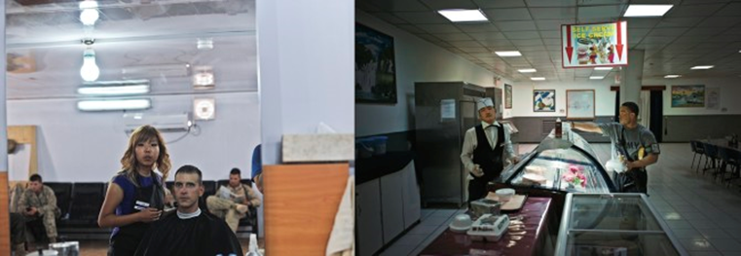
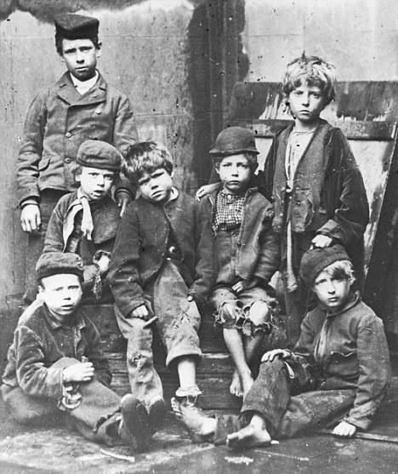
Impoverished: Children who worked were subject to appalling conditions. Many who worked died before they reached 25
http://www.newyorker.com/reporting/2011/06/06/110606fa_fact_stillman?currentPage=all
http://www.dailymail.co.uk/news/article-1312764/Britains-child-slaves-New-book-says-misery-helped-forge-Britain.html
https://www.youtube.com/watch?v=GIJ7yvTNCDg
- Referring to any four of the following sources to be read for developing context—Martin Miller, “A Boxer's last Battle Royal”; Jim Crow Museum, “Negro Battle Royal”; Without Sanctuary: Photographs and Postcards of Lynchings in America; Tulsa Race War: Background; and/or James Benton Kelly, “From ‘The Birth of a Nation’ to ‘American Sniper’: In the Dark With Our Eyes Open”—compare any two of the stories read during this semester on a theme of battle royals, of lynchings and pogroms, of “lotteries” and “hunger games,” and on a on a resonant theme of “know your place” vis-à-vis the “set-up,” juxtaposing with Claude Mckay’s “America” or “If We Must Die”, with Langston Hughes’ “Mulatto” or Song for a Dark Girl”, Billie Holiday’s “Strange Fruit”, or with at least any one or two resonant poems, lyrics, or artifacts as may be linked through e-campus or as juxtaposed in quizzes. (Stories read most recently including James Baldwin, Sonny’s Blues; Ralph Ellison, “Battle Royal”; Herman Melville, “The Paradise of Bachelors and The Tartarus of Maids”; Herman Melville, Bartleby the Scrivener; Franz Kafka, The Metamorphosis; Leo Tolstoy, The Death of Ivan Ilych; Isabel Allende, “Our Secret”; Cesar Verduguez, “The Scream in Your Silence”; Nikolai Gogol, The Nose; Ernest Hemingway, “A Clean, Well-Lighted Place”)
http://www.mc.maricopa.edu/~barmd97231/SongforaDarkGirl.html
http://mixedroots.blogspot.com/2008/08/mulatto-by-langston-hughes.html
http://www.poetryfoundation.org/poem/173957
http://www.poetryfoundation.org/poem/173960
http://www.kerr-of-ardgowan.com/4.html
http://www.kerr-of-ardgowan.com/7.html
http://www.kerr-of-ardgowan.com/9.html
http://www.kerr-of-ardgowan.com/16.html
http://withoutsanctuary.org/main.html
http://www.ferris.edu/jimcrow/question/may14/battleroyal.htm
http://articles.latimes.com/2005/jan/15/entertainment/et-johnson15
http://truth-out.org/opinion/item/29420-from-birth-of-a-nation-to-american-sniper-us-in-the-dark-with-our-eyes-open
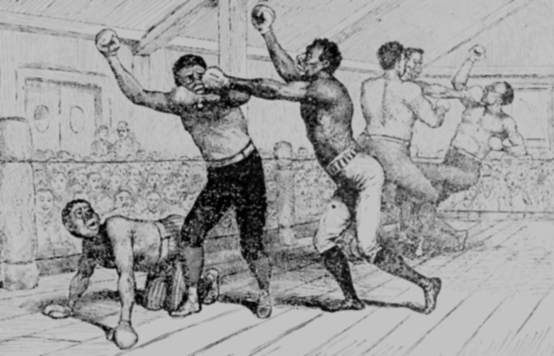
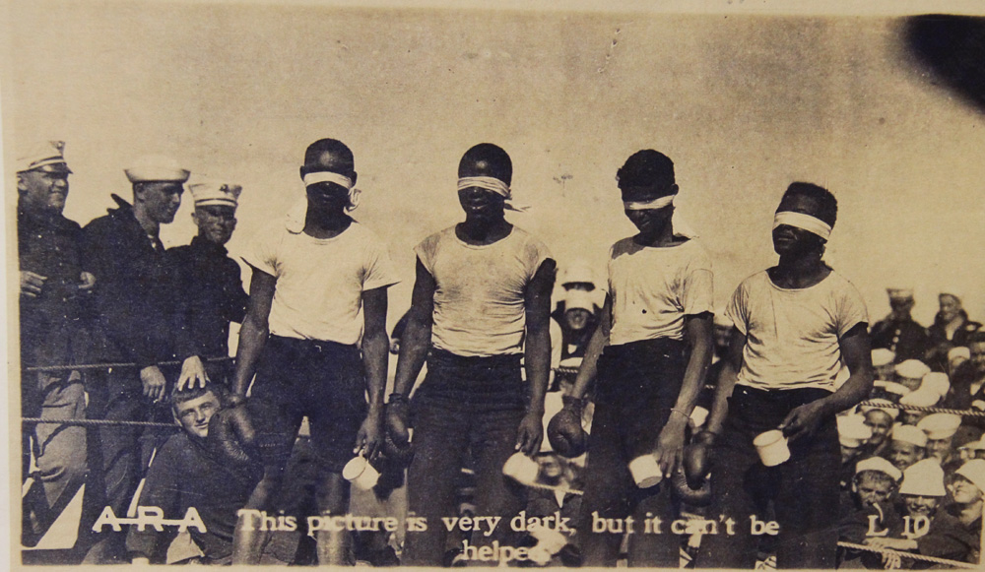
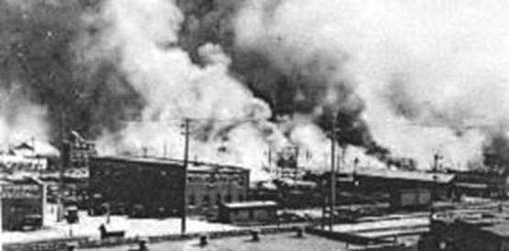
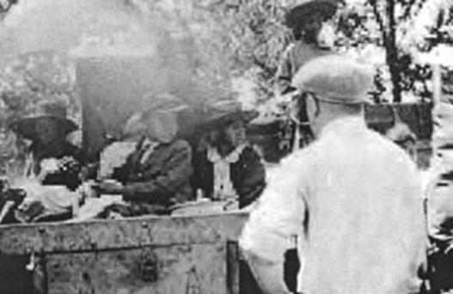
Black children held prisoners-of-war
by Tulsa City Government.
- “After these light skirmishers had vanished, the heavy artillery of the feast marched in, led by that well-known English generalissimo, roast beef . . .”
~ Herman Melville. “The Paradise of Bachelors and the Tartarus of Maids”
“At the period just preceding the advent of Bartleby, I had two persons as copyists in my employment, and a promising lad as an office-boy. First, Turkey; second, Nippers; third, Ginger Nut.”
. . . . . . . . . . . . . . . . . . . . . . . . . . . . . . . . . . . . . . . . . . . . . . . . . . . . . . . . . . . . . . . . . . .
“Bartleby, this is Mr. Cutlets; you will find him very useful to you.”
~ Herman Melville. Bartleby the Scrivener
“As they turned the corner on each floor they disappeared and would reappear a few moments later; the further down they went, the more that the Samsa family lost interest in them; when a butcher's boy, proud of posture with his tray on his head, passed them on his way up and came nearer than they were, Mr. Samsa and the women came away from the landing and went, as if relieved, back into the flat.”
~ Franz Kafka. The Metamorphosis
On the basis of this quote, which is to say on a theme of butchery and cannibalism, or on a resonant theme of cogs in the machine, of interchangeable parts and consummables—of “not so much seem[ing] accessory wheels to the general machinery as mere cogs to the wheels” (“know your place”) vis-à-vis the scythe and the slaughter . . . “dancing on the corpses ashes,” the buffet and the bachelors’ banquet, the rich man’s sucking Lazarus’s jugular unto death (the institutional “set-up”)—compare any two of the stories read during this semester, juxtaposing with Charles Simic’s “Fork” or “Butcher Shop”, or with at least any one or two resonant poems, lyrics, or artifacts as may be linked through e-campus or below or as juxtaposed in quizzes. (Stories read most recently including Herman Melville, “The Paradise of Bachelors and The Tartarus of Maids”; Herman Melville, Bartleby the Scrivener; James Baldwin, Sonny’s Blues; Ralph Ellison, “Battle Royal”; Franz Kafka, The Metamorphosis; Leo Tolstoy, The Death of Ivan Ilych; Isabel Allende, “Our Secret”; Cesar Verduguez, “The Scream in Your Silence”; Nikolai Gogol, The Nose; Ernest Hemingway, “A Clean, Well-Lighted Place”)
Faces of Lost Youth: Adolescent girls from Bibb Mfg. Co. in Macon, Georgia.
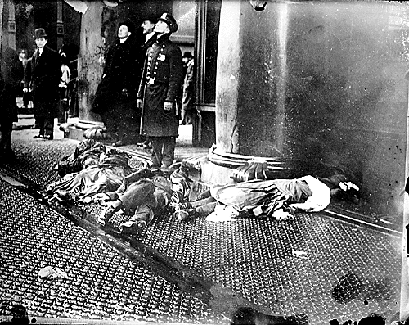
Police and onlookers standing by the bodies of women who leapt from the burning building.
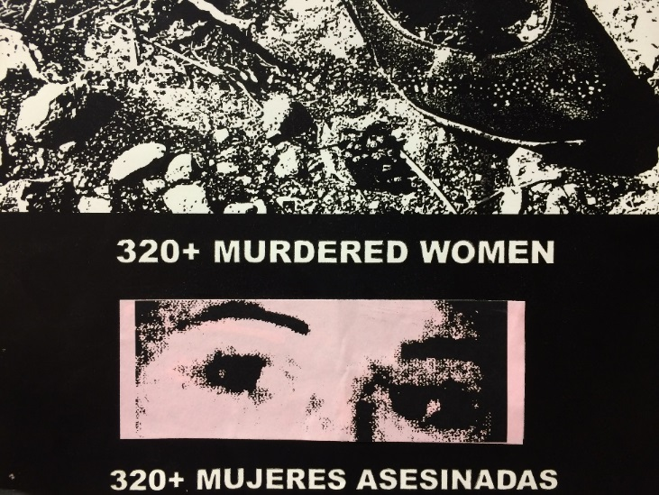
From the femicides in Juarez, to the disappearing Indigenous women of Canada, mass incidences of violence against women and specifically women of color continue to go unchecked and even supported through worldwide government inaction.
https://www.youtube.com/watch?v=8wR1MVdDmUA
http://www.spiegel.de/international/business/european-companies-linked-to-collapsed-bangladesh-factories-a-897149.html
http://people.southwestern.edu/~bednarb/su_netWorks/projects/teters/index.html
http://www.english.illinois.edu/maps/poets/m_r/pinsky/triangle.htm
http://www.democracynow.org/2006/1/4/forced_abortions_sweatshops_a_look_at
http://www.globalexchange.org/blogs/peopletopeople/2010/12/13/meet-chie-abad-activist-and-former-sweatshop-worker/
http://www.historyplace.com/unitedstates/childlabor/index.html
https://www.biblegateway.com/passage/?search=Luke+16:19-31&version=KJV
http://www.poetryfoundation.org/poem/171686
http://www.animaladvocate.net/writing/simic.html
- “I would prefer not to.”
~ Herman Melville. Bartleby the Scrivener
“’I want to play jazz,’ he said.
. . . . . . . . . . . . . . . . . . . . . . . . . . . . . . . . . . . . . . . . . . . . . . . . . . . . . . . . . . . . . . . . . .
I suggested, helpfully: ‘You mean—like Louis Armstrong?’ . . . ‘No. I’m not talking about none of that old-time, down home crap.’”
~ James Baldwin. Sonny’s Blues
On the basis of these quotes, which is to say on a theme of civil disobedience or existential freedom, of opting out of complicity in “dead letters,” or in being accessory to a killing machinery—accessory to the shenanigans of “counselors and kings,” accessory to Omelas, lotteries, and hunger games—compare any two of the stories read during this semester, juxtaposing with at least any one or two resonant poems, lyrics, or artifacts as may be linked through e-campus or below or as juxtaposed in quizzes. (Stories read most recently including Herman Melville, “The Paradise of Bachelors and The Tartarus of Maids”; Herman Melville, Bartleby the Scrivener; James Baldwin, Sonny’s Blues; Ralph Ellison, “Battle Royal”; Franz Kafka, The Metamorphosis; Leo Tolstoy, The Death of Ivan Ilych; Isabel Allende, “Our Secret”; Cesar Verduguez, “The Scream in Your Silence”; Nikolai Gogol, The Nose; Ernest Hemingway, “A Clean, Well-Lighted Place”)
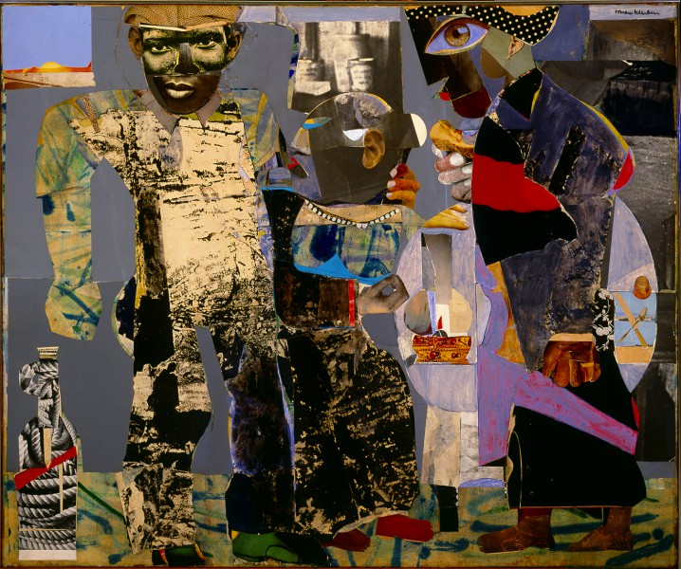
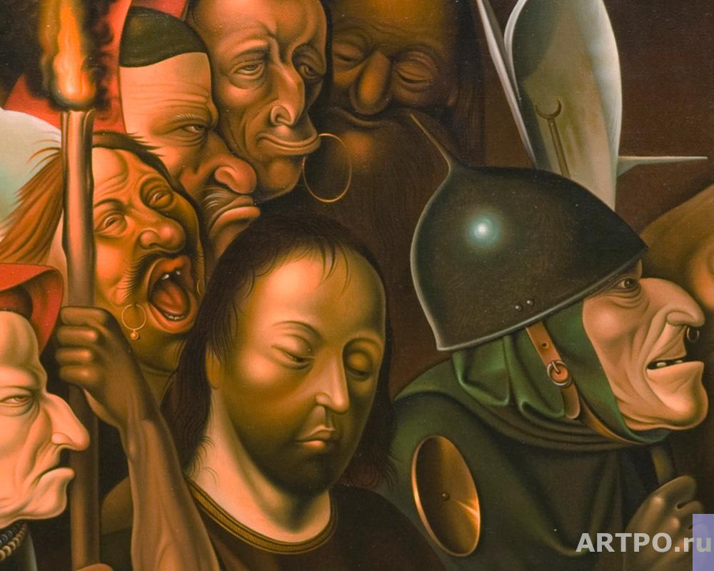
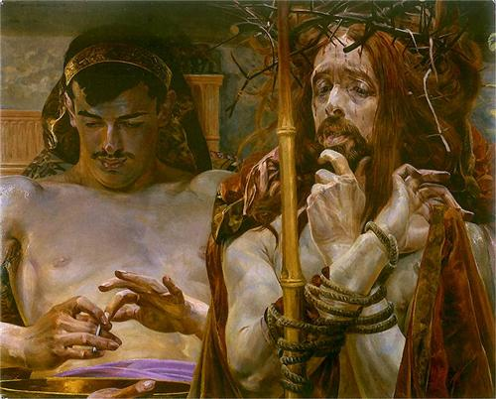
https://www.biblegateway.com/passage/?search=Mark+15&version=KJV
https://www.biblegateway.com/passage/?search=Matthew%2027&version=KJV
https://www.biblegateway.com/passage/?search=Luke%2023&version=KJV
http://www.wikiart.org/en/jacek-malczewski/christ-before-pilate-1910
http://www.internetmonk.com/wp-content/uploads/2007/11/marcella-paliekara-suffering-servant-2005_jpg.jpg
http://en.wikipedia.org/wiki/File:Christos_Acheiropoietos.jpg
http://artpo.ru/en/p603?img=660&
http://www.albrightknox.org/collection/collection-highlights/piece:bearden-return-prodigal-son/
http://linhdinhphotos.blogspot.com/2015/03/ali-razeens-hell-of-our-present.html
https://www.youtube.com/watch?v=Mk1U1yHcnR8
- Dead letters! does it not sound like dead men? Conceive a man by nature and misfortune prone to a pallid hopelessness, can any business seem more fitted to heighten it than that of continually handling these dead letters and assorting them for the flames? For by the cart-load they are annually burned. Sometimes from out the folded paper the pale clerk takes a ring:—the finger it was meant for, perhaps, moulders in the grave; a bank-note sent in swiftest charity:—he whom it would relieve, nor eats nor hungers any more; pardon for those who died despairing; hope for those who died unhoping; good tidings for those who died stifled by unrelieved calamities. On errands of life, these letters speed to death.
~ Herman Melville. Bartleby the Scrivener
Then Creole stepped forward to remind them that what they were playing was the blues. He hit something in all of them, he hit something in me, myself, and the music tightened and deepened, apprehension began to beat the air. Creole began to tell us what the blues were all about. They were not about anything very new. He and his boys up there were keeping it new, at the risk of ruin, destruction, madness and death, in order to find new ways to make us listen. For, while the tale of how we suffer, and how we are delighted, and how we may triumph is never new, it must always be heard. There isn't any other tale to tell, it's the only light we've got in all this darkness.
~ James Baldwin. Sonny’s Blues
On the basis of these quotes, which is to say on a theme of The Word’s being primal—being sacred—as Light and as agent of Love’s redeeming potency—(“In the beginning was the Word, and the Word was with God, and the Word was God.” ~ John 1:1; “Whoever does not love does not know God, because God is love.” ~ 1 John 4:8)—compare any two of the stories read during this semester, juxtaposing with at least any one or two resonant poems, lyrics, or artifacts as may be linked through e-campus or below or as juxtaposed in quizzes. (Stories read most recently including Herman Melville, “The Paradise of Bachelors and The Tartarus of Maids”; Herman Melville, Bartleby the Scrivener; James Baldwin, Sonny’s Blues; Ralph Ellison, “Battle Royal”; Franz Kafka, The Metamorphosis; Leo Tolstoy, The Death of Ivan Ilych; Isabel Allende, “Our Secret”; Cesar Verduguez, “The Scream in Your Silence”; Nikolai Gogol, The Nose; Ernest Hemingway, “A Clean, Well-Lighted Place”)
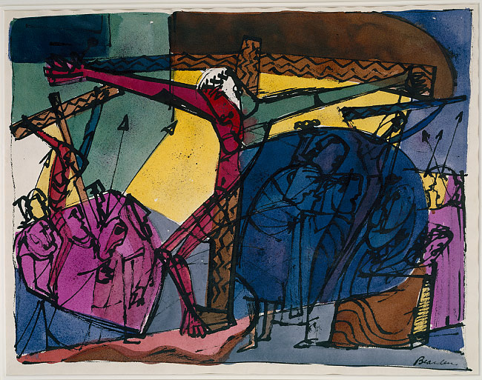
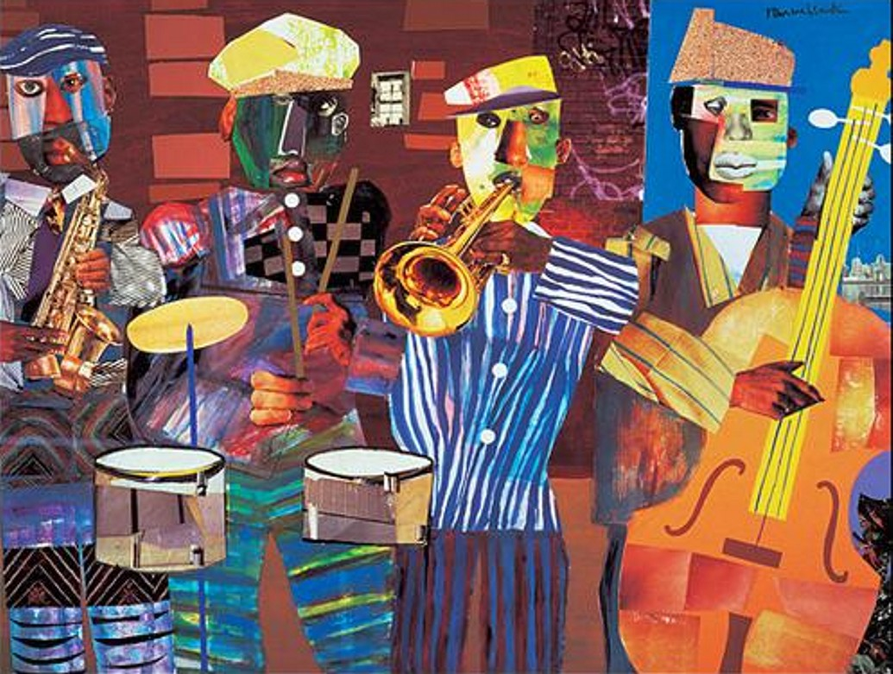

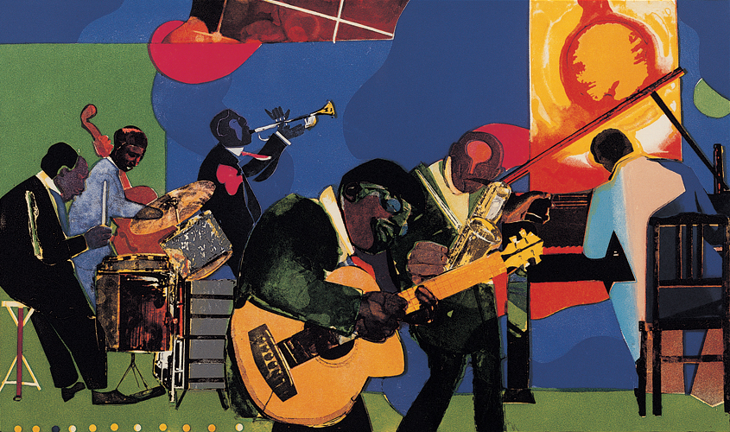
https://stephenaroth.files.wordpress.com/2013/11/2008-romare-bearden-calendar-front2_its-a-black-thing.jpg
http://www.wikiart.org/en/romare-bearden/golgotha
http://www.beardenfoundation.org/artlife/beardensart/collage/artwork/return_of_the_prod_i.shtml
http://en.wikipedia.org/wiki/Book_of_Kells
https://www.youtube.com/watch?v=4zLfCnGVeL4
https://www.youtube.com/watch?v=QQPHglh1WsQ

- One morning, when Gregor Samsa woke from troubled dreams, he found himself transformed in his bed into a horrible vermin.
~ Franz Kafka. The Metamorphosis
Collegiate Assessor Kovalyov woke up rather early and made a ‘brring’ noise with his lips. He always did this when he woke up, though, if you asked him why, he could not give any good reason. Kovalyov stretched himself and asked for the small mirror that stood on the table to be brought over to him. He wanted to have a look at a pimple that had made its appearance on his nose the previous evening, but to his extreme astonishment found that instead of a nose there was nothing but an absolutely flat surface! In a terrible panic Kovalyov asked for some water and rubbed his eyes with a towel. No mistake about it: his nose had gone.
~ Nikolai Gogol. The Nose
On the basis of these quotes, which is to say on a common narrative, on a resonant theme of Metamorphosis in the Machine, which is to say a theme of totalitarian terror and the absurdity thereof—vermin and man: digits, widgets, accessories and humanity; economy, efficiency, utility and disposability—compare any two of the stories read during this semester, juxtaposing with at least any one or two resonant poems, lyrics, or artifacts as may be linked through e-campus or below or as juxtaposed in quizzes. (Stories read most recently including Herman Melville, “The Paradise of Bachelors and The Tartarus of Maids”; Herman Melville, Bartleby the Scrivener; James Baldwin, Sonny’s Blues; Ralph Ellison, “Battle Royal”; Franz Kafka, The Metamorphosis; Leo Tolstoy, The Death of Ivan Ilych; Isabel Allende, “Our Secret”; Cesar Verduguez, “The Scream in Your Silence”; Nikolai Gogol, The Nose; Ernest Hemingway, “A Clean, Well-Lighted Place” )
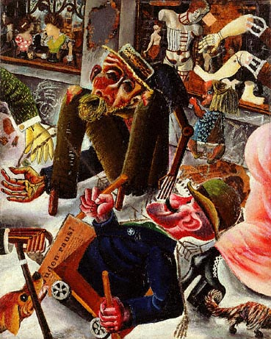

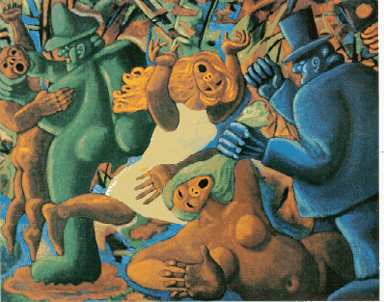
http://www.newyorker.com/magazine/2011/06/06/the-invisible-army?currentPage=all
http://www.poetryfoundation.org/poem/171686
http://www.animaladvocate.net/writing/simic.html
http://www.epilogue.net/art/29563-insect-archaeologists
http://www.humanitiesweb.org/human.php?s=g&p=c&a=p&ID=1473

- “Who in this exhausted and overworked family had time to worry about Gregor any more than was absolutely necessary?”
~ Kafka. The Metamorphosis;
“The nose looked at the major and scowled slightly. ‘You are mistaken, my dear sir. I am by myself. Besides, there can be no close relationship between us. Judging by the buttons on your uniform, you must serve in a different department”
~ Nikolai Gogol. “The Nose”
On the basis of these quotes, which is to say on a resonant theme of apocalypse as entropy or the death of love, love frozen to absolute zero, in antithesis to Love and the imperative of love’s kindling and rekindling—( All the way from where we came / Built a mansion in a day /Distant lightning, thunder claps / Watch our neighbor's house collapse / Looked the other way / And then the storm was overhead / All the oceans boiled and rivers bled / We auctioned off our memories / In the absence of a breeze / Scatter what remains, /Scatter what remains! ~ Metric. “Speed the Collapse”; Why didn't you come / When I beat my drum / And screamed off my head / Out into the rain / Your mother told you / Our father stopped you / Out of the hospitals you are afraid / When universe will collide / Don't get caught on the wrong side ~ Gogol Bordello. “When Universes Collide”; “And because iniquity shall abound, the love of many shall wax cold. But he that shall endure unto the end, the same shall be saved.” ~ Matthew: 12-13)—compare any two of the stories read during this semester, juxtaposing with at least any one or two resonant poems, lyrics, or artifacts as may be linked through e-campus or below or as juxtaposed in quizzes. (Stories read most recently including Herman Melville, “The Paradise of Bachelors and The Tartarus of Maids”; Herman Melville, Bartleby the Scrivener; James Baldwin, Sonny’s Blues; Ralph Ellison, “Battle Royal”; Franz Kafka, The Metamorphosis; Leo Tolstoy, The Death of Ivan Ilych; Isabel Allende, “Our Secret”; Cesar Verduguez, “The Scream in Your Silence”; Nikolai Gogol, The Nose; Ernest Hemingway, “A Clean, Well-Lighted Place” )
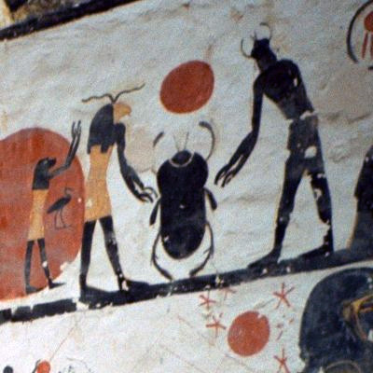

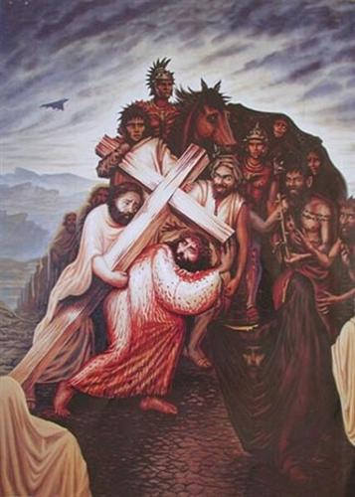
http://www.wikiart.org/en/octavio-ocampo/jesus-christ
http://en.wikipedia.org/wiki/Dung_beetle
http://graphicwitness.org/group/duress.htm
http://graphicwitness.org/group/thirst.gif
https://www.youtube.com/watch?v=hfcOc6ss5rw
https://www.youtube.com/watch?v=x3hwPiHosFY
https://www.youtube.com/watch?v=YlOir1yOhXo
https://www.youtube.com/watch?v=CsLhNxzwK1Y
https://www.youtube.com/watch?v=rH1XTOBF0YQ

- As reader, applying such critical perspective—historical, political/socio/economic, philosophical, metaphysical or otherwise—as the texts linked below enable to contextualize the literature, develop a comparative analysis of how the narrator of Ralph Ellison’s “Battle Royal” suffers his battle royal, his “lottery,” in common with some character of any other story assigned this semester, some persona of any poem or lyric juxtaposed through e-campus, quizzes or otherwise, and the human subjects of any one or two of the linked articles.
http://www.eji.org/lynchinginamerica/
http://www.slate.com/articles/news_and_politics/politics/2003/07/stroms_skeleton.html
http://www.democracynow.org/2015/2/4/johann_hari_everything_we_know_about

Yeah, not far from where we are now, in 1939, Billie Holiday stands on stage in a hotel, and she sings the song "Strange Fruit," which obviously your viewers will know is an anti-lynching song. Her goddaughter Lorraine Feather said to me, "You’ve got to understand how shocking this was, right?" Billie Holiday wasn’t allowed to walk through the front door of that hotel; she had to go through the service elevator. To have an African-American woman standing up, at a time when most pop songs were like twee, you know, "P.S. I Love You," that kind of thing, singing against lynching in front of a white audience was regarded as really shocking. And that night, according to her biographer, Julia Blackburn, she’s told by the Federal Bureau of Narcotics, "Stop singing this song."
Federal Bureau of Narcotics was run by a man called Harry Anslinger, who I think is the most influential person who no one’s ever heard of. Harry Anslinger takes over the Department of Prohibition just as alcohol prohibition is ending, and he wants to find a new purpose for it. You know, he’s got this huge bureaucracy he wants to run. And he’s really driven by two passions: an intense hatred of African Americans—I mean, this is a guy who was regarded as a crazy racist by the crazy racists in the 1930s; he used the N-word in official police reports so often that his senator said he should have to resign—and a really strong hatred of addicts. And Billie Holiday, to him, was like the symbol of everything that was going wrong in America. And so, he gives her this order.
She refuses. She basically says, "Screw you. I’m an American citizen. I’ll say what I want." She had grown up in segregated Baltimore, and she had promised herself she would never bow her head to any white man. And that’s when Harry Anslinger begins the process of stalking her, and eventually, I think, playing a role in her death, as was explained to me by her friends and by all the archival research.
~ Johann Hari. “Everything We Know About the Drug War & Addiction is Wrong”

- As reader, applying such critical perspective—historical, political/socio/economic, philosophical, metaphysical or otherwise—as the texts linked below enable to contextualize the literature, develop a comparative analysis of how Melville’s Bartleby prefers not to be complicit in or be a party to any institutional degradation of The Word—of a classical idea of education, of the humanities, of literature, of the soul’s odyssey through the infinite—in common with some character of any other story assigned this semester, some persona of any poem or lyric or text juxtaposed through e-campus, quizzes or otherwise, and the human subjects of any one or two of the linked articles.
http://host.madison.com/news/local/govt-and-politics/scott-walker-removes-wisconsin-idea-from-uw-s-mission-in/article_75700525-7d2c-5f87-9de9-8309258c0674.html
http://www.post-gazette.com/opinion/Op-Ed/2013/09/18/Death-of-an-adjunct/stories/201309180224
http://www.slate.com/articles/news_and_politics/education/2013/11/death_of_duquesne_adjunct_margaret_mary_vojtko_what_really_happened_to_her.html
http://www.theguardian.com/us-news/2016/feb/24/university-of-houston-faculty-campus-carry-law-texas-guns

In Section 1111 of Walker’s proposed budget legislation, Senate Bill 21, he strikes language specifying that the UW has a public service mission to “extend knowledge and its application beyond the boundaries of its campus" and to "serve and stimulate society."
Walker adds “to meet the state’s workforce needs" as a core mission of the university.
Walker also strikes language ensuring that the mission of the UW is to extend "training and public service designed to educate people and improve the human condition," as well as the language: "Basic to every purpose of the system is the search for truth."
The Wisconsin Idea dates back more than a century, about which UW President Charles Van Hise commented he would “never be content until the beneficent influence of the university reaches every family in the state.”
Walker’s proposed revised statute reads:
36.01 (2) The mission of the system is to develop human resources to meet the state’s workforce needs, to discover and disseminate knowledge, to extend knowledge and its application beyond the boundaries of its campuses and to serve and stimulate society by developing develop in students heightened intellectual, cultural, and humane sensitivities, scientific, professional and technological expertise, and a sense of purpose. Inherent in this broad mission are methods of instruction, research, extended training and public service designed to educate people and improve the human condition. Basic to every purpose of the system is the search for truth.
(Yellow highlighting: Walker’s addition. Red highlighting: Walker’s deletions.)
Read more: http://host.madison.com/news/local/govt-and-politics/scott-walker-removes-wisconsin-idea-from-uw-s-mission-in/article_75700525-7d2c-5f87-9de9-8309258c0674.html#ixzz3ViPoq7XX
- As reader, applying such critical perspective—historical, political/socio/economic, philosophical, metaphysical or otherwise—as the texts linked below enable to contextualize the literature, develop a comparative analysis of how Kafka’s Gregor Samsa seems to detect some toxicity, a stench of fascist / moloch obscenity menacing Gregor as it in fact menaced Kafka and his sisters (see excerpts from Janouch’s Conversations With Kafka), in common with some character of any other story assigned this semester, some persona of any poem or lyric or text otherwise juxtaposed through e-campus, quizzes or otherwise, and the reading audience of any one or two or three of the linked articles.
http://www.belfasttelegraph.co.uk/opinion/john-pilger-why-the-rise-of-fascism-is-again-the-issue-31040612.html
http://www.nobelprize.org/nobel_prizes/literature/laureates/2005/pinter-lecture-e.html
https://consortiumnews.com/2015/03/27/neocons-the-echo-of-german-fascism/
https://consortiumnews.com/2015/03/20/a-family-business-of-perpetual-war/
http://truth-out.org/news/item/29863-beyond-homan-square-us-history-is-steeped-in-torture

“I have referred to death quite a few times this evening. I shall now quote a poem of my own called 'Death'.”

Where was the dead body found?
Who found the dead body?
Was the dead body dead when found?
How was the dead body found?
Who was the dead body?
Who was the father or daughter or brother
Or uncle or sister or mother or son
Of the dead and abandoned body?
Was the body dead when abandoned?
Was the body abandoned?
By whom had it been abandoned?
Was the dead body naked or dressed for a journey?
What made you declare the dead body dead?
Did you declare the dead body dead?
How well did you know the dead body?
How did you know the dead body was dead?
Did you wash the dead body
Did you close both its eyes
Did you bury the body
Did you leave it abandoned
Did you kiss the dead body

~ Harold Pinter
- As reader, applying such critical perspective—historical, political/socio/economic, philosophical, metaphysical or otherwise—as the texts linked below enable to contextualize the literature, develop a comparative analysis of how Allende’s anonymous love-seekers, or Verduguez’s trinity of son, mother and father, both undergo a passion, a dying for love, and are tortured—cannibalized by the beast, from the outside in and from the inside out—in common with some character of any other story assigned this semester, some persona of any poem or lyric or text otherwise juxtaposed through e-campus, quizzes or otherwise, and the late Chilean musician Victor Jara, as explained or evidenced in one or two or three of the linked texts.
https://www.youtube.com/watch?v=en8yqVxuT-U
http://www.latimes.com/news/la-oe-zirin12dec12-story.html
http://upsidedownworld.org/main/chile-archives-34/1880-chile-ex-soldier-arrested-for-vor-jara-murder
http://www.commondreams.org/views/2008/05/22/why-bananas-are-parable-our-times
https://networks.h-net.org/node/28443/reviews/30323/neagle-menjivar-and-rodriguez-when-states-kill-latin-america-us-and

I don’t sing for love of singing / Or to show off my voice / But for the statements
made / By my honest guitar / For its heart is of the earth / And like the dove it goes flying.... / Endlessly as holy water / Blessing the brave and the dying / So my song has found a purpose / As Violet Parra would say. / Yes, my guitar is a worker /
Shining and smelling of spring / My guitar is not for killers / Greedy for money and power / But for the people who labour / So that the future may flower. / For a song takes on a meaning / When its own heart beat is strong / Sung by a man who will die singing / Truthfully singing his song. / I don’t care for adulation / Or so that strangers may weep. / I sing for a far strip of country / Narrow but endlessly deep.

~ Victor Jara—“Manifiesto”

All I could think of was: My God! This is National Stadium, where the bleachers were once filled with dissidents of every stripe after the coup, a mass waiting room for those about to be executed or tortured. This is where women were raped for the crime of wearing pants.
And it was at nearby Chile Stadium where the great Victor Jara — the Bob Dylan of Chile and a political activist (or was Dylan the Victor Jara of the U.S.?) — was murdered by the Pinochet regime. Jara's fingers were mutilated in front of thousands of other prisoners. He attempted to sing songs of resistance, his hands bloody stumps, only to be gunned down as people in the stands tried to join him in chorus.
I didn't want to be near these places any more than I would want to watch a baseball game at Auschwitz.
~ Dave Zirin

- As reader, applying such critical perspective—historical, political/socio/economic, philosophical, metaphysical or otherwise—as the texts linked below enable to contextualize the literature, develop a comparative analysis of how Gogol’s narrative of The Nose develops or even “systematizes” apocalypse out of systemic, institutional implosion/explosion—entropy, “the blizzard of the world”—civilization’s ultimate failure so-to-speak—in common with any other story assigned this semester, some persona of any poem or lyric or text otherwise juxtaposed through e-campus, quizzes or otherwise, and both the article and the song lyric linked below.
http://truth-out.org/opinion/item/29664-the-four-horsemen-of-the-apocalypse
https://www.youtube.com/watch?v=0V0Vu_utUZY
https://www.youtube.com/watch?v=mkRqQQWu_mA

It's nature's way of telling you something's wrong
It's nature's way of telling you in a song
It's nature's way of receiving you
It's nature's way of retrieving you
It's nature's way of telling you something's wrong
It's nature's way of telling you, summer breeze
It's nature's way of telling you, dying trees
It's nature's way of receiving you
It's nature's way of retrieving you
It's nature's way of telling you something's wrong
It's nature's way, it's nature's way
It's nature's way, it's nature's way
It's nature's way of telling you something's wrong
It's nature's way of telling you in a song
It's nature's way of receiving you
It's nature's way
It's nature's way of retrieving you
It's nature's way
It's nature's way of telling you something's wrong
Something's wrong, something's wrong
~ Randy California. “Nature’s Way”

Things are going to slide
Slide in all directions
Won't be nothing
Nothing you can measure anymore
The blizzard
The blizzard of the world
Has crossed the threshold
And it's overturned the order of the soul
~ Leonard Cohen. “The Future”

