Fallacies Scavenger Hunt

You need to find 2 fallacies from each of the 3 Aristotelian Appeals: Ethos, Pathos, and Logos.
Look at website, blog articles, editorials, syndicated columns, news reports, interviews, speeches, advertisements (digital as well as print) and cartoons for Fallacies.
Explain the fallacy in depth. Why did you think this was a fallacy and what fallacy was used. Do not assume your teacher will understand the fallacy. It is your job to clarify in detail the fallacious nature of that fallacy.

Emotional Appeal Fallacies (Pathos)
1)
"A vote for the Democrats in November is a vote to let MS-13 run wild in our communities."
(From the speech of Donald Trump)
(Website: https://www.cnn.com/2018/07/06/politics/donald-trump-montana-speech/index.html)

(Scare Tactics)
-This part of the speech is a fallacy. MS-13 is a criminal gang here in the U.S... Also, there are no documented association between this gang and the Democratic Party. So, President Trump is just using this false analogy to alarm voters, to vote against the Democratic candidates this upcoming election.
2)
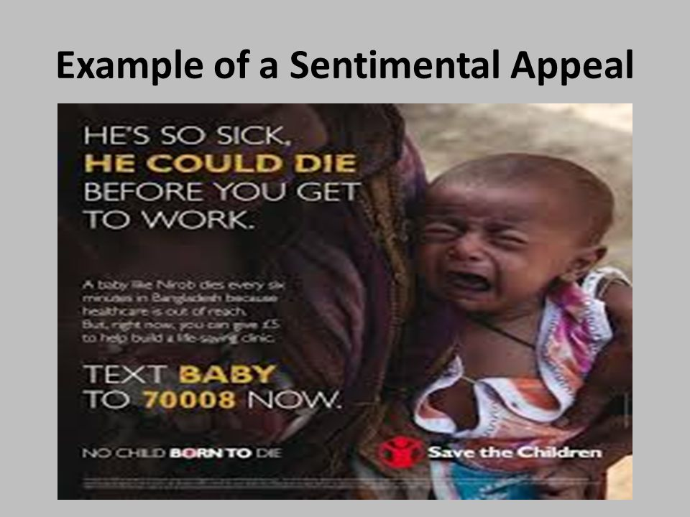

(Website: https://www.google.com/search?q=overly+sentimental+fallacy+examples&source=lnms&tbm=isch&sa=X&ved=0ahUKEwibi4-C6O3dAhVM- qwKHdYfDBwQ_AUIDygC&biw=1707&bih=821)
(Overly Sentimental Appeal)
- It showed the child crying in his mother’s arms, with dingy clothes, with a text saying “he could die before you get to work”. This picture is a fallacy because it overly state the fact to affect the individual’s emotion and feel guilty into donating for this cause. But, there are no known fact that this child will die if you don’t donate.

Ethical Appeal Fallacies (Ethos)
1)
“I just realized that if you listen to Carly Fiorina for more than ten minutes straight, you develop a massive headache. She has zero chance!”
12:06 PM - Aug 9, 2015 (tweeted by Donald Trump)

(Ad Hominem Argument)
-It is a fallacy. Carly Fiorina is one of Donald Trump’s opponent in 2015 for the republican nomination for President. Mr. Trump at that time tweeted a critique of Carly Fiorina’s way of speaking, instead of her ideas or opinions.

2)
“I have lost 26 lbs., and I have eaten bread every day”
(Video testimonial by Oprah Winfrey for weight watchers)
(Website: https://twitter.com/Oprah/status/692031497373548545)

(Appeals to False Authority)
-Oprah Winfrey is one of the most recognizable personality in the world, but she is not a medical doctor, nor a registered dietician, which makes her statement a fallacy. Since bread is a carbohydrate, unless it is burned through exercise, it would turn into fat and cause weight gain. Simple carbohydrates cause more weight gain than complex carbohydrates, it includes sugar and starches (JAMA network, 2014).
(Ref: https://jamanetwork.com/journals/jama/fullarticle/1900513)

Logical Appeal Fallacies (logos)

1)
"Winning the Electoral College is very tough for a Republican, much tougher than the so-called 'popular vote,' where people vote four times, you know. Much tougher. Much, much tougher."
(From the speech of Donald Trump)
(Website: https://www.cnn.com/2018/07/06/politics/donald-trump-montana-speech/index.html)

(Faulty Analogy)
- Donald Trump’s speech is a fallacy. Because he won the Electoral College and not the popular vote, he made a faulty comparison by saying it is more difficult to win the Electoral College than the popular vote since, according to him, you can cheat with the popular vote, but not with the Electoral College.

2)
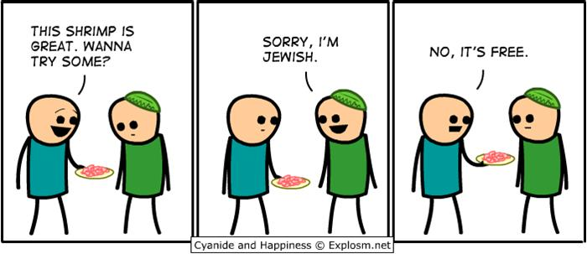
(Website: https://www.google.com/search?biw=1707&bih=821&tbm=isch&sa=1&ei=wJW2W9TNI9CWtQWk6KGAAg&q=hasty+generalization+fallacy+examples&oq=hasty+general&gs_l=img.1.1.0j0i67l3j0l6.176461.10591326..10594345...7.0..0.243.5637.30j22j1......0....1..gws-wiz-img.......0i24j0i30j0i8i30.RHx6C-csLfw#imgrc=n9OSDjHt4s_f_M:)

(Hasty Generalization)
- The illustration is stereotypical view of Jewish people as cheap, which is a fallacy. Because, even if a few people is observe with certain characteristic, it does not mean this group of people have similar behavior. Jerry Seinfeld, who is Jewish, always leave a generous tip for the waiters in his show “Comedians in Cars Having Coffee”.
(Ref: “Comedians in Cars Having Coffee” viewed in Netflix)

Jose

