Exploring Databases and Being Strategic When Conducting Research

Part 1: Exploring the Databases
1. Go the Canvas Student Resource center and access the Library. Find the Databases section and select the Go to A-Z List icon.

How many databases are in the list? ________

2. Change the All Subjects menu dropdown to correspond to your field of study at Herzing.

(For example if you are an Accounting major, select Business; if you are a Criminal Justice major, select Public Safety; if you are a Medical Assistant major, select Healthcare; if you are a Nursing major, select Nursing, etc.)

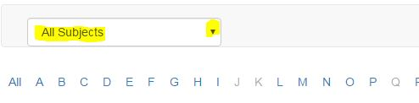
List your field of study/major at Herzing University: ________________________

List the corresponding subject from All Subjects dropdown: _________________________

How many databases are in the list? __________

3. Go back to the Databases section of the Library and notice that the same Subjects are listed. Once again, select your subject area; browse the list of databases available.

If you were assigned to write a paper about the most current issue facing your profession, which database would you select to conduct research on this topic and why?

Database name: ______________________________________________________

Explain why you chose this database:

4. Go back to the A to Z list. Once again, select Clear Filters.

Using the “Letter” menu select “P” to jump to that section, and scroll until you find ProQuest Central and select it.

This database will open up to the Basic Search Page.
Enter search terms related to a medical topic of your choice.

List your keywords/search terms: ________________________________________

5. Click on the “I” next to Peer Reviewed.
What process do peer-reviewed publications go through?

Who authors scholarly journals?

6. Check the box next to Peer Reviewed (for this step leave Full Text unchecked) and run your search.

How many results are displayed? _____________

7. Now limit to “full-text” by doing one of the following: either check the box for full-text and hit search OR look for Full-Text in the left margin under Narrow results and click that.

How many results are displayed after applying this limit? _______

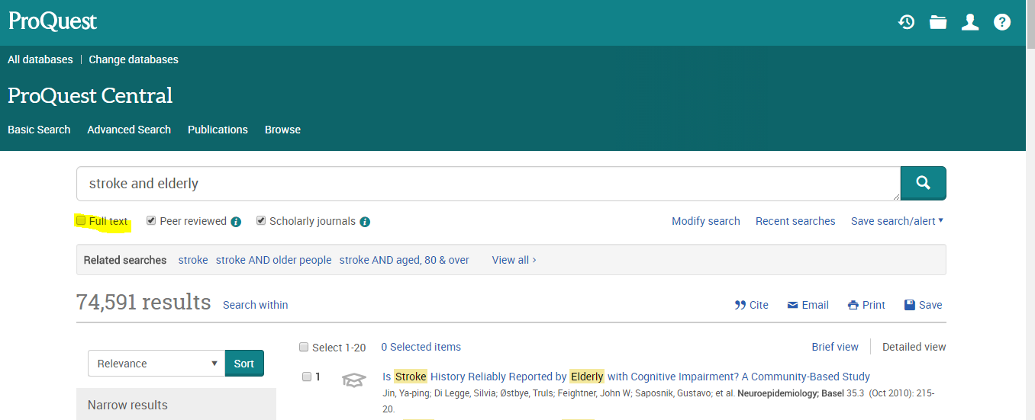

8. Scroll down to below where you are allowed to adjust the date range, on the left-hand side of the screen. What is listed there are ways you can narrow your search. Please list two of these options.

List two options:

9. Find a result that is of interest to you and select the blue title words to reveal more details about the article.

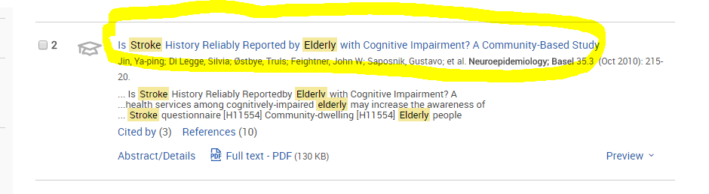

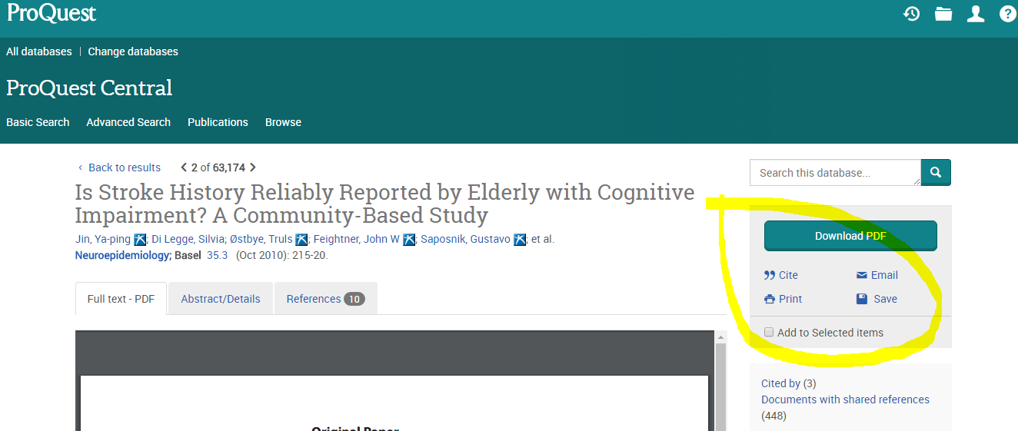

In this view of the article notice the tools at the right for downloading the PDF (if available) as well as Cite, Email, Print, and Save. Select “Cite”

Explain what the Cite button does:

Click Cancel.

10. Close out of this database and return to the A to Z List. Once again, select Clear Filters.
In the “All Subjects” drop-down menu, select Business. You will see a “Best Bets!” section at the top of the list, these are the most relevant databases related to that subject matter.

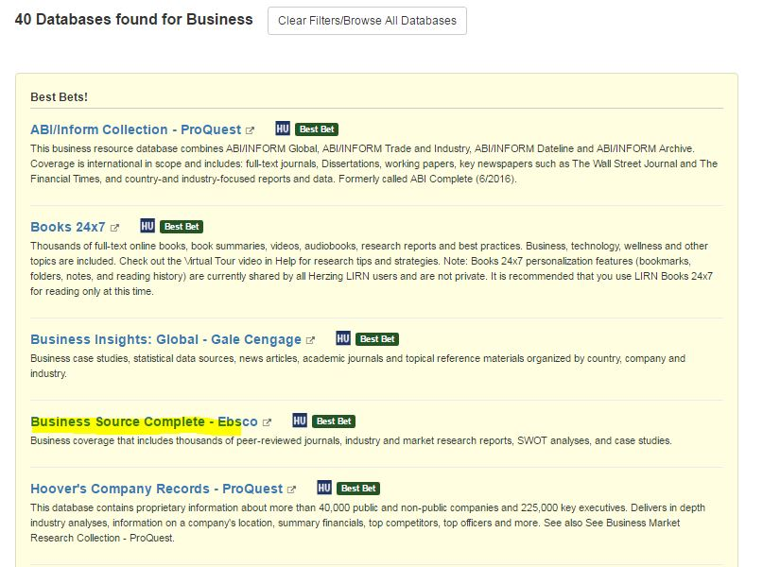

Select Business Source Complete - Ebsco from the list.

11. Business Source Complete opens up to the Advanced Search Screen
Enter search terms related to a business topic of your choice (example advertising and sports).

List your keywords/search terms: ________________________________________

In the Limit your results section, check the boxes for Full Text and Scholarly (Peer-Reviewed) Journals and run your search.

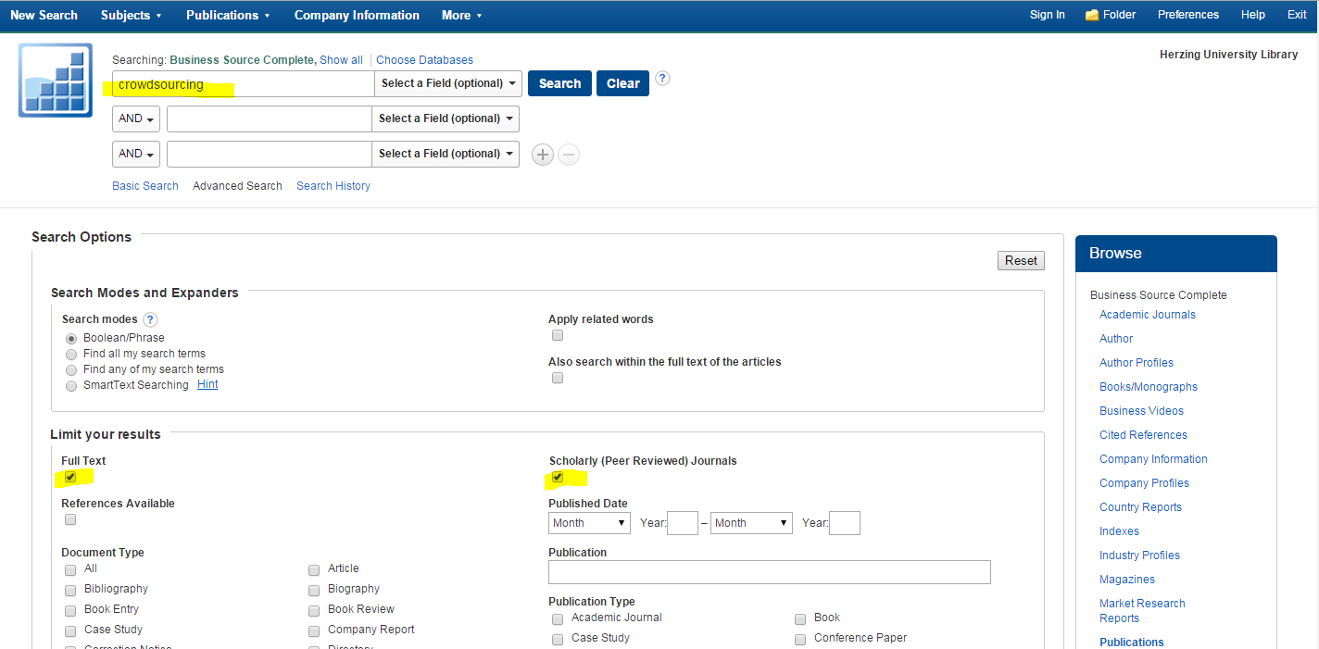

List the number of search results: _________________________________

12. On the results list, using the Limit to options on the left side of the screen move the “date slider” to change the date range of your results. Set the date range from 2010 to the present.

List the new number of search results: ____________________________

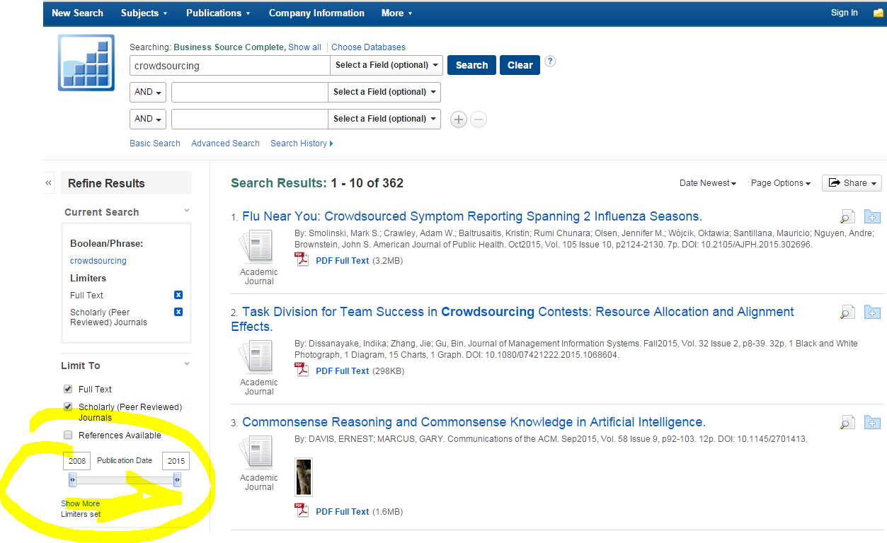

13. Select any article by clicking on the title. Notice the Tool options on the right side of the screen.

List two of the tools available:

14. Close out of this database and return to the A to Z List. Once again, select Clear Filters.
Using strategies you have learned so far find and select Films on Demand.

Search for “study skills” by titles (default).
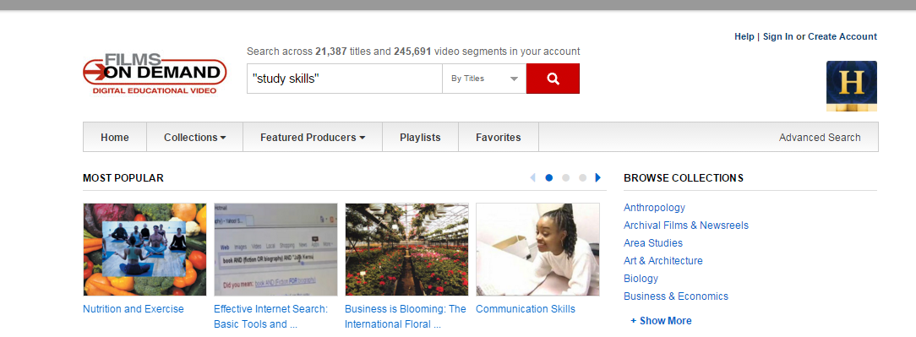

List one of the Films on Demand titles from the results list.

15. Did you know about Guides from the HU Library that contain links to the HU Library databases? Go back to the Library area in the Canvas Student Resource Center and look for the Guides section. Select a Guide of interest to you and provide your selection:

_____________________________________________________________________________________

Select the Find Articles Tab (select another guide if your first choice does not include this tab) and list one of the databases from that you find:

_____________________________________________________________________________________

Feel free to go back and explore any of these resources. Remember when you have questions on database selection and using the tools, please contact the Herzing University Librarians. They are here to assist you and all Herzing University Students.

Part 2: Being Strategic When Conducting Research

Now we will focus on the topic you have developed in the prior units. This activity will set you up for success as you use the library databases to research your topic in our next unit.

16. Enter the thesis statement you have formulated for your topic.

17. Keywords: (What are the main words that describe your subject and what you want to say about it?)

18. Synonyms: (What other words can you use that mean the same thing as your keywords?) Using synonyms EXPANDS your search.

19. Narrower Terms: (What are some specific things you want to know about the keywords?)

20. Boolean strategies:
List one Boolean search strategy you could use to broaden or narrow your search.
Example: “Marketing AND bakeries”
Example: “Cars OR automobiles"

Hint: See the next page for some search strategy reminders

21. Indicate two (2) Herzing University Library databases you will use to search for your topic:
Database #1:
Database #2:

22. Identify one (1) source (article, e-Book, video, etc.) you locate that addresses your topic. Include title, author, date of publication, which database you located it in.
Title:
Author:
Date:
Database:

23. Please describe your experience completing the library search in Part 1 of the assignment. What did you learn that you did not know before? What seemed particularly useful? Then, do the same for Part 2. How does identifying search terms, databases and a source move you forward in your research process? How will this be useful?

Use Linking Words and Symbols for Precise Results
Boolean Logic Searching – Great Search Strategy for Precise Results:
AND = documents include both one word and another. This narrows your focus.
OR = documents include one word or the other. Use with synonyms. This broadens focus.
NOT = eliminates documents with even one occurrence of the word. Use this cautiously!

Check to see if you can use a wildcard to catch multiple endings. This is also call truncation. For example, work* might get work, worked, working, work, workers. Look for Search Tips or Help on the search screen to see which symbol is used in the database or search engine you are using.

Use parenthesis for grouping or nesting terms together.

Here is a sample search: research and (skills or strateg*)

It will retrieve:
- All documents retrieved will have the word research AND all documents will have some form of the word with strateg as the root. For example, strategy, strategies, strategize would all be found and included in my results list.
- OR All documents retrieved will have the word research AND the word skills.

Most databases use Boolean linking words. So, if you entered in the search research skills without an AND connector, you would only be searching for the exact phrase research skills. You would not get occurrences such as skills in research or research and writing skills. Some databases have the option to use Boolean or not. Check out the “Advanced” search function or the Help and Search Tips links in the database.

