How much money a central bank prints may be less important to inflation than commodity prices

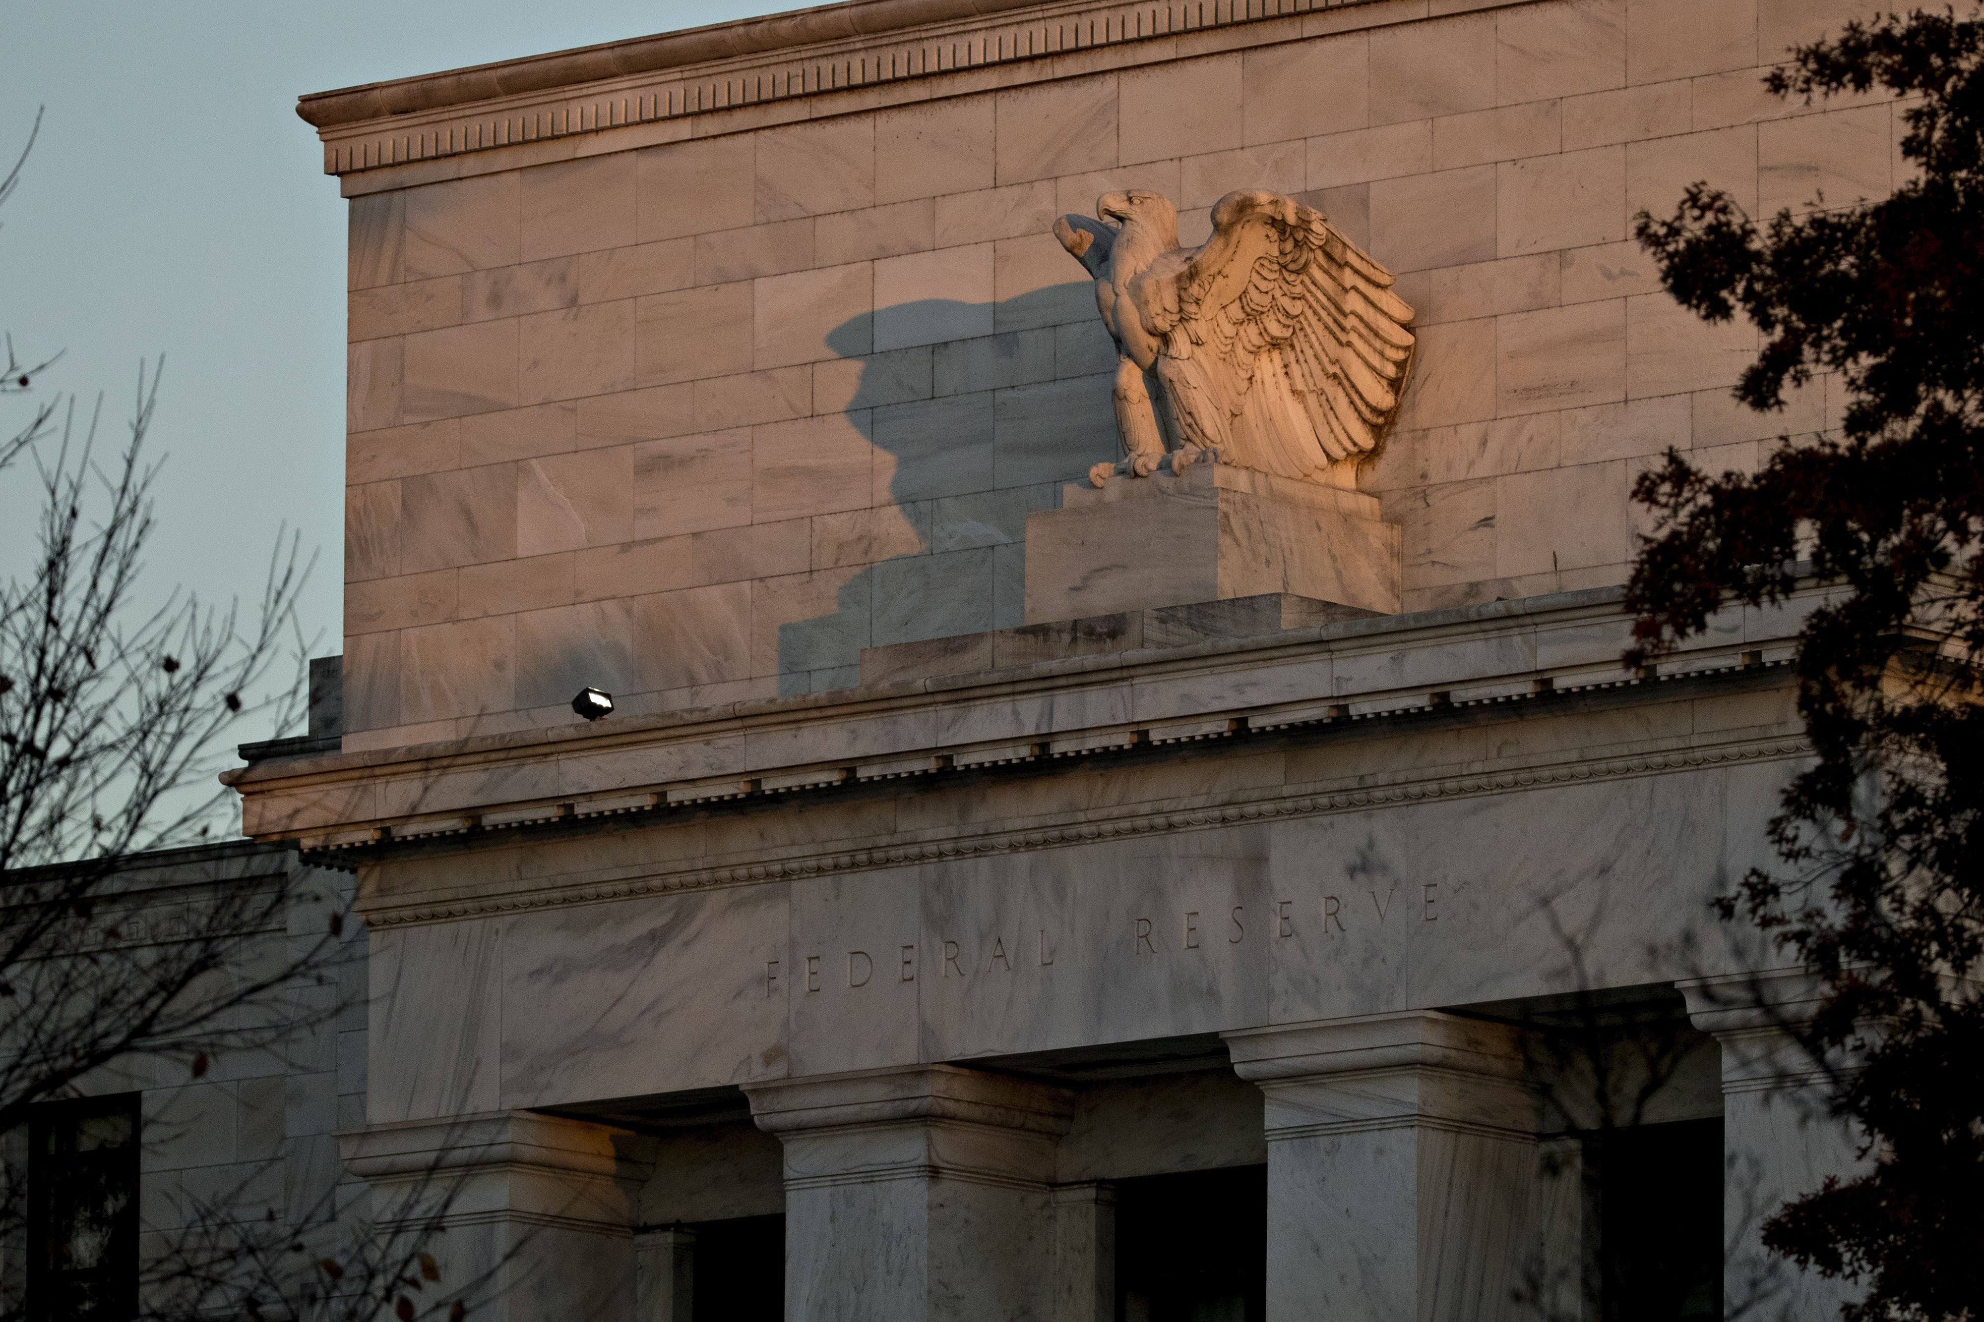

For decades, the assumption has been that central banks have the ultimate handle on inflation. Above, the Federal Reserve building in Washington, D.C. *Photo: Andrew Harrer/Bloomberg News*

By

Jon Sindreu

Jon Sindreu

The Wall Street Journal

* [BiographyJon Sindreu](https://www.wsj.com/news/author/8085)
* [@jonsindreu](http://twitter.com/jonsindreu)
* [jon.sindreu@wsj.com](mailto:jon.sindreu@wsj.com)

Updated March 6, 2017 10:23 a.m. ET

[**95 COMMENTS**](https://www.wsj.com/articles/everything-the-market-thinks-about-inflation-might-be-wrong-1488796206#livefyre-toggle-SB11455692400262464455204583000783856169650)

No number is more important for investors right now than inflation. The belief that it will continue to rise underpins the recent rally in financial stocks and the slump in government bonds. It is key to commodities, currencies and more.

Yet investors are in a quandary: Theories used to forecast it just don’t seem to work.

“I don’t think we know what inflation is. It takes so many different forms,” said David Lafferty, chief strategist at Natixis Global Asset Management, which manages about $900 billion. Inflation is this year’s “wild card,” Mr. Lafferty said.

For decades, the assumption has been that central banks have the ultimate handle on inflation. When inflation goes up, they raise interest rates to quell it; when it goes down, they lower the rates.

Investors care a lot, because bond yields broadly track interest rates. They need to predict inflation levels as well as how central banks would react.

Neither is easy, and it just got more complicated: After years of postcrisis monetary experimentation, it’s not even clear central bankers can do much about inflation at all.

On Friday, five top economists presented a paper at a monetary-policy conference saying the main gauges policy makers typically use to understand inflation—such as “slack” in the labor market—[don’t actually explain it](https://research.chicagobooth.edu/~/media/806FC2DED9644B5DA99518D2B07CC637.pdf).

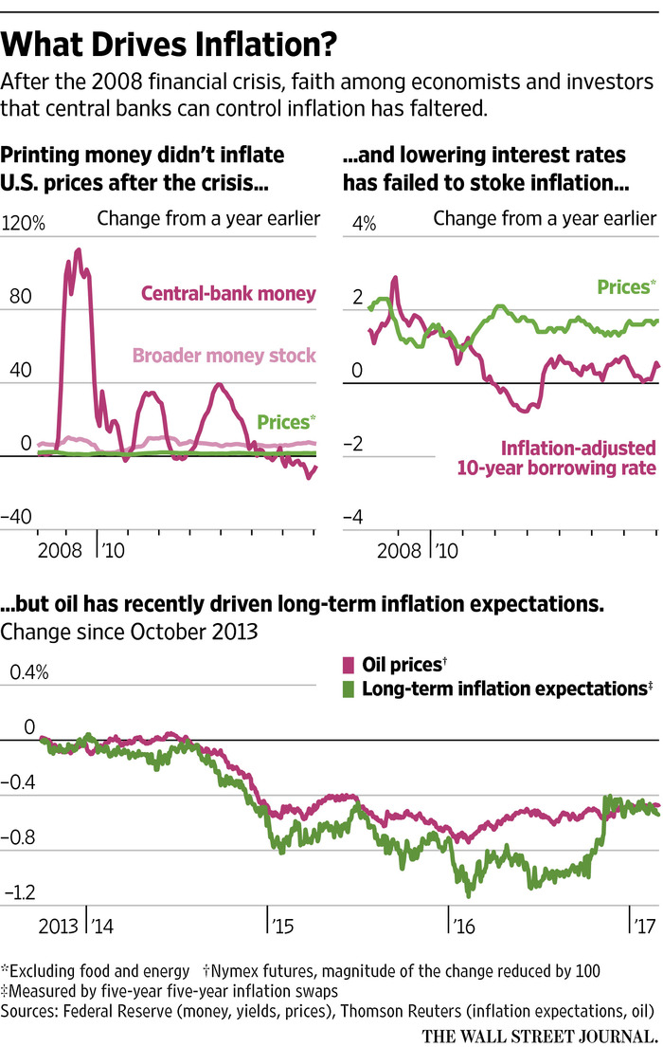

What’s more, the last several years of extraordinary monetary policy have shaken a theory that had held sway for decades in financial markets: American economist Milton Friedman’s view that inflation is ultimately a function of how much money a central bank prints.

That theory posits that if the economy has only two apples and two dollars, each apple has to be worth $1. When the central bank issues two more dollars, there is suddenly $2 for every apple: inflation. And what people think inflation will be in the future is crucial: Workers will bargain harder for pay raises if they believe prices will rise faster in the years to come.

Yet, after the 2008 crisis hit, central banks in developed economies slashed interest rates and printed trillions of dollars, euros, pounds and yen. Many investors and policy makers believed inflation—and a selloff of government bonds—would soon follow.

“I thought we’d see inflation before authorities could respond,” said James Athey, a fund manager at [Aberdeen Asset Management](http://quotes.wsj.com/UK/XLON/ADN). So confident was one former eurozone central-bank governor that, over dinner in late 2013, he made a 10 Hong Kong dollar bet (pegged by the government at US$1.29) with economics professor Ken Kuttner that money printing would cause inflation to soar.

It didn’t. In fact, economists who study central-bank operations broadly believe that the amount of money created is a consequence of rising prices, not the cause. That is, if the price of apples goes from $1 to $2, the central bank will eventually need to issue more money to prevent money from getting scarce and interest rates from skyrocketing.

“I think I can count those 10 Hong Kong dollars as money in the bank,” said Mr. Kuttner, of Williams College.

Mr. Athey laments not having bet heavily on U.S. Treasury bonds, which have been on a roll since 2008. “The bond investor community in aggregate for a long time got that wrong.”

Friday’s research also found little connection between people’s expectations of future inflation and what prices actually turn out to be.

The reality check for economic theory goes further: Surveys show that lower interest rates aren’t a key factor in the decisions of households and businesses to take on credit and spend more.

If central banks printing money and lowering rates doesn’t cause inflation, what does? Investors are scrambling for alternative answers.

Before the 1980s, many economists described inflation as coming from a complex mix of sources. Companies nudged up prices when their input costs were higher—“cost-push” inflation—or when shelves were depleted by booming sales—”demand-pull” inflation.

Indeed, some money managers today believe President Donald Trump’s [tax-cutting policies](https://www.wsj.com/articles/trump-looks-to-jump-start-momentum-on-key-initiatives-1488306346) may spur demand and thus inflation. His protectionist policies may also push up domestic wages and make imported goods more expensive.

Yet, historically, a better guide to inflation has been prices of raw materials, largely commodities. Swings in oil markets and market expectations of long-term inflation have moved in lockstep. Arend Kapteyn, chief economist of UBS’s investment bank, calculates that 84% of the variation in inflation since 2002 is explained by shifts in oil and food prices.

Demand may play a small role indeed in fueling inflation. Research finds that businesses rarely price their products based on how much they are able to sell. Rather, companies pass on to consumers as much of their costs as competition will allow. Throughout history, most sudden spikes in inflation were preceded by rising commodity prices pushing up costs.

But even costs are complicated to measure. Wages aren’t negotiated in the smooth manner economists imagine, because power dynamics between employers and employees can shift. A globalized workforce, weaker unions and changing government policy likely play strong roles in keeping prices down.

Analysts and investors are paying closer attention to indicators like corporate margins and the amount of industry concentration. Fatter profits allow companies to respond to rising commodity and labor costs without increasing prices, but a position of monopoly can lead them to pass on costs to consumers regardless.

Mark Tinker, head of AXA IM Framlington Equities Asia, said the current rise in prices doesn’t give him the information needed to forecast the future. “An indication of pricing power is much, much more relevant,” Mr. Tinker said.

Central bankers’ reactions have also changed. Economists believe that house prices and household debt loads now play a more important role in their decisions.

Neil Williams, chief economist at Hermes Investment Management, is looking at land prices to gauge whether Japanese officials would start rolling back two decades of ever-increasing stimulus. In the past, a fall in the value of land has always driven them to backtrack, Mr. Williams said.

To be sure, many investors still fear the danger they see in all the money printed by central banks.

“‘Too many dollars chasing too few goods’ is easy to explain, and it’s a theory that can almost fit on a bumper sticker,” said Mr. Kuttner, who is still waiting for his opponent to concede the $1.29 bet. The former central banker declined to comment.

Adjusted for inflation, the prize is still worth $1.24 after more than three years.

**Write to** Jon Sindreu at [jon.sindreu@wsj.com](mailto:jon.sindreu@wsj.com)

* + Save Article
  + Save to Profile
  + Remove Saved Article
  + [View Saved Articles](http://www.wsj.com/user/personalization/saved-content)
  + Text Size
  + Regular
  + Medium
  + Large
  + Google+

Recommended Videos

[[](http://www.wsj.com/video/howard-schultz-to-step-down-as-starbucks-ceo/1BA722E3-C97F-40D0-BBC0-4C98B925A62E.html?mod=trending_now_video_1)](http://www.wsj.com/video/howard-schultz-to-step-down-as-starbucks-ceo/1BA722E3-C97F-40D0-BBC0-4C98B925A62E.html?mod=trending_now_video_1)

[Howard Schultz to Step Down as Starbucks CEO](http://www.wsj.com/video/howard-schultz-to-step-down-as-starbucks-ceo/1BA722E3-C97F-40D0-BBC0-4C98B925A62E.html?mod=trending_now_video_1)

[[](http://www.wsj.com/video/logan-star-hugh-jackman-on-the-greatest-showman/CB2701A9-46DD-4F75-91A9-DDCFAE1F1029.html?mod=trending_now_video_2)](http://www.wsj.com/video/logan-star-hugh-jackman-on-the-greatest-showman/CB2701A9-46DD-4F75-91A9-DDCFAE1F1029.html?mod=trending_now_video_2)

['Logan' Star Hugh Jackman on 'The Greatest Showman'](http://www.wsj.com/video/logan-star-hugh-jackman-on-the-greatest-showman/CB2701A9-46DD-4F75-91A9-DDCFAE1F1029.html?mod=trending_now_video_2)

[[](http://www.wsj.com/video/alligator-takes-a-stroll-with-a-fish-in-its-mouth/9B6B19CD-3F3C-4828-A186-87E0E41B4C07.html?mod=trending_now_video_3)](http://www.wsj.com/video/alligator-takes-a-stroll-with-a-fish-in-its-mouth/9B6B19CD-3F3C-4828-A186-87E0E41B4C07.html?mod=trending_now_video_3)

[Alligator Takes a Stroll With a Fish in Its Mouth](http://www.wsj.com/video/alligator-takes-a-stroll-with-a-fish-in-its-mouth/9B6B19CD-3F3C-4828-A186-87E0E41B4C07.html?mod=trending_now_video_3)

[[](http://www.wsj.com/video/land-rover-performs-the-hatch-trick/48CBB34A-E34F-4910-9E8E-56206F2C4458.html?mod=trending_now_video_4)](http://www.wsj.com/video/land-rover-performs-the-hatch-trick/48CBB34A-E34F-4910-9E8E-56206F2C4458.html?mod=trending_now_video_4)

[Land Rover Performs ‘The Hatch Trick’](http://www.wsj.com/video/land-rover-performs-the-hatch-trick/48CBB34A-E34F-4910-9E8E-56206F2C4458.html?mod=trending_now_video_4)

[[](http://www.wsj.com/video/drowning-in-charging-cables-here-a-hack/1ADB0C24-455D-4619-8492-FE8ED18F85B5.html?mod=trending_now_video_5)](http://www.wsj.com/video/drowning-in-charging-cables-here-a-hack/1ADB0C24-455D-4619-8492-FE8ED18F85B5.html?mod=trending_now_video_5)

[Drowning in Charging Cables? Here's a Hack](http://www.wsj.com/video/drowning-in-charging-cables-here-a-hack/1ADB0C24-455D-4619-8492-FE8ED18F85B5.html?mod=trending_now_video_5)

Most Popular Articles

* [](http://www.wsj.com/articles/the-exhaustion-of-american-liberalism-1488751826?mod=trending_now_1)

[Opinion: The Exhaustion of American Liberalism](http://www.wsj.com/articles/the-exhaustion-of-american-liberalism-1488751826?mod=trending_now_1)

* [](http://www.wsj.com/articles/one-tiny-north-carolina-town-votes-to-disband-1488718801?mod=trending_now_2)

[One Tiny North Carolina Town Votes to Disband](http://www.wsj.com/articles/one-tiny-north-carolina-town-votes-to-disband-1488718801?mod=trending_now_2)

* [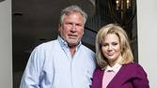](http://www.wsj.com/articles/brought-down-by-long-bust-texas-oil-men-pray-for-another-boom-1488739082?mod=trending_now_3)

[Brought Down by Long Bust, Texas Oilmen Pray for Another Boom](http://www.wsj.com/articles/brought-down-by-long-bust-texas-oil-men-pray-for-another-boom-1488739082?mod=trending_now_3)

* [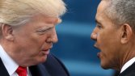](http://www.wsj.com/articles/trump-accuses-obama-of-wire-tapping-in-october-1488637355?mod=trending_now_4)

[Trump Faces Furor Over Unsubstantiated Claim Obama Wiretapped Him](http://www.wsj.com/articles/trump-accuses-obama-of-wire-tapping-in-october-1488637355?mod=trending_now_4)

* [](http://www.wsj.com/articles/white-house-to-ask-congress-to-probe-potentially-politically-motivated-investigations-1488724467?mod=trending_now_5)

[FBI Asks Justice Department to Rebut Wiretap Claim](http://www.wsj.com/articles/white-house-to-ask-congress-to-probe-potentially-politically-motivated-investigations-1488724467?mod=trending_now_5)

SHOW COMMENTS HIDE COMMENTS (95)

Failed to load comments

Show More Archives

**What To Read Next...**

**[technology](https://api.cxense.com/public/widget/click/Qgea6QLYPV_Bu285hElCssva374dUm892ng6XUDj3No4dfod_WJioOrjfZMRYaiS6Vk2nsNPyqhABevMhtEn_HVOr7KeQpACx9w2bMhCryAKbHF4M_bJuB9D8HVZtvg5gP78G326cnSgdq78TQJLArUbCsNuT9Yem0eBCYpjT5EYBfZel3rmkcHxY_xElzo3KgUGBcBx-PZd2zOuBxSc43RmGXw5DQc3y06z5Gh6zKkP3Xo1QcuM9AnV6XByB6_U0vSGFENXFrdfHkicmkntxm00ullid45BePwVnu1Kh2BmV1EbLok05T4fNzWdv8bolOdszfhtsKxdKyTRml7H1zNMtfoYU1KCsXQwbSfQld-YLjS5lCDjbglTg-3Lq3-dE_ISSg6qHcgW4HURPiW-crbfr8MGQf2yqlQmUNbtekPWq7I9_a02Xu5pa_DdR--T_lfsHQ8Q9rTYVu3dDc-CdPqgCfuNt1cVOlfpvtVomQGaIbxbM_IxBxXsAQmh04ZpJgYbrv-Lgz0M7IgusP7rO2FHxgOh1I5umzuemjLGtC22nw2845D2FJy03jqinyPDgj040eklrq9eSuuQqpRaP8NTS-vckpX27JkzHTpOMgO501iCWAE9t8GAPOVuN0SN-iItvftq-_-62G2zy8oYkf2YDJwA3MrXCuVk9XMfhYtW_wXAkAv6K1vG-npKXnWfrUnTf3nwZB8akhVigtVhpgwWHGO5peFhfQ0?mod=cx_picks&cx_navSource=cx_picks&cx_tag=poptarget&cx_artPos=1" \o "Facebook, Rushing Into Live Video, Wasn’t Ready for Its Dark Side" \t "_top)**

**[Facebook, Rushing Into Live Video, Wasn’t Ready for Its Dark Side](https://api.cxense.com/public/widget/click/Qgea6QLYPV_Bu285hElCssva374dUm892ng6XUDj3No4dfod_WJioOrjfZMRYaiS6Vk2nsNPyqhABevMhtEn_HVOr7KeQpACx9w2bMhCryAKbHF4M_bJuB9D8HVZtvg5gP78G326cnSgdq78TQJLArUbCsNuT9Yem0eBCYpjT5EYBfZel3rmkcHxY_xElzo3KgUGBcBx-PZd2zOuBxSc43RmGXw5DQc3y06z5Gh6zKkP3Xo1QcuM9AnV6XByB6_U0vSGFENXFrdfHkicmkntxm00ullid45BePwVnu1Kh2BmV1EbLok05T4fNzWdv8bolOdszfhtsKxdKyTRml7H1zNMtfoYU1KCsXQwbSfQld-YLjS5lCDjbglTg-3Lq3-dE_ISSg6qHcgW4HURPiW-crbfr8MGQf2yqlQmUNbtekPWq7I9_a02Xu5pa_DdR--T_lfsHQ8Q9rTYVu3dDc-CdPqgCfuNt1cVOlfpvtVomQGaIbxbM_IxBxXsAQmh04ZpJgYbrv-Lgz0M7IgusP7rO2FHxgOh1I5umzuemjLGtC22nw2845D2FJy03jqinyPDgj040eklrq9eSuuQqpRaP8NTS-vckpX27JkzHTpOMgO501iCWAE9t8GAPOVuN0SN-iItvftq-_-62G2zy8oYkf2YDJwA3MrXCuVk9XMfhYtW_wXAkAv6K1vG-npKXnWfrUnTf3nwZB8akhVigtVhpgwWHGO5peFhfQ0?mod=cx_picks&cx_navSource=cx_picks&cx_tag=poptarget&cx_artPos=1" \o "Facebook, Rushing Into Live Video, Wasn’t Ready for Its Dark Side" \t "_top)**