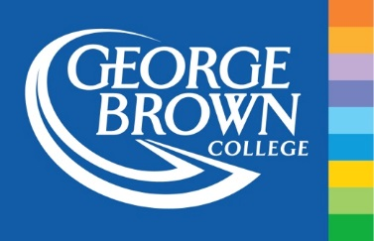

**HOST 1066: Re-create a Daiquiri Assignment**

**NAME(S):**

**1. Explain the reasoning behind your modified cocktail’s name?**

**2. Discuss your choice of glassware:**

**3. Provide your recipe below. Use a format similar to that in the bar manual. Make sure EVERY step is followed in order so that anyone could recreate your cocktail. If you made syrups, be sure to include the recipe for making your syrup.**

**4. Discuss your procedure (build, shake, stir, et cetera. Why did you choose this procedure over another one?**

**5. Discuss your choice of garnish/ingredients:**

**6. What is the cost and cost percentage of your cocktail? Explain your reasoning behind the price. This includes describing the type of venue and target market/demographic.**