***Sierra Leadership***

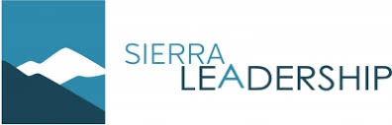

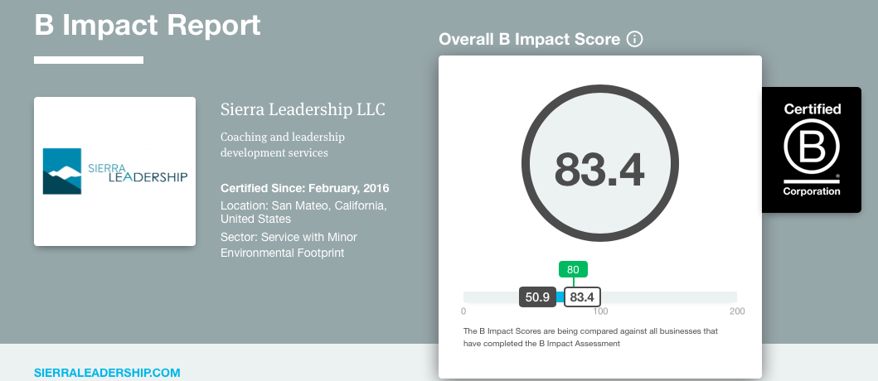

**•History:** Sierra Leadership was founded in 2008 by Eric Nitzberg, its headquarters are located in San Mateo, California. Prior to founding the company Eric Nitzberg was a minister and a church leader for many years. Eric Nitzberg gravitated to a impact-oriented work and founded Sierra Leadership. At the beginning it was very difficult, being a sole proprietorship most of the work was subcontracting assignments from other large firms. As the team grew it became easier to the point where with a small team and their own clients Sierra Leadership has been able to be a successful company. Sierra Leadership is an executive coaching and leadership development firm that helps mission-driven, socially conscious business leaders achieve their goals. They are a certified B Corp, currently more than 75% of their business is with companies that have significant commitments to sustainability through their treatment of employees, the environment, and other stakeholders.

**•Motivation of founders**

●Through one-on-one coaching and group sessions, clients will :

○Increase their leadership and communication skills.

○Enhance their level of authenticity,confidence, and impact.

○Develop their teams through coaching, delegation and feedback.

○Become more strategic in designing their work and lives.

●Passion for business leaders who believe that making a profit and making a difference go hand-in-hand and that being socially conscious and responsible is one of the most valuable assets an organization can possess, especially today.

●Believe that in the coming decades, business will be a major driving force in solving the world’s biggest problems. They became a B Corp to model a strong commitment to business as a vehicle for good.

**•Industry:** Sierra Leadership is a Privately Held company in the Professional Training and Coaching industry, they specialize in Executive Coaching, Presentation Consulting, Team Development, Leadership Coaching, and Coaching. Executive Coaching, is a professional relationship between a trained coach and a client with the goal to enhance the client's leadership or management performance and development. Presentation Consulting, help organizations communicate better using presentations and strategic content and template systems. Team Development, stages and forming an effective team. It is essential to consider the fact that teams develop and mature over a period of time. Team development creates a captivating atmosphere by encouraging co-operation, teamwork, interdependence and by building trust among team members. Leadership Coaching, is an individualized process that builds a leader's capability to achieve short- and long-term organizational goals. Coaching is personalized, customized, usually conducted one-on-one for a defined period of time and with a specific business purpose in mind.

Through these five specializations Sierra Leadership helps its clients create a more adequate and successful working environment with strong leadership and communication that leads to a strong team that achieves company goals.

**•Business Model: NEED RESEARCH**

**•Overall performance**

* Their B-Corp score is 83.4
  + Governance 17.8
  + Environment 15.6
  + Community 30.6
  + Workers 15.8
  + Customer 3.6

**•Primary challenges facing them in the future: NEED RESEARCH**

**Questions answered from Eric Nitzberg:**

**1. Why did your company decide to get certified as a B-Corp?**

It was already our vision to provide leadership coaching services to "Mission driven, socially conscious business leaders." We decided to get certified (a) to have an independent way of assessing our overall level of sustainability and impact, and (b) to be able to communicate to others that we have those commitments, for marketing purposes.

**2. What's the history behind how you came to be? Was your founding vision tightly tied to B-Corp values?**

Prior to founding the company I was a minister and church leader for a number of years, so I very much gravitate towards impact-oriented work.

When I started our company about 12 years ago, it was a sole proprietorship (just me!), and for a number of years most of my work involved subcontracting assignments from other, larger firms. Now we have our own clients, and we have a small team running Sierra Leadership.

We always aspired to be aligned with B Corp values.

**3. How hard was the certification process?**

It was hard. I was lucky in that the first time we certified we had an intern who was happy to put in a lot of time to help make it happen. For us, the issue was not so much that it was hard to get the minimum number of points. It was hard because they required so much information. Plus we did take some actions, like creating an HR handbook, to increase our score.

Also, to be honest, B Lab's process made it harder than it seemed like it should be. That wasn't just about them being rigorous; some of their process seemed unnecessarily bureaucratic.

**4. Benefits:**

·  **What did you expect to come of certification? Have these been realized?**

We were hoping it would help us connect with more mission-driven clients in the B Corp community (that was one goal), and that has not happened much so far. Though I think it would have happened more if we were more engaged with the B Corp community.

We also wanted to use the certification as a learning process and a tool to help keep us honest with our own sustainability commitments. I think it's been useful in that way for sure.

· **Any unforeseen or unexpected?**

I was surprised at how frustrating the recertification process was for my staff.

On the positive side, I think being a B Corp is motivating and inspiring to me personally. I'm proud of it, and I think it helps our team feel more engaged to know that they work for a company that has such a deep commitment to sustainability. We tend to have long-time staff who are pretty committed to the company. I believe being a B Corp helps.

**5. Any disadvantages?**

The lengthy, rigorous process of becoming a b-corp.

**6. How is certification received by employees? By customers? By partners?**

I think it's positive all around, though mostly it's known to our staff. I don't talk a lot with other stakeholders about the fact that we are a B-Corp.

**7. How has becoming a B-Corp helped your company?**

I'd say the biggest help has been the inspiration / motivation it provides us internally--to know we are committed to doing good in the world, and we are holding ourselves accountable to that.

**8. Has it been worth it? Would you do it again? Why?**

We talked about this last year, one of my staff thinks it's not worth the expense and effort. It's costing us $1,000 per year, plus the work of recertification every 3 years. But I think it's worth doing to keep us focused on our sustainability mission. Also, in the future we may do more client work in the B Corp community.

**9. Do you have any advice for company founders contemplating going B-Corp?**

If you want to start a business, I would focus first about having a viable business, and then think about B Corp certification. Of course, you can do both. But we waited until our business was on pretty good footing before we went through the certification process. To me the most basic sustainability question for a business is whether you have a functioning business at all -- can you add value to your customers, pay your employees, etc. If you aren't able to do those basic things yet, then getting certified as a B Corp might not be the best use of your time right now.

But I would also say, many businesses can get a lot out of being a B Corp. I think consumer-facing brands can get a lot of value from the B Corp designation, from a marketing perspective. And if you are able to invest time, everything I've seen / heard is that it's a wonderful community to be a part of.

**10.Would it have been possible to accomplish everything you wanted without getting B Corp?**

Absolutely. But I would say another benefit of being a B Corp is that we learned about more ways to operate sustainably. They have recommended best practices, and some of the things we've done for certification--that have been useful--we might not have done otherwise

**11. What are some of the positive impacts your B-Corp has provided for the community?**

We help leaders in sustainable companies be more effective, so ultimately that benefits all the stakeholders around them, as well as the mission and impact of those companies. Internally, knowing we are a B Corp keeps us honest and on track with our mission as a sustainable company.