Final Project Management Plan

David Mabon, Harold Meza, Jason Price, Shaun Forsberg, Steven Brown, Willi Kroenke

CPMGT/305

October 8th, 2018

Professor John P. Braeger

**Final Project Management Plan**

Carlin Portal Mines request US$0.856 million to install a fan to increase the total air flow within the Pete Bajo mine. The requested monies will enable underground earthworks necessary to install two 300 HP fans. Execution of the new ventilation plan at Pete Bajo is vital to continue mining due to high diesel particulate matter (DPM) concentrations, especially in the Full House zone. Additional air flow will enable the mine to meet the budgeted production targets of 75 thousand ounces in 2018 through 2027 at the budgeted capital cost. The ‘Do Nothing’ option will require additional capital footage to maintain budgeted production levels to replace planned production from the Full House zone. An incremental evaluation of upgrading the ventilation at Pete Bajo versus ‘Do Nothing’ indicates a net present value of $7.577 million and free cash flow of $8.356 million.

Exploration in the Full House Zone has identified a high-grade resource which continues to grow with additional exploration. The zone currently has 136,041 contained ounces designed to be extracted in the next few years with an average grade of 0.350 ounces per ton. The current plan indicates mining is to start in this area during the third quarter of 2018; however, mining this area will be exceeding the limitation of the overall air flow needed to mine safely in the zone.

**Summary of Milestones**

For this project to be completed the milestones that need to be completed. The project manager must order the new ventilation motors and ventilation plenums. The concrete pads and mounts need to be formed and cast before the new motors are delivered. All electrical cables and conduits will be run so that once the fans are delivered, they can be wired. The airlock doors will be installed and tested after the new ventilation fans are installed to check to see if they are operational. Once the systems are operational, the project manager will sign off on the installation and functional tests and let the stakeholders know the status of the ventilation system.

**Work Breakdown Structure (WBS)**

The WBS is attached in the separate Microsoft Project file.

**Gantt Chart**

The Gantt chart is attached the separate Microsoft Project file.

**Costs and Budget**

|  |  |
| --- | --- |
| **Pete Bajo Fan Installation** | |
| Dual 300 H.P Fans | $ 218,500 |
| Freight Cost for Fan & Accessories (2 Freights) | 3,500 |
| Shipping Costs for New Blades/ Impeller | 1,800 |
| Main Fan Bulkhead | 18,000 |
| Pete Bajo Air Doors (2 Sets) | 153,100 |
| Cable Bolts/Plates/extensometer | 21,500 |
| Main Fan Excavation | 56,000 |
| Underground Infrastructure – Foundation/Install | 163,800 |
| Underground Infrastructure – 2 Starters | 31,200 |
| Underground Infrastructure – Starter Freight Cost | 1,000 |
| Underground Infrastructure - Cable | 41,000 |
| Underground Infrastructure – Freight Cost | 1,000 |
| Carlin East/ Leeville - Airdoors/ Bulkhead/Excavation | 67,600 |
| **Sub-Total** | **$ 778,000** |
| Contingency (10%) | $ 77,800 |
| **Total Request** | **$ 855,800** |

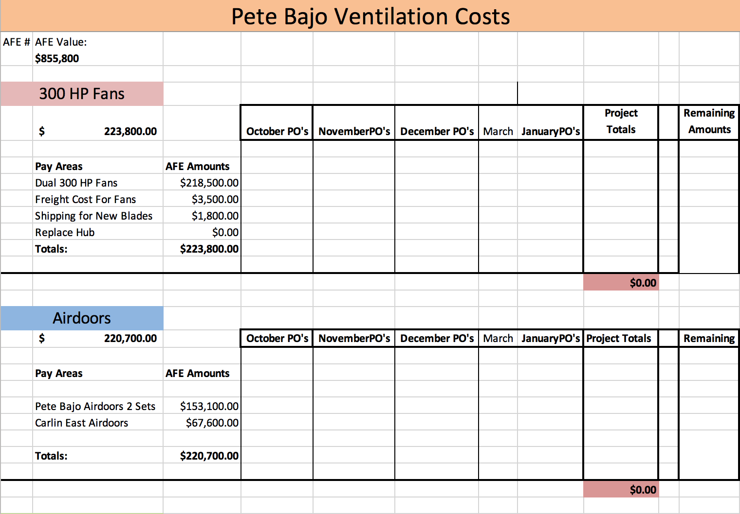

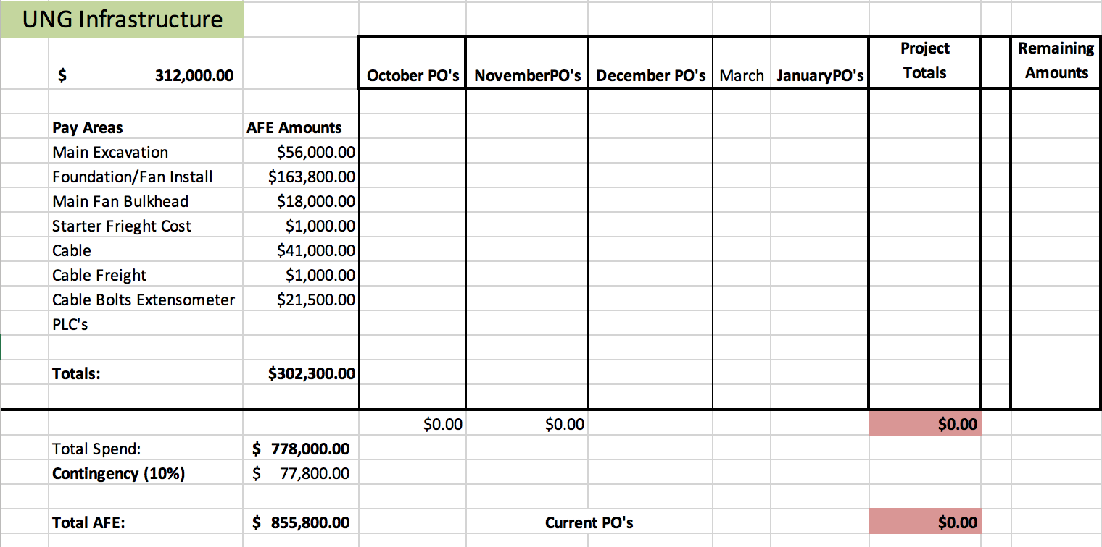

**Network Diagram**

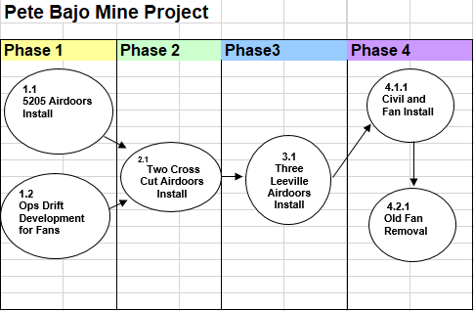

**Phase Schedule**

|  |  |  |  |  |
| --- | --- | --- | --- | --- |
|  | **Pete Bajo Mine Project** | **Effort Estimate in days** | **Planned Start Date** | **Planned End Date** |
| **1** | **Phase One 5205 Airdoors Install** | 24 days | Mon 10/29/18 | Thu 11/29/18 |
| **1.1** | Order Materials | 25 days | Mon 10/1/18 | Fri 11/2/18 |
| 1.1.1 | Delivery of Materials | 1 day | Mon 10/22/18 | Mon 10/22/18 |
| 1.1.2 | Remove Top Doors | 6 days | Mon 10/22/18 | Mon 10/29/18 |
| 1.1.3 | Install Top doors | 6 days | Tue 10/30/18 | Tue 11/6/18 |
| 1.1.4 | Remove Lower Doors | 6 days | Wed 11/7/18 | Wed 11/14/18 |
| 1.1.5 | Install Lower Doors | 6 days | Thu 11/15/18 | Thu 11/22/18 |
| 1.2.1 | **Phase One Ops Drift Development for Fans** | 24 days | Mon 11/5/18 | Thu 12/6/18 |
| 1.2.2 | Order Materials | 6 days | Mon 10/1/18 | Mon 10/8/18 |
| 1.2.3 | Delivery of Materials | 1 day | Mon 11/5/18 | Mon 11/5/18 |
| 1.2.4 | Shoot Left Rib (Newmont) | 6 days | Mon 11/4/19 | Mon 11/11/19 |
| 1.2.5 | Cable Bolts Left Rib (SMD) | 6 days | Tue 11/12/19 | Tue 11/19/19 |
| 1.2.6 | Shoot Right Rib (Newmont) | 6 days | Wed 11/20/19 | Wed 11/27/19 |
| 1.2.7 | Cable Bolts Left Rib (SMD) | 6 days | Thu 11/28/19 | Thu 12/5/19 |
| 2.1.1 | **Phase Two Cross Cut Airdoors Install** | 25 days | Thu 12/6/18 | Wed 1/9/19 |
| 2.1.2 | Order Materials | 49 days | Mon 10/1/18 | Thu 12/6/18 |
| 2.1.3 | Delivery of Materials | 1 day | Wed 12/5/18 | Wed 12/5/18 |
| 2.1.4 | Remove Top Doors | 6 days | Thu 12/6/18 | Thu 12/13/18 |
| 2.1.5 | Install Top doors | 6 days | Fri 12/14/18 | Fri 12/21/18 |
| 2.1.6 | Install Top doors | 6 days | Fri 12/14/18 | Fri 12/21/18 |
| 2.1.7 | Remove Lower Doors | 6 days | Mon 12/24/18 | Mon 12/31/18 |
| 2.1.8 | Install Lower Doors | 7 days | Tue 1/1/19 | Wed 1/9/19 |
| 3.1.1 | **Phase Three Leeville Airdoors** | 13 days | Wed 1/9/19 | Fri 1/25/19 |
| 3.1.2 | Order Materials | 73 days | Mon 10/1/18 | Wed 1/9/19 |
| 3.1.3 | Delivery of Materials | 1 day | Wed 1/9/19 | Wed 1/9/19 |
| 3.1.4 | Remove Doors | 7 days | Thu 1/10/19 | Fri 1/18/19 |
| 3.1.5 | Install Doors | 6 days | Mon 1/21/19 | Mon 1/28/19 |
| 4.1.1 | **Phase Four Civil and Fan Install** | 20 days | Wed 1/9/19 | Tue 2/5/19 |
| 4.1.2 | Delivery of Fan and Evase | 0 days | Mon 1/7/19 | Mon 1/7/19 |
| 4.1.3 | Form and Pour Pedestals | 6 days | Wed 1/9/19 | Wed 1/16/19 |
| 4.1.4 | Form and pour Pad | 7 days | Thu 1/17/19 | Fri 1/25/19 |
| 4.1.5 | Fan and Bulkhead Installation | 7 days | Mon 1/28/19 | Tue 2/5/19 |
| 4.2.1 | **Phase Four Fan Removal** | 6 days | **Wed 2/6/19** | **Wed 2/13/19** |
| 4.2.2 | Remove old Fan | 6 days | Wed 2/6/19 | Wed 2/13/19 |
| 4.2.3 | Remove Bulkhead | 6 days | Thu 2/14/19 | Thu 2/21/19 |

**References**

Forsberg, S. L. (n.d.). *IRP Pete Bajo Ventilation*(Tech.).

Forsberg, S. L. (n.d.). *Scope of Work Pete Bajo Ventilation*(Tech.).