Project Plan Overview and Preliminary Project Plan

David Mabon, Harold Meza, Jason Price, Shaun Forsberg, Steven Brown, Willi Kroenke

CPMGT/304
October 1, 2018
Professor John P. Braeger
Project Plan Overview and Preliminary Project Plan
Carlin Portal Mines request US$0.856 million to install a fan to increase the total air flow within the Pete Bajo mine. The requested monies will enable underground earthworks necessary to install two 300 HP fans. Execution of the new ventilation plan at Pete Bajo is vital to continue mining due to high diesel particulate matter (DPM) concentrations, especially in the Full House zone. Additional air flow will enable the mine to meet the budgeted production targets of 75 thousand ounces in 2018 through 2027 at the budgeted capital cost. The ‘Do Nothing’ option will require additional capital footage to maintain budgeted production levels to replace planned production from the Full House zone. An incremental evaluation of upgrading the ventilation at Pete Bajo versus ‘Do Nothing’ indicates a net present value of $7.577 million and free cash flow of $8.356 million.
Exploration in the Full House Zone has identified a high grade resource which continues to grow with additional exploration. The zone currently has 136,041 contained ounces designed to be extracted in the next few years with an average grade of 0.350 ounces per ton. The current plan indicates mining is to start in this area during the third quarter of 2018; however, mining this area will be exceeding the limitation of the overall air flow needed to mine safely in the zone
Project Selection Criterion
The project that our team selected Pete Bajo underground ventilation upgrade. This system will also be 75% more efficient then the old ventilation system. The system will replace the inefficient ventilation system being more cost effective using less energy, the most important feature will be the ventilation system ability to insure the safety of employee’s. The performance management system will provide quarterly status reports for each employee’s progress towards their goals to their organizational leadership. We will consider the high level project scope, why the ventilation system is necessary, project purpose, project objectives, major requirements, High-level risks, milestones schedule, and preliminary project plan. The system will also retain feedback for the leadership each quarter and at the end of the year. Finally, this system will provide an end-of-year review so the leadership can use to factor in for bonuses.
The criteria Team E used to select this process were based on our own experiences and knowledge. We all agreed on the project to ensure we got the whole team’s buy-in for the selection. (Appendix A)
 |  | Score
Criteria | Weight | Jason | Shaun | Steven | David | Harold | Willi
High-level project scope | 20% | 80 | 45 | 40 | 15 | 35 | 80
Risk | 20% | 60 | 85 | 30 | 20 | 75 | 60
Project objectives | 15% | 55 | 80 | 50 | 15 | 25 | 55
Schedule | 10% | 30 | 60 | 55 | 65 | 30 | 30
Compliance | 5% | 35 | 50 | 60 | 50 | 50 | 35
Relationships | 5% | 80 | 70 | 50 | 85 | 80 | 80
Major requirements | 15% | 25 | 50 | 45 | 60 | 60 | 26
Urgency | 10% | 60 | 25 | 40 | 65 | 80 | 60
Weighted Scores | 100% | 54.8 | 60.0 | 43.3 | 38.0 | 52.3 | 54.9

Preliminary Project Plan
An overview of the project shows that the primary scope is the installation of two fans into the Pete Bajo Corridor at the Carlin Portal Mines. This project will ensure that continual, safe operation of the mines and an increase in the health and welfare of the miners. The location was selected because of an increase in mining around the area and, therefore, a need to improve the airflow in this region of the mine. The completeness of this initial project plan, the nature of this project, and, the underground aspect were factors that impacted the team choice for this project.
The scheduling for the project had previously been delayed because of the inability of the planning group to decide on the application that was best suited for the mine. The funds were budgeted for the end of the 2017 BP and the group was unable to meet the timeframe. We are now ready to submit the unbudgeted AFE for approvals so that we can move forward with the ventilation upgrade needed for the development of the Bullmoose area of the Pete Bajo mine. The following timeline details the work to be completed if the requested funds are approved:
- August 2018: Submittal of AFE
- September 2018: Approval of AFE
- September 2018: Issue RFP for contractor
- October 2018: Award contract and begin construction activities
- January 2019: Complete contracted activities
- February 2019: Close out project
A schedule of the actual work has also been identified and attached in the form of Microsoft Projects scheduling. Also, please see (Appendix B) for the Final Project Charter.
Learning_Team_E_wk2.mpp
Budgetary quotes have been obtained from various vendors and compiled to create a preliminary budgetary plan. Of course with the ever changing underground environment a 10% contingency is added on to the total amount to cover any unexpected changes to the project. The budgeted amounts are broken down as follows:
Cost
Pete Bajo Fan Installation
Dual 300 H.P Fans | $ 218,500
Freight Cost for Fan & Accessories (2 Freights) | 3,500
Shipping Costs for New Blades/ Impeller | 1,800
Main Fan Bulkhead | 18,000
Pete Bajo Air Doors (2 Sets) | 153,100
Cable Bolts/Plates/extensometer | 21,500
Main Fan Excavation | 56,000
Underground Infrastructure – Foundation/Install | 163,800
Underground Infrastructure – 2 Starters | 31,200
Underground Infrastructure – Starter Freight Cost | 1,000
Underground Infrastructure - Cable | 41,000
Underground Infrastructure – Freight Cost | 1,000
Carlin East/ Leeville - Airdoors/ Bulkhead/Excavation | 67,600
Sub-Total | $ 778,000
Contingency (10%) | $ 77,800
Total Request | $ 855,800

The Air Doors will be supplied by Hoffman Manufacturing to keep the applications consistent with what is already in the rest of the mine. The parts are interchangeable with what already exists throughout the mine and they have been proven to stand up in the underground environment. The install will consist of the following criteria from the contractor that is awarded the bid pouring Pedestals for Fan, Plenum and Dampener (Appendix C)
• Any dirt work for grading
• Pouring a pad for the entire set up of fan, 50’x28’ at 6” depth
• Installing Fan, Plenum and Dampener
• Erection of Bulkhead and attachment of Evase to bulkhead (Materials provided By Newmont)
• Grouting of pedestals to level the fan
• Supply own concrete (3D or Modern suggested)
• Delivery of materials from surface to underground (provide your own forklift)
• Provide own remix truck
Spendrup Fan Company will also be providing the fans again to keep the equipment being used consistent to the rest of the mine. Drawing that have been sent from Spendrup will be attached so that the engineered drawings for the Civil can be completed. Also some of the pieces do not come assembled for the plenum do to size, so they will need to be assembled underground. Shipping packages will be attached as well. First section of Eaves will come fully assembled, APV-130707. (Appendix D) The second section will be quartered and assembled underground, DIFF-244-274. (Appendix E)
Main Fan excavation as well as the excavation for the Leeville Airdoors will be figured and $1339.64 per Foot and the actual footage has been estimated by the Engineering group from Pete Bajo mine. The excavation will be provided by the Pete Bajo operations department, and installs of all the Airdoors will be provided in house by the Fixed Maintenance group so there will not be any labor costs for this work put towards the AFE.
Conclusion
As the project plan overview and preliminary project plan have demonstrated, the criteria used to select this project can be used in real-world projects as well. By utilizing a weighted project selection table, this project was identified as the most complete. In the final project charter, the selected project has been defined and is clear to all members of the team. When the team got to the preliminary project plan, the overview, the preliminary project schedule, and the preliminary budgetary plan all reflected their relevant information and demonstrated the project plan was complete. The method to select a project is not always as clear as this example; however; with detailed information, the better projects will become more noticeable.

References
Forsberg, S. L. (n.d.). IRP Pete Bajo Ventilation(Tech.).
Forsberg, S. L. (n.d.). Scope of Work Pete Bajo Ventilation(Tech.).

Appendix A
Team E used the Weighted Scoring Method to make a decision on the project.
 |  | Score
Criteria | Weight | Jason | Shaun | Steven | David | Harold | Willi
High-level project scope | 20% | 80 | 45 | 40 | 15 | 35 | 80
Risk | 20% | 60 | 85 | 30 | 20 | 75 | 60
Project objectives | 15% | 55 | 80 | 50 | 15 | 25 | 55
Schedule | 10% | 30 | 60 | 55 | 65 | 30 | 30
Compliance | 5% | 35 | 50 | 60 | 50 | 50 | 35
Relationships | 5% | 80 | 70 | 50 | 85 | 80 | 80
Major requirements | 15% | 25 | 50 | 45 | 60 | 60 | 26
Urgency | 10% | 60 | 25 | 40 | 65 | 80 | 60
Weighted Scores | 100% | 54.8 | 60.0 | 43.3 | 38.0 | 52.3 | 54.9

Appendix B
This is the Final Project Charter in reference to the preliminary project plan in paper above.
The Pete Bajo underground ventilation upgrade
- High-level project scope
This project consists of installing two 300 HP fans in parallel in the 5050 Pete Bajo Corridor. (Appendix C) A contractor will be responsible for the Civil work including but not limited to: Pouring the pedestals for the fans, ventilation plenums and dampeners. Contractors will also be responsible for and grading, pouring of a concrete pad that is 50 feet by 28 feet by 6 inches thick, installing the ventilation fans, vent plenums and dampeners and the erection of bulkheads for the new ventilation fans. The fixed Maintenance Department will be responsible for the assembly of the two high-pressure airlocks that will be needed to direct the airflow. The Operations Department will be responsible for the corridor development as well as the additional development needed for proper fitment of the airlocks.
- Why this work is necessary
Current ventilation system is not adequate for the development of the section of the mine. New ventilation upgrade will last until the end of mine life.
- Project purpose
Execution of the new ventilation plan at Pete Bajo is vital to continue mining due to high diesel particulate matter (DPM) concentrations, especially in the Full House zone. Additional air flow will enable the mine to meet the budgeted yearly production targets of 75 thousand ounces in 2019 through 2027 at the budgeted capital cost.

Appendix B cont.
4. Project objectives
Commissioning new fans for Pete Bajo underground will allow the Carlin Portal Mines to ensure continuity of production by opening more working areas to mine (such as the Full House zone containing 136,041 ounces) to meet the 2019BP targets. With the new ventilation installed the health and safety of the miners and health related issues will be reduced by 50%.
Operational- Constructing the new ventilation fans at Pete Bajo will enable more efficient mining as additional areas are opened in zones currently inaccessible due to limited air flow. It will also allow the mine to produce the budgeted ounces as well as potentially exceed the targets. Clear out blasting areas of CO2 in half the time.
Leeville must continue to get 150,000 CFM to stay in compliance. After the fans are
commissioned, tests will be administered to see if an additional set of Air doors will need to be put in place to allow re-direct more air to the Lee
5. Major requirements
Complete risk and safety reviews and conduct on-site training with all contractors and subcontractors. Solicit and award the contract for the purchase of the fan components, installation and construction work. Begin the project and have a weekly production meeting to discuss updates and schedules.

Appendix B cont.
6. High-level risks
There is always risk involved when working in an underground environment including ground fall and any other incidents that have the possibility of presenting themselves. Additional risks regarding employee health are the exposure to high DPM and Silica exposure. Other than the apparent health risk we run the risk of not completing the project in time which would, in turn, hurt the production side as far as reaching the targets for 2019 BP. Some of the more
significant components also present a risk because of the long lead times that they have.
7. Milestones schedule
The major milestones that need to be established are: The approval of funds, bidding the contract to the best bidder, complete the corridor for the air lock doors, the arrival of the fan and any items that have a long lead times, and the final installation and commissioning of the fans.

Appendix C
This drawing is the Pete Bajo Corridor where the two fans will be installed.
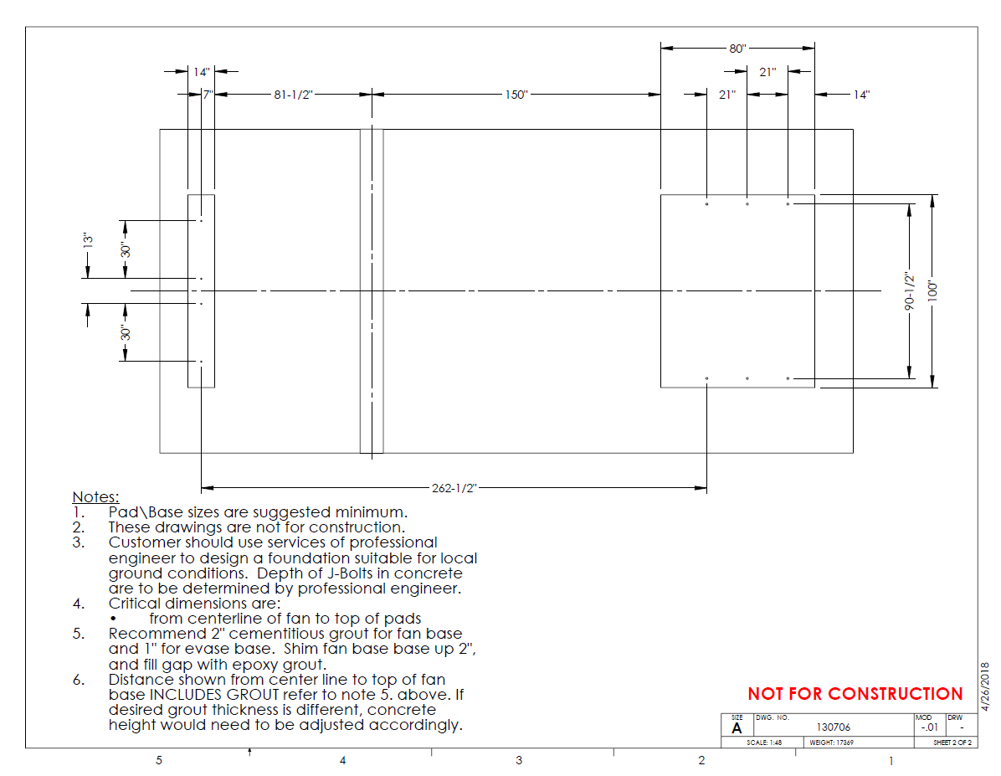
Appendix D
First section of Eaves fully assembled, APV-130707.
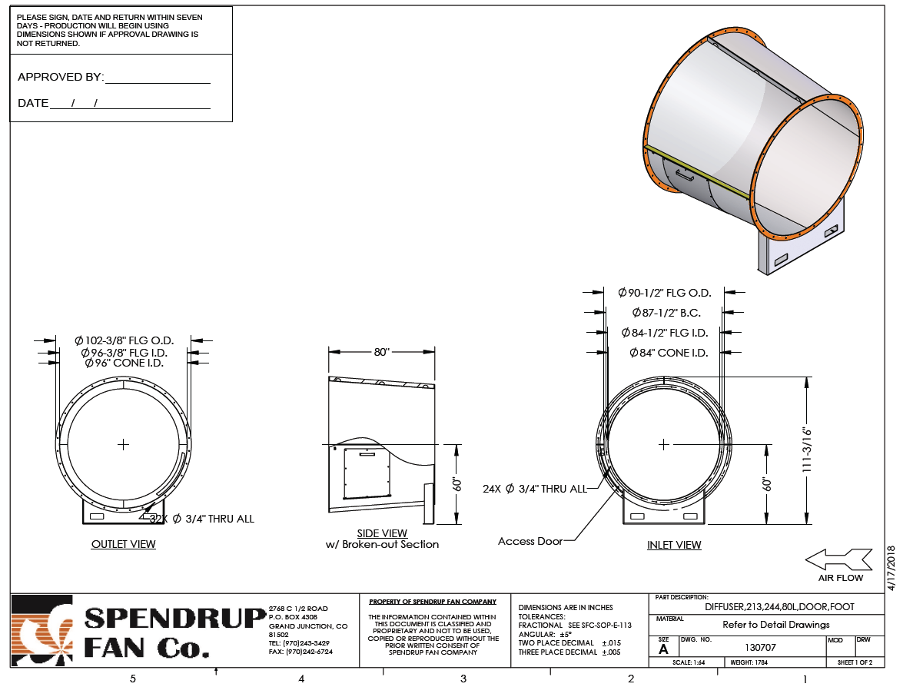
Appendix E
The second set of Eaves will be quartered and assembled underground, DIFF-244-274.
