
Investment Review Paper
Pete Bajo Ventilation Upgrades
Investment Owner: General Manager, Carlin Underground
Investment Leader: Mine Manager, Carlin Portal Mines
Investment Manager: Superintendent, Carlin Portal Mines
Date:

Executive Summary
Carlin Portal Mines request US$0.856 million to install a fan to increase the total air flow within the Pete Bajo mine. The requested monies will enable underground earthworks necessary to install two 300 HP fans. Execution of the new ventilation plan at Pete Bajo is vital to continue mining due to high diesel particulate matter (DPM) concentrations, especially in the Full House zone. Additional air flow will enable the mine to meet the budgeted production targets of 75 thousand ounces in 2018 through 2027 at the budgeted capital cost. The ‘Do Nothing’ option will require additional capital footage to maintain budgeted production levels to replace planned production from the Full House zone. An incremental evaluation of upgrading the ventilation at Pete Bajo versus ‘Do Nothing’ indicates a net present value of $7.577 million and free cash flow of $8.356 million.

Exploration in the Full House Zone has identified a high grade resource which continues to grow with additional exploration. The zone currently has 136,041 contained ounces designed to be extracted in the next few years with an average grade of 0.350 ounces per ton. The current plan indicates mining is to start in this area during the third quarter of 2018; however, mining this area will be exceeding the limitation of the overall air flow needed to mine safely in the zone.

The requested funds are not included in the 2018 Business Plan (19BP). The project was planned to be completed during the second half of 2017, but delays occurred in finalizing the project. Multiple additional options were evaluated and more time was needed to make the most cost effective decision. This deferred the project into 2018. The 18BP had already been submitted, so it was too late to reforecast. However, this unbudgeted request will be offset by savings from Leeville’s dewatering well and equipment requests ($319K and $537K, respectively), as shown in the first quarter (Q2) forecast. The current request is the preferred option for decreasing the DPM levels in the mine and deliver on the business plan.

 |  | Requested Amount
 | Total Investment Cost | Total AFE Funding Request | Budgeted | Unbudgeted
Capital | US$0.856M | US$0.856M | US$0 | US$0.856M
Expense | US$0 | US$0 | US$0 | US$0
Total | US$0.856M | US$0.856M | US$0 | US$0.856M

Due to the specialized work required to complete the project, contractors will perform the new fan installation, housing and electrical work. Alternate mine plans that do not require the upgrade are considered in the ‘Do Nothing’ case.

 |  | P50
Summary of Financial Metrics | Units | Base w/ Sunk Costs | Base w/o Sunk Costs
NPV @ 7% | $M | 7.6 | 7.6
IRR | % | N/A | N/A
Profitability Index | PI | 8.9 | 8.9
Discounted Payback Period | Yrs | 0.5 | 0.5

The diagram below shows the life of mine design of Pete Bajo with the zones identified. The arrows show the current ventilation flow of the Pete Bajo mine.

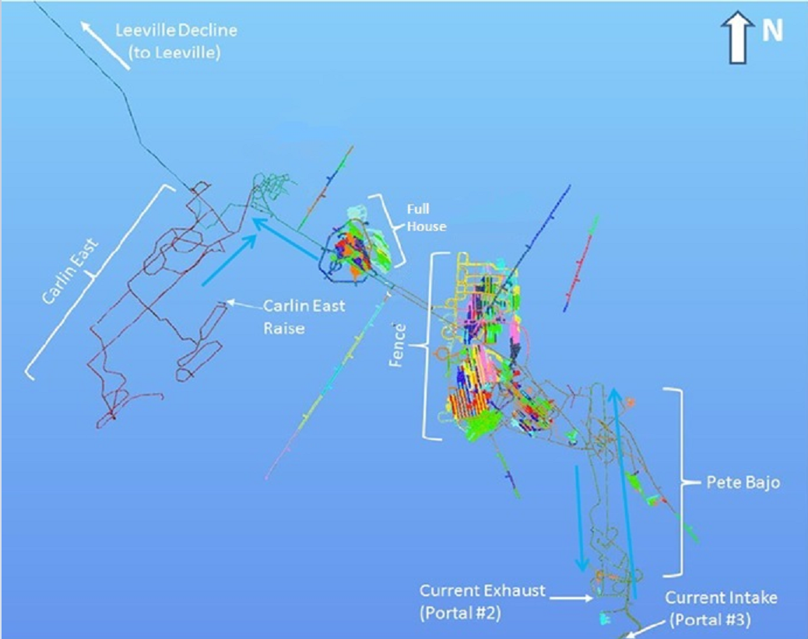

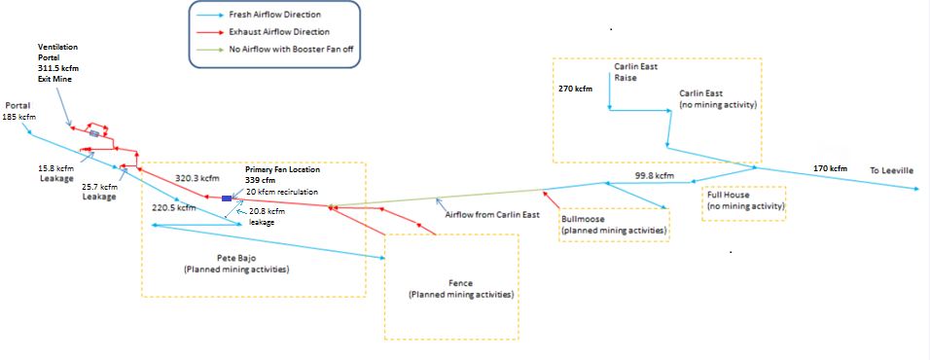

Background
The Pete Bajo underground mine is located within the Pete open pit. The mine has been in operation since 2011 and current mine life extends through 2027. It was determined that with the current ventilation plan, Pete Bajo cannot achieve an average of 75,000 ounces per year through the life of mine. Additionally, the DPM levels need to be reduced to safely mine the zones and to do this, more air flow is required. The upside to more air flow will be the potential to increase production in the future, reducing DPM concentrations, and providing sufficient ventilation for the development and initial production from the new zone.

With the help of the Newmont corporate ventilation specialist, a study was conducted to identify various ventilation scenarios in 2018. From that work it was determined that having Pete Bajo use airflow from the East Carlin vent raise was a preferred option. This initial plan was not chosen as the cost was close to $2 million, so alternative scenarios were studied to bring the cost of the project down. Therefore, due to the delay in finding a suitable option, the project will be completed in 2019, outside the original budgeted timeline.

A proposed new ventilation flow model was built by the corporate ventilation engineer and a common agreement was reached between the Pete Bajo and Leeville teams in deciding a suitable course of action. A budgetary quote was requested from vendors and contractors for the new fan installation, bulkhead, internal booster fan, and air door work.

Options
Option | Description | Pros | Cons
Recommended: | Install new air fans at Pete Bajo | - More air flow into the mine (safety)  - Meeting and possibly exceeding budgeted ounce production | - Capital monies required for construction
Not Recommended: | Do nothing | - No additional capital monies needed | - Will affect the budgeted ounce production profile of Carlin and/or sustaining capital for additional deferred mine development  - DPM level will exceed MSHA limits in certain areas of the mine

Strategic Performance and Purpose
Commissioning new fans (“Do Something”) for Pete Bajo underground will allow the Carlin Portal Mines to ensure continuity of production by opening more working areas to mine (such as the Full House zone containing 136,041 ounces) to meet the 18BP targets.

Installing a new fan is an important risk mitigation measure to necessary to achieve continuous mining at Pete Bajo and decrease the DPM concentrations.

Health & Safety
Execution of work will follow all Health, Safety and Loss Prevention policies and procedures. Zero Harm throughout the project is the expectation for the entire team – both Newmont employees and contractors. All work that requires a contractor will adhere to the Newmont North America Contractor Management program and procedures.

Following testing by industrial hygiene, it was determined that not only the Full House zone but the entire mine requires additional air flow to dilute DPM concentrations in the exhaust airways. Constructing the new ventilation fans will allow the site to increase the overall air flow within the mine, decrease the DPM levels and meet the 18BP production targets.

Operational Excellence
Constructing the new ventilation fans at Pete Bajo will enable more efficient mining as additional areas are opened in zones currently inaccessible due to limited air flow. It will also enable the mine to produce the budgeted ounces as well as potentially exceed the targets.

Growth
The Full House and Fence zones offer good exploration growth potential. Installation of the new fan is necessary to continue drilling and adding reserves.

People
The Pete Bajo group will manage the vendors and contractors of the fan installation activities with cross-functional support from Supply Chain, Environmental, and Health, Safety and Loss Prevention. Construction services will be performed by Newmont approved contractors chosen through a competitive bidding process and is estimated to take two to three months.

The Carlin Portal Mines Operations group will self-perform the drill and blast work for the construction of the air door, fan chamber excavation and bulkhead.

Once fan installation is completed, only regular monitoring and preventative maintenance is required by the Portal Mines Maintenance team.

Sustainability & External Relations
The work associated with this request will occur in an area that has been permitted through all necessary parties. All work will be performed following Newmont policies and state standards. Best practices will be implemented where applicable. There will be minimal impact to the surrounding local communities.

Cost
Pete Bajo Fan Installation
Dual 300 H.P Fans | $ 218,500
Freight Cost for Fan & Accessories (2 Freights) | 3,500
Shipping Costs for New Blades/ Impeller | 1,800
Main Fan Bulkhead | 18,000
Pete Bajo Air Doors (2 Sets) | 153,100
Cable Bolts/Plates/extensometer | 21,500
Main Fan Excavation | 56,000
Underground Infrastructure – Foundation/Install | 163,800
Underground Infrastructure – 2 Starters | 31,200
Underground Infrastructure – Starter Freight Cost | 1,000
Underground Infrastructure - Cable | 41,000
Underground Infrastructure – Freight Cost | 1,000
Carlin East/ Leeville - Airdoors/ Bulkhead/Excavation | 67,600
Sub-Total | $ 778,000
Contingency (10%) | $ 77,800
Total Request | $ 855,800

Budgetary quotes obtained in 2018 are the basis of the cost estimates. Competitive bids will be solicited by Supply Chain to obtain the best value for the contracted portion of the work.

Value Creation
The main driving factor for installing new fans is to decrease the DPM levels and increase the overall air flow within the mine, making it safe for the miners to work in zones planned for production in 19BP.

The ‘Do Nothing’ option requires an additional 9,500 feet of capital development footage in the next three years to achieve the budgeted production profile. The ‘Do Something’ option includes the installation of the new fans and allows capital development footage to stay in line with 19BP, which requires less sustaining capital expenditure than the ‘Do Nothing’ option.

Commercial Production / Ready for Intended Use Decision Criteria
This section is not applicable for the investment.

Execution / Implementation Plan
The following timeline details the work to be completed if the requested funds are approved:

- August 2018: Submittal of AFE
- September 2018: Approval of AFE
- September 2018: Issue RFP for contractor
- October 2018: Award contract and begin construction activities
- January 2019: Complete contracted activities
- February 2019: Close out project

The execution of this project will take place in Q3 and Q4 of 2018.

The project execution approach will be to obtain funding for the project using budgetary quotes for contractor work and concurrently pursue hard quotes and ensure contractor availability. Coordination of contract work will be managed by the Portal Mines Maintenance General Foreman and the Pete Bajo Mine General Foreman. Contractor selection and scope development will be executed by the Portal Mines group.

Implementation Plan
- Solicit and award contract for purchase of fan components, installation and construction activities.
- Complete risk and safety review and conduct on-site training with all parties involved
- Begin project, have daily meeting with all groups involved
- Execute air door and bulkhead activities by Portal Mines group
- Install new fans and place in service, demobilize construction team.
Risk / Opportunity Summary
Risks | Mitigation Plans
Concern of workforce regarding longevity and ability to safely perform their job with the current ventilation. | Continue sharing ventilation project status with crews.
DPM concentrations in areas of the mine are above the action limit. | Provide additional air to decrease the DPM in the mine.
Opportunities | Realization Plans
- Establishing a permanent ventilation fans at Pete Bajo.  - Upsize the system / reuse fans elsewhere as drilling continues to grow Fence. | - Constructing the area to house the fans for the new ventilation plan.  - Install air doors and bulkhead for the new ventilation plan.

Key Measures of Success
- Zero Harm
- Execution of mining and development plans per the 2018 Business Plan
- Complete the project at or below the requested amount of $0.856 million

Recommendations, Requests and Next Steps
The Carlin Portal Mines recommends approval of $0.856 million for the Pete Bajo Ventilation Upgrades. This new fan installation will enable mining at the Pete Bajo to continue safely and profitably. The project execution will begin upon approval.

Authorization For Expenditure Cover Page

AFE Date: | August 10, 2018
Investment: | Pete Bajo Ventilation Upgrades
Region/Site:  BPC ID #: | North America/Carlin Portal Mines  10100116014
AFE Funding Requested: | Total: US$855,800  Budgeted: US$0  Unbudgeted: US$855,800

Regional Approvals:

