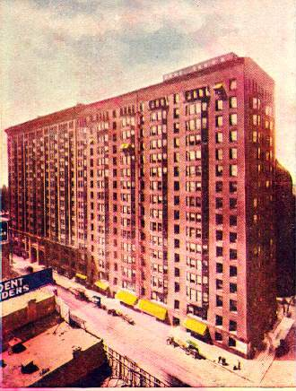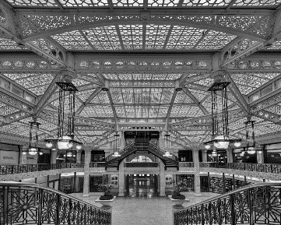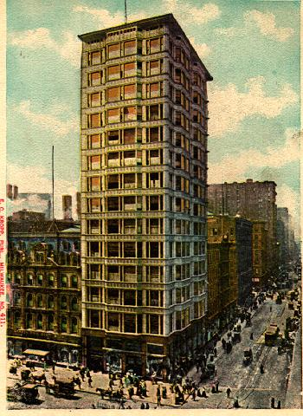

The Monadnock The Rookery The Reliance

1891-1893 1888 1890-1891

53 W. Jackson Boulevard 209 S LaSalle 32 N State Street

**Part One: Architecture and Daniel Burnham and John Root Presentation**

***Directions: In a group of 3, choose one of the buildings or structures below by Burnham and Root. Research it. Prepare a 6 slide power point (mostly pictures) of the building. Tell the class everything you found out about it.***

Union Stockyard Gate (1875) Exchange Avenue at Peoria Street

Montauk Block (1882) at Monroe and Dearborn

Rookery Building (1888) at LaSalle and Adams 209 S LaSalle

Monadnock Building (1891) at Jackson and Dearborn 53 W. Jackson Boulevard

Rand-McNally Building (1890), on Adams Street between LaSalle and Quincy

Reliance Building/Hotel Burnham (1895) 32 N. State Street

Marshall Field and Company Store (1892) 111 N. State

Orchestra Hall (1905) on Michigan Avenue south of Adams Street.

Railway Exchange Building (1904), now the Santa Fe Building

**Part Two: Reading Questions**

***Directions: Choose 6 of the following questions. Explain, give examples and expand your answers by connecting it to something else in the text or other reading.***

1. What was Chicago like in the 1890's? Why is the city described as black? How is this color symbolic of life in the times of the 1890s? (pp. 11-14)
2. What was the big idea that Burnham proposed? Where did it come from? (pp. 14-15)
3. Erik Larson describes Englewood as a neighborhood on the south side of Chicago. He also describes many of the streets in the neighborhood of Englewood. Look at the map of Englewood and label the following locations mentioned on pages 36-37.
   * Jackson Park
   * Washington Park
   * 63rd Street
   * Wallace Street
   * Wentworth Street
4. What was Herman Mudgett’s childhood like? (pp. 38-40)
5. What illegal plan did Herman Mudgett and his classmate come up with? (pp. 42-43)
6. How did Herman Mudgett get the store after Dr. Holton died and what happened to Mrs Holton? (pp. 46-47)
7. Who was Theodore Dreiser and what was his book sister Carrie about? Read the first chapter of *Sister Carrie*. Write a 5 sentence summary. <https://archive.org/stream/ost-english-sistercarrie00dreiiala/sistercarrie00dreiiala#page/n11/mode/2up>
8. What kind of architects and artists did Burnham want to have working with him to design the world's fair? (pp. 48 - 56; pp. 75-84)
9. Why do you think Holmes is being so secretive about his building? (pp. 66-67)
10. Who was Myrta? (pp.62-66) What qualities of Holmes did she find so disconcerting? (pp. 87)
11. What was H.H. Holmes’ new idea for his building?  How was he going to modify it now that he knew that the World’s Fair would be built just East of his building? (pp. 85-6)
12. What was Holmes planning to build in the basement of his building?  How was this thing supposed to ‘help’ him with his plans?  (pp. 90 – 92)
13. Why were the eastern architects “discouraged and full of regret” when they took a tour of Jackson Park, the site of the World’s Fair? (pp. 94- 96)
14. Explain Larson’s statement “Vanishment seemed [to have become] a Chicago pastime.” (p. 102)
15. What was happening to some of Burnham’s co-leaders of the World’s Fair Project?  Why is this section of the text entitled “Alone”? (pp. 104 – 109)

