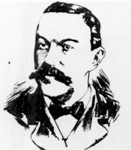 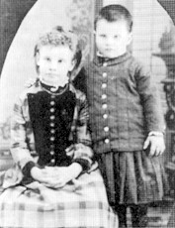 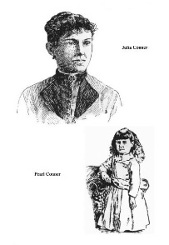

Detective Geyer Pietzel Children Julia and Pearl

Devil in the White City

Part Four and Epilogue Questions

***Directions: Choose 5 of the following questions. Explain, give examples and expand your answers by connecting it to something else in the text or other reading.***

**Introducing Frank Geyer** pp. 339-346

1. Holmes up to this point did not keep trophies. Why did he keep the children's letters to their mother?
2. Why does Holmes lead Georgiana Yoke, Mrs. Pietzel, and the Pietzel children around at the same time if he had planned on killing them anyways?

**Alice's Letters** pp. 347 – 350

1. What significant information did Detective Geyer learn from Alice's letters?
2. Why doesn't Geyer want Holmes to read the paper when he discovered the Pietzel girls' bodies in Toronto?

**Moyamensing Prison** pp. 351 – 353

1. Why did Holmes keep his diary? What parallels can you find today, in the news, to Holmes' diary?

**The death of Alice and Nellie** pp. 354-359

1. Why didn't Geyer tell Ms. Pritezel about the girls' discovery himself? Why was it in the paper in the first place?

**Holmes' Memoir** pp. 360 – 362

1. What evidence did Holmes state that proved that Minnie was still alive? Geyer felt that Holmes was enjoying the national hunt for the children. Why did he think so? Was he right, in your opinion?

**Finally, Chicago Wakes Up** pp. 363 – 368

1. What's your body count? Do you think it could have been two hundred? Why or why not?

**Holmes Is Finally Charged** pp. 369-370

1. Why didn't Chicago discover Holmes earlier?

**Burnham Again** pp. 373-378

1. What was the "Chicago Plan"? Why do you think Burnham turned down other offers to do this work for free?

**Wrapping Up Loose Ends** pp. 379-383

1. Why is this chapter called "Recessional"?

**Holmes' Trial** pp. 384-388

1. How does Holmes' demeanor throughout his trial reflect his sanity?
2. Please explain why Holmes would be able to "…look at himself in a mirror and tell himself that he was one of the most powerful and dangerous men in the world…" and that "…he could feel that he was a god in disguise." Do you agree?

**Epilogue** pp. 389 – 390

1. What is the significance of the location of the bodies in Graceland Cemetery?
2. If it wasn't for Holmes' personality and charm, how successful would had he been in his endeavors?

