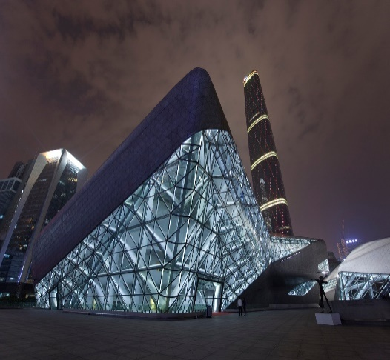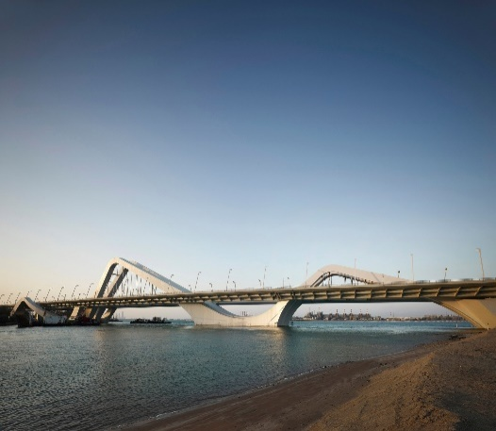

Guangzhou opera house, China Sheikh Zayed Bridge, Abu Dhabi, United Arab Emirates

Dame Zaha Mohammad Hadid also known as ZahaHadid was an Iraqi born British architect. She was born on October 1950 and died in March 2016. The reason what makes her different from other architects is that she was a woman in the art of architect unlike other architects who are men mostly. The art of architecture is not quite known for women architects. ZahaHadid become one of the most well-known architects in modern history.

She learned from Rem Koolhaas who is a Dutch architect, currently a professor at Harvard University He is widely known as most important architectural thinker of his generation. He also won Pritzker Prize in 2002. Because of this person ZahaHadid learned a lot and she admitted this throughout her life that without her master she would have never done all of her works.

She has designed many buildings, including low level fire stations to FIFA football stadium. Many of her designs are known to be very wondrous for world. Every design of ZahaHadid is like a masterpiece. For her innovations, she earned many awards including Pritzker Architecture Prize in 2004, Stirling Prize in 2010, Royal Gold Medal from the Royal Institute of British Architects, etc. Beside all these awards she was made a Dame by Elizabeth II for services to architecture.

She was dubbed as the “Queen of curves” by The Guardian because in her designs she used curves elegantly. In every design, we can observe slight curves like a painting of an artists who has made curves on the canvas with brushes. For her, these designs were like a painting, and her inspiration was the chaos and flux of modern society. Hadid was influenced by her early childhood on villages of the marshes in Southern Iraq. The beauty of the landscape where sand, water, buildings and people all somehow flowed together.

The Maxxi National Museum of 21st Century Arts in Rome is an example of ZahaHadid’s finest works. Unlike other architects she doesn’t hold on to a design with old perspective because it was a museum she blends the idea of history and her influence of modernism and make something innovative. Anyone can see a curvy pattern in her designs this was her style.

As Zaha said “For a woman to go out alone in architecture is still very, very hard. It’s still a man’s world.” But she proved the point. As she died her firm was fastest growing architect firm in Britain. She left so many incomplete works behind her. This was her success that she left a marvelous legacy behind. She gave a new modern aspect of architectures to world. She has left such a legacy behind that even after her death she will remain alive for centurie