Reconstruction Packet

**Document A**:

Background information from *Give Me Liberty*

This chapter concentrates on the history of Reconstruction. Opening with an explanation of Special Field Order 15 from General Sherman that set aside "40-acres and a mule" for the freedmen, the chapter explores what freedom meant to the blacks and how the white American society responded to emancipation. The meaning of freedom for the blacks was many, and they relished the opportunity to express their liberation from slavery. Land became a contentious issue as blacks were ultimately denied free access to land. Likewise, due to the devastation caused by the Civil War, many white farmers faced new poverty as tenant farmers and sharecroppers.

The politics of reconstruction is explored next, viewing Lincoln's ten percent plan as moderate, Andrew Johnson’s plan as too lenient, and the Radical Republican’s plan as ground breaking. With Johnson's many presidential pardons to ex-Confederates and the South's implementation of Black Codes, the Republicans in Congress fought back with the Civil Rights Act of 1866, the Fourteenth Amendment, and the Military Reconstruction Act. Johnson resisted and was impeached by the House, but avoided being removed from office by the Senate. The Fifteenth Amendment finished the Radical Republican's reconstruction agenda, but split the feminist movement due to its failure to give the vote to women.

The chapter then looks at how reconstruction shaped Southern politics as blacks held over 2,000 public offices. The white Southerners, however, felt threatened by black suffrage and the Ku Klux Klan began a campaign of terror and violence. After the Klan was abolished through the efforts of President Grant, the South took matters into their own hands and began to "redeem" the South from perceived corruption, misgovernment, and northern and black control. Reconstruction ended in 1877, after a compromise was met between the Republicans and Democrats on the 1876 presidential election.

**Document B:**

General William Sherman's Special Field Order 15 (1865)

*At the war's end, General William Sherman held administrative possession of an enormous area of the South, including some of the areas most densely settled with slaves. Faced with the urgent problem of how to settle and feed this enormous population of newly freed individuals, Sherman issued Special Field Order 15. The order set aside coastal areas for settlement of freed slaves in lots of 40 acres and offered broken down military mules. This order led to the common phrase, "40 acres and a mule," that circulated widely among the freed people as a symbol of the economic independence that they, like most other Americans, believed was the cornerstone of true freedom. As you examine the order, consider what Sherman's plan would have meant for an individual freed family. What practical and legal difficulties might this military order raise with the former owners of this land? Would division of the land into smaller plots have created larger economic problems for these regions?*

IN THE FIELD, SAVANNAH, GA., January 16th, 1865 SPECIAL FIELD ORDERS, No. 15.

1. The islands from Charleston, south, the abandoned rice fields along the rivers for thirty miles back from the sea, and the country bordering the St. Johns river, Florida, are reserved and set apart for the settlement of the negroes now made free by the acts of war and the proclamation of the President of the United States.
2. II. At Beaufort, Hilton Head, Savannah, Fernandina, St. Augustine and Jacksonville, the blacks may remain in their chosen or accustomed vocations—but on the islands, and in the settlements hereafter to be established, no white person whatever, unless military officers and soldiers detailed for duty, will be permitted to reside; and the sole and exclusive management of affairs will be left to the freed people themselves, subject only to the United States military authority and the acts of Congress. By the laws of war, and orders of the President of the United States, the negro is free and must be dealt with as such….

**Document C:**

Carl Schurz, Report on the Condition of the South (1865)

**EDUCATION OF THE FREEDMEN.** It would seem that all those who sincerely desire to make the freedman a freeman in the true sense of the word, must also be in favor of so educating him as to make him clearly understand and appreciate the position he is to occupy in life, with all its rights and corresponding duties, and to impart to him all the knowledge necessary for enabling him to become an intelligent co-operator in the general movements of society. As popular education is the true ground upon which the efficiency and the successes of free-labor society grow, no man who rejects the former can be accounted a consistent friend of the latter. It is also evident that the education of the negro, to become general and effective after the full restoration of local government in the south, must be protected and promoted as an integral part of the educational systems of the States. I made it a special point in most of the conversations I had with southern men to inquire into their views with regard to this subject. I found, indeed, some gentlemen of thought and liberal ideas who readily acknowledged the necessity of providing for the education of the colored people, and who declared themselves willing to co-operate to that end to the extent of their influence. Some planters thought of establishing schools on their estates, and others would have been glad to see measures taken to that effect by the people of the neighborhoods in which they lived.

But whenever I asked the question whether it might be hoped that the legislatures of their States or their county authorities would make provisions for negro education, I never received an affirmative, and only in two or three instances feebly encouraging answers. At last I was forced to the conclusion that, aside from a small number of honorable exceptions, the popular prejudice is almost as bitterly set against the negro's having the advantage of education as it was when the negro was a slave. There may be an improvement in that respect, but it would prove only how universal the prejudice was in former days. Hundreds of times I heard the old assertion repeated, that "learning will spoil the nigger for work," and that "negro education will be the ruin of the south." Another most singular notion still holds a potent sway over the minds of the masses—it is, that the elevation of the blacks will be the degradation of the whites. They do not understand yet that the continual contact with an ignorant and degraded population must necessarily lower the mental and moral tone of the other classes of society. This they might have learned from actual experience, as we in the north have been taught, also by actual experience, that the education of the lower orders is the only reliable basis of the civilization as well as of the prosperity of a people.

**Document D:**

The Civil Rights Bill of 1866

*This Civil Rights Bill was passed by Congress on April 9, 1866. It defined all persons born in the United States as citizens and mandated certain rights regardless of race. President Andrew Johnson vetoed the bill, but Congress passed the legislation again in April -- the first time a major piece of legislation had been enacted over a presidential veto. As you examine the legislation, consider what practical effect the law would have for non-whites. What new or revised principle did the law seek to impose on what was, until the Civil War, a white man's country?*

IN THE SENATE OF THE UNITED STATES. JANUARY 5, 1866.

Agreeably to notice, Mr. Trumbull asked and obtained leave to bring in the following bill; which was read twice, referred to the Committee on the Judiciary, and ordered to be printed.

A BILL

To protect all persons in the United States In their civil rights, and furnish the means of their vindication.

Be it enacted by the Senate and House of Representatives of the United States of America in Congress assembled, That there shall be no discrimination in civil rights or immunities among the inhabitants of any State or Territory of the United States on account of race, color, or previous condition of slavery, but the inhabitants of every race and color, without regard to any previous condition of slavery or involuntary servitude, except as a punishment for crime whereof the party shall have been duly convicted, shall have the same right to make and enforce contracts, to sue, be parties and give evidence, to inherit, purchase, lease, sell, hold, and convey real and personal property, and to full and equal benefit of all laws and proceedings for the security of person and property, and shall be subject to like punishment, pains, and penalties, and to none other, any law, statute, ordinance, regulation, or custom, to the contrary notwithstanding.

SEC. 2. And be it further enacted, That any person who under cover of any law, statute, ordinance, regulation, or custom, shall subject or cause to be subjected any inhabitant of any State or Territory to the deprivation of any right secured or protected by this act, or to different punishment, pains or penalties on account of such person having at any time been held in a condition of slavery or involuntary servitude, except as a punishment for crime whereof the party shall have been duly convicted, or by reason of his color or race, than is prescribed for the punishment of white persons, shall be deemed guilty of a misdemeanor, and on conviction shall be punished by fine not exceeding one thousand dollars, or imprisonment not exceeding one year, or both, in the discretion of the court….

**Document E:**

Johnson's Veto Message (1866)

*In 1866, the Republican controlled Congress passed the Civil Rights Bill. The legislation defined all persons born in the United States as citizens and mandated certain rights regardless of race. President Andrew Johnson surprised everyone by vetoing the legislation. Congress overturned his veto in April, marking the first time a major piece of legislation had been enacted over a presidential veto. As you examine this document, consider what principles of American government Johnson believed he was upholding by exercising his veto power. Does Johnson's view have roots in any of the major political traditions -- republican or liberal -- upon which the nation was first founded? What new values does the law seek to impose on what until the crisis of the Civil War was by and large a white man's country?*

To the Senate of the United States: ...

By the first section of the bill, all persons born in the United States, and not subject to any foreign power, excluding Indians not taxed, are declared to be citizens of the United States. This provision comprehends the Chinese of the Pacific States, Indians subject to taxation, the people called Gypsies, as well as the entire race designated as blacks, people of color, negroes, mulattoes, and persons of African blood. ...

The right of Federal citizenship thus to be conferred on the several excepted races before mentioned is now, for the first time, proposed to be given by law. ... If...such persons are not citizens...the grave question presents itself, whether, when eleven of the thirty-six States are unrepresented in Congress, at this time it is sound policy to make our entire colored population and all other excepted classes citizens of the United States? Four millions of them have just emerged from slavery into freedom. Can it be reasonably supposed that they possess the requisite qualifications to entitle them to all the privileges and immunities of citizens of the United States? Have the people of the several States expressed such a conviction? It may also be asked whether it is necessary that they should be declared citizens in order that they may be secured in the enjoyment of civil rights? ... Besides, the policy of the Government, from its origin to the present time, seems to have been that persons who are strangers to and unfamiliar with our institutions and our laws should pass through a certain probation, at the end of which, before attaining the coveted prize, they must five evidence of their fitness to receive and to exercise the rights of citizens as contemplated by the Constitution of the United States. This bill, in effect, proposes discrimination against large numbers of intelligent, worthy, and patriotic foreigners, and in favor of the negro, to whom, after long years of bondage, the avenues to freedom and intelligence have now been suddenly opened. He must, of necessity, from his previous unfortunate condition of servitude, be less informed as to the nature and character of our institutions than he who, coming from abroad, has to some extent at least, familiarized himself with the principles of a Government to which he voluntarily intrusts "life, liberty, and the pursuit of happiness." Yet it is now proposed by a single legislative enactment to confer upon all persons of African descent, born within the extended limits of the United States, while persons of foreign birth, who make our land their home, must undergo a probation of five years, and can only then become citizens upon proof that they are of "good moral character, attached to the principles of the Constitution of the United States, and well disposed to the good order and happiness of the same." ...

In the exercise of State policy over matters exclusively affecting the people of each State, it has frequently been though expedient to discriminate between the two races. By the statues of some of the States, northern as well as southern, it is enacted, for instance, that no white person shall intermarry with a negro or mulatto. Chancellor Kent says, speaking of the blacks, that "marriages between them and the whites are forbidden in some of the States where slavery does not exist, and they are prohibited in all the slaveholding States, and when not absolutely contrary to law, they are revolting, and regarded as an offense against public decorum." I do not say this bill repeals State laws on the subject of marriage between the two races, for as the whites are forbidden to intermarry with the blacks, the blacks can only make such contracts as the whites themselves are allowed to make, and therefore cannot, under this bill, enter into the marriage contract with the whites. I cite this discrimination, however, as an instance of the State policy as to discrimination, and to inquire whether, if Congress can abrogate all State laws of discrimination between the two races in the matter of real estate, of suits, and of contracts generally, Congress may not also repeal the State laws as to the contract of marriage between the two races? ...

If it be granted that Congress can repeal all State laws discriminating between whites and blacks in the subjects covered by this bill, why, it may be asked, may not Congress repeal in the same way all State laws discriminating between the two races on the subjects of suffrage and office? If Congress can declare by law who shall hold lands, who shall testify, who shall have capacity to make a contract in a State, the Congress can by law declare who, without regard to color or race, shall have the right to sit as a juror or as a judge, to hold any office, and, finally, to vote "in every State and Territory of the United States." ...

I do not propose to consider the policy of this bill. To me the details of the bill seem fraught with evil. The white race and the black race of the South have hitherto lived together under the relation of master and slave – capital owning labor. Now, suddenly, that relation is changed, and as to the ownership, capital and labor are divorced. They stand now each master of itself. ... Capital, it is true, has more intelligence; but labor is never so ignorant as not to understand its own interests, not to know its own value, and not to see that capital must pay that value. This bill frustrates this adjustment. ...

**Document F**

Mississippi Black Codes, 1865

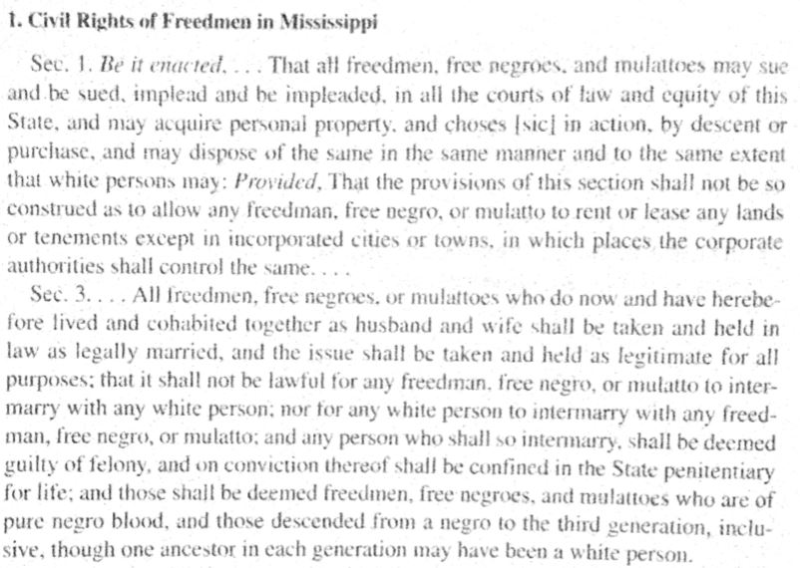

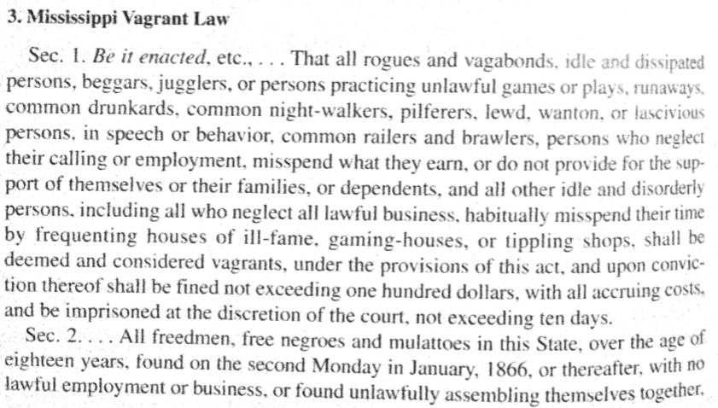

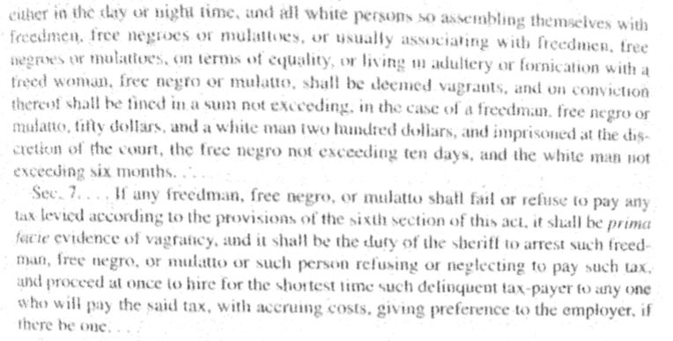

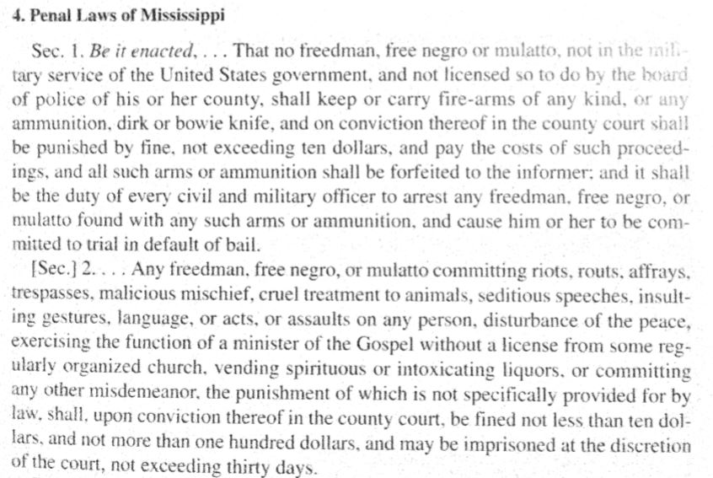

**Document G:**

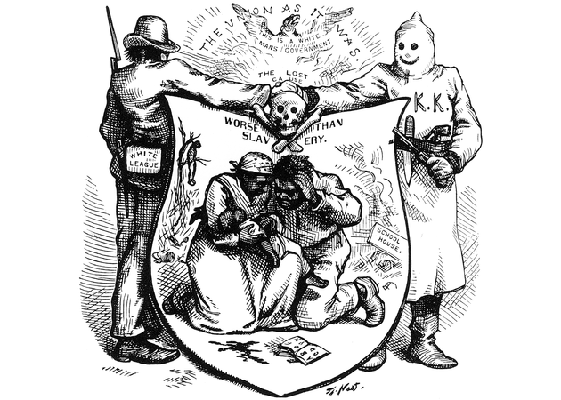

**Document H:**

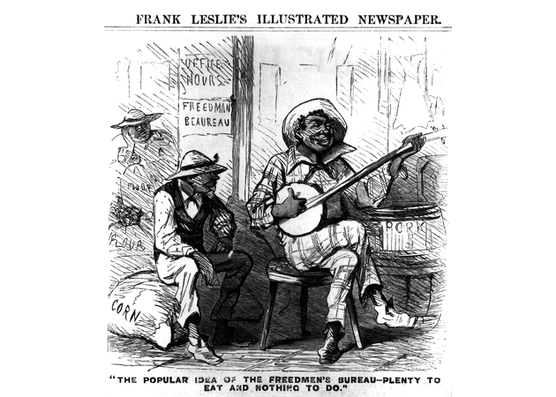

**Document I**

The Reconstruction Amendments

13th Amendment

*Abraham Lincoln and his Republican supporters in Congress moved quickly at the war's end to cement the abolition of slavery into the fundamental law of the land, the Constitution. The first of three amendments, the 13th was passed December 6, 1865 to abolish slavery, ending any hope that human property might be returned to their former owners.*

Article XIII. Section I. Neither slavery nor involuntary servitude, except as a punishment for crime whereof the party shall have been duly convicted, shall exist within the United States, or any place subject to their jurisdiction. Section 2. Congress shall have power to enforce this article by appropriate legislation.

14th Amendment

*When Congress took over Reconstruction of the South from President Johnson in 1866, they began with the passage of the Civil Rights Act and the 14th amendment. While it did not grant the slaves the right to vote, it prohibited states from abridging the "privileges and immunities of citizens" or denying them "equal protection of the law." While the federal government lacked the power and the will to enforce the full implications of this guarantee, later courts and agencies would base major extensions of civil rights on this constitutional principle. It was ratified July 28, 1868.*

ARTICLE XIV Section 1. All persons born or naturalized in the United States, and subject to the jurisdiction thereof, are citizens of the United States and of the State wherein they reside. No State shall make or enforce any law which shall abridge the privileges or immunities of citizens of the United States; nor shall any State deprive any person of life, liberty, or property, without due process of law; nor deny to any person within its jurisdiction the equal protection of the laws.

15th Amendment

*The last amendment of this period was the 15th which Congress passed in 1869. It guaranteed the right to vote for citizens regardless of race. The was the single most important right of citizenship for which abolitionist had fought for four decades, although its explicit exclusion of women produced bitter disappointment among female suffrage supporters and created a permanent split in the abolitionist movement. Taken together, these amendments were nothing short of a "great Constitutional revolution" that broke the connection between citizenship and race and put the national government at the center of struggles for freedom. It was ratified February 3, 1870.*

Article XV. Section 1. The right of citizens of the United States to vote shall not be denied or abridged by the United States or by any State on account of race, color, or previous condition of servitude. Section 2. The Congress shall have the power to enforce this article by appropriate legislation.

**Document J:**

William A. Dunning Explains the Failure of Reconstruction in Terms of Corruption and Failure of Government (1901)

The leading motive of the reconstruction had been, at the inception of the process, to insure to the freedmen an effective protection of their civil rights,—of life, liberty, and property. In the course of the process, the chief stress came to be laid on the endowment of the blacks with full political rights,—with the electoral franchise and eligibility to office. And by the time the process was complete, a very important, if not the most important part had been played by the desire and the purpose to secure to the Republican party the permanent control of several Southern states in which hitherto such a political organization had been unknown. This last motive had a plausible and widely accepted justification in the view that the rights of the negro and the "results of the war" in general would be secure only if the national government should remain indefinitely in Republican hands, and that therefore the strengthening of the party was a primary dictate of patriotism.

Through the operation of these various motives successive and simultaneous, the completion of the reconstruction showed the following situation: (1) the negroes were in the enjoyment of the equal political rights with the whites; (2) the Republican party was in vigorous life in all the Southern states, and in firm control of many of them; and (3) the negroes exercised an influence in political affairs out of all relation to their intelligence or property, and, since so many of the whites were defranchised, excessive even in proportion to their numbers. At the present day, in the same states, the negroes enjoy practically no political rights; the Republican party is but the shadow of a name; and the influence of the negroes in political affairs is nil. This contrast suggests what has been involved in the undoing of reconstruction.

Before the last state was restored to the Union the process was well under way through which the resumption of control by the whites was to be effected. The tendency in this direction was greatly promoted by conditions within the Republican party itself. Two years of supremacy in those states which had been restored in 1868 had revealed unmistakable evidences of moral and political weakness in the governments. The personnel of the party was declining in character through the return to the North of the more substantial of the carpet-baggers, who found Southern conditions, both social and industrial, far from what they had anticipated, and through the very frequent instances in which the "scalawags" ran to open disgrace. Along with this deterioration in the white element of the party, the negroes who rose to prominence and leadership were very frequently of a type which acquired and practiced the tricks and knavery rather than the useful arts of politics, and the vicious courses of these negroes strongly confirmed the prejudices of the whites. But at the same time that the incapacity of the party in power to administer any government was becoming demonstrable the problems with which it was required to cope were made by its adversaries such as would have taxed the capacity of the most efficient statesmen the world could produce. . . . No attention was paid to the claim that the manifest inefficiency and viciousness of the Republican governments afforded a partial, if not wholly adequate explanation of their overthrow. Not even the relative quiet and order that followed the triumph of the whites in these states were recognized as justifying the new regime.

**Document K:**

Barrow Plantation (March 1881)

*A Harper's Magazine article detailing the productivity of the former slaves and discussing their inherent suitability for sharecropping work as "free" laborers. The article also includes a map detailing the steps slaves took to distance themselves from the control of their former masters, as well as to create churches and schools*

A GEORGIA PLANTATION.

THAT in many parts of the South (and notably the State of Georgia) the labor-relations of the two races are adjusting themselves and working out a solution of the dreaded "negro problem" in a practical way, has been known to all observant residents or visitors. The confident prophecies of the croakers that Southern plantations would go to waste, and that nothing but ruin lay before us, have proved the merest bosh. The enormous increase in the cotton crop of the South alone shows that the colored people, as free laborers, have done well, for it is not to be disputed that they form very nearly the same proportion of the laborers in the cotton fields that they did when they were slaves. I do not wish to be understood as stating a proportion in which free labor is to slave labor as the cotton crop since the war is to the cotton crop before the war. This is not true; the yield of cotton has been increased by other causes. But I do say that under no circumstances could worthless labor have produced the enormous increase in this crop.

In Georgia, the negro has adapted himself to his new circumstances, and freedom fits him as if it had been cut out and made for him. It is not true that the negroes have formed a restless, troublesome population, nor is it true that they are like a lot of huddled sheep, frightened at the approach of strange white men, in dread of the terrible Ku-klux. As far as I know, our philosophers have presented them in one or the other of these phases, according as the writer wished to show the dread which is felt by the country of the negro, or the terror which his surroundings inspire in him. Nothing can be further from either of these ideas than the facts of the case; and when we come to look at these, we find the solution to the whole difficulty at our very doors….

**Document L:**

*Birth of a Nation* (1915)

<https://www.youtube.com/watch?v=R4v_yRFf4-Y>

<https://www.youtube.com/watch?v=9t-7SVbLjBw>

In 1915, 50 years after the end of the Civil War, D.W. Griffith, released his epic film *Birth of a Nation*. The greatest blockbuster of the silent era, *Birth of a Nation* was seen by an estimated 200 million Americans by 1946. It left a lasting imprint on Americans’ conception of Reconstruction. From this movie, audiences learned that Reconstruction was an utter disaster. The film depicted the Ku Klux Klan as latter-day knights who restored order in the South by placing power in the hands of the region’s rightful rulers. Even more distressing, the film depicted former male slaves as beasts lusting after white women. The movie’s impact was summed up by President Woodrow Wilson, who called it “history written with lightning.”

Based on a novel by a Baptist preacher named Thomas Dixon, the film painted Reconstruction, the period following the Civil War, as a time when vengeful former slaves, opportunistic white scalawags, and corrupt Yankee carpetbaggers plundered and oppressed the former Confederacy until respectable white Southerners rose up and restored order. A "scalawag" was a southern white who supported the Republican Party; a "carpetbagger" was a northern-born Republican who had migrated to the South.

The film depicted a vindictive northern Congressman (modeled on the Pennsylvania Republican Thaddeus Stevens)and a power-hungry mulatto eager to marry the Congressman's daughter. The film's hero is an aristocratic Confederate veteran who joins the Ku Klux Klan and at the film's climax rescues the woman from armed freedmen. President Woodrow Wilson reportedly described the film as "history written with lightning."

During the 20th century, far more Americans probably learned about Reconstruction from Hollywood rather than from history books or lectures. Films like *Birth of a Nation* and *Gone With the Wind* depicted Reconstruction as a misguided attempt to overturn the South's "natural" order by giving political power former slaves.

Even though the Confederacy lost the Civil War, it succeeded, in the late 19th and early 20th centuries, in winning the ideological war that determined how Americans viewed the Civil War era. For much of the 20th century, the dominant view of Reconstruction, repeated in many high school and college textbooks, was that it was a period of "bayonet rule," during which vindictive northern carpetbaggers and their white and black puppets engaged in an orgy of corruption and misrule. According to this view, a courageous President Johnson, seeking to carry out Lincoln's policy of reconciliation, was confronted by a hostile Congress trying to punish the defeated South.

In recent years, this interpretation of Reconstruction has been thoroughly dismantled. It is now clear that Reconstruction was a failed, but admirable, attempt to adjust to the realities of emancipation: To guarantee the civil and political rights of former slaves and forge a more just society out of the ruins of slavery. President Johnson's reconstruction policy, far from being a continuation of Lincoln's, was steadfastly opposed to protecting the rights of African Americans.

Reconstruction was the most daring experiment in American history. It represented an attempt to transform the institutions and patterns of social relations of the Old South. It gave black Americans in the South their first taste of political power. Out of Reconstruction came constitutional amendments that extended citizenship and voting rights to African Americans. This era also witnessed the federal government's first efforts to create social welfare programs.

In the end, Reconstruction failed to establish a less racially divided society. Its failure doomed the South to decades of relative economic underdevelopment and ensured that the South would be dominated by a single political party. It also left the entire country with the unfinished task of achieving full economic and political equality for the descendants of slaves.