# Alfred Adler

Psychology 220

## Adler’s Biography

* Adler was born in Vienna in 1870
* As a young child he developed rickets which kept him from walking till the age of four
* In 1895 he received his medical degree and opens a private practice across from the Prater
* He later turns to psychiatry and in 1907 he joins Freud’s discussion group

## Adler’s Biography

* After joining the group, Adler writes a series of papers critiquing Freud’s theory- specifically that Freud’s sexual notions be take more metaphorically than literally
* In 1911 Adler resigns as president of the Vienna Psychoanalytic Society and begins the Society for Free Psychoanalysis
* Adler later serves in the military as a physician
* He dies in May 1937 during a series of lectures at Aberdeen University

## Individual Psychology

* Adler called his approach individual psychology b/c he believed in the unique motivations of individuals and the importance of each individual niche in society.
* Adler (unlike Freud) was concerned w/ life’s meaning and the effects of future aspirations (goal-directedness) on one’s life.
* Adler sees the mind as an integrated “whole” working to attain future goals of the person.

## Inferiority Feelings

The Source for Human Striving

## Basic Motives

* Adler believed that one of the basic motivators for behavior were *feeling of inferiority*
* According to Adler, individual growth resulted from compensation- our attempts to overcome our feelings of inferiority

# Inferiority Complex

* **Inferiority Complex** develops when an individual has an overwhelming sense of helplessness or experience some event that leaves them powerless, they are likely to feel inferior.

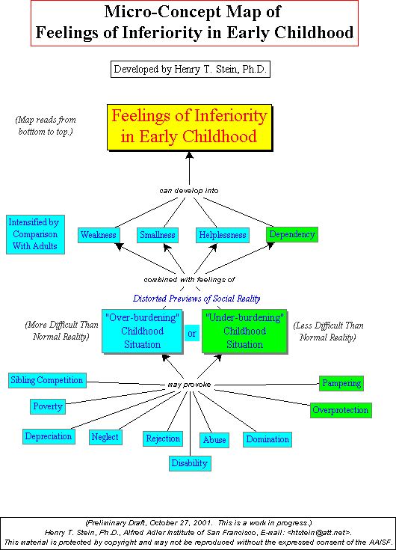

# Superiority Complex

* + **Superiority Complex** develops when individuals concentrate on themselves exclusively while ignoring others and of society.

– These individuals tend to be domineering, vain, boastful, and arrogant

## Evolution of Adler’s (Drive) Theory

* + - **Organ Inferiority:** The idea that we are all born with some physical weakness- people’s reactions to the weaknesses were motivators in life

– All drives could be explicitly expressed or reversed

* + - **Aggressive Drive:** the reaction when other drives (e.g. inferiority or helplessness) are not met- lashing out
    - **Masculine Protest:** Because young children are relatively powerless- they strive for independence and autonomous

## Perfection Striving

* Adler believed a central core of personality was the striving for superiority or perfection.
* **Perfection Striving**- people who are not neurotically bound to an inferiority complex spend their lives trying to meet “fictional goals.”
  + **Fictional goals (Final Fictionalism)** reflect what each person sees as perfection and requiring the elimination of their flaws.
  + Having fictional goals provide motivation and focus

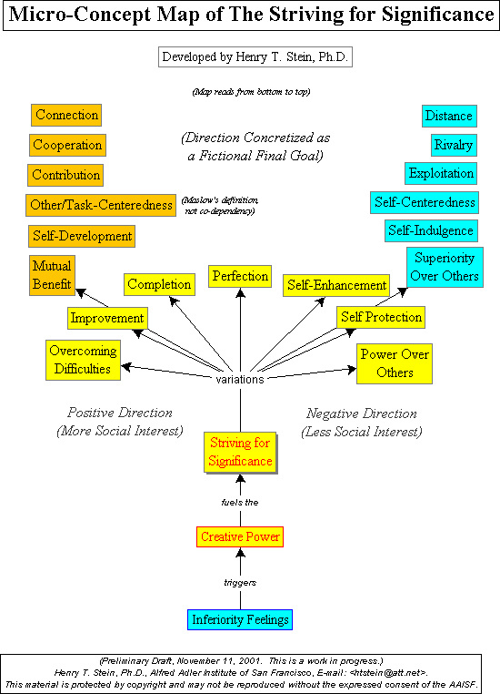

## Style of Life

Style of Life

* Style of Life (lifestyle)– is a unique character structure or pattern of personal behaviors and characteristics each if us develop

– Life style refers to how you live your life, how you handle problems and interpersonal relations

## Style of Life

* **Ruling Dominant** (Aggressive domineering)
* **Getting-Leaning** (takes away from others; somewhat passive)
* **Avoiding** (conquers problems by running away)
* **Socially Useful** (meets problems realistically; is cooperative and caring)

## Does Birth Order Matter?



Birth Order and Personality

* + Adler believed that each child is treated differently w/in a family depending on the child’s birth order and this differential treatment influences the child’s worldview and thus his choice of life’s goals and lifestyle.

## Birth Order II

* First Born: is focus of attention until ‘dethroned’- may develop resentment towards younger sibling; understands power and authority.

▪▪ Second Born: has to be extremely ambitious b/c he or she is trying to catch up with the older sibling

## Birth Order III

▪▪ Youngest Child: most likely to seek a unique identity w/in the family such as becoming a musician in a family of scientists or visa versa.

▪▪ Only Child: exaggerated sense of superiority and a sense that the world is a dangerous place.

Research Support for Birth Order

* First-borns more likely to go to college and high achievers (Recently- higher IQ’s)
* Later-born children are more likely to be creative, rebellious and revolutionary

## Adler’s Personality Typology

Adler’s Personality Typology

* + Adler developed these ideas from the Greek notions of temperamental humors underlying personality.
  + Adler believed that these orientations/ typologies grew out of early experiences

## Adler’s Typology

|  |  |  |  |  |
| --- | --- | --- | --- | --- |
| **Greek Humors** | **Greek Types** | **Social Interest** | **Activity** | **Adler’s Type** |
| **Yellow Bile** | **Choleric** | **Low** | **High** | **Ruling- dominant** |
| **Phlegm** | **Phlegmatic** | **Low** | **Low** | **Getting- leaning** |
| **Black Bile** | **Melancholic** | **Very low** | **Low** | **Avoiding** |
| **Blood** | **Sanguine** | **High** | **High** | **Socially useful** |