University of Phoenix Material

Nonverbal Communication Codes

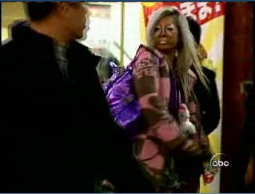

- What nonverbal messages are being sent in this image?

- What type of nonverbal communication codes are being used to deliver the messages?

- What effect does each message have on the other people in the image?

- What nonverbal communication skills and strategies could be used to communicate effectively in this situation?

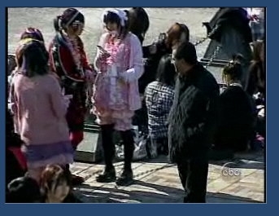

- What cultural barriers are seen in this image?

- What type of nonverbal communication codes are being used to deliver the messages?

- What effect does each message have on the other people in the image?

- What nonverbal communication skills and strategies could be used to communicate effectively in this situation?

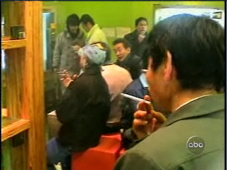

- What nonverbal messages are being sent in this image?

- What type of nonverbal communication codes are being used to deliver the messages?

- What effect does each message have on the other people in the image?

- What nonverbal communication skills and strategies could be used to communicate effectively in this situation?

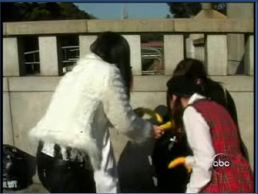

- What cultural barriers can be seen in this image?

- What nonverbal messages are being sent in this image?

- What type of nonverbal communication codes are being used to deliver the messages?

- What effect does each message have on the other people in the image?

- What nonverbal communication skills and strategies could be used to communicate effectively in this situation?

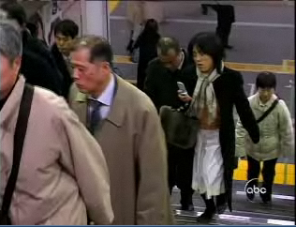

- What cultural barriers can be seen in this image?

- What nonverbal messages are being sent in this image?

- What type of nonverbal communication codes are being used to deliver the messages?

- What effect does each message have on the other people in the image?

- What nonverbal communication skills and strategies could be used to communicate effectively in this situation?

