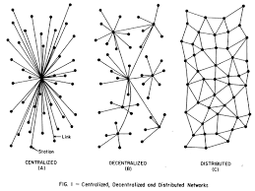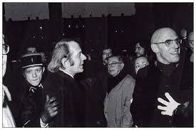**Deleuze & Guattari**

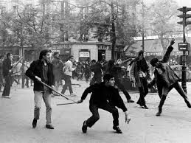**Writing Assignment**

****Try to construct an interpretation of the project of Deleuze and Guattari via an analysis of an aspect of their work that was provocative, interesting, not entirely absurd, etc., to you. Ideal would be to also include in some passing way reference to concepts/strategies/arguments you developed in your earlier papers (pomo intro, Derrida, Foucault). In other words, while providing an interpretation of their project see if you can’t discern connections to the works of Foucault, Derrida, etc.

I think this paper should be three to four pages long… it is more meant to be a single intense session of writing rather than a sustained segmented work. The use of quotes from primary texts or secondaries is encouraged and respected… but is not required for a top-notch, exemplary, or stellar grade.