Book login

<https://redshelf.com/accounts/login/>

[nataschabain@gmail.com](mailto:nataschabain@gmail.com)

wadebain83

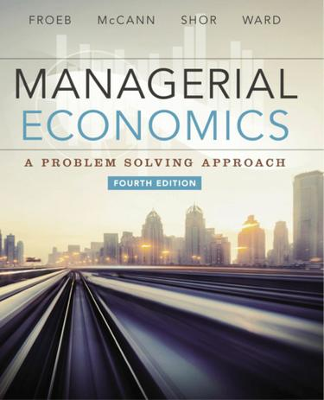

**THE PROBLEMS ARE AT THE END OF EACH CHAPTER PLEASE DOUBLE CHECK YOU ARE DOING THE RIGHT PROBLEMS**

**[Homework 3](https://courses.cityu.edu/webapps/assignment/uploadAssignment?content_id=_6051170_1&course_id=_81426_1&group_id=&mode=view)**

Chapters 6,7,8

Chapter 6

* + Multiple Choice Questions:  #1-10
  + Individual Problems:
    - 6-1 Elasticity of T-Shirt Sales
    - 6-3 Increasing Movie Ticket Prices
    - 6-4 Nike Demand

Chapter 7

* + Multiple Choice Questions:  #1-10
  + Individual Problems:
    - 7-3 Rangers’ T-shirts
    - 7-4 Average and Marginal Costs

Chapter 8

* + Multiple Choice Questions:  #1-10
  + Individual Problems:
    - 8-1 Widget Market
    - 8-4 Chocolate Candy Bars Market
    - 8-5 Demand shifts

[**Homework 4**](https://courses.cityu.edu/webapps/assignment/uploadAssignment?content_id=_6051171_1&course_id=_81426_1&group_id=&mode=view)

Chapters 9, 10, 11

Chapter 9

* + Multiple Choice Questions:  #1-10
  + Individual Problems:
    - 9-3 Entry & Elasticity
    - 9-4 Competitive Industries

Chapter 10

* + Multiple Choice Questions:  #1-10
  + Individual Problems:
    - 10-4 Five Forces and the Airline Industry
    - 10-5 Smartphone market

Chapter 11

* + Multiple Choice Questions:  #1-10
  + Individual Problems:
    - 11-3 The Russian Ruble
    - 11-5 Dollar Devaluation

[**Homework 5**](https://courses.cityu.edu/webapps/assignment/uploadAssignment?content_id=_6051172_1&course_id=_81426_1&group_id=&mode=view)

Chapters 12, 13, 14

Chapter 12

* + Multiple Choice Questions:  #1-10
  + Individual Problems:
    - 12-2 Parking at Cowboys Stadium
    - 12-5 Concert Prices

Chapters 13 & 14

* + Multiple Choice Questions:  #1-10 (located at the end of Chapter 14)
  + Individual Problems:
    - 14-3 Selling Salsa
    - 14-4 Microwave Ovens
    - 14-6 Bundling

[**Homework 6**](https://courses.cityu.edu/webapps/assignment/uploadAssignment?content_id=_6051173_1&course_id=_81426_1&group_id=&mode=view)

Chapters 15, 16, 17

Chapter 15

* + Multiple Choice Questions: #1-10
  + Individual Problems:
    - 15-5 Renegotiating Employment Contracts

Chapter 16

* + Multiple Choice Questions: #1-10
  + Individual Problems:
    - 16-2 Airline Merger
    - 16-3 House Closing

Chapter 17

* + Multiple Choice Questions: #1-10
  + Individual Problems:
    - 17-1 Global Expansion
    - 17-4 Disposing of Used Assets