Health, Safety and Nutrition Teaching Unit for Children and Families

[Submit Assignment](https://gcccd.instructure.com/courses/18805/assignments/187470)

* **Due** Dec 9 by 11:59pm

* **Points** 100

* **Submitting** a file upload
* **File Types** doc, docx, pdf, and ppt

* **Available** until Dec 10 at 11:59pm

Create a Health, Nutrition and Safety teaching unit that can be used in a classroom for children and their families.  The unit should include 1 lesson plan for Health, 1 lesson plan for Safety and 1 lesson plan for Nutrition.  Each lesson plan must include an objective, amount of time it takes to complete the activity, materials, resources and an activity that families can do with their children at home and a section for modifications for children with special needs. Lesson plans should not include worksheets and/or art projects that have one correct way of completing it.  Children learn best through hands on opportunities.  Here is your chance to be creative. See photos below for activities that should NOT be included in your lesson plans.

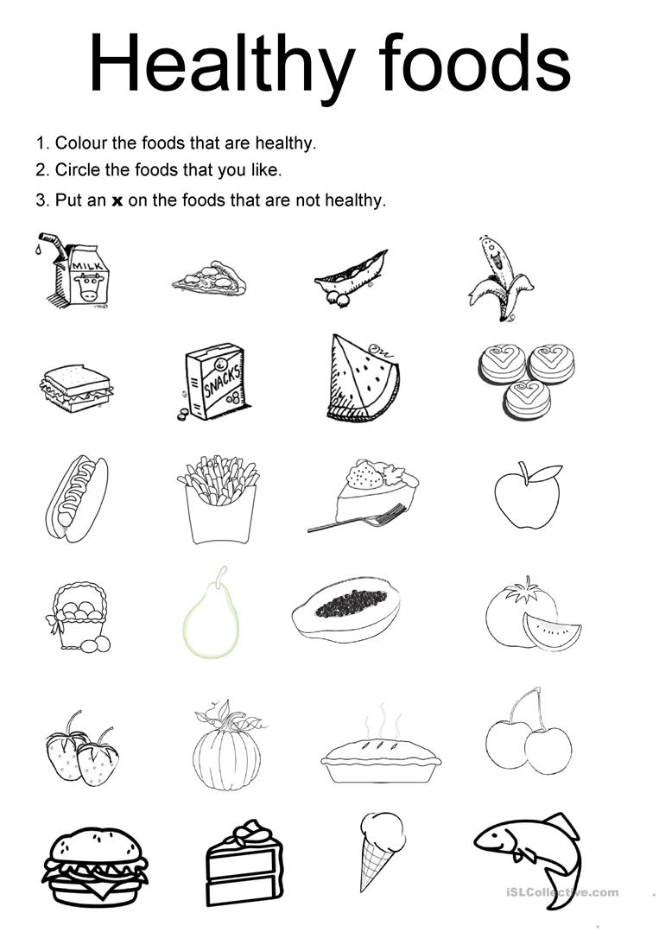

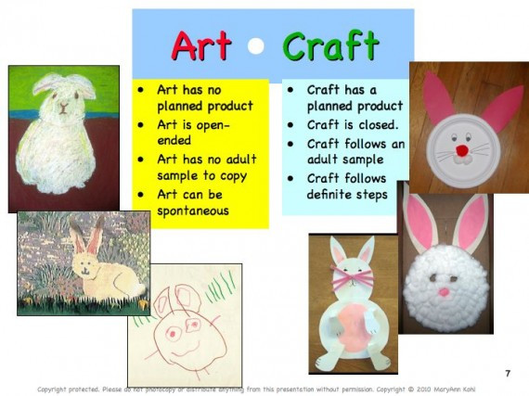

[Health Lesson Plan FormPreview the document](https://gcccd.instructure.com/courses/18805/files/910536/download?verifier=2NGHjyGz20PONefL3ocJm7vCPSYYIyC6YWHsEbbi&wrap=1)

[Safety Lesson Plan FormPreview the document](https://gcccd.instructure.com/courses/18805/files/910537/download?verifier=219fdmuAZaFKlEOGHYlvKiiEpl2H2GkgxnTn08Zi&wrap=1)

[Nutrition Lesson Plan FormPreview the document](https://gcccd.instructure.com/courses/18805/files/910539/download?verifier=0DcMKwgvQr1H2hPF3CRXG0khN91s1SNALV3Hb56c&wrap=1)

[Example LessonPreview the document](https://gcccd.instructure.com/courses/18805/files/910568/download?verifier=eEIILk8pmDc5V2ybIsT7XrFMPiRcgldswPdWzBef&wrap=1)

Rubric

**Health, Safety and Nutrition Teaching Unit for Children and Families**

| Health, Safety and Nutrition Teaching Unit for Children and Families | | |
| --- | --- | --- |
| **Criteria** | **Ratings** | **Pts** |
| This criterion is linked to a Learning OutcomeSafety Lesson Plan | |  |  |  | | --- | --- | --- | | **25.0 pts**  **All Components Present** | **15.0 pts**  **Some Components** | **0.0 pts**  **No Components** | | 25.0 pts |
| This criterion is linked to a Learning OutcomeNutrition Lesson Plan | |  |  |  | | --- | --- | --- | | **25.0 pts**  **All Components** | **15.0 pts**  **Some Components** | **0.0 pts**  **No Components** | | 25.0 pts |
| This criterion is linked to a Learning OutcomeHealth Lesson Plan | |  |  |  | | --- | --- | --- | | **25.0 pts**  **All Components** | **15.0 pts**  **Some Components** | **0.0 pts**  **No Components** | | 25.0 pts |
| This criterion is linked to a Learning OutcomeActivities | |  |  | | --- | --- | | **15.0 pts**  **Developmentally Appropriate** | **0.0 pts**  **Does not meet the requirements** | | 15.0 pts |
| This criterion is linked to a Learning OutcomeSimilarity Score | |  |  |  | | --- | --- | --- | | **10.0 pts**  **Less than 10%** | **5.0 pts**  **10%-15%** | **0.0 pts**  **more than 16%** | | 10.0 pts |
| Total Points: 100.0 | | |