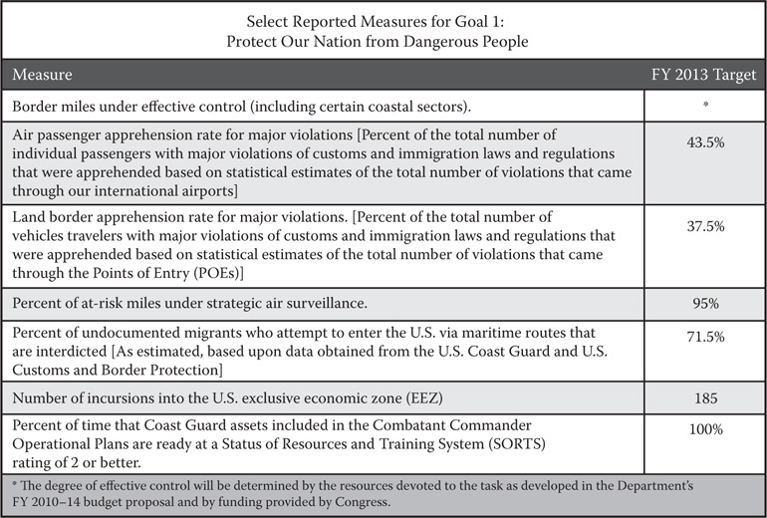

**FIGURE 12.2  Goal 1 performance. (From: One Team, One Mission, Securing the Homeland, 2008–2013.)**