DHS must recognize and know, on some level, that it cannot do all it seeks to accomplish. The Federal Emergency Management Agency (FEMA) seems to acknowledge this reality when it labels its current effort as *government centric*.

We fully recognize that a government-centric approach to emergency management is not enough to meet the challenges posed by a catastrophic incident. *Whole community* is an approach to emergency management that reinforces the fact that FEMA is only one part of our nation’s emergency management team; that we must leverage all of the resources of our collective team in preparing for, protecting against, responding to, recovering from, and mitigating against all hazards; and that collectively we must meet the needs of the entire community in each of these areas.[4](https://jigsaw.vitalsource.com/books/9781498749121/epub/ops/xhtml/21_chapter12.xhtml#ch12fn_4)

As DHS seeks to generate enthusiasm within the public, especially in publishing documents such as “One Team, One Mission, Securing the Homeland, 2008–2013,”[5](https://jigsaw.vitalsource.com/books/9781498749121/epub/ops/xhtml/21_chapter12.xhtml#ch12fn_5) the contents of the report paint a somewhat disappointing picture of half successes. In “Goal 1: Protect Our Nation from Dangerous People,” arguably the central reason for the mission of DHS, the results by and large are mixed to poor no matter how you look at it ([Figure 12.2](https://jigsaw.vitalsource.com/books/9781498749121/epub/ops/xhtml/21_chapter12.xhtml#ch12fig12_2)).

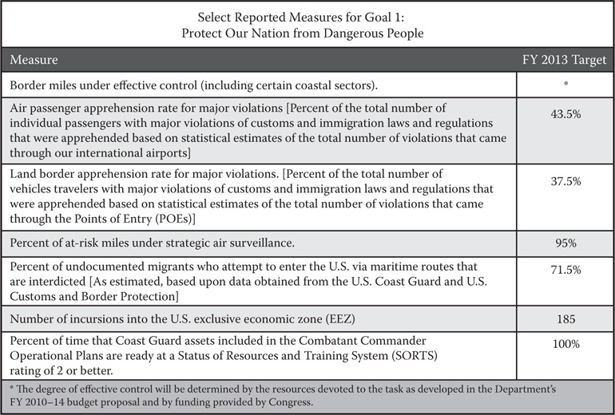

**FIGURE 12.2  Goal 1 performance. (From: One Team, One Mission, Securing the Homeland, 2008–2013.)**

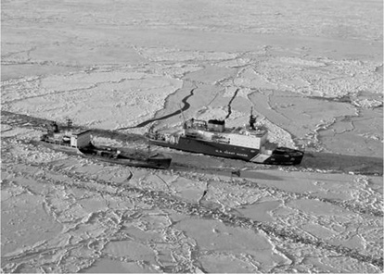

**FIGURE 12.3  Bering Sea: the Coast Guard cutter Healy breaks ice around the Russian-flagged tanker vessel Renda 250 miles south of Nome, Alaska, January 6, 2012. (From: U.S. Coast Guard photo by Petty Officer 1st Class Sara Francis.)**

Less than half of the air passengers with major violations of customs and immigration laws and regulations are apprehended. Just over one-third of vehicle travelers with major violations of customs and immigration laws and regulations are apprehended. The only true success story among those listed is that of the Coast Guard—an agency that remains mission oriented and does what it does exceedingly well. As exhibited by its response in the Haiti earthquake of 2011 and the BP oil spill, and per the Coast Guard’s own posture statement for 2011, it is rightfully characterized as an entity “biased for action,” with an “ability to meet expanded mission requirements.”[6](https://jigsaw.vitalsource.com/books/9781498749121/epub/ops/xhtml/21_chapter12.xhtml#ch12fn_6) DHS as a whole could learn much from this key player in both emergency response and homeland defense roles ([Figure 12.3](https://jigsaw.vitalsource.com/books/9781498749121/epub/ops/xhtml/21_chapter12.xhtml#ch12fig12_3)).

At present, DHS seemingly continues down a path of agency building by looking for more fields of coverage and control. With a nation $19 trillion in debt and counting, and a military complex now facing severe and significant cuts, little—including DHS’s massive budget—will be spared the budgetary realities of the decade to come.[7](https://jigsaw.vitalsource.com/books/9781498749121/epub/ops/xhtml/21_chapter12.xhtml#ch12fn_7)

**Internet Exercise**: Visit the U.S. Debt Clock to get some sense of how staggering our national debt has become at <http://www.usdebtclock.org>.

[**12.2 Growth without Reason**](https://jigsaw.vitalsource.com/books/9781498749121/epub/ops/xhtml/05_toc.xhtml#sec12_2)

From its inception, DHS was running on a different clock than its governmental counterparts. Aside from its origination, it could change like a chameleon. Today’s threat was tomorrow’s agenda item, only lower on the list. DHS could consume, like a ravenous beast, most of its competing agencies, even those with a historically different approach. Nothing is all that surprising about bureaucracies growing, self-perpetuating, and feeding on mission to develop other parts of the bureaucratic puzzle. Yet this journey is neither a trek nor a run, but a propulsion that simply knows no bounds. FEMA’s inclusion in DHS is an excellent illustration of this phenomenon. In FEMA the natural disaster sets the tone—the hurricane, the earthquake, the fire, and so on. That is what FEMA was intended to direct its energies toward. Even so, FEMA would be subsumed into the DHS model. Some have wondered whether this tendency to simply swallow any event resembling a disaster has been good for DHS or FEMA. It is a question worth asking, and in the hubbub of growth and bureaucratic delirium, a pandemic of frenzy if there ever was one, one must stop and smell the roses. To grow and evolve is natural. To grow without much thought is mindless. Maybe FEMA’s response to hurricane damage is not really the building blocks of DHS. Maybe earthquakes are flat out different and do not benefit from the DHS mentality. While not perfect, the generally positive signs in the planning in advance of and in response to Hurricane Sandy in the fall of 2012 indicate that FEMA may in fact be able to operate and function successfully within DHS. Certainly the leadership, response, and rebuilding efforts in the wake of Sandy show remarkable improvement over such efforts during, and in the wake of, Hurricane Katrina. Hopefully such improvement can be a repeatable trend across DHS.

As you read through the pages of this text, you have witnessed growth in both form and substance. You have witnessed the absorption of departments at a pace never seen before. You have gleaned that the term infrastructure means more than brick and mortar—that the FDA has a homeland plan just as the National Monuments Agency does. Everyone has a plan. Everyone combats terrorism. Page by page you have read about new plans, new stratagems, new policies, new mergers, and realignments. You can get dizzy reading about these changes. And one other thing—you can be sure that what is here likely will be different in a short time. I contend that more is not always more. Sometimes more is less. Fewer results, less efficiency, less coordination. Is it possible to take on too many agencies, too much responsibility, and thus lose the focus of what is truly important or necessary?

As an example, does the hiring of 60,000 new border agents—throwing sheer numbers at the problem—automatically guarantee a more secure border? Or is the border today any safer or more reassuring than 3 years ago? There is no definitive answer to such questions and while there has been progress in some areas, results are dubious at best in others.

Revisiting policy and enforcing current laws on the books would take care of many of the issues. We build fences to keep people out, but illegal immigration is still a consistent problem. While border security is necessary, a more holistic policy solution would include (1) increased border security in conjunction with encouraging legitimate immigration and naturalization and (2) a more consistent policy on illegal immigrants within the country. Establishing a reliable, efficient process for those individuals and families who are in the country now and want to become U.S. citizens would help alleviate some of the strain on the system, set the proper tone, and provide a clear and consistent path to obtaining citizenship. Current considerations around taking in foreign refugees, including those from the Syria conflict, cause serious and impassioned debate. Much of the disscussion surrounds the identification and vetting of individuals before taking them into our country. In addition, there is the overall perception of other countries to consider—about our willingness to help, or not, as a world power and leader in what is inarguably a human rights crisis. At present, it remains to be seen how all will play out.

Why do our agencies neglect targeting those that should be targeted and