Final Marketing Plan

John Doe

Kirkwood University

August10, 2019

**Market Research Paper Proposal**

The product that I choose is jeans for both ladies and gents. Unlike the other jeans, the product will be fabricated and designed in a manner that will make it unique when compared to other products of the competitors. The most preferred marketing strategy for this product is digital marketing. Digital advertising incorporates all promoting endeavors that utilize an electronic gadget or the web. Organizations influence advanced channels, for example, web crawlers, social media, email, and different sites to associate with present and forthcoming customers. Digital promoting is done crosswise over many advertising jobs today. In minor organizations, one generalist may possess a considerable lot of advanced advertising strategies depicted above simultaneously. In more prominent organizations, these strategies have different pros that each attention on only a couple of the brand's advanced channels.

First, the product will consider various aspects of the target customers. Such attributes include shopping preferences, personal interests, challenges, motivations, geographical location, gender, and age. In this marketing plan, I will utilize various avenues to market my product. The first avenue is social media, with the capability to point out the target consumers, social media depicts an essential tool to boost digital marketing endeavors. LinkedIn can be utilized to reach out to some consumers, like business professionals (Charlesworth 43). For the millennial demographics, Instagram, Facebook, and Twitter will be more effective.

Consequently, the product may use mobile strategy depending on several factors like the resources available. This can be achieved through the mobile-friendly website and social media. Therefore, it is possible to fabricate the actual mobile app; this is important as it facilitates customization possibilities.

The country that will market my product in is the United Kingdom. In the UK, the company will communicate the brand, as well as its values to its target customers in the market and this, can be facilitated by progressed media channels like Broadcast media, print media, electronic media, display media, and network media. Furthermore, the firm will likewise publicize its brand as well as its benefits by the use of social media instruments since it is a vital and useful tool among the younger generation. Therefore, the general marketing plan will concentrate on digital marketing.

Digital advertising can work for any business in any industry. Notwithstanding what your organization sells, advanced advertising still includes working out purchaser personas to distinguish your group of spectators' needs and making the profitable online content. In any case, this isn't to imply that all organizations should actualize a digital advertising system similarly. For this reason, the company will utilize other marketing strategies to back up digital marketing. The overall success of the company is determined by the success of the marketing strategy employed. In the UK, there are potential customers for the product following a significant number of the population being youths. Consequently, the company may opt for e-Commerce platforms like eBay and Amazon; this may play a vital role in the marketing of the product. Furthermore, the product will be available in physical stores like the boutiques.

In conclusion, the product chosen for this discussion is the jeans for all genders. This product is easy to market since most of the youths usually prioritize them; therefore, its utility is high. Thus, the primary marketing strategy that will be employed for this product is digital marketing; it is a strategy which has an array of marketing avenues. If used effectively, it is likely to depict positive results.

**Jeans Marketing Project**

The marketing project will involve production of jeans for both ladies and gents. Unlike the other jeans, the product will be fabricated and designed in a manner that will make it unique when compared to other products of the competitors. The country that will market this product is the United Kingdom. In the UK, the company will communicate the brand, as well as its values to its target customers in the market and this will be facilitated by progressed media channels like Broadcast media, print media, electronic media, display media, and network media. The overall success of the company is determined by the success of the marketing strategy employed. The target market will be youths, as they are the most group who love wearing jeans. With the prolonged use of jeans in the UK from all ages and people from all walks, our business strategy will be essential to camp base and conquer the ready market. With the changes in market demand from customers a detailed market research will be undertaken. The market research will entail five steps.

The first step will be defining the problem. Since the key product we are offering is production of jeans for both men and women, the first question will be to determine the rate of jeans usage in the UK. Another consideration will be the quality and types that the target market prefers to use in the UK. The target market leisure activities will be a key factor to determine the usage. As UK has more population of youths in urban areas, the ideal environment for the target market, the business will blossom. The jeans target market from UK has outgoing individuals who love outdoor events. It is estimated that about sixty percent of the UK citizens go to various outdoor events such as sports (Braham, 2017). In all the events, most of the people prefer jeans as their main outfit. To enter deep into this target market, different unique types of jeans will be produced with different functionality to enable the target market to accept the new brand faster.

The second step will be to conduct a market research. The market plan will enable the project to successfully seal all the loopholes. The research will involve interviewing customers and all stakeholders (Senior, Smyth, Cooke, Shaw, & Peel, 2007). The interview process will help the project get underlying views from all the local residents. The next step will be conducting a survey. Additionally, running user test will provide an insight of how the customers perceive introduction of new items. The third step will be collecting all the data. The qualitative and quantitative data from the survey and interviews will be collated. The data will be analyzed, and the summary recorded (Bair, &Gereffi, 2004). Trends from the data will be used to get the feedback from the research. Finally, the research will be presented, and all the actions required taken. The research will enable the project manager to determine the tidbits of the business in the region. Competitors and all their ways of doing business, the quality of their products and the prices of their products will be a key factor to enable the company to progress smoothly.

The market changes were assessed and presented, and the following were the results.

|  |  |  |
| --- | --- | --- |
| Company | Type | %sales |
| Company 1 | Unisex | 16 |
| Company 2 | Men | 18 |
| Company 3 | Unisex | 17 |
| Company 4 | Women | 25 |

The table above shows the market prevalence by different companies in the UK

The chart for the assessment is presented below

The chart below shows the production of Jeans among four different companies.

Each company had different prevalence ratio in the sales and manufacture of the three types of jeans. Company 1 and Company 4 produce more jeans for men. Company 2 produces more jeans for women while company 3 produces more unisex jeans.

**Product development and product life cycles.**

Production of the jeans will involve seven major steps. Cotton production has been divided into three categories which are conventional farming system, integrated pest management and organic production. The quality of the cotton depends on the method used during growth. The best cotton for jeans production comes from irrigated fields. Jeans production end life focuses more on the recycling techniques. The cotton fibers are eventually converted to polymers by chemical modification. The denim cotton can be recycled to produce cellulosic fibers. After collecting cotton, it is taken in the factory for manufacturing process. Spinning and weaving takes place and solely depends on energy consumption, dust and waste material. Later the cotton is taken for dyeing which involves chemical use by bleaching and reductive agents. Additionally, dyes, wastewater and energy are also used. In the garment production, solid waste, dust, labor conditions and combination of acetate and rivets are used. While finishing, bleaching by use of chemicals and enzymatic treatments is applied (Braham, 2017). Moreover, mechanical treatment by sand blasting, stone washing, and grinding are applied. At long last, the denim jeans are packed while the solid waste is disposed-off and transport by energy consumption. While handling the denim jeans, the maintenance for the products can happen by using less energy and washing chemicals. End of life involves incineration, landfill, reuse and unraveling into fibers. Cotton products are further classified into class A which contains recycled cotton, nylon, polyester, organic hemp and linen. Class B contains organic cotton, tencel and conversion cotton. Part C is made by Ramee, conventional hemp, linen and pla. Class D has lenzying model, poly-acrylic and virgin polyester. Class E on the other hand contains virgin nylon, conventional cotton, rayon, wool, generic viscose and bamboo viscose. Unclassified category contains organic wool, acetate, alpaca, cashmere, leather and silk. When reprocessing, new equipment are used that contain longer fibers, and better cleaning performance. The materials spearhead production of spinnable quality of fiber and textile production using traditional lines.

**Assembled and delivered**

Production will be done in USA due to the available resources. As is the norm with our industry, the products will be exported to our overseas shops in the UK. The production of the jeans in UK will be initiated after some few years of being in the market. This fact is due to the proximity of the raw materials in America.

**Transportation logistic issues**

Since textile goods are sensitive to humidity, the vehicles that will be used have to be equipped appropriately to ensure optimal humidity level. Specific polythene bags must be available for the transport of the jeans and the cargo specifically labeled. The preferred transport mode is road, followed by sea. Road transport is the best as it maintains quality to the last destination.

**Product to the market and to the customer**

With the manufacturing industry available in USA, the product will be exported to UK. Transport system preferred between two continents is sea transport. Sea transport is the fastest and safest. Air and train transport tend to destroy the quality of the products. On reaching UK, the product will be transported in containers and offloaded to our main stores in the country. Every store will get equal measures of the cargo and some special measures too in regard to their selling preference in the locality.

**Measuring success**

The success of the project will be determined by the following five aspect; schedule, quality, cost, stakeholder satisfaction and performance in the market. Schedule involves gauging the project in reference to the set duration. A good project is implemented within the given time frame. Quality review will enable the project to be perfect before reaching the target market. Quality products attract loyal customers, and this will be a big boost to the firm. Cost is a key factor and the project manager should be keen on the expenses incurred during the implementation to ensure that there is no overspending. Stakeholders must review the new product and ascertain its use before it breaks to the market. Performance of the business in the market will determine the efficiency and profitability the company will incur during its operations.

**Marketing Forecast**

A market forecast projects the future characteristics, trends and numbers in the target market. In a standard analysis, the prospective customers are distributed into segments. The table below shows the market segments in the jeans industry and also shows projected potential customers.

***Market size forecast for projected market growth***

|  |  |  |  |  |  |  |
| --- | --- | --- | --- | --- | --- | --- |
| Potential Customers | Growth (%) | 2019 | 2020 | 2021 | 2022 | 2023 |
| Men Jeans | 15 | 15000 | 17250 | 19838 | 22813 | 26235 |
| Women Jeans | 10 | 8000 | 8800 | 9680 | 10648 | 11713 |
| Unisex Jeans | 5 | 5000 | 5250 | 5513 | 5788 | 6078 |
| Total | **30** | **30019** | **33320** | **37052** | **41271** | **46049** |

The forecast above show that the potential customers who buy male jeans are 15,000 and the number is rising at an estimate of 15% per year. Women jeans potential customer increase is 10% and the number available is 8,000. Moreover, unisex jeans have a growth rate of 5% and the number of customers available is 5,000. The numbers are estimates produced by the research team. Themarket size forecast chart is displayed below

The market value in a forecast is an important factor. The sales of Unisex are important too despite not being as much as the sales for men jeans. The market value of unisex turns out to be more when compared to the customer sales.

|  |  |  |  |  |
| --- | --- | --- | --- | --- |
| Potential Customers | Average (Customer) | Market Value | Attitude | Willingness to buy |
| Men Jeans | 20227 | 74 | Positive | Ready |
| Women Jeans | 9768 | 82 | Indifferent | Reluctant |
| Unisex Jeans | 5526 | 90 | Depends | Willing |

Average per customer is the important part of a market value. Unisex seems to have a big market value compared to the other types. The market value is calculated by taking the average value of customers in the five years divided by the sales per customer.

The market focus should undergo a reality check to ascertain the truth indicators in the market. The reality check for the case study will be done by interviewing vendors and matching their numbers with the ones available in the market value chart. The market analysis will enable the company to develop a picture of the target market. It will also reveal the potential the market absorbs over time. Moreover, the market value will state the best brands of products preferred in the market and the ones that makes big sales.

A forecast market helps organizations determine the expectations when the sales begin. They help in providing an estimate budget that can help the organization create a budget regarding the market consumption. Forecast metrics always align to the sales and revenues of the business (Armstrong, & Brodie, 1999). The business should select meaningful and predictable metrics. To determine the outcome of the business in coming months a forecast metric is designed. The forecast uses revenues and total sales. The example of a market forecast is shown below

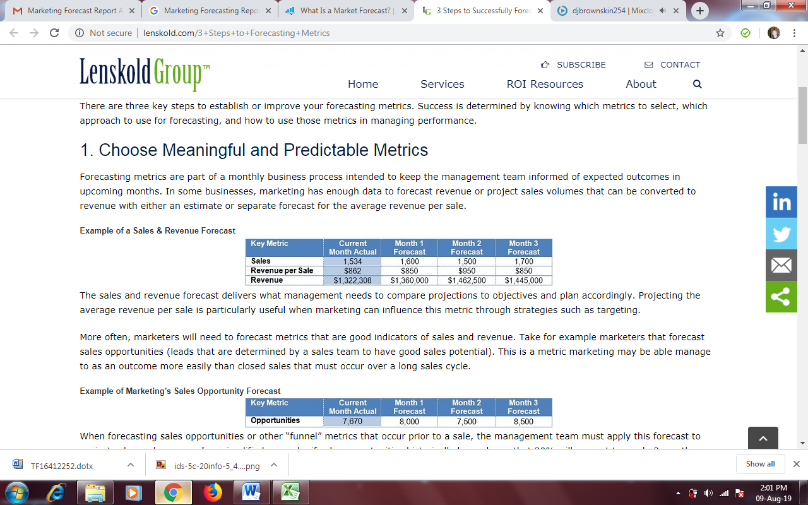

The forecast sales and revenues give the management projection objectives that help them plan accordingly. Marketers use metrics that indicate the sales and revenue to aid in the projection and expectations of the business. Marketers who use the most sales to determine the forecast show good market understanding. Example is displayed in the table below



The forecast above is applied to enable the company project sales and revenues. For example, if the sales are increasing by 20% from being an opportunity to total sales within 3 months, the results are displayed in the table below

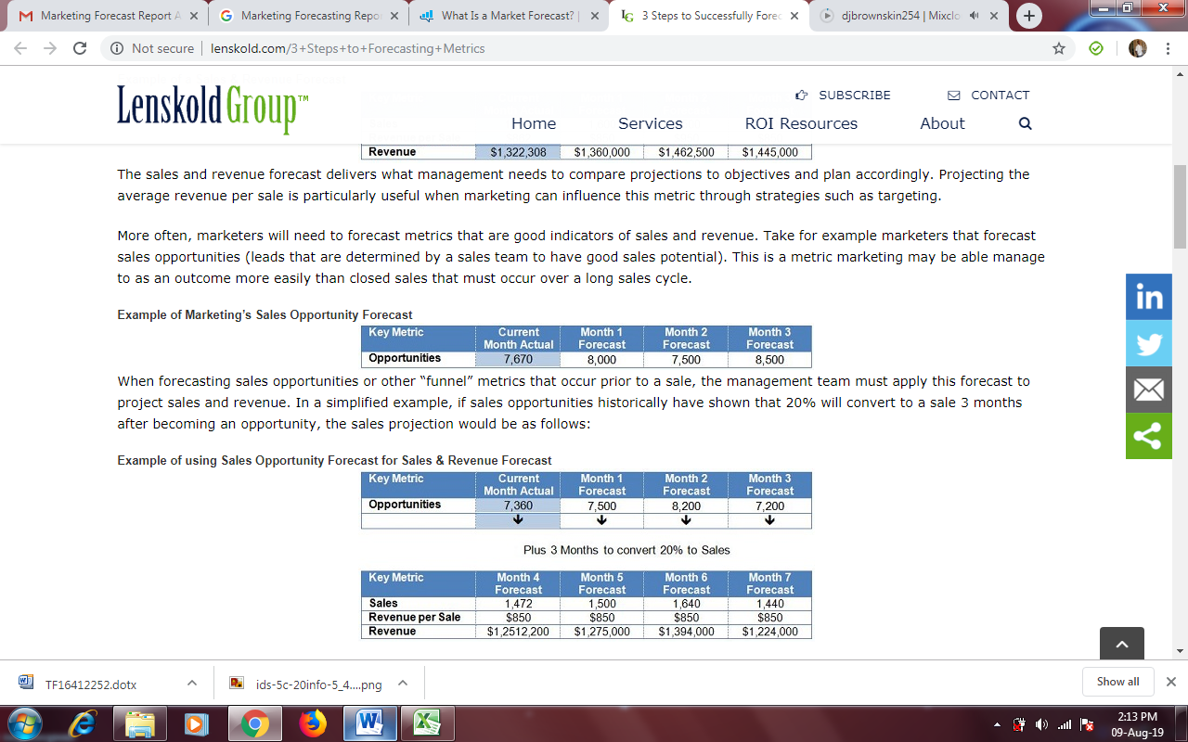

The following four months the sales and revenue will have grown and are displayed in the chart below



The right metrics used for projecting forecast should be aligned closely to sales and revenues. The metrics should also be consistent on financial outcomes. Moreover, the metrics must be predictable using the data available, contain clear meanings to stakeholders and be within the ability to market and impact. When forecasting, the marketer should ensure the data used are accurate to project correct and up to date information (Makridakis, & Wheelwright, 1977). Underestimating the market metrics results to unnecessary market adjustments that affect credibility of the business. Forecast metrics are based on data available, required precision and the available analytic skills. Forecast data being used should include customer actions (engagements, opportunities, responses), marketing activities (events, advertising levels), product info (new products, pricing, offers) and external influences (competitive activities). The approaches to consider include historical conversion, predictive scoring and forecasting models.

Historical conversion is used when tracking an outcome before a decision to purchase is made. It works best during product trials since the rates are somehow consistent. Predictive scoring is used by marketers to improve accuracy of the forecast by engaging directly with customers. Predictive scoring uses contact-specific data such as purchase history to determine the probability of getting higher sales. Moreover, the predictive scoring determines the value of buyers. Forecast modeling approach develops predictive sales outcomes. Forecast modeling uses many variables and produces accurate long-term results. Forecast modeling approach is the most preferred approach.

**References**

Charlesworth, A. "Marketing goes digital." Digital Marketing, 2018, pp. 26-60, doi:10.4324/9781315175737-3.

Armstrong, J. S., & Brodie, R. (1999). Forecasting for marketing.

Makridakis, S., & Wheelwright, S. C. (1977). Forecasting: issues & challenges for marketing management. *Journal of Marketing*, *41*(4), 24-38.

James, A. (2003). Levy Launches Forecast for Co-Prod’n Play. *Variety*, *392*(13), 15. Retrieved http://search.ebscohost.com/login.aspx?direct=true&AuthType=cookie,ip,cpid&custid=s8396221&db=f5h&AN=11412624&site=ehost-live

