**Task Organization of Unit to Conduct Operation**

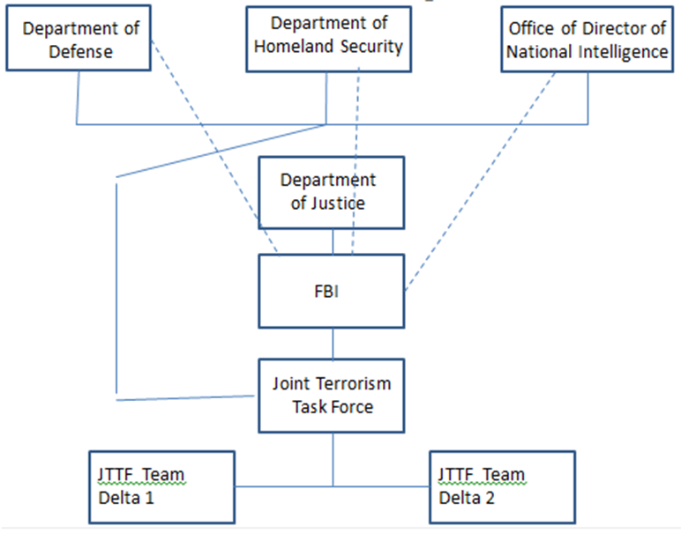

1. **Analysis of the current situation:**
   1. Define terrorism and organized crime. How are they alike and different?.
   2. Discussion of possible or actual terrorist threats to an area of the U.S. or U.S. interest.
      * 1. Identified terrorist organization name/symbol(s).
        2. Terrorist organization’s identified or implied mission and objective(s) against the U.S.
        3. Cell structure composition (types of specialists involved) and disposition (geographical or specific locations).
        4. Reporting structure (names of leaders and team/cell members).
        5. Communications strategy and methodology.
        6. Types of threat capabilities available to the organization.
        7. Terrorist organization’s center of gravity (critical vulnerability that when destroyed or disabled make the organization ineffective).
   3. Discussion of Nexus between terrorist organization(s) identified as a threat and organized crime (OC)/transnational organized crime (TOC) organization(s).
      * 1. Identified organized crime/transnational OC organization name/symbol(s).
        2. OC/TOC organization’s vision and mission for its illegal business enterprise.
        3. Organization’s composition (structure) and disposition (geographical locations).
        4. Reporting structure (Leaders and organization members).
        5. Communications strategy and methodology.
        6. Identified nexus between the OC/TOC organization and the terrorist organization (*Explain the symbiotic nature of the two organizations and how this relationship is in effect.*).
        7. Impact of risk related to the nexus.
        8. What is the illegal activity (…ies) of the OC/TOC and level of participation?
        9. OC/TOC organization’s center of gravity (critical vulnerability that when destroyed or disabled make the organization ineffective).
   4. Threat assessment and identification of potential targets to include type(s) of threat medium and corresponding deliverable(s).
      * 1. Type of threat(s).
        2. Delivery means.
        3. Date, time group (DTG) of potential terrorist attack.
        4. Location(s) of possible attack(s).
        5. Potential after effects of attack(s).
2. **MISSION of the Operation** (Who, what, when, where, and purpose/end state)**.**
3. **Strategies for countering the identified organizations.**

**Strategic Operational Plan Proposal Reviewed by:________________________________**

**(Instructor’s Name)**

**APPROVED/DISSAPROVED**

**Date/Time:____________________/___________hours.**