**Task Organization of Unit to Conduct Operation**

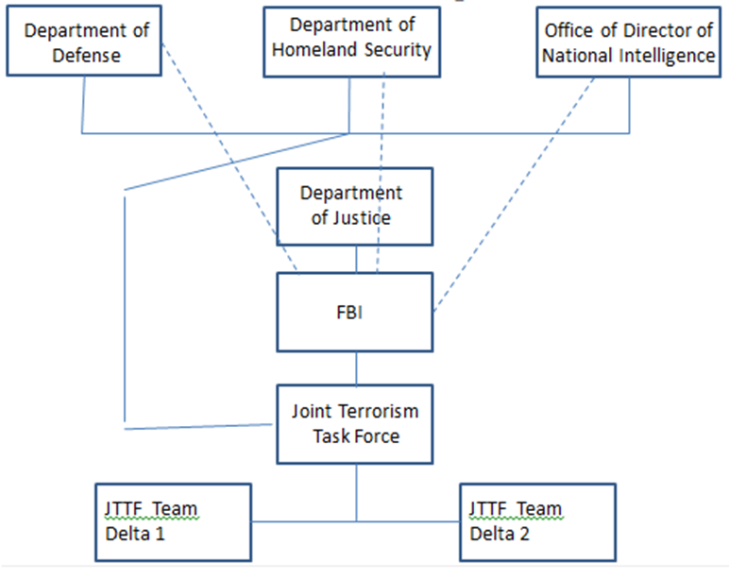

**A**

Terrorism comprises of crimes committed with the aim of daunting a population, compelling government, or any organization to attain political or social gain.On the other hand, organized crime is a criminal behavior througha violent or coerced way of obtaining material and financial benefit from a group. Important to note that, distinctive similarities exist between terrorism and organized crime, as discussed in the following context. Despite thedefiniteobjectives of terrorism and organized crime, terrorist use violent or coerced ways to finance their political activities.

**B**

According to the case provided, al-Qaeda is attempting to penetrate to Chicago in the United States of America (US) and displace its Outfit. The al-Qaeda terrorist organization comprises of two cells of 12 individuals attempting to enter the significant town of US; 2 Arab descent, 7 Philippines and 1 American. The overall organization is led by a Russian organized crime faction that funds its operations. Prominent to memo that, the names of the leaders are AlwaniAbu Rayan who liaises with Roberto Matinez. The biological father of Matinez is an Iranian while his mother is a Columbian. Again, the American terrorist is John Q. Citizen from Chicago.

The formed organization to take control of the al-Qaeda group has the mandate to take a risk and withstand the overall threats of the terrorist group. During the entire process mobile phone were used as a strategy of communication.Generally, the foremost vital threatis viewed under social perspective whereby most people including the selected team are likely to be killed by the terrorists. Also, O’Hare and Midway are the most targeted destination of the weapons of the terrorist. Therefore, to make the terrorist organization ineffective, it is highly advisable to deal with the financing faction; the Russian organized crime faction. Supportively, one the funding body is shut, then the organization starve in its operation hence easing its teeming.

**C**

The organized crime by the al-Qaeda is to invade Chicago and displace its overall outfit. Also, murder cases, prostitution, and gambling are the most notified issues in the costume of the city. The mission of the organized crime by the al-Qaeda terrorists is to bomb the entire city resulting inconsiderable damages as well as killing a massive number of people while the vision is to control the territory belonging to the outfit. According to the formed organization to curb the operations planned by the terrorists include the department of defense, homeland security and director of national intelligence.To have better results, all the mentioned department have to collaborate to curb and keep the Chicago city safe. The overall communication in the organization is mobile-based through use of emails.

The two organizations in the scenario should symbiotically relate to having mutual benefit hence have a positive result. For instance, both delta 1 and 2 have to correlate for pleasing outcomes in their duties. The impact of risk related to the focal point in the scenario is the threats of weapons that would destroy a significant part of the city. The illegal activity and the level of participation of OT is financing the terrorists. Again, to make anineffective organization, one has to deal with the financing body.

**D**

The threat type in the scenario is mostly based on the fear of the destruction of the outfit of Chicago. The threats are delivered through counterterrorismoperations through 6 July 2019 in Vicinity of Tucson. Potential after the effects of risks is destroying terrorist cells.

**The Mission of the Operation**

Conduct counterterrorist operations in the vicinity of Tucson, AZ apprehends, and destroy terrorist cell infiltrating the US.

**Strategies for Countering the Identified Organizations.**

Identified organizations can be countered through apprehending and destroy the terrorist cell in the outfit of the city.