Executive Summary

CNC technology

Table of Contents

Introduction

Experiment Overview

The equipment used within the experiment include, a computer with Mastercam Design 2020, a usb flash drive and a CNC machine. First a rectangle of dimensions 3” x 2” is generated on the machining axis in Mastercam Design 2020 and accordingly a stock is generated to match its dimensions. Then all entities of the stock are displayed as a wireframe and the height of the stock is defined as 1”. The completed stock is then centered and a 2d top view of the part is drawn, in this case 6 circles will be drawn. The central points of two circles are placed at the center of the rectangle, one with a diameter of 1.8” and the other a diameter of 0.6”. The remaining 4 circles of diameter 0.25” will have they’re central points placed orbiting around the rectangles center at a distance of 0.7” and at the angles of 90°, 180°, 270° and 360°.

Having the necessary dimensions specified the toolpaths can now be created. Spindle speed and feed rate can be constant throughout or slightly varied to display the effects of varying values while CNC machining.

First, the toolpath for removing the top layer of the material. This involves selecting a toolpath, setting it to mill toolpaths, 2D high speed, dynamic mill, creating a directional chain in a clockwise direction from the rectangle, toolpath type - dynamic mill, machining strategy - from outside, tool - ¼ “ cutter #285 (tool# 1), feed rate - 10, spindle speed - 10,000, and depth at -0.1” absolute.

Second, the toolpath for the circular extrusion. This toolpath follows the same steps as the previous toolpath except the largest circle of 1.8” diameter is selected as an avoidance region and the depth is changed to -0.3” absolute.

Third, the toolpath to drill the center hole of 0.6” diameter. This toolpath requires selecting a toolpath, Mill toolpaths, Pocket, chain - central circle, toolpath type- pocket, tool# 1, and depth at -0.5”.

Fourth, the toolpath to drill the four holes with a 0.25” diameter. This toolpath requires selecting a toolpath, Mill toolpaths, drill, drill point selection - center of all four 0.25” diameter circles, toolpath type - drill, tool - 0.257” cutter #125 (tool# 2), depth at -0.5” absolute.

Finally, select all operations and verify them, this will display a simulated machining of the part to check all toolpaths. Save to a flash drive as a NC file after using the G1 button to create the code. Turn on the CNC machine, load the stock material, select the saved file on the flashdrive, memory, rapid 25%, and start the cycle. After the process of machining the part is complete.

Results

Discussion

The steps below are for the proposed toolpaths for assigned question 2.

First, the toolpath for removing the top layer of the material. This involves selecting a toolpath, setting it to mill toolpaths, 2D high speed, dynamic mill, creating a directional chain in a clockwise direction from the rectangle, toolpath type - dynamic mill, machining strategy - from outside, tool - ¼ “ cutter #285 (tool# 1), feed rate - 10, spindle speed - 10,000, and depth at -0.1” absolute.

Second, the toolpath for the three circular extrusions. This toolpath follows the same steps as the previous toolpath except the three circles with respective diameters of 0.25”, 0.5” and 0.25” are selected as avoidance regions and the depth is changed to -0.3” absolute. The cut is shown below.

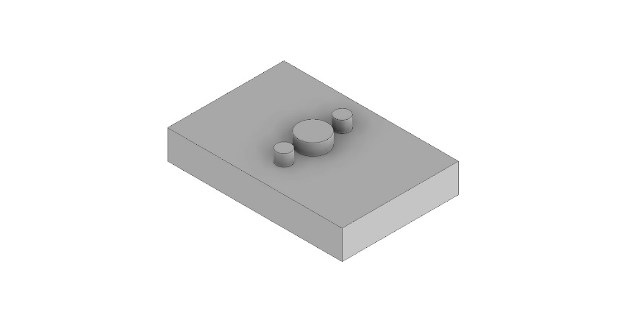

Third, the toolpath for the circular extrusion. This toolpath follows the same steps as the previous toolpath except the largest circle of 1.8” diameter is selected as an avoidance region and the depth is changed to -0.5” Absolute. The cut is shown below.

”. 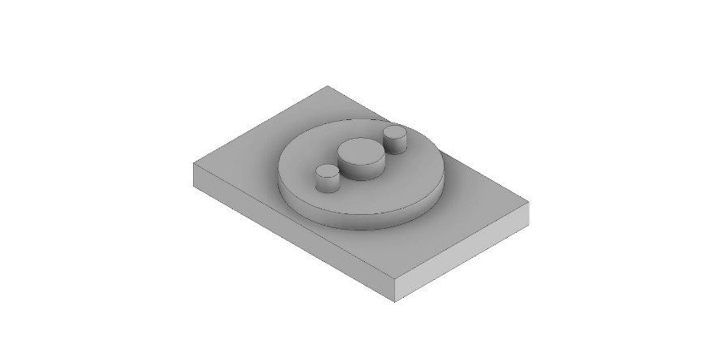

Fourth, the toolpath to drill the rectangle with 2 rounded edges. This toolpath requires selecting a toolpath, Mill toolpaths, Pocket, chain - rectangle with 2 rounded edges, toolpath type- pocket, tool# 1, and depth at -0.5”. The cut is shown below.

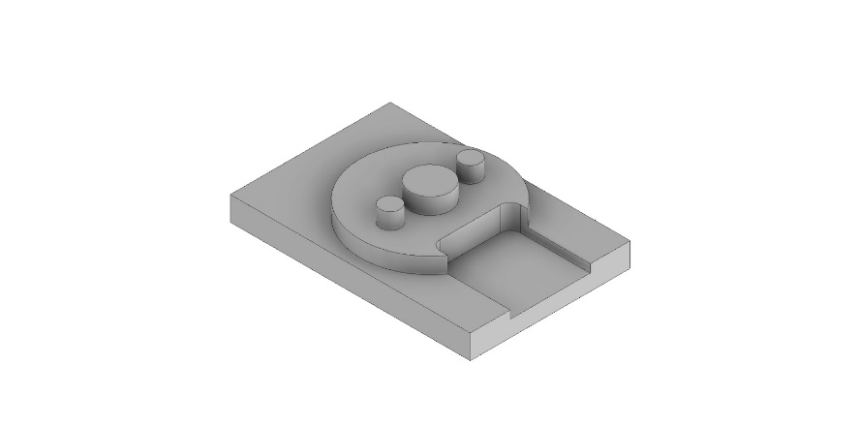

Fifth, the toolpath to drill the outer hole with a 0.25” diameter. This toolpath requires selecting a toolpath, Mill toolpaths, drill, drill point selection - center of the 0.25” diameter outer circle, toolpath type - drill, tool# 1 and depth at -0.2”. The cut is shown below.

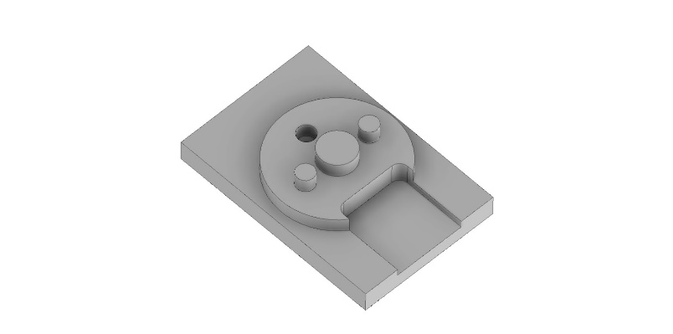

Sixth, the toolpath to drill the inner hole with a 0.25” diameter. This toolpath requires selecting a toolpath, Mill toolpaths, drill, drill point selection - center of the 0.25” diameter outer circle, toolpath type - drill, tool# 1 and depth at -1.0” absolute. The cut is shown below.

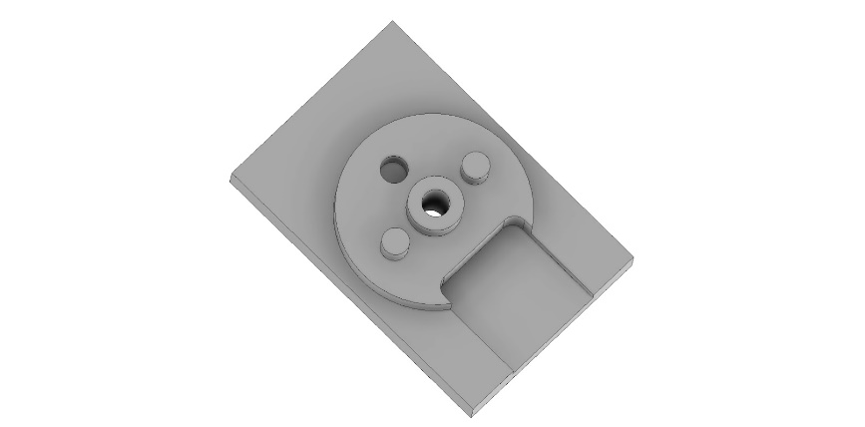

Conclusion