NPR Broadcast
PHARMACEUTICAL SCIENCE I CLASS (PHA 3003), Fall 2019 Semester - ASSIGNMENT GIVEN BY DR. K. REDDA (a total of 30 points as part of your grade).

This is an article from theNPR broadcastrelated to the subject of Antipsychotic Drugs. Please read carefully and answer the following questions:

1.List four lessons that you have learned from reading this article as a future pharmacist? Justify, support or reinforce your choices with no more than two sentences each (Please use your own words).

2.What are the chemical names of Haldol, Risperdal, Zyprexa and Seroquel.

3. DEADLINE: On or before Monday, November 25, 2019,11:00 pm.

4.Use Arial Font size 11, margins 1” on all sides and use no more than one page.

5. Submit as a word document on the blackboard system
HERE IS THE ARTICLE:

NPR Broadcast:

Risks Run High When Antipsychotics Are Prescribed For Dementia
March 18, 20151:35 PM ET
SCOTT HENSLEY
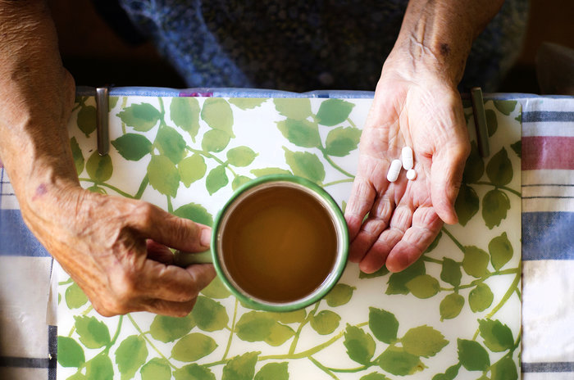
Is the benefit from antipsychotic drugs for people with dementia symptoms worth the risk?

When you hear about dementia, the chances are you think about memory problems.But other common symptoms of dementia, including Alzheimer's, can be even more troublesome to patients and their families’ aggressiveness, agitations, delusions and hallucinations.
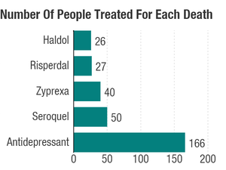
The lower the number, the riskier a drug. A University of Michigan analysis finds that 1 in 26 older patients would be expected to die within six months of starting Haldol for symptoms of dementia.JAMA Psychiatry

More than 90 percent of patients with dementia will experience some of those symptoms over the course of their illness, says University of Michigan psychiatrist Donovan Maust. And it's these burdensome symptoms that often lead doctors to prescribe antipsychotic medicines for these patients.
But the medicines are particularly risky for older patients with dementia. Years ago, the Food and Drug Administration required makers of the drugs to warn that they raised the risk for death when prescribed to control behavioral problems in demented patients. What's more, the drugs were never approved for that use.
Despite the risks and the lack of FDA approval for dementia symptoms, the drugs are widely prescribed to these vulnerable patients. "It really speaks to how distressing these behaviors are that the use of the medicines persists," Maust tells Shots.
He and his colleagues decided it was time to get a better bead on the risks and to see if some medicines were better choices than others. The researchers pored over more than 10 years of data for patients 65 and older from the Veterans Affairs Administration comparing the records for 46,000 patients who got one antipsychotic drug or antidepressant for symptoms of dementia with a roughly equal number of patients in similar circumstances who didn't receive an antipsychotic drug.For the most part, the people were living at home, not in nursing homes or hospitals.


The key question: What happened to patients during the first six months of after diagnosis? By comparing the number of deaths among patients who received antipsychotic drugs with those among the patients who didn't get them, the researchers were able to estimate the risks.The researchers also boiled down their findings in a way that could be useful for busy doctors and families trying to decide what to do. How many older patients would have to be on a drug for one of them to die within six months? The shorthand for that is the number needed to harm, or NNH.
What did they find? Haloperidol, one of the oldest antipsychotics, was the riskiest. The analysis found that among 26 elderly people taking the drug, brand name Haldol, for dementia symptoms, one would be expected to die within six months. That's an NNH of 26.For other commonly prescribed antipsychotics the NNHs break down like this: 27 for Risperdal (generic name risperidone); 40 for Zyprexa (olanzapine); and 50 for Seroquel (quetiapine).
The researchers also looked at the risk for antidepressants, which have been tried as an alternative. The risks are lower — the NNH is 166. But "there's not a ton of evidence that they're especially useful" for dementia symptoms, Maust says.
The results were published online Wednesday by JAMA Psychiatry.

A recent report by the Government Accountability Office found that among older demented who aren't in nursing homes, the chance of being prescribed an antipsychotic is about 1 in 7. The GAO report recommended that the government do more to curb the use of antipsychotics in patients with dementia.
Looking back through the VA records comes with some drawbacks. The researchers could have made errors in matching patients and adjusting for other health conditions and medicines taken. Also, almost all the people in the study were men.
Still, the work goes further than previous studies by seeing what happens over six months after the initial diagnosis. The results also depict a higher risk than seen in earlier studies."My hope would be that the findings would part of the process for raising the bar for when these medicines are used," Maust says.

