Comparative Stakeholder Analysis

Darby Mullis

Colorado State University-Global Campus

ENG102-Composition II

Dr. James Walther

November 10, 2019

Comparative Stakeholder Analysis

Project Management is a quickly evolving and rapidly growing industry. This profession is anticipated to outperform overall job growth globally within the next decade, fashioning millions of job opportunities. As project management careers get competitive, you must prepare for long-term success with relevant certifications, on-the-job experience, and right educational background. A professional degree, such as PMP certification or an MBA, is meant to help individuals stay ahead in their careers. These programs meet three essential requirements: It should boost your suitability for the job market, help you earn more, and should have both short-term and long-term benefits. This study delves into a comparison between salary expectations and the job market for project managers with different degree levels compared to managers with either a degree and certificate or certificate alone. The research focuses on stakeholder views, includingregulators, corporate executives,Steve DelGrosso, and governance.

**Stakeholders and their Positions**

**a. Regulator**

The Project Management Institute is a provider of the Project Management Professional (PMP) certification and an essential stakeholder in the project management debate. Its value is to impart relevant skills to individuals to boost their suitability to fit into diverse project-management careers. The goal of PMI is to churn out skilled project managers to help meet the needs of various industries. Therefore, certified individuals are easily identified within the job market since they possess real skills. Appendix 1 shows the salaries of project managers based on certification. The institute affirms that PMP certification has a higher job market value than an MBA program since it produces technocrats while the master's program produces bureaucrats. This stakeholder supports PMP certification since it makes individuals job-ready for the fastest-growing careers in the contemporary labor market. As such, certification is a guarantee for earning high salaries. According to Coolman,“degree advancement is more meaningful after a manager has practiced project management skills in the field” (2017). This topic is essential for PMI to increase the number of project managers enrolling in certification programs.

**b. Steve DelGrosso**

Steve DelGrosso is a significant stakeholder in project management and a consultant. He values PMP certification since it has high standards that impart essential skills to enable project managers to succeed in this professional field. Certification boosts the threshold of a manager’s salary (Alexander, 2017). Steve advises that individuals should pursue both Certificate programs such as the PMP and master's degree programs such as MBA to boost job sustainability in the evolving field of project management. A combination of various practices enables an individual to apply consulting practices and principles to large, complex programs and projects. Steve leverages his experience in global leadership to challenge students interested in the project management field. He advises that students should consider the technical, business value, and strategic impacts of all decisions and recommendations. Steve’s view supports the statement, “The profession of project management continues to advance, and as such, global deficiency of project talent will offer great opportunities for qualified individuals to begin and develop their careers” (Tandon, 2019). Therefore, Steve believes that this topic is essential to enlighten project managers about what makes them the most competitive.

**c. Corporate Executives**

International Business Machines Inc. is an American-based computer hardware firm that represents the interest of corporations when hiring project managers. It representsthe view of corporate executives. Its guiding principles are personal responsibility and trust in all associations. It is dedicated to the success of clients. IBM's customers prefer professionals with PMP certification. Therefore, the company ensures that all its employees are trained and certified in PMP. It stresses on this certification as a requirement to hire new employees. The goal of IBM on project management is to keep up with changes in project management to guarantee the sustainability of their services. Moreover, IBM exists in the industry of IT services that lead to requiring professionals with PMP certification, as shown in appendix 2.The bottom line ofPMP certification is producing complete professionals. This certification attracts higher salaries, facilitates the widening of career prospects, boost individual recognition, and produce agile professionals (StarAgile, 2019).

**d. Governance Groups**

This category constitutes groups of people who are interested in project management. The groups comprise of regulatory bodies of project managers who specialize in various fields that include construction management, healthcare management, and IT management. All these groups appreciate the essence of certification in either PMP or lean Six Sigma but add that furthering education is an efficient way to take full control of one's job security. Therefore, an MBA in one's area of specialty makes individuals stand out as top candidates who would advance easily in their careers. Therefore, PMP certification is a basic requirement that cuts across all industries. The master's program boosts the manager's salary expectations. Governance groups value further education since it imparts theories and business practices that certification programs do not cover.Therefore, this topic is significant to such groups to guarantee the sustainability of project managers in an environment where labor practices change regularly.

**Connecting Stakeholders**

The four stakeholders believe the job market for project managers is diverse. Nevertheless, salary expectations for managers depend on relevant education. Some stakeholders believe salaries of project managers depend on certification, while others believe salaries depend on both certification and a relevant master’s degree.

**Opinion on Similarities**

All the stakeholders described above note the essence of PMP certification for all project managers. The job market outlook for a certified individual is bright, and this certification results in high salaries due to the proof of licensure. Non-certified managers would earn low wages regardless of the level of higher education due to a lack of accreditation. Certifications matter, irrespective of the location of an individual. Corporations set both short-term and long-term goals. Certification makes managers competent to make immediate changes in organizations through handlings various projects. PMP program imparts knowledge that yields quick return on investment.

**Opinion on Differences**

Regulators and corporate executives disregard the essence of master’s programs.Schweitzer concurs with these stakeholders by affirming that a degree is not mandatory to secure job opportunities as a project manager (Schweitzer, 2019). Steve DelGrosso supports certification processes and adds that the master's program is a supplementary material that would add significant value in the life of a project manager. The governance bodies, on the other hand, state that certification without further education makes a manager incomplete. Practitioners who possess a vital mix of competencies, including leadership, technical, business, and strategic management skills, are required (“Project Management Institute,” 2019). These regulators of standards in corporations believe that managers should focus on career advancement and ways to make their job sustainable. As such, a master's in project management or an MBA in management of one’s area of interest would make managers fit to fill all emerging talent gaps.A combined PMP certification with an MBA produces better-rounded project managers (Verma, 2019).

**Confounding Issue**

Experience is another essential factor for project managers. Some corporations usually consider experience during hiring, and others consider qualifications while the rest value certification. The issue of experience affects the research topic that focuses on degree level and certification. Some project managers are marketable and earn higher salaries courtesy of their years of experience at work, which does not lean on either qualification or accreditation. This confounding variable affects the validity of the research results.

**Conclusion**

To sum up, a combination of certification and further education are a perfect match that opens up the job market and high salary expectations for project managers. MBA programs prepare individuals to rise into higher levels of management while PMP certification imparts industrial knowledge that improves the productivity of managers. Salary increment at work is directly related to growing within one's career and by extension, a master's degree.The future job market and salary expectations for project managers will rely heavily on digital literacy to enhance digital transformation. Besides, the availability of a ready market for project managers causes a corresponding talent gap that will require individuals to seek all additional training to stand out.

References

Alexander, M. (2017). Project management salaries: Talent gap reveals long-term growth. Retrieved 23 October 2019, from https://www.cio.com/article/2399822/careers-staffing-project-management-salaries-show-earnings-growth-career-potential.html

Coolman, A. (2017). Getting a Master's Degree in Project Management: To Do or Not To Do. Retrieved 23 October 2019, from https://www.wrike.com/blog/getting-a-masters-degree-in-project-management-to-do-or-not-to-do/

Project Management Institute. (2019). Job Growth and Talent Gap: 2017-2027. Retrieved 23 October 2019, from https://www.pmi.org/-/media/pmi/documents/public/pdf/learning/job-growth-report.pdf?v=c304efd3-8c2a-48dc-9489-a945a8a07614&sc_lang_temp=en

Schweitzer, K. (2019). How a Project Management Degree Could Help Your Business Career. Retrieved 23 October 2019, from https://www.thoughtco.com/earn-a-project-management-degree-466406

StarAgile. (2019). Why Project Manager should get PMP Certification | PMP Certified. Retrieved 6 November 2019, from https://staragile.com/why-project-manager-should-get-pmp-certification

Tandon, R. (2019). Project Management Jobs in High Demand as Industry Job Growth Accelerates in India. Retrieved 23 October 2019, from http://www.businessworld.in/article/Project-Management-Jobs-in-High-Demand-as-Industry-Job-Growth-Accelerates-in-India/19-04-2019-169543/

Verma, E. (2019). 5 Advantages of PMP over the MBA. Retrieved 6 November 2019, from https://www.simplilearn.com/pmp-advantages-over-mba-article

**Appendices**

Appendix 1

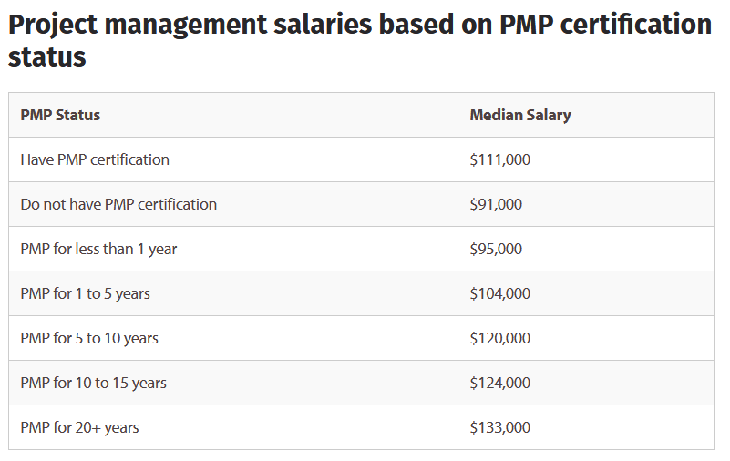

Appendix 2

