**Please read the following article. Then, carefully read the instructions and respond to the** question prompt**that follows.**

**Ponzi scheme king Bernie Madoff, who bilked investors out of billions, seeks medical release from prison**

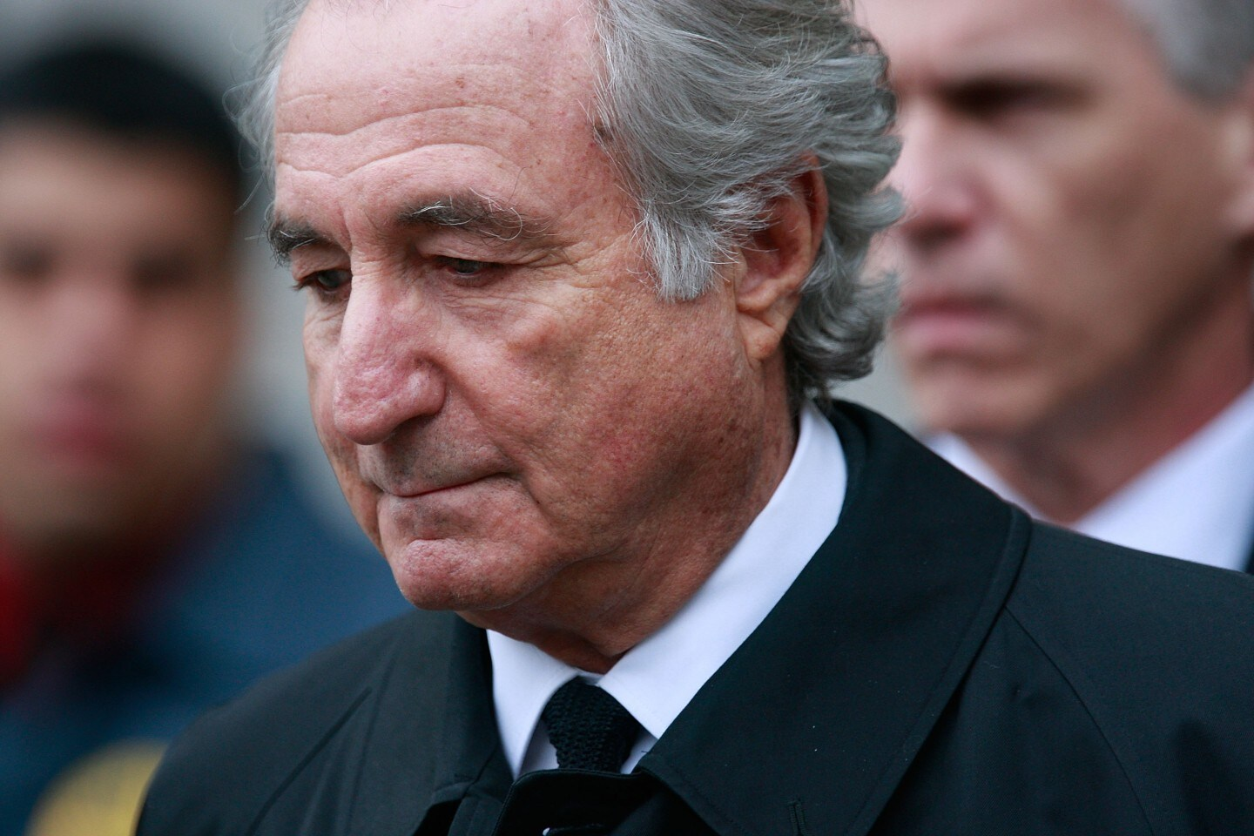Bernie Madoff leaves federal court in New York in 2009. (Mario Tama/Getty Images)

By

[Justin George](https://www.washingtonpost.com/people/justin-george/)

Feb. 5, 2020 at 4:22 p.m. EST

<https://www.washingtonpost.com/local/public-safety/ponzi-scheme-king-bernie-madoff-who-bilked-investors-out-of-billions-seeks-medical-release-from-prison/2020/02/05/d16a9098-475d-11ea-bc78-8a18f7afcee7_story.html?itid=hp_regional-hp-cards_rhp-card-national%3Ahomepage%2Fcard-ans>

The man convicted of the greatest Ponzi scheme in modern American history, guilty of bilking thousands of investors in 49 states and more than 120 countries, is asking a judge to release him from a life sentence so he can die outside prison walls.

Bernie Madoff said he is in the end stages of kidney disease, must use a wheelchair and is in need of round-the-clock help. At 81, he is too old for a transplant, and he has been moved to palliative care within the Federal Medical Center prison in Butner, N.C. He is asking for compassionate release so he can die at home.

In phone interviews with The Washington Post, Madoff expressed remorse for his massive fraud, in which he swindled investors out of billions, and said his dying wish is to salvage relationships with his grandchildren.

He has served 11 years of the 150-year sentence he was given in 2009, after pleading guilty to 11 criminal counts, including fraud and money laundering.

“I’m terminally ill,” Madoff said. “There’s no cure for my type of disease. So, you know, I’ve served. I’ve served 11 years already, and, quite frankly, I’ve suffered through it.”

Relatively few inmates seeking compassionate release have had their petitions approved by the Federal Bureau of Prisons since the federal program was created in 1984. But a bipartisan criminal justice reform law passed in late 2018 gave prisoners the right to appeal denials to a federal judge, and that is what Madoff is attempting. His attorney filed a motion late Wednesday in the Southern District of New York.

Madoff’s request will test the justice system’s capacity for compassion weighed against his unprecedented crimes. His scheme ruined scores of lives, stole the financial futures of thousands and sent many retirees back to work after wiping out their nest eggs.

At least four people connected to Madoff have died by suicide, including his son, Mark, who hanged himself on the second anniversary of his father’s arrest. Madoff’s remaining child, [Andrew](https://www.washingtonpost.com/national/andrew-h-madoff-son-of-convicted-financier-dies-at-48/2014/09/03/49c10da4-0e81-11e4-b8e5-d0de80767fc2_story.html?tid=lk_inline_manual_12), died of cancer in 2014.

Others continue to suffer. Gregg Felsen’s savings were wiped out. Now 72, Felsen works as a wedding and event photographer in Palm Springs, Calif., to make a living. He said that he will never be able to retire and that Madoff doesn’t deserve to be granted a compassionate release.

“I never got a break; why should he get a break? He’s terminally ill? I’m terminally broke,” said Felsen, who said he did not receive restitution. “He ruined a lot of people’s lives and changed them forever. He deserves no leniency whatsoever.”

The Bureau of Prisons acknowledges that Madoff has about 18 months to live, according to his medical records. A prison doctor diagnosed him with end-stage renal disease, hypertension, cardiovascular disease and hyperparathyroidism, among other ailments. The Bureau of Prisons said he fits the criteria for compassionate release but rejected his application in December.

“His condition is considered terminal with a life expectancy of less than 18 months,” Ken Hyle, general counsel for the Bureau of Prisons, wrote in the rejection letter. “However, Mr. Madoff is accountable of a loss to investors of over $13 billion. Accordingly, in light of the nature and circumstances of his offense, his release at this time would minimize the severity of his offense.”

The bureau, citing privacy reasons, declined a Post request to comment on Madoff’s case.

**The cost to incarcerate**

Congress established compassionate release to reflect its desire for ethical and humane treatment of prisoners with the burden on taxpayers for the rising cost of in-prison medical care. Medical expenses for the Bureau of Prisons, not including psychology services or drug treatment, have risen from $1.18 billion in fiscal 2017 to $1.23 billion in 2019, according to federal budget estimates. At the same time, the average age of inmates in federal prisons has increased by 8 percent over the past decade to 41 years, according to the prison system. The number of people age 55 or older in state and federal prisons increased 264 percent from 1999 to 2015, the Pew Charitable Trusts reported.

Today, prisoners age 51 and older make up 19 percent of the more than 174,000 federal prisoners, up from about 16 percent in 2009, according to Bureau of Prisons records.

A 2015 Justice Department inspector general’s report on aging prisoners noted that 19 percent of the Bureau of Prisons’ budget in 2013 was spent incarcerating aging inmates, who cost nearly $2,000 more a year each than inmates younger than 50. It found that federal prisons with the highest percentages of aging inmates spent five times more per inmate on medical care and 14 times more on medication than institutions with the lowest percentages of aging inmates.

Madoff said he is on dialysis and takes about 10 medications a day, including amlodipine and diltiazem for high blood pressure, atorvastatin (Lipitor) for high cholesterol, and calcitriol (a man-made form of vitamin D).

He said he has been given a back brace, bed wedge, medical shoes and a lower bunk. He said that he has pain and cramping in his thighs, hips and knees and that he rarely sleeps more than an hour at a time, often waking from leg cramps.

Prison records indicate that Madoff is Care Level 4, defined as “functioning may be so severely impaired as to require 24-hour skilled nursing care or nursing assistance.”

It costs about $59,000 a year to house someone at a federal prison medical center, according to the Justice Department inspector general’s report. If the prison system had a “modest” 5 percent release rate of prisoners 50 and older, the report estimated, the Bureau of Prisons could save about $28 million a year. The prison system restricts eligibility to those 65 and older.

According to an [analysis by the Marshall Project](https://www.themarshallproject.org/2018/03/07/old-sick-and-dying-in-shackles), a nonprofit news organization that focuses on criminal justice, the Bureau of Prisons approved 6 percent of 5,400 applications for compassionate release between 2013 and 2017; 266 of those whose applications were denied died in custody. The low number of approvals prompted Congress to draft the First Step Act, a broad prison and sentencing reform law that, in addition to providing a way for prisoners to appeal denials, shortened sentences for drug crimes, boosted the number of credits for good behavior, pledged improvements to job-training courses and resulted in the early release of more than 3,000 federal prisoners.

Considered the most significant prison rehabilitation law in more than a decade, the First Step Act was highlighted by President Trump in his State of the Union address Tuesday.But the law has also been criticized by some conservatives who say its leniency was misguided and opened the door for notorious criminals such as Madoff to be released.

At least 124 people were granted compassionate release in 2019, the first full year of the First Step Act, according to the Justice Department, compared with 34 in all of 2018.

**Punishment versus mercy**

Among those to benefit from the law was Bernard Ebbers, the former chief executive of WorldCom, a telecom giant once valued at more than $150 billion.

Ebbers was convicted in 2005 of securities fraud for falsifying the company’s financial results and inflating the stock’s worth. Millions of dollars in shareholder and investment stocks and bond values were lost, [including $565 million from the country’s largest public pension fund](https://www.washingtonpost.com/local/obituaries/bernard-ebbers-worldcom-ceo-convicted-in-historic-fraud-scandal-dies-at-78/2020/02/03/91c8cfe4-4696-11ea-8124-0ca81effcdfb_story.html?tid=lk_inline_manual_41), the California Public Employees’ Retirement System.

Ebbers was in the middle of a 25-year federal sentence when his daughters began to notice their 6-foot-4 father wither and slip into dementia.

In August 2019, Joy Ebbers Bourne said, the Bureau of Prisons denied Ebbers’s application for compassionate release. The family filed a motion challenging the ruling, and it drew opposition from the U.S. Attorney’s Office for the Southern District of New York, which said the prison system could provide adequate medical care.

“However the [Bureau of Prisons] had no diagnosis or treatment plan in place,” Ebbers Bourne said in a statement. “In October, Dad experienced a rapid decline and was transferred to a unit with 24-hour nursing care. We could get no answers from the medical staff.”

The family presented Ebbers’s circumstances to U.S. District Judge Valerie E. Caproni, “confident in our case, believing Dad’s situation was just what Congress had intended when they changed the compassionate release laws in the First Step Act,” Ebbers Bourne said.

The judge ruled in their favor in mid-December.

On Sunday, Ebbers died surrounded by his family at his home in Brookhaven, Miss.

“I know many of the victims of WorldCom opposed Dad’s release,” Ebbers Bourne said. “Many stockholders and employees lost their investments in the fall of WorldCom. Many of our friends — and many in our family — did too.”

But keeping Ebbers in prison “would not bring back anyone’s investments,” she said.

[Bernard Ebbers, WorldCom CEO convicted in historic fraud scandal, dies at 78](https://www.washingtonpost.com/local/obituaries/bernard-ebbers-worldcom-ceo-convicted-in-historic-fraud-scandal-dies-at-78/2020/02/03/91c8cfe4-4696-11ea-8124-0ca81effcdfb_story.html?tid=lk_interstitial_manual_52)

Pat Nolan, director of the American Conservative Union Foundation’s Center for Criminal Justice Reform, worked with lawmakers drafting the First Step Act and said society gains nothing by letting people who are losing their physical and mental faculties languish in prison. With their bodies and minds failing, he said, prison walls become redundant.

“For some, it’s never enough, but none of what he suffers is going to get a dime back to what he swindled or cheated,” Nolan said. “And, again, I don’t minimize at all [what Madoff has done]. But it’s the hallmark of a society to not punish somebody beyond reasonableness.”

Madoff’s attorney, Brandon Sample, said there shouldn’t be a compassionate release program if all prisoners, including Madoff, aren’t eligible.

“What does it say about us as a society? Are we going to be so insistent that it doesn’t matter, let them suffer there in prison? If that’s the case, why do we need compassionate release?” he asked. “I don’t dispute that his conduct, his offense behavior impacted many, many people’s lives and caused harm. There’s no dispute. But the question now is, with his present situation, what would that hypothetical jury do today faced with the Bernie Madoff who’s in a wheelchair, who’s on his last legs of life?”

In conversations with The Post, Madoff said all the things you’d expect someone seeking judicial mercy to say: that he was sorry. That the deaths of his sons have punished him more than prison could. That he was responsible for his crimes, and that he knows he hurt many.

“You know there hasn’t been a day in prison that I haven’t felt the guilt for the pain I caused on the victims and for my family,” he said. “You know I lost both my sons, and my wife is not really well. So it’s horrible. I was very close with my family. I made a terrible mistake. And you know I suffer with it. I’ll suffer with it when I get out.

“The only hope that I have when I get out is to try and possibly see them — my grandchildren — and at least, you know, try and explain how my problems evolved.”

He said he has worked with prosecutors to recoup as much money as he could for investors. He said he persuaded members of his Ponzi scheme who had received payouts to return them. About $14.3 billion has been recovered or settled, with $12.9 billion distributed to investors, according to the trustee handling the recovery.

“I felt the one thing I wanted to do was try and be helpful in some way to recover the victims’ [money],” he said. “My business was perfectly legitimate for 36 years, and I just made a mistake at one point, and I didn’t realize at the time that I wouldn’t be able to get myself out of it, and it was certainly not my intention to create all these issues and all these problems for everybody.

“You know, I took a [plea]. I didn’t go to trial because I felt that I was, I was really the guilty one,” Madoff said. “My family had nothing to do with it. And, you know, quite frankly, I deserve to be punished. It wasn’t something I should find some sort of excuse for. I didn’t. I didn’t. I had no idea that it would evolve the way it did. And I just couldn’t help it.”

In a 5 to 10 sentences, respond to the following question. Responses should be emailed directly to me in a *fresh* email (do NOT respond to the thread or simply hit “reply”) at [cates.cindy@gmail.com](mailto:cates.cindy@gmail.com)Responses should be written directly in the body of the email. Do NOT send as an attached document. Responses must be in my electronic mailbox by 3P.M. on Friday, February 7th. Responses received after 3P.M. will not be accepted or credited.

Continuing our theme of law and justice, in general, what do you think of compassionate release policies? Specifically, do you think Bernie Madoff should be released? Have a good rest of the week. I’ll see you on Monday. Remember to read “Before the Law.”