Coming to America: The Québécois

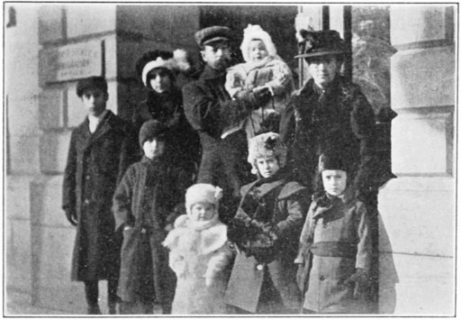

A Québécois family arriving from Montreal, 1913. (Click button for citation) [](https://commons.wikimedia.org/wiki/File:PSM_V83_D341_French_canadian_family_arriving_from_montreal.png)

From the late 19th century until the beginning of the Great Depression in 1929, an estimated one million French-speaking Canadians came to America in search of jobs, an event sometimes referred to as the Quebec diaspora. Also known as Québécois (or Quebeckers, in English), this population of French-speaking people was drawn to America by the promise of industrial jobs in New England. This group was initially slow to **assimilate** because of the language barrier and the fact that most of them were Catholic, in contrast to the predominantly Protestant populations of Maine, Massachusetts, and New Hampshire.

Québécois were able to enter the United States easily during this time period because the border was open. Before 1895, immigration officials did not even monitor the border between the United States and Canada, so numbers of Québécois immigrants during this period are only estimates. When the U.S. imposed immigration quotas in 1921, Canadians were exempt. It was not until the system changed almost half a century later that Canadians would be subject to immigration quotas; 1968 was the first year in which Canadians were required to get visas in order to permanently relocate to this country. (Kelly, 2013)

Click on the tabs below to learn more about different aspects of life for the Québécois in the United States.

Select a list item tab, press enter, then search down for text. When you hear End of tab content, go back to the next list item to access the next list item tab.

* [**Historical Context**](https://snhu.mindedgeonline.com/content.php?cid=115625#tabs-1)
* [**Immigrant Experience**](https://snhu.mindedgeonline.com/content.php?cid=115625#tabs-2)
* [**Backlash**](https://snhu.mindedgeonline.com/content.php?cid=115625#tabs-3)
* [**Assimilation**](https://snhu.mindedgeonline.com/content.php?cid=115625#tabs-4)

Historical Context

In 1870, the city of Lowell, Massachusetts, just outside of Boston, was the second largest textile manufacturing city in the United States. Three out of four working people in Lowell earned a living in the textile factories. At that time, six percent of the population of the city was Canadian. By 1900, that number jumped to 16 percent, because of the increased immigration of Québécois to the area. (Early, 1982)

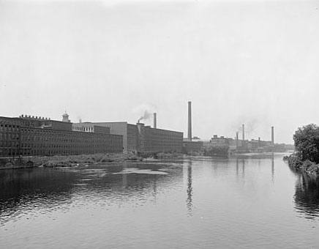

Lowell, MA, mills on the Merrimack River. (Click button for citation) [](https://commons.wikimedia.org/wiki/File:Lowell,_Mass.,_mills_on_Merrimack_River;_LOC;_det.4a18323.jpg)

Lowell is just one example of the rapid migration of Québécois from Quebec to the northeastern United States. This migration was spurred in part because of the overpopulation of rural areas in Quebec, high birthrates, and poverty in the rural farming areas of Quebec. All of these changes meant that participants in the older, rural economies and social structures did not have sufficient land to continue that way of life as urban development spread. A recession in Quebec in the early 1920s also meant Québécois needed to look elsewhere for work.

#### Immigrant Experience

In 1870 and the years following, quality of life for Québécois in Lowell and the rest of New England was not desperate, but it was bleak. They came to the United States for jobs, which is what they found. They spoke French and initially found it hard to communicate. Despite their predominantly rural farming backgrounds, the Québécois went where jobs were plentiful but often undesirable. This usually meant they ended up in the industrial centers of New England.

Due to this influx of immigrants, Québécois replaced the Irish as the primary source of unskilled labor in the United States after the Civil War. (Early, 1977) The textile mills and shoe factories of the Northeast needed reliable, cheap labor in order to keep up with the manufacturing boom during this time period. Mill owners even traveled to Quebec to recruit more labor because it was in such high demand.

Very few immigrants in Lowell, MA and other cities at this time owned land, and most of them lived in overcrowded tenement houses. They had very little to eat, and they were not adequately clothed for the harsh winters, because of their extreme poverty. Québécois women and children over the age of 10 were overwhelmingly employed in working-class laborer positions, usually in the textile factories. (Richard, 2009) A typical working day in the factory was 12 hours long, leaving little time for food preparation or properly tending to children (Early, 1977).

Québécois immigrants distinguished themselves not only by the language they spoke but also by the religion they practiced. The Catholic Church was instrumental in helping Québécois adjust to life in New England. The establishment of a French Catholic parish in Lowell in 1868 meant that new immigrants had a familiar place to go when they reached their new home. (Early, 1977) The priests of these parishes operated as intermediaries between the rest of the town and the Québécois communities, often called "Little Canadas." They also formed their own charitable organizations to provide help for fellow immigrants who needed it, so they would not be forced to request government assistance.

Some towns in the Northeast had populations that were majority Québécois—because once families were settled in one place, other family members followed behind. Towns such as Woonsocket, Rhode Island and Biddeford, Maine were almost 60 percent Québécois by 1900. Crowded, dingy tenement housing was prevalent in the industrial factory towns where most Québécois settled, which meant that these communities were especially important to these settlers. Their homes no longer enjoyed the fresh open air of farmland that they enjoyed in Canada.

#### Backlash

Their Roman Catholic faith, the French language, and the formation of their own neighborhoods made Québécois and their descendants targets of the Ku Klux Klan in Protestant New England. By 1920, half of the population in the industrial center of Lewiston, Maine was Québécois, most of whom were Catholic. (Richard, 2009) The Ku Klux Klan's nativist ideas and religious prejudice—most were Protestant—led them to target the Québécois in the area.

Membership to the Klan in Maine skyrocketed as the Protestants in the state rallied to take back what they believed belonged to them. They attempted to assert their control over the communities they felt were being threatened. Leaders of the Klan in the state spoke out against any ethnic groups that brought religions other than Protestantism to the area. They warned that if Catholics became involved in politics in the area, the offices would be tainted by foreign influence.

In Dexter, Maine, in 1924, Protestants and Catholics grew increasingly intolerant of each other. One activist priest told members of his congregation to boycott any establishments run by Klan sympathizers, and in return, Protestants refused to support Catholic merchants. During this time, the Klan burned a cross on a hill in Dexter, Catholics heckled Protestants, and members of each side resorted to violence by throwing rocks at each other and brandishing weapons. Although the Franco-American community in the town attempted to thwart the efforts of Klan, Protestant candidates still swept the elections in town that year. (Richard, 2009)

Some people were resistant to the presence of these immigrants because they thought they were uninterested in assimilating into American culture. Public officials in places like Lowell argued that the availability of cheap immigrant labor was driving wages down. The KKK's hostility towards the Québécois is just one example of the persecution they faced because of their religion, language, and cultural differences.

#### Assimilation

Despite the initial cultural and language barriers the Québécois faced in the United States, over time their experience successfully became a piece of this country's history. They contributed to the U.S. economy at a time when cheap labor was necessary to power the transition to a new landscape of factories and manufacturing after the Industrial Revolution.

The Québécois were not only instrumental in the success of the manufacturing boom, but many of them also served in both World Wars for the United States. Many notable Americans are descendants of Québécois immigrants. Jack Kerouac, author of On the Road, was born to Québécois parents in Lowell, MA, for example.

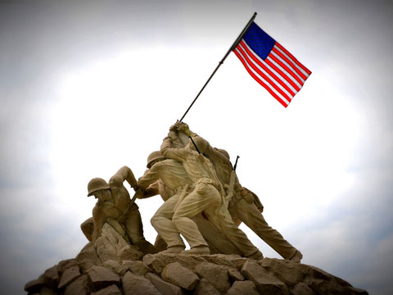

Rene Gagnon, one of the men pictured raising the flag at Iwo Jima, was born to Québécois immigrant parents who worked at a shoe factory in Manchester, NH. (Kelly, 2013)

### Exercise: Further Readings

As you begin research for your historical analysis essay, you will encounter secondary sources, such as scholarly journals and periodicals. The following passage is excerpted from a scholarly journal article by historian Frances Early called ["Mobility Potential and the Quality of Life in Working-Class Lowell, Massachusetts"](http://www.jstor.org.ezproxy.snhu.edu/stable/pdf/25139903.pdf?_=1460989987436), pages 214 to 218. This article examines the quality of life of Québécois immigrants in Massachusetts during the late 19th century.

Click on the title of the article to read, download, and print a copy of the text. These readings are provided by the Shapiro Library. This reading is required. You will have to log into Shapiro Library with your SNHU credentials to access this article.

As you read the passage, keep in mind the concept of historical **context**. You will need to choose a sentence or passage that illustrates this concept for your discussion board posting. Click on the highlighted section that serves as an example and explanation of what context the information can provide for readers who are unfamiliar with this time period.

**Mobility Potential and the Quality of Life in Working-Class Lowell, Massachusetts**

Lowell, at the close of the American Civil War in 1865, was a major industrial town and center for textile production. Only Fall River, Massachusetts, exceeded Lowell in the production of textiles in the United States in this period. Almost 40 percent of Lowell's workforce was engaged in manufacturing and mechanical industries, mostly related to textile production. Although 65 percent of Lowell's populace of 41,000 was native-born in 1870, the majority of workers in the textile industry were drawn from the various, largely English-speaking immigrant groups resident in Lowell at this time: 22 percent of the total population was Irish, 4 percent was English, and 3 percent was from Scotland, Nova Scotia, New Brunswick, Newfoundland, Prince Edward Island, and "other." In addition, in 1870, 6 percent of Lowell's citizenry was Canadian, in large measure Québécois.

Lowell attracted many working-class people in the immediate post-Civil War years. In its annual report for the year 1866 the Ministry-at-Large of Lowell, a non-denominational charity organization, noted with consternation that in the past two years over 10,000 persons, many of whom were "utterly destitute," had entered the city in search of work. Many of the persons arriving in Lowell were "wretchedly poor" working-class people from other New England cities who were attempting to "better their condition." The report continued with a statement that a significant portion of the newcomers were Québécois. They were described in a highly unflattering manner:

"They are nearly all Catholic, do not speak English, are in a low, sensual condition of life, and are less disposed than others to improve themselves. They are not so accessible to our influence. Not mingling freely with society, they do not catch the dominant spirit. The great hope is with the children, who, in our common schools, are readily acquiring our language and adopting our ideas and feelings, and will become teachers to their parents."

The Ministry-at-Large evidently accepted, albeit grudgingly, that the French-Canadian influx into Lowell was not a temporary phenomenon. In this, the report was correct. In 1865 only a handful, perhaps 100 Québécois, resided in Lowell. By 1868 the number was around 1200. A brief two years later, in 1870, the approximate number of Québécois living in Lowell was 2000, 5 percent of the Lowell population of 41,000. In the next three decades the French-Canadian population would increase to 15,000, accounting in 1900 for about 16 percent of the 95,000 residents of the city.

The French-Canadian presence in Lowell in the latter part of the nineteenth century was part of a larger pattern of migration. Between 1860 and 1900 approximately 600,000 Québécois migrated to New England. By 1900 one in every ten New Englanders or about 575,000 persons, was of French-Canadian stock. Roughly one in every four French Quebecers was living in New England in 1900.

Québécois abandoned their homeland for economic reasons: the rural system could no longer provide livelihoods for many farmers' sons and Quebec industry was undeveloped. Soil depleting farming methods combined with repeated subdivision of lands among the offspring of the large French-Canadian families had by mid-century destroyed the viability of the traditional Quebec agricultural system. Although Quebec land was available for colonization, this alternative was largely unsuccessful as most virgin farm land was located in remote areas of Quebec with inadequate transportation facilities. To a large extent, therefore, Québécoiss had little choice but to migrate. As noted in the report of the Seventh Census of Canada (1931), Québécois were forced to settle in New England in this period "not in quest of a higher standard of living but to avoid a lower."

The economic and demographic factors which pushed Québécois out of Quebec were complemented by similar factors which favored their settlement in New England. Southern New England was by 1865 experiencing rapid economic growth. Industrialization, well under way by the 1860s, created a stiff demand for workers in the textile and boot and shoe industries. Laborers were also needed in building construction and in canal and railroad work. The native and Irish-immigrant labor force present in New England in 1865 could not meet the labor demands of industry. In increasing numbers, therefore, Québécois responded to the lack of economic opportunity in Quebec by moving to industrial centers like Lowell in New England to procure work.

### Primary Sources

A **primary source** is a source directly related to a historical topic by time period or participation in the event. Primary sources include letters, speeches, diaries, newspaper articles, photographs, paintings, and oral histories, to name a few. Primary sources are created by someone who was a participant in, or witness to, the historical event you are studying. A primary source can take many different forms, but what is important is that it is defined by its direct relation to the historical event being researched.

For example, let's say you were examining the New York Draft Riots of 1863 as an example of ethnic and racial tension in America in the 19th century. Primary sources might include pictures of participants, political cartoons depicting the event, newspaper articles about the riots, and firsthand accounts of what happened.

#### Importance of Primary Sources

Primary sources give you a glimpse into the past, so that you can see history with your own eyes. Firsthand accounts and documents can make history feel more real, and they give you an opportunity to draw your own conclusions about historical events. Primary sources also help develop your critical thinking skills as you analyze the sources, and they require other knowledge of the event, as primary sources are often incomplete.

Studying primary sources allows you to examine any potential biases surrounding an event and how the point of view may affect an eyewitness account. By looking at primary sources, you can draw conclusions about historical events for yourself, rather than relying on someone else's interpretation.

#### Finding Primary Sources

Shapiro Library has many suggestions for digital collections that include primary sources such as photographs, manuscripts, and documents. **You can find a list of those databases**[**at this link.**](http://libguides.snhu.edu/c.php?g=92272&p=596237) Additionally, there are many other resources available online, which are listed below.

* [Primary Source Sets](http://www.loc.gov/teachers/classroommaterials/primarysourcesets/): This collection from the Library of Congress provides primary source sets for selected key topics in American History.
* [100 Milestone Documents](http://www.ourdocuments.gov/content.php?flash=true&page=milestone): From the National Archives, this collection includes documents that chronicle American history from 1776 to 1965. Original and transcribed copies are both available.
* [Library of Congress Prints and Photographs Online Catalog (PPOC)](http://www.loc.gov/pictures/): This database includes photographs, drawings, prints, and drawings that represent close to 95% of the holdings in the Library of Congress.
* [Smithsonian Source](http://www.smithsoniansource.org/): A collection of primary sources from the Smithsonian Institute that can be searched by keyword, topic, or type of source.

These resources will be valuable as you begin to research the historical topic for your writing plan and your essay. You will learn more about searching for and examining primary sources in **Theme: Communicating Historical Ideas**. For now, you need to know what a primary source is and start thinking about what primary sources might be helpful in your historical event analysis.

Secondary Sources

A **secondary source** summarizes, evaluates, or otherwise informs you about primary sources. Secondary sources include scholarly journal articles, books, and other periodicals. Most of the sources you will find in the Shapiro Library, such as journal articles and books written by historians, will be secondary sources.



Secondary sources give you an idea of what others have written about a topic and what arguments historians have made about certain issues. This context will be important to know when writing your historical analysis, so that you can compare and contrast your argument to existing material.

Types of Secondary Sources

Authors of secondary sources create their own interpretation or narrative of events based on primary source documents. Below are some examples of secondary sources that you might find when researching your historical event analysis.

Some examples of secondary sources you might find during your research in Shapiro Library:

* **Journal articles:** Scholarly journals are a great resource for shorter historical analyses. These essays will give you an idea of what arguments already exist surrounding your topic.
* **Popular periodicals:** Magazines and newspapers can provide context for the historical event you choose. For example, editorial pieces can reveal how people felt about certain events, either when they happened on in retrospect.
* **Monographs:** These books deal with narrow topics or an aspect of a topic, such as a specific time period in American history.

**Reference books, such as *Encyclopedia Britannica*, and reference websites, such as Wikipedia, provide basic information about your topic for you to use as a cursory reference. These reference books and websites may give direction as to where to look for academic resources (people, places, events to research for example), but they are not in and of themselves a valid academic resource. They should not be used for critical research and should not be referenced in your paper. *You should use Shapiro Library as the starting point for all your research.***

### Graphic: Types of Sources

The graphic below summarizes the difference between primary and secondary sources.

To determine whether or not a source is a primary or secondary source, you need to assess its relationship to the historical event you are analyzing. If it was created by a participant directly involved in the event, then it is a primary source. If it was created by someone who was not directly involved, it is a secondary source. **It is possible for a primary source for one historical event to be a secondary source for another event.**

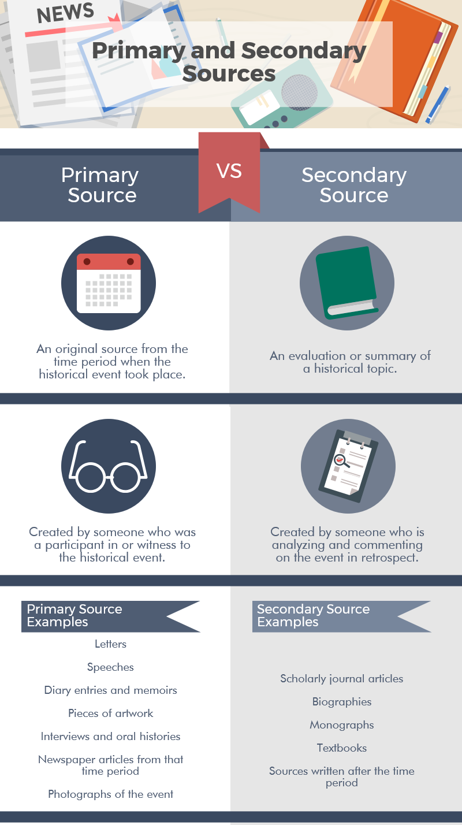

### Effective Searching

With all of the resources at your disposal, it might be overwhelming to start searching for information about your chosen topic. Utilizing these search strategies will ensure that you are not wasting your time searching through resources that you cannot use in your analysis.

**Keyword searching**

This type of searching is the one that you are probably most familiar with, since it uses "natural language." When you enter a phrase into Google or a similar search engine, you are using natural language. **Keywords** are used to search through content to find certain themes and ideas.

When searching for your topic, try out different combinations of words and phrases. Don't worry if your initial search yields irrelevant or insufficient results. Try multiple keywords, different combinations, and synonyms.

You can find more helpful information about keyword searching through the Shapiro Library [at this link](http://libanswers.snhu.edu/faq/8741).

**Subject searching**

Subject searching allows you to search by categories within a database or online catalog. Subject terms are predefined within a database. You can usually find the subjects of an article or periodical under the "info" tab.

This method of searching is most effective after you have found a useful resource on your topic and find which subject search terms are associated with that resource. Subject searching allows you to broadly search for sources on a topic. Since the subjects are assigned to each articles within a specific database, results will vary from one database to another.

You can find more helpful information about subject searching through the Shapiro Library [at this link](http://libanswers.snhu.edu/faq/8742).

**Boolean searching**

Boolean searching uses **Boolean operators** to search with more precision. The most common Boolean operators are **AND**, **OR**, and **NOT**. These words help search engines broaden or narrow search results.

**AND:** Tells the search engine that you want to find information about two or more search terms. The search engine will only bring back results that include both or all of your search terms.

**OR:** Tells the search engine that you want information about either of the search terms you entered. Using OR will broaden your search results because the search engine will return any results that have either (or any) of your search terms in them.

**NOT:** Tells the search engine that you want to find information about the search term but not the second one. This method will narrow your search results.

Using Boolean operators helps make connections between keywords when you are searching to yield more specific results. This is a good method to use in conjunction with keyword searching.

You can find more helpful information about subject searching through the Shapiro Library [at this link](http://libanswers.snhu.edu/faq/8739).

SECOND PART

### Search Terms and Secondary Sources

#### Writing Plan Progress Check 2

Now that you have seen examples of how to search effectively, it is time to start looking for sources for your chosen topic. This [mind-mapping resource](https://www.library.unlv.edu/services/instruction/tutorials/topic_narrowing/) will be helpful in narrowing your topic.



What keywords or other search terms would you use when searching for sources related to your chosen topic in the databases in Shapiro Library? List at least four search terms.

Open the document **firstname_lastname.Writing_Plan**, which you created in Theme: Approaches to History, Learning Block 1-3. Add the keywords and other search terms that you plan to use while researching your historical event analysis essay. Save this document locally on your computer.

Next, take at least **30 minutes** to conduct independent research in Shapiro Library with the search terms you have created for your topic. What sources do you plan to use in your historical event analysis essay? Be specific, and choose at least two secondary sources. Now reopen **firstname_lastname.Writing_Plan** and list the name of each source, the author and publication, the date it was published, and where you found the source. This should not be an exhaustive list of the sources you plan to use, but it is just a place to start your research.

Below is an example of what your document should look like by now:

Jane Doe

HIS 200: Applied History

Southern New Hampshire University

April 8, 2016

Topic and Research Question

**Topic:** For my historical event analysis, I have chosen to focus on Congressman John F. Fitzgerald of Boston, the son of Irish immigrants, and his opposition to an 1897 immigration bill which would have barred illiterate foreigners from entering the United States.

**Research Question:** How did John Fitzgerald's political ambitions, and the interests of the Democratic Party in Massachusetts, affect his position on the 1897 immigration reform bill?

Search Terms and Sources

Search terms that I have used in my research so far include: FITZGERALD, John F.; LODGE, Henry Cabot; Emigration and immigration law; Massachusetts politics; 1897 immigration bill; and LODGE, Henry Cabot and CLEVELAND, Grover AND Immigration.

One secondary source is "Honey Fitz": Three Steps to the White House: The Colorful Life & Times of John F. ("Honey Fitz") Fitzgerald, by John Henry Cutler. Indianapolis, IN: Bobbs-Merrill, 1962. I found a review of this book in Shapiro Library, and located a copy online at http://www.abebooks.com/book-search/title/honey-fitz/used/.

Another secondary source is The Fitzgeralds and the Kennedys: An American Saga, by Doris Kearns Goodwin. New York: Simon & Schuster, 1987. This book is in Shapiro Library.

Second part continue….

The first assessment for this course will consist of a one- to two-page writing plan for your essay analyzing a historical event. The writing plan must include:

1. A brief description of your topic—that is, the historical event you have chosen to analyze
2. The research question you will attempt to answer in your essay
3. Some sources you plan to utilize (not an exhaustive list)
4. A working thesis statement and message of your essay **(this will be covered in Theme: Communicating Historical Ideas)**
5. The audience for your essay and a description of how you plan to communicate your ideas to the chosen audience **(this will be covered in Theme: Communicating Historical Ideas)**

#### Writing Plan Progress Check 2



You have already assembled several major elements of the writing plan for your historical event analysis essay. In the first week of Theme: Approaches to History, you chose a topic and a research question; so far in the second week of Theme: Approaches to History, you have selected some search terms as well as secondary sources that you will consult as you research your essay.

Now it's time to put those pieces together to form your preliminary writing plan. Open **firstname_lastname.Writing_Plan** and look over what you've written so far. You should have the bare bones of your preliminary writing plan, but you need to flesh it out some.

If you haven't already done so, consider a sentence or two that explains why the event you have chosen is historically significant. You might also think about going into more detail about your research question: what other questions are likely to arise as you continue to research this topic? What other aspects of this issue interest you?

You should also give some more information about your secondary sources. Why are these sources important? What sort of insight do they provide?

Take a look at a sample preliminary writing plan for a historical event analysis that focuses on the efforts of Congressman John F. Fitzgerald—later mayor of Boston and the grandfather of President John Fitzgerald Kennedy—to oppose a restrictive immigration law that would have forbidden any person who could not read or write from entering the United States.

Click on the highlighted text to learn more about the individual pieces of the writing plan.

Jane Doe

HIS 200: Applied History

Southern New Hampshire University

April 10, 2016

**Preliminary Writing Plan**

For my historical event analysis, I have chosen to focus on Congressman John F. Fitzgerald of Boston, the son of Irish immigrants, and his opposition to an 1897 immigration bill which would have barred illiterate foreigners from entering the United States. According to contemporary observers, Fitzgerald's opposition helped convince President Cleveland to veto the bill in one of his final official acts as President.

In examining Fitzgerald's opposition to the immigration reform bill, I will try to recreate the political calculations that drove Fitzgerald to champion the idea of open immigration. Specifically, I will try to answer the following research question: How did John Fitzgerald's political ambitions, and the interests of the Democratic Party in Massachusetts, affect his position on the 1897 immigration reform bill?

Why was this issue so important to Fitzgerald, who would go on to become mayor of Boston and a major figure in Massachusetts politics? Was he simply trying to make a political name for himself? How much of a factor was Fitzgerald's personal distaste for Senator Henry Cabot Lodge Sr., the Republican sponsor of the immigration bill?

Search terms that I have used in my research so far include: FITZGERALD, John F.; LODGE, Henry Cabot; Emigration and immigration law; Massachusetts politics; 1897 immigration bill; and LODGE, Henry Cabot and CLEVELAND, Grover AND Immigration.

My analysis needs to take into account how this issue played out, both for Fitzgerald and for the nation, in the ensuing years. One valuable secondary source, then, is "Honey Fitz" Three Steps to the White House: the Colorful Life & Times of John F. ("Honey Fitz") Fitzgerald, by John Henry Cutler (Indianapolis, IN: Bobbs Merrill, 1962). This book, the only full-length biography of Fitzgerald, traces Fitzgerald's political career and contains several revealing anecdotes about Fitzgerald's contentious relationship with Senator Lodge.

Another extremely valuable secondary source is The Fitzgeralds and the Kennedys: An American Saga, by Doris Kearns Goodwin (New York: Simon & Schuster, 1987). This book, the definitive history of the Fitzgerald family, places Fitzgerald's career in broad historical context and relates his efforts to the development of the Irish-controlled Massachusetts Democratic Party.