You have been assigned a company from the Nasdaq 100 (WDAY - Workday, Inc. Class A Common Stock) to assess based on their latest financial information. Some will have recently filed 10k’s, some will have more recent 10 Q’s. All will have some type of earnings release or information within the last several months, and many will have released information in the last few weeks or will this week or early next. You are acting as a financial analyst to assess the company’s health and prospects given current events, financial condition and overall market position. Imagine that I’m a portfolio manager with investments in selected Nasdaq 100 companies and I have to decide what to do with each of them.

You’ll fill out the attached template with an assessment of each component and an overall assessment of the company’s situation. Please consider all sources, including analysts reports, press information, earnings information, etc. Be assured that I will be looking at these sources as well. I’m not looking for an opus—this is a minimum two single page brief giving me the key considerations about the company and its prospects in the current environment.

Grading will be on the thoroughness of the analysis, your reasoning, and how well you back up your reasoning with the data.

Balance sheet strength
The total revenue recorded in the 2020 fiscal year was 3.63 billion dollars, which is a 28.5% increase in the previous fiscal year. Such indicated the revenue from subscription to have a 28.5% increase with revenues of 3.1 dillion USD. The Operating loss recorded in the 2020 financial year was 502.2 million USD, while the previous year recorded an operating loss of 484.5 million USD (Last10-K, 2020).
The operating loss for the 2020 fiscal year was 502.2 million. That marked a 13.8% decrease in the total revenue from the previous year, which had a total operating loss of 463.3 million USD (Last10-K, 2020). Such can be attributed to the effects of the current COVID-19 pandemic that has ravaged the financial element internationally after the necessitated restriction of social contact and movement. Given so, Workday Inc. had to undergo significant losses to manage its operations.
Altogether, considering the Non-GAAP income from operations was 484.5 million USD, an increase in 13.4% revenue compared to 291.3 million USD recorded in the previous fiscal year ending Jan 31^{st,} 2019, such represented a 10.3% increase in revenue. Given that Workday Inc. managed to record a higher operating income than the previous financial year, it is then evident that the income statements of Workday Inc. regarding the currently ended financial year (2020) is somehow weak, given the deterrence of the current COVID-19 outbreak.
Reference
Last10-K (2020). Workday Announces Fourth Quarter and Full Year Fiscal 2020 Financial Results. Retrieved from: https://last10k.com/sec-filings/wday

Income Statement Strength
Weak
Strong
From the consolidated balance sheet for Workday Inc., the total assets recorded for the 2019 fiscal year ending on Jan 31st were 6.8 billion USD, an all-time high comparison throughout the previous financial years. For instance, Workday Inc. has continuously managed to heighten its total assets by maintaining a constant increase from 2.8 billion USD in the 2016 fiscal year to 8.8 billion USD by the close of the 2019 financial year. The majority of the assets incorporated in the consolidated balance sheet are marketable securities that Workday Inc. has been trading under NASDAQ. Here, the total assets recorded by Workday Inc. in its 10-K report indicates that Workday Inc. has been able to develop and acquire more assets, much of which is used in trading securities.
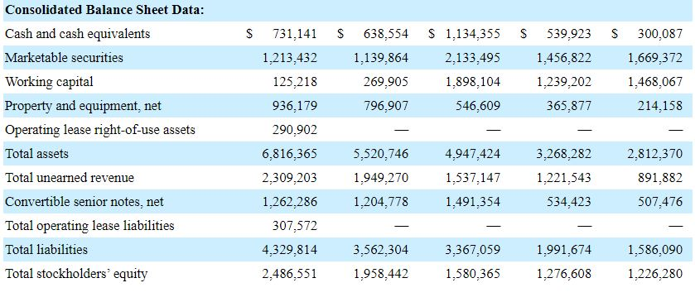
Figure 1: WDAY Consolidated Balance Sheet (in thousands, except share and par value data)
The total liabilities of Workday Inc. for the 2015 – 2016 financial year was 1.58 billion USD. Workday Inc. has had an increased its liabilities to 4.33 billion USD by the close of the 2019 financial year closing on 31st 2020. Such indicates a strong balance sheet that has had continuous and constant growth and expansion for five consecutive years. Similar conclusions can also be made from the amount of shareholder equity. The shareholder’s equity has grown from 1.23 billion USD from the 2015 – 2016 financial year to the 2019 – 2020 financial year, ending on Jan 31st at 2.49 billion USD. Such indicates a constant rise in the share returns that portray a healthy Workday Inc.
The Class A Common Stock had a par value of $0.001 after total shares worth 750 million were authorized and traded by the reach of Jan 31^{st,} 2020. The fiscal year ended Jan 31st, 2019 had recorded exchange of 170 million shares. Such portrays that the number of shares and market interest rises with time, marking the Workday Inc. balance sheet very strong Last10-K (2020).
Reference
Last10-K (2020). Workday, Inc. (WDAY) SEC Filing 10-K Annual report for the fiscal year ending Friday, Jan 31st, 2020. Retrieved from: https://last10k.com/sec-filings/wday/0001327811-20-000022.htm#fullReport

Weak
Strong

Target
Acquiror
Cash flow Strength
Currently, Workday Inc. stands is at a bi-faceted edge where strategies and turnoff events would determine whether this company can overcome a downturn. Specifically, the current COVID-19 pandemic has crippled the majority of the commercial procedures happening around the world. For instance, the limitation of commerce, movement both internationally and locally, as well as the need to maintain social distance, has contributed significantly to the reduced performance of this company. Notably, the weak cash flows have been due to the intensified expenditure on operations for that specific year. Given new strategies for the 2021 financial year, Workday Inc. would be in a position to recover from the effects caused by the corona pandemic internationally. On the same note, failure to adjust to the pandemic era would have workday Inc. losing more on securities given the low economic curve internationally.
Positioning to survive downturn
Given that Workday Inc. had high rates of expenses arising from share-based losses, amortization, unearned revenue, and depreciation, the financial year ending Jan 31^{st,} 2020 recorded the highest net expenditure for its activities at $864.60 million, and the cash flows from investing recorded a negative 86.92 million for the same year. The cash flows for all Workday Inc. financing activities was recorded 125.12 million USD. That leaves a net increase in the cash and cash equivalent, as well as restricted cash at 92.52 million USD with the restricted cash and cash and cash equivalents recorded at fiscal year ending Jan 31st, 2020, at 734.72 million USD (Last10-K, 2020).
The cash flows for operations have significantly increased in 2020, with 865 million USD than in 2019, with 607 million USD and 2018 with 466 million USD. The cash flows for financing activities for the year ending Jan 31^{st,} 2020 was 125 million USD from 257 million USD for the previous fiscal year. While such contributes to weak cash flow, Workday Inc. spent 897 million USD for the fiscal year ending Jan 31^{st,} 2020, while had spent 843 million USD for the previous fiscal year. Such indicates that the income statements of Workday Inc. have a high probability to rise given the recently identified vigor to invest and indulge in financial activities. However, such stands a significant chance to be deterred by the high cost of operating activities. Altogether, Workday Inc. claims that the 2020 fiscal year ending on Jan 31^{st,} 2021, stands a better chance for Workday Inc. to make more on investment capital expenditure (Last10-K, 2020).

Reference
Last10-K (2020). Workday, Inc. (WDAY) SEC Filing 10-K Annual report for the fiscal year ending Friday, Jan 31st, 2020. Retrieved from: https://last10k.com/sec-filings/wday/0001327811-20-000022.htm#fullReport

Weak
Strong

Terminal
Healthy
Analyzing the information presented above, it is evident that Workday Inc. has been a sure performer as human capital and financial manager Software Company in the United States of America. This company recorded a healthy balance sheet in the 2020financial year after recording total assets of 6.8 billion USD and has been a trend for the last several years. Much of these assets are under marketable securities traded under NASDAQ. Given that the increase in liabilities for Workday Inc. in the 2020 financial year was 2.49 billion USD, an increase from the previous years, it is evident that Workday Inc. has been dramatically affected by the current events, more attributed to the rapid international spread of the coronavirus pandemic.
Such has been indicated by the rapid fall of share value due to the social, commercial, and movement limitations placed by the administration. Such has affected the regular runoff business, leading to deterrence with the productivity of Workday Inc. in the stock market. Altogether, the stock market seems to favor Workday Inc. since this company had already sold shares worth 750 million in the securities exchange market. Such is confidence, higher than in 2019, where the total number of shares sold was 170 million in their Class A Common Stock, as reported by Last10-K (2020).
It, therefore, can get concluded that current trends, including the COVID-19 pandemic, have realty affected the performance of Workday Inc. on the securities exchange, and mostly, the Class A Common Stock. If the pandemic prolongs for long, Workday Inc. stands to lose more and might never recover.
Reference
Last10-K (2020). Workday, Inc. (WDAY) SEC Filing 10-K Annual report for the fiscal year ending Friday, Jan 31st, 2020. Retrieved from: https://last10k.com/sec-filings/wday/0001327811-20-000022.htm#fullReport
Overall assessment

