Week 4: Borrowed Theories Used by Nursing

[Table of Contents](https://chamberlain.instructure.com/courses/65025/pages/week-4-borrowed-theories-used-by-nursing?module_item_id=8752550)

Borrowed Theories

As a fledgling profession in the late 1800s and early 1900s, the vast majority of the knowledge base for nursing practice was borrowed from medicine. During the 1950s and later, nursing became determined to separate itself from medicine and establish itself as a unique profession. To do so, nursing needed to demonstrate the characteristics of a profession with one of these being the presence of a unique knowledge base.

Each profession needs to have a focus or object (i.e., another characteristic of a profession). The object or focus of a profession indicates the discrete aspect of reality that is the subject of the discipline (Parker & Smith, 2015).

The following table assists with understanding the object of a profession.

| **Discipline** | **Primary Knowledge Base** | **Focus or Object of Care** |
| --- | --- | --- |
| **Medicine** | Emphasis on biologic and pharmacologic theory | Diagnosis and treatment of health alterations |
| **Nursing** | Emphasis on biologic, psychological, and social theories | Emphasis on individuals as biopsychosocial beings to determine appropriate actions in order to foster health |
| **Pharmacy** | Emphasis placed on biologic, chemistry, and pathophysiology | Provide safe and appropriate medications while educating the consumer |
| **Dieticians** | Emphasis on biologic, nutritional, and psychological theory | Determine nutritional needs and provide appropriate interventions |

There is an interesting and ongoing debate in the literature regarding the use or avoidance of theories from non-nursing disciplines. On one side, borrowed theories may not adequately describe, explain, or predict nursing phenomena (Villarruel, Bishop, Simpson, Jemmott, & Fawcett, 2001). However, advocates believe nursing's theoretical foundations depend on borrowed theories (McEwen & Wills, 2014); and are important to guiding nursing practice in a variety of settings. It is important to note the use and application of borrowed theories in nursing. McEwen and Willis (2014) cautioned that "simply adopting concepts or theories from another discipline does not convert them into nursing concepts or theories" (p.40). Borrowed theories can become shared theories as they are applied to nursing specific situations (Bond et al., 2011). Desbiens, Gagnon, and Fillion (2012) further stated shared theory, although not derived from nursing, is used to explain or predict nursing phenomena.

Borrowed Theories Used by Nursing

**Borrowed Theories Used by Nursing**

Open the activity below to explore borrowed theories used by nursing.

[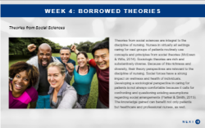](https://lms.courselearn.net/lms/CourseExport/manual/interactives/CU/NR501/NR501_W4_BorrowedTheories/story_html5.html)

[Borrowed Theories Used by Nursing (Links to an external site.)](https://lms.courselearn.net/lms/CourseExport/manual/interactives/CU/NR501/NR501_W4_BorrowedTheories/story_html5.html)

[Transcript](https://chamberlain.instructure.com/courses/65025/pages/week-4-borrowed-theories-used-by-nursing?module_item_id=8752550)

**Specialty Tracks**

Click on the link below to download theories related to specialty tracks.

[NR501 Specialty Areas Nursing Theories (Links to an external site.)](https://lms.courselearn.net/lms/content/1550/55171/NR501NP/NR501_W4_Lesson_Specialty_Areas_Nursing_Theories.docx)

**Reflection**

Think about your future professional nursing practice. Explore a theory identified above related to your specialty track and consider ways in which the selected theory could be used to guide your practice.

Theory Analysis

In a previous week we discussed concept analysis as a process for examining concepts, contextually, as building blocks of theory. Not only do concepts need analysis to provide clarity, but so do the various nursing theories used. Theory analysis takes a critical look at the various components and linkages within any given nursing theory. While there are a variety of methodologies described, the key components or areas of consideration are comprehensiveness and parsimony (Melnyk & Fineout-Overholt, 2015; McEwen & Wills, 2014).

Comprehensiveness asks if the theory can be used in all areas of practice, whereas parsimony takes a close examination of the multiple parts of the theory (Parker & Smith, 2015; Walker & Avant, 2011). While there are a variety of approaches to the analysis of theory available in literature, most strategies focus on similar criteria (McEwen & Wills, 2014). In addition to determining comprehensiveness and parsimony, theory analysis involves looking at the usefulness of theory. Is the theory being used by direct patient caregivers and nurse educators, or is it restricted to one specific area of practice? What about the fruitfulness? Are other nurses publishing on how they are using the theory?

Walker and Avant (2011) offer the following steps for theory analysis.

**Theory Analysis Definitions**

Click on the interactive to learn more about theory analysis definitions.

[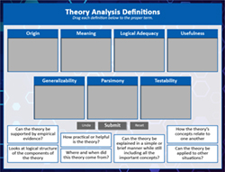](https://lms.courselearn.net/lms/CourseExport/manual/interactives/CU/NR501/NR501_W4_Theory_Analysis_Definitions/index.html)

[Theory Analysis Definitions (Links to an external site.)](https://lms.courselearn.net/lms/CourseExport/manual/interactives/CU/NR501/NR501_W4_Theory_Analysis_Definitions/index.html)

[Transcript](https://chamberlain.instructure.com/courses/65025/pages/week-4-borrowed-theories-used-by-nursing?module_item_id=8752550)

**Origin** - Where and when did this theory come from?

**Meaning** - How the theory’s concepts relate to one another

**Logical Adequacy** - Looks at logical structure of the components of the theory

**Usefulness** - How practical or helpful is the theory?

**Generalizability** - Can the theory be applied to other situations?

**Parsimony** - Can the theory be explained in a simple or brief manner while still including all the important concepts?

**Testability** - Can the theory be supported by empirical evidence?

## Theory

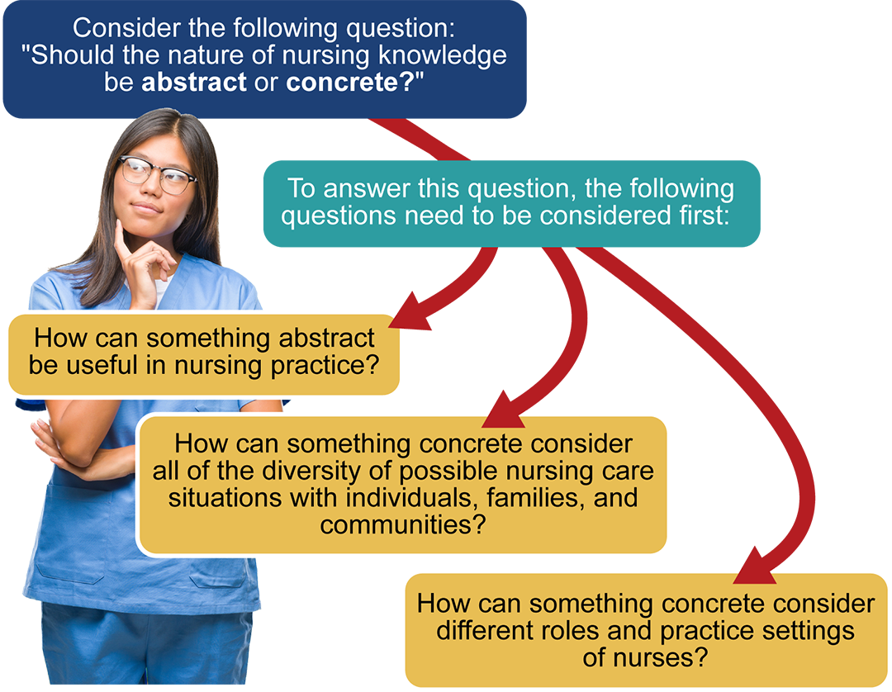

[Transcript](https://chamberlain.instructure.com/courses/65025/pages/week-4-nursing-theories?module_item_id=8752555)

Consider the following questions: "Should the nature of nursing knowledge be abstract or concrete?"

To answer this question, the following questions need to be considered first:

* How can something abstract be useful in nursing practice?
* How can something concrete consider all of the diversity of possible nursing care situations with individuals, families, and communities?
* How can something concrete consider different roles and practice settings of nurses?

## Definition of a Theory

A theory is a frame of reference on how individuals view reality. A formal definition notes that theory is a group of interrelated concepts, assumptions, and propositions that explains or guides action. For the nursing profession, a nursing theory provides a view of or a window into the reality of nursing. It guides the thinking about and the doing of nursing. A comprehensive theory includes an explanation of both the noun and verb aspects of the profession, as well as a consideration of the concepts of the nursing metaparadigm: person, health, environment, and nursing (Melnyk & Fineout-Overholt, 2011; McEwen & Wills, 2014). Theories go beyond interventions to consider, in both speculative and practical manners; the focus of the person using the theory; and the desired nursing outcome. Practitioners, researchers, and educators of nursing have a common discussion point of what is and what is not nursing (Parker & Smith, 2015).

## Level of Abstraction

**Grand Theories**

How can something abstract be useful in nursing practice?  Let's first consider the level of abstraction and how it applies to the scope of a theory. Take a moment a look into the following picture.



[Image Description  (Links to an external site.)](https://chamberlain.instructure.com/courses/65025/pages/week-4-nursing-theories?module_item_id=8752555#descbox1)

How many objects do you see?

The first time you read a grand nursing theory with its high level of abstraction, the words may seem fuzzy and unclear. But as you peer into the words more closely, the theory along with its concepts becomes discernible and comprehensible, similar to the picture (Parker & Smith, 2015).

A grand theory uses a high level of abstraction so that its scope or picture of the nursing profession is very broad and generalized. Only by being abstract, ideal, visionary, and even transcendental is a grand nursing theory able to address all of the variables that a professional nurse may encounter while providing care to individuals, families, groups, and communities (Parker & Smith, 2015).

By definition, a grand theory must consider all of the concepts of a profession. Remember, for the profession of nursing, the metaparadigm concepts are person, health, environment, and nursing itself (Parker & Smith, 2015). So the question becomes: How can something abstract be useful in nursing practice? Without careful thought, the initial answer may be: "It can't be used, because it is abstract."

Actually, grand nursing theories are too broad to orchestrate direct patient-care activities, but they are useful in nursing practice because more specific theories (i.e., middle-range, practice) can be derived from the grand theories.

## Examples of Grand Theories

Lets take a look at a few examples of grand theories. Open the activity by clicking the link below.

**Examples of Grand Theories**

View the following activity on Examples of Grand Theories.

[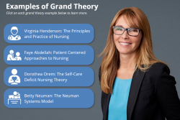](https://lms.courselearn.net/lms/CourseExport/manual/interactives/CU/NR501/NR501_W4_Examples_of_Grand_Theory/story_html5.html)

[Examples of Grand Theories (Links to an external site.)](https://lms.courselearn.net/lms/CourseExport/manual/interactives/CU/NR501/NR501_W4_Examples_of_Grand_Theory/story_html5.html)

[Transcript](https://chamberlain.instructure.com/courses/65025/pages/week-4-nursing-theories?module_item_id=8752555)

**Virginia Henderson: The Principles and Practice of Nursing**

In 1937, Virginia Henderson and other scholars developed a nursing curriculum for the National League of Nursing in which the education was focused on patient-centered care and nursing problems. Thus, her theory was derived from her practice and education. The major assumption of Henderson’s framework is that nurses care for patients until patients can care for themselves. For patients, the desire is to return to a state of wellness and health. The major concepts of the theory relate to the nursing metaparadigm (i.e., patient, nursing, health, and environment). Henderson believes that the unique function of the nurse was to assist the patient during illness and assist in performing those activities that restore the patient to health. She defined the patient as someone who needs nursing care but not limited to illness (McEwen & Wills, 2014).  ​

**Faye Abdellah: Patient Centered Approaches to Nursing**

Faye Abdellah was one of the first major nursing theorists. Her nursing theory was developed inductively form her practice and considered a human-needs framework. Abdellah and her colleagues developed a list of 21 nursing problems and 10 steps in identifying patient problems. They also identified 10 nursing skills to be used in developing treatment typology. Furthermore, her team distinguished between nursing diagnosis and nursing functions. Diagnoses were a determination of the nature and extent of the patient problems. Other concepts central to her work were: healthcare team, professionalization of nursing, patient, and nursing (McEwen & Wills, 2014).  ​

**Dorothea Orem: The Self-Care Deficit Nursing Theory**

Dorothea Orem is well recognized for her conceptual framework of self-deficit nursing theory. Between 1971 and 1995, several revisions have been made to the model, but the premise underlying her theory is the individual and the idea of nursing as a system. The paradigms supporting her theory include: nursing meets the needs of patients for self-care; humans are defined as men, women, and children; the environment has a physical and chemical component; and health is defined as beings structurally and functionally whole (McEwen & Wills, 2014). Orem felt that humans engage in continuous interaction between themselves and the environment to remain well and live. Human agency is exercised and discovered by developing, engaging, and transmitting with others in a way that provides meaning to oneself. Self-care requisites are common to all humans, as is growth and development and deficits. Nurses play a major role in assisting patients with healthcare deficits. Orem’s theory has been adopted by many nursing school curriculums (McEwen & Wills, 2014).  ​

**Betty Neuman: The Neuman Systems Model**

Since the 1960s, Betty Neuman has been recognized as a pioneer in nursing, particularly in the specialty area of mental health. She developed her model while lecturing in community mental health at UCLA. The model uses a systems approach that is focused on human needs and protection against stress. Neuman believed that stress can be modified and remedied through nursing interventions (McEwen & Wills, 2010). She emphasized the need for humans to maintain a dynamic balance that nurses can provide to patients by assisting them to identify problems and agreed-upon mutual goals. The environment component of Neuman's model is both the internal and external forces surrounding the client and can be influenced or changed at any time. Neuman identified five variables of her theory: physiological, sociocultural, psychological, developmental, and spiritual (McEwen & Wills, 2014).  ​

## Middle-Range Theories

How can something concrete consider all of the diversity of possible nursing care situations with individuals, families, and communities?

The initial answer is that as a theory becomes more concrete or narrow in scope, something is left out. For example, a middle-range theory regarding chronic illness leaves out acute illnesses, as well as preventive healthcare. A middle-range theory regarding home healthcare would leave out providing healthcare to individuals in other settings such as an extended-care facility. A practice theory concerning abused children from chemically addicted parents would not consider abused children from other situations, such as economically stressed families (Melnyk & Fineout-Overholt, 2011).

Middle-range theories were first suggested in the discipline of sociology in the 1960s and introduced into nursing in 1974. Middle-range theories were useful in other disciplines because they were more readily operationalized and addressed through research than grand theories (McEwen & Wills, 2014). Development of middle-range theories was supported by the critique that grand theories were difficult to understand and apply to the practice setting. Thus, the function of the middle-range theory is to describe, explain, or predict phenomena and be explicit and testable. Middle-range theories are more readily applied to research studies. In addition, middle-range theories are able to guide nursing interventions and change conditions to enhance nursing care. Furthermore, each middle-range theory addresses concrete or specific phenomena by stating what the phenomena are, why they occur, and how they occur. These theories support the connection between diagnosis and outcomes of care (McEwen & Wills, 2014).

A major disadvantage to a middle-range and/or practice theory is that something is left out, but one advantage is that the information gained is far more focused and can be verified with research. This would contribute to evidence-based practice for nursing. To see the comprehensive picture of the nursing profession, a grand theory is needed. But to work with specific actions or develop researchable topics, a middle-range or practice theory is needed (McEwen & Wills, 2014).

## Examples of Middle Range Theories

Click on each tab below to explore a few examples of middle range theory.

* [Benner's Model of Skill Acquisition in Nursing](https://chamberlain.instructure.com/courses/65025/pages/week-4-nursing-theories?module_item_id=8752555#NR501NP_1551731088533_tab1_container)
* [Pender's Health Promotion Model](https://chamberlain.instructure.com/courses/65025/pages/week-4-nursing-theories?module_item_id=8752555#NR501NP_1551731088533_tab2_container)
* [The Synergy Model](https://chamberlain.instructure.com/courses/65025/pages/week-4-nursing-theories?module_item_id=8752555#NR501NP_1551731088533_tab3_container)



Benner's model depicts five stages of skill acquisition: novice, advanced beginner, competent, proficient, and expert. The model emphasizes the importance of rewarding nurses for their clinical expertise and leadership in clinical practice settings because it describes the process of excellence and a caring practice. Expertise develops when the nurse tests and refines clinical expertise and practical knowledge. The central essentials of Benner's model are those of skill acquisition, experience, competence, clinical knowledge, and practical knowledge (McEwen & Wills, 2014).

Summary

A formal definition notes that theory is a group of interrelated concepts, assumptions, and propositions that explains or guides action. Grand theories are abstract, general, and broad incorporating all concepts of the metaparadigm. Mid-range and practice theories are narrower in focus, may include one or all of the metaparadigm concepts, and lend to practical application in practice settings. For the nursing profession, a nursing theory provides a view or a window into the reality of nursing.

Borrowed, shared, and interprofessional theories add value to nursing practices. Understanding and incorporating non-nursing theories in our practice, helps to expand our perspectives, provides enhanced person-centered care, and promotes effective work within interdisciplinary health care teams. However, it is still essential for nursing to generate new nursing specific theories for continued knowledge development of the nursing discipline and to maintain a separate identity for the profession of nursing.

Key Points

* Grand nursing theory provides a high level of abstraction and may be applied to all areas of the profession
* Middle range nursing theories are narrow in scope and address a specific aspect of nursing
* Nursing uses many theories borrowed from other professions